UPLOAD VENDOR LIST PRICE IN ACS

OBTAIN LIST PRICE FILE FROM VENDOR. MOST VENDORS WILL SUPPLY IN EXCEL
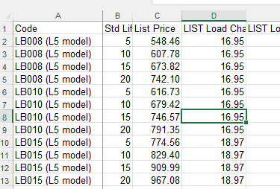

REVIEW AND CHANGE THE MFG P/N TO SAME P/N LOADED IN ACS, IF NECESSARY
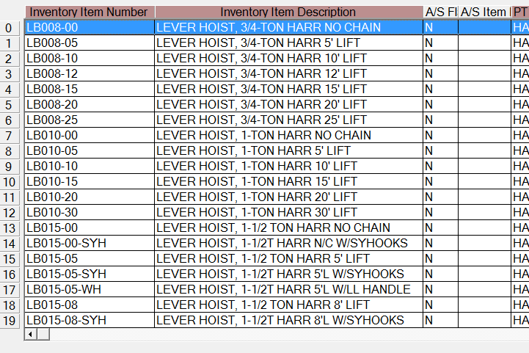

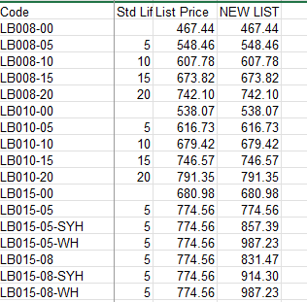

CONFIRM ANY LIST PRICE ADDERS ARE CORRECTLY CALCULATED IN THE “LIST PRICE” FIELD
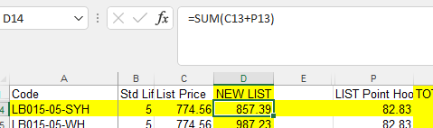

SAVE NEW TXT FILE WITH P/N, DESCRIPTION AND LIST PRICE IN ACS OUTPUT FILES: Z\OUTPUTFILES
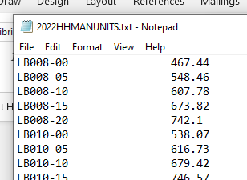

AT ACS MAIN SCREEN: INVENTORY - MAINTENANCE - VENDOR PRICING UPDATE EDIT LIST
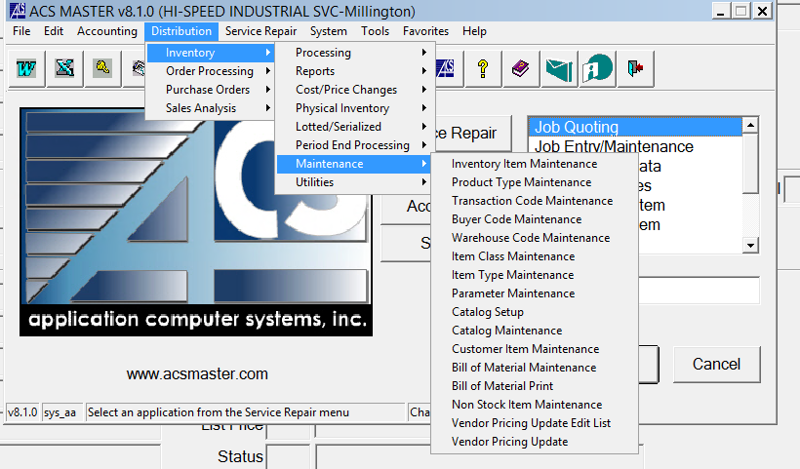

VENDOR PRICING UPDATE EDIT LIST WILL CONFIRM THE FILE IS ACCURATE AND PROVIDE THE LIST OF ITEMS 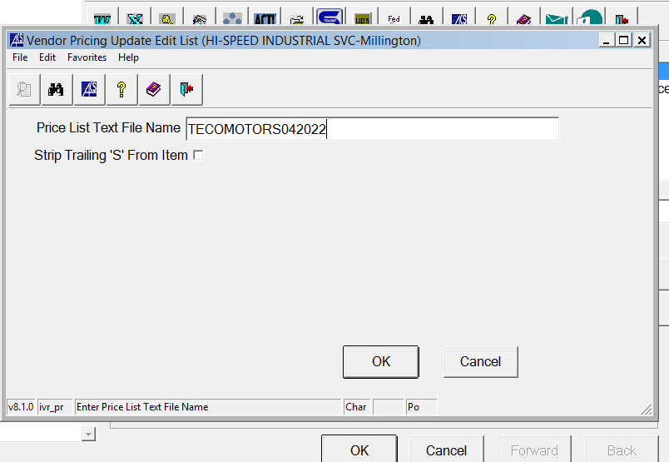

CLICK OK TO GENERATE THE LIST TO REVIEW

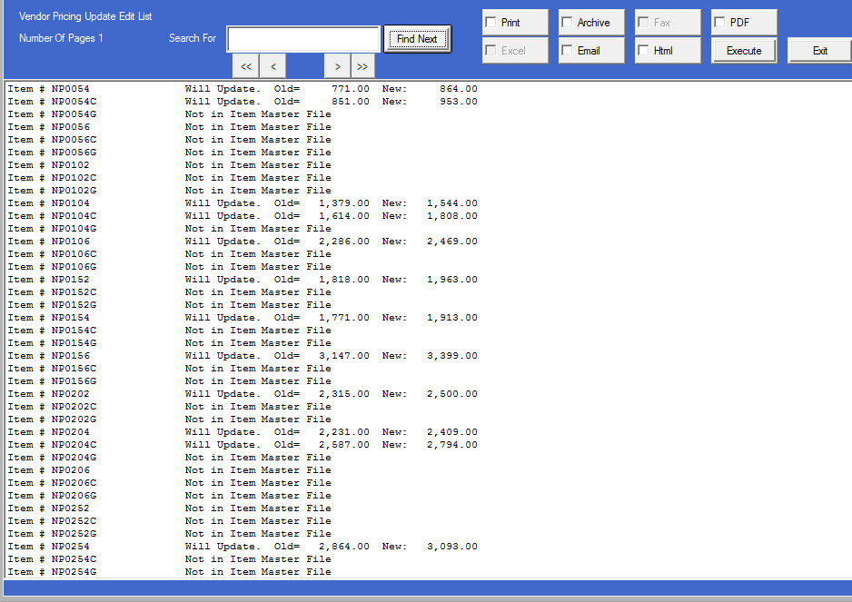

VENDOR PRICING UPDATE WILL UPDATE THE PRICE USING THE SAME STEPS:
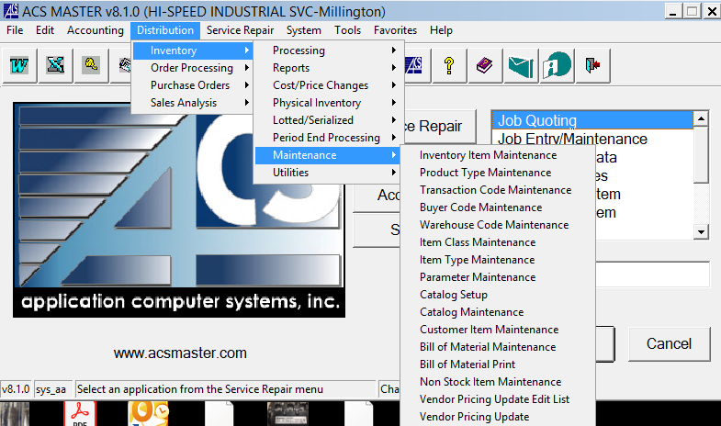
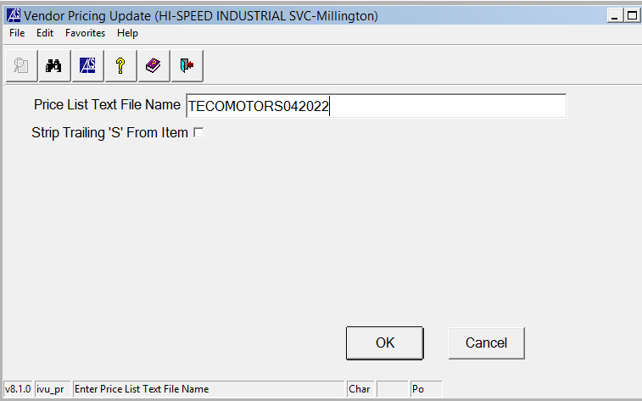

CLICK OK TO GENERATE THE UPDATED LIST
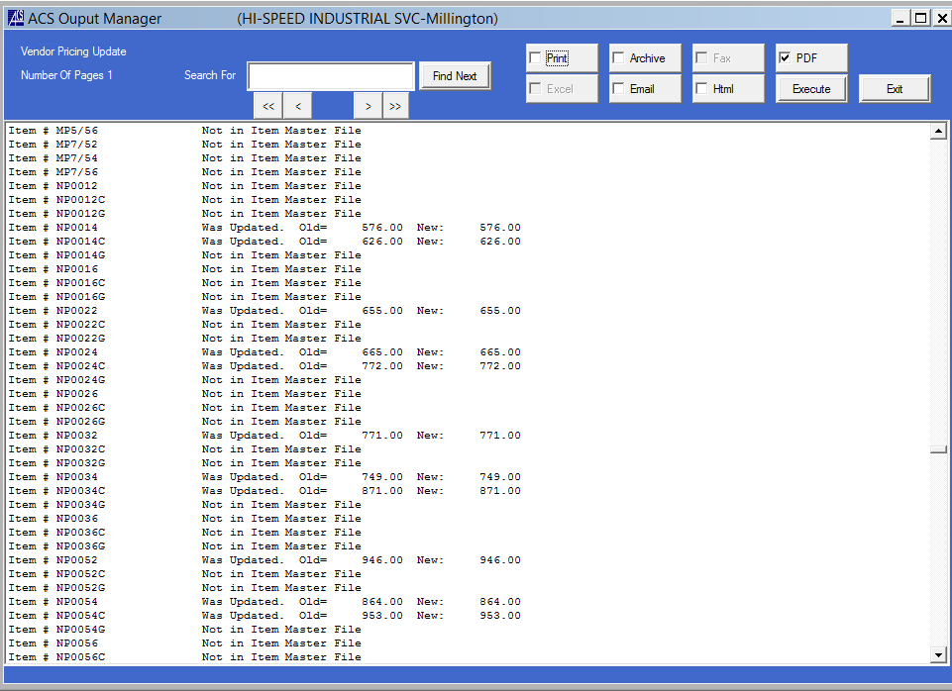

CHECK THE PDF BOX
CLICK EXECUTE TO GENERATE THE PDF
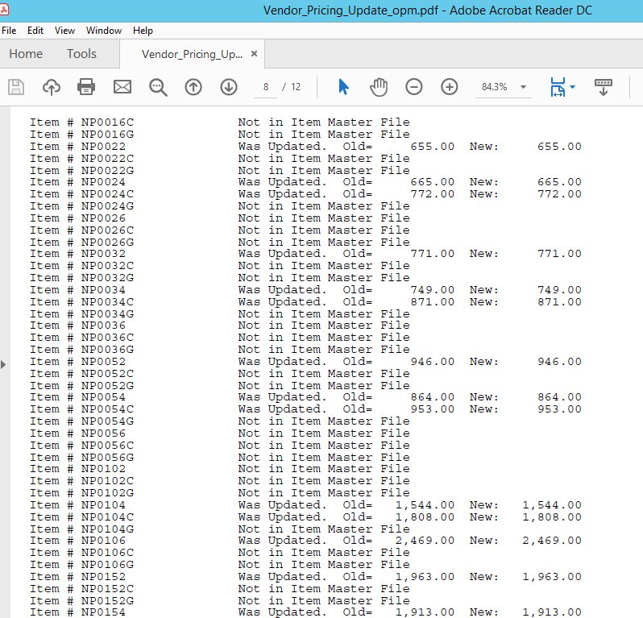

SAVE THIS PDF IN S:PRICING/VENDORS

REPEAT STEPS IN LR ACS SYSTEM

