Time Entry – Batch Report

* Time needs to be submitted DAILY to prevent delays with job billing and payroll.
* Once time is completed, it will be submitted to [Time@gohispeed.com](mailto:Time@gohispeed.com) and copy Amy.
* Time is typically completed and submitted by 9:00am daily- If there are delays with submitting, you will need to notify Amy when time is expected to be completed. Time for the COMPANY will not be submitted until ALL departments have submitted time.
* There are two ways to access the timecard- this will detail the daily report only. *Additional training required to access the manual batch report.*

1. The .txt file is generated by Comet daily at 7:30am DAILY (including Saturday and Sunday) and report emailed to Dept Coordinator (additional emails can be added as necessary). The file name is for the date the work was completed. If multiple days are included in the report, include all days (Example- 02.24.20-02.25.20)
2. .Txt file needs to be saved to computer; any location will do (example- 02.25.20 ML HR Timecard Report Final)
3. Open Excel
4. Open the saved 02.25.20 ML HR Timecard Report Final.txt
   1. Open file as comma delimited

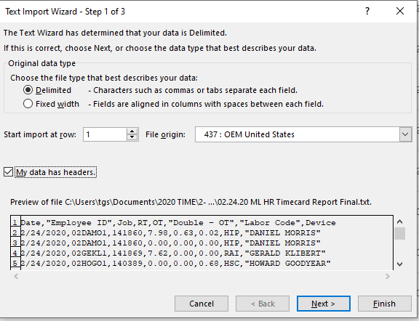

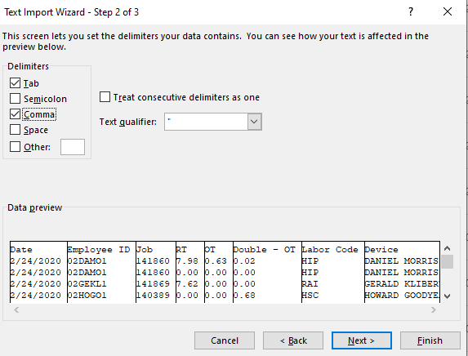

* 1. Select “My data has headers” hit next, select “Comma”, hit Finish.

1. Check time, check for errors, check for lunches (Will need to reference back to Comet)
   1. Check all job numbers- CONFIRM they are correct every day, every tech. 5 minutes of checking for correct job numbers will alleviate errors with invoicing
   2. Check for lunches- techs should have a 30-minute lunch every day. You will need to verify that they took and lunch and clocked their time correctly.
   3. Be mindful of how much time SHOULD be on each job- Coordinators should know about every job, if it was completed within the quoted amount of time, if there were delays on the job, etc.
   4. Confirm Labor Code is correct. These need to be in CAPITAL letters every time and must be corrected prior to submitting.
   5. If there are any questions on time, call the technician. Did they clock time correctly? Did they clock out on the correct job at the correct time? Most techs have between 8-10 hours day. If it is less than 8 hours, confirm with the tech. If they have NO time, are they scheduled off for the day?
   6. IF ANY TECH SAYS THEY CLOCKED TIME WRONG, THEY NEED TO EMAIL YOU THEIR CHANGES (Example- I forgot to clock in at 7am, please clock me in; I forgot to clock out, please clock me out at 5:30). This is a frequent occurrence.

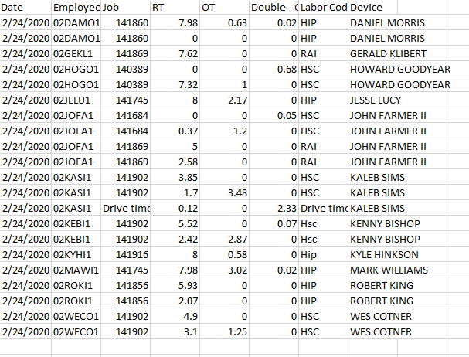

6. Once all time is correct, save the file as a .csv file.

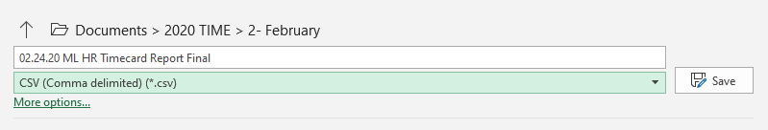

7. Submit .CSV report to Time and copy Amy. Time is complete for the day unless there are questions regarding the file. If Job numbers are incorrect and the labor code is not capitalized, the report will be kicked back to you for the needed changes.

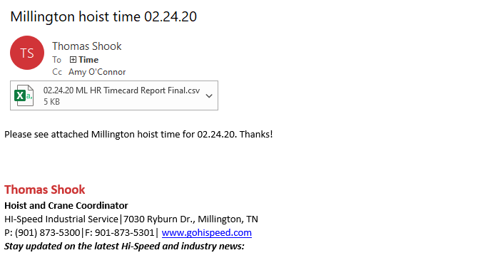

Time Entry – Manual Download Report

* Time needs to be submitted DAILY to prevent delays with job billing and payroll.
* Once time is completed, it will be submitted to [Time@gohispeed.com](mailto:Time@gohispeed.com) and copy Amy.
* Time is typically completed and submitted by 9:00am daily- If there are delays with submitting, you will need to notify Amy when time is expected to be completed. Time for the COMPANY will not be submitted until ALL departments have submitted time.
* There are two ways to access the timecard- this will detail the manual download report only. *\*\*\*Additional training required to access this report\*\*\**

1. To begin the manual batch report, select “Charts & Reports” on the header, and “Reports” on the sidebar. A pop-up window will appear to access the manual download.
   1. You will need to click “Batch Reports” from the pop-up menu to access the data entry dropdown menu

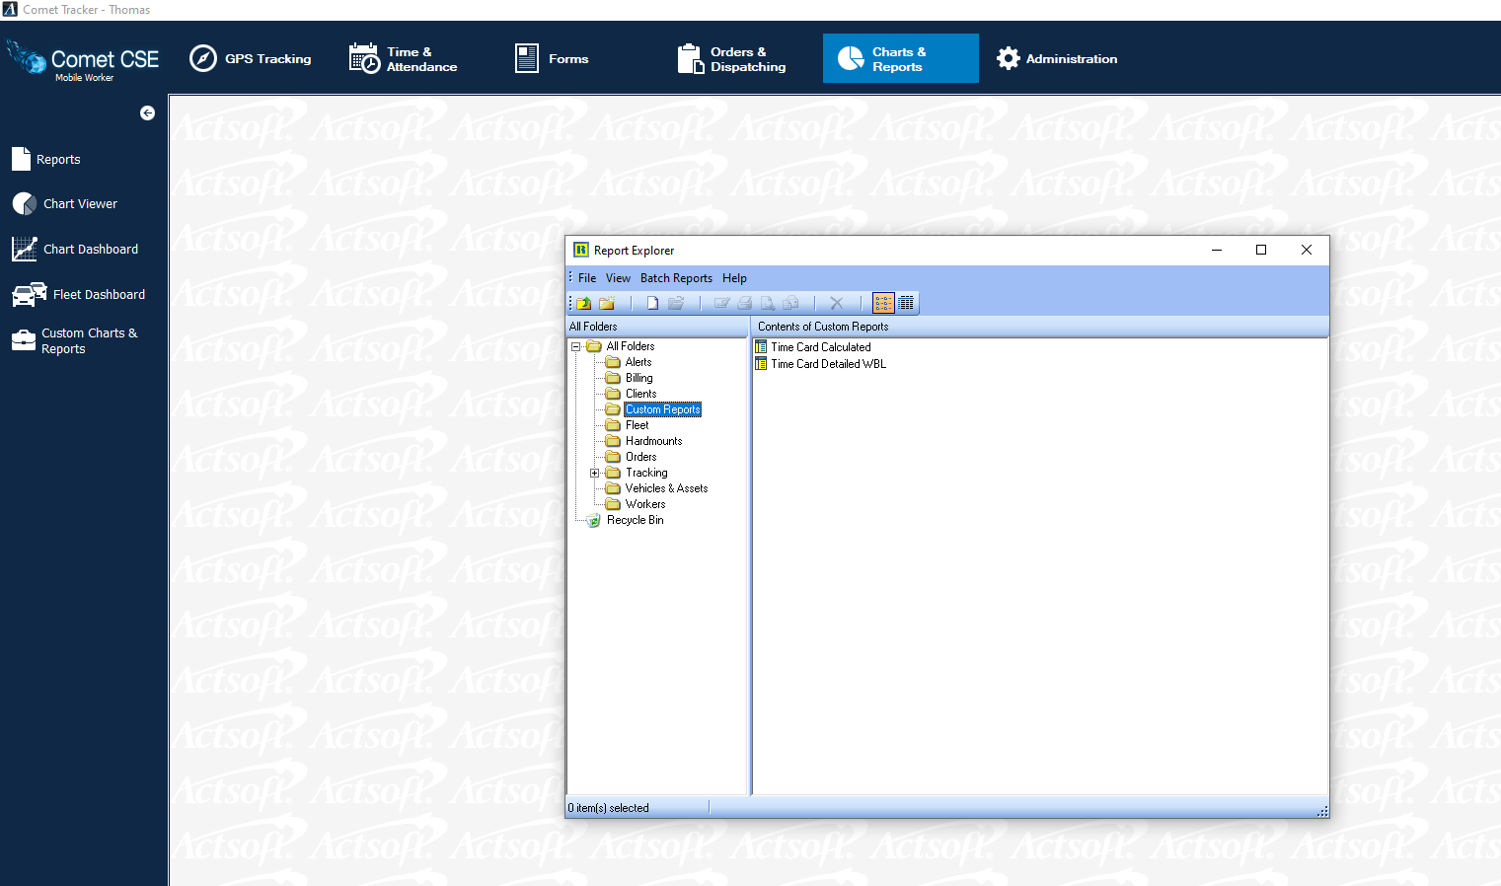

* 1. Click “Time Card Calculated” in the Custom Reports file to open the dropdown menu.
  2. Under the “Employee Num” dropdown, select the first employee for the correct department. *All employees will need to be manually added to the report before downloading.* Employees not added to the report will not have time calculated for this report.

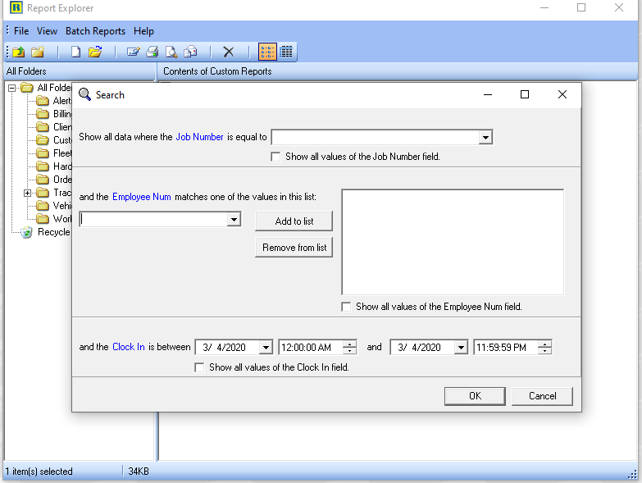

* 1. Select employee (one at a time), click add. The employee will appear in the right-hand column. Repeat process for all employees in the department.

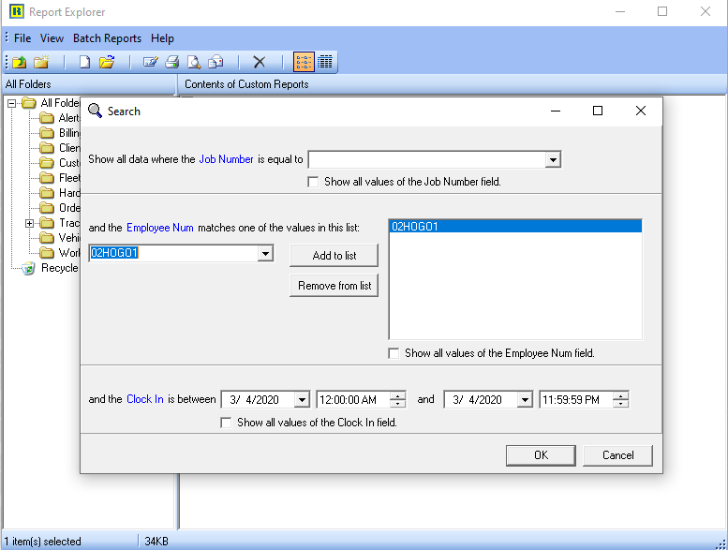

3

2

1

* 1. After all department employees are added to the column, select date range. DO NOT CHANGE THE HOURS SET. Report will run from 12:00:00 AM through 11:59:59 PM. Select “OK”

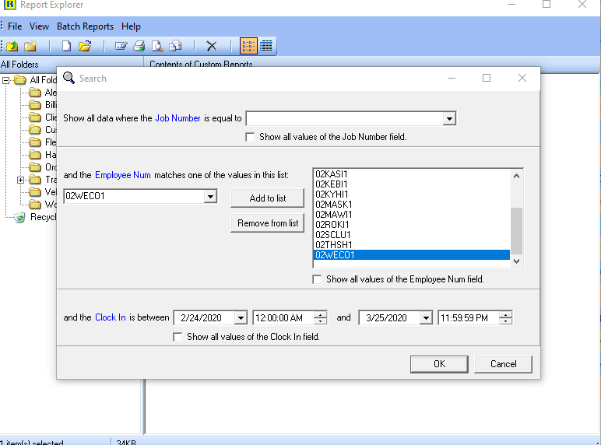

* 1. 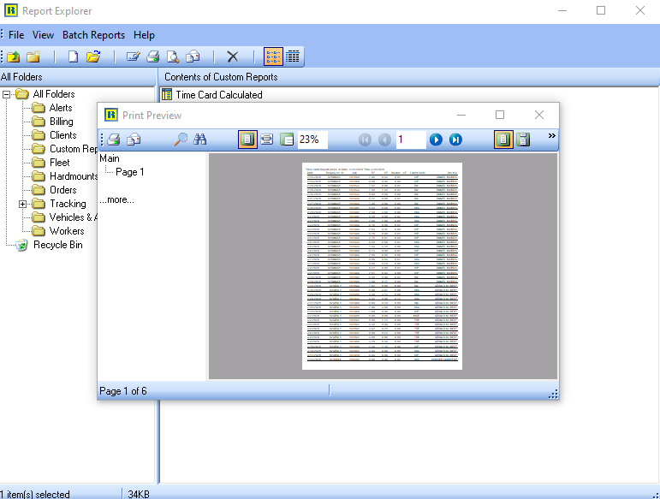A new pop-up window will appear. Click “Print” and save as .txt file to new file location. Refer to standard Batch Report procedures (Begin at Step 2)

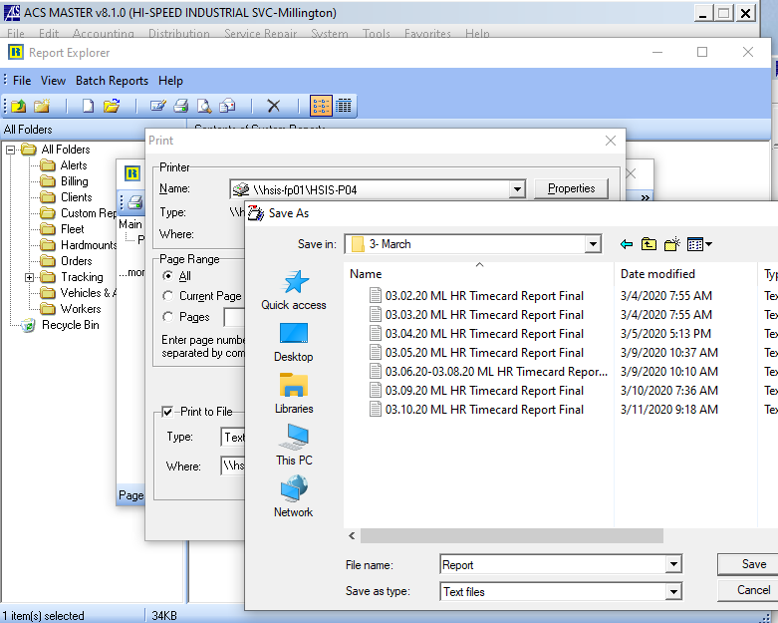

1. Complete time as you would with standard batch procedures. Check time, correct job numbers and labor codes, and submit to [Time@gohispeed.com](mailto:Time@gohispeed.com) when complete.