**Service Call Estimates**

* Step 1- Log into ACS and click on Job entry/maintenance

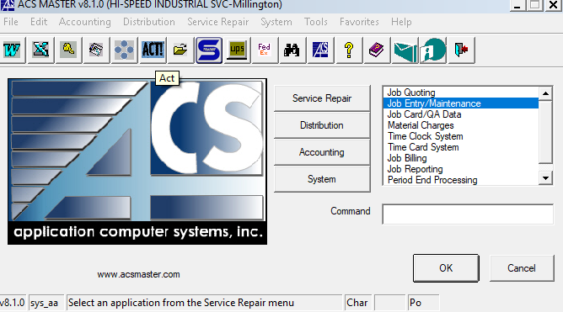

* Step 2- Click Job Entry

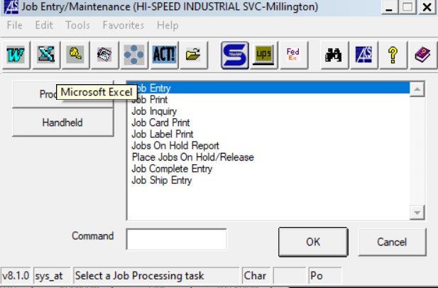

* Step 3- Right click or press F2 to assign a new job number and click yes if it is a new job, if not hit F3 on your keyboard to look up an existing job.

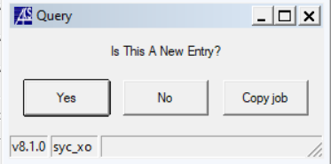

* Step 4- Click in department – Department code for a service call HR
* Step 5- Click in type- Type for a service call is HS

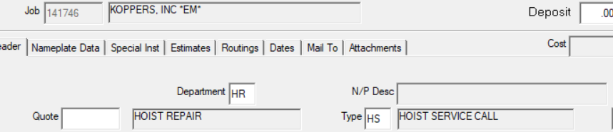

* Step 6- Click customer number- If you do not know the customer number, you can hit F3 or right click and click on lookup.

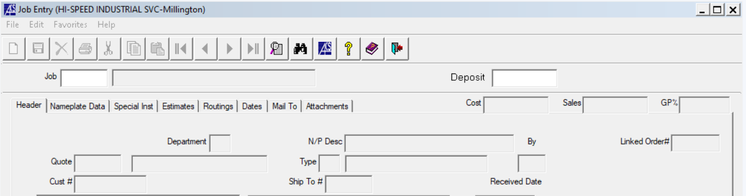

* Step 7- Click on ship to number- if you do not know the ship to address, hit F3 or right click and hit lookup.
* Step 8- Input the received date (when you opened the job) and input promise date of when you and the customer confirmed service call to be scheduled and/or parts to be installed.
* Step 9- Click on customer PO and add it
* Step 10- Click on job description and fill it out
* Step 11- Click on contact (whomever called in the job)
* Step 12- Click on priority- most of the time it will be 3

1. Full overtime
2. Rush
3. Standard

* Step 13- Click on amount- $2,000.00 is the estimated amount to open a job that is not quoted and hit enter for the remain boxes.

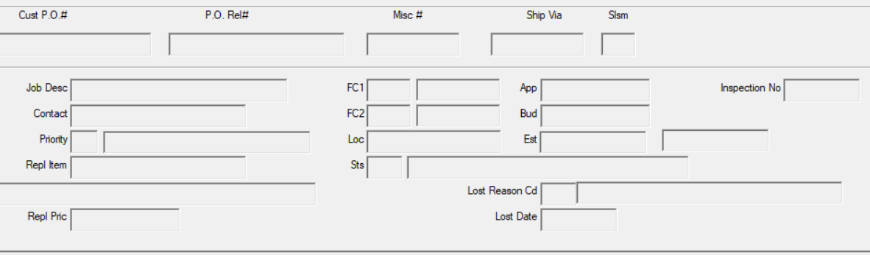

* If the job is already open skip steps 4-13
* Step 14- click on the estimates tab in the job entry and leave this open.

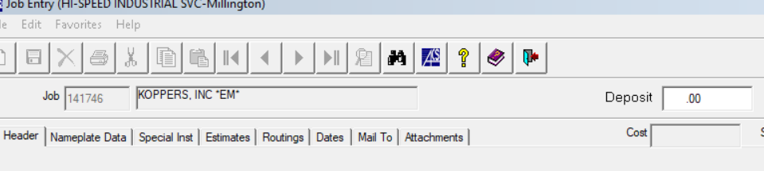

* Step 15- Log into Inspectall and type job number in search box and under folders it will pull up the service call report- click on service calls & breakdowns

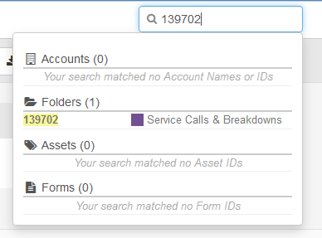

* Step 16- Click on service worksheet asset tracking to find out what is needed and then the blue arrow to open

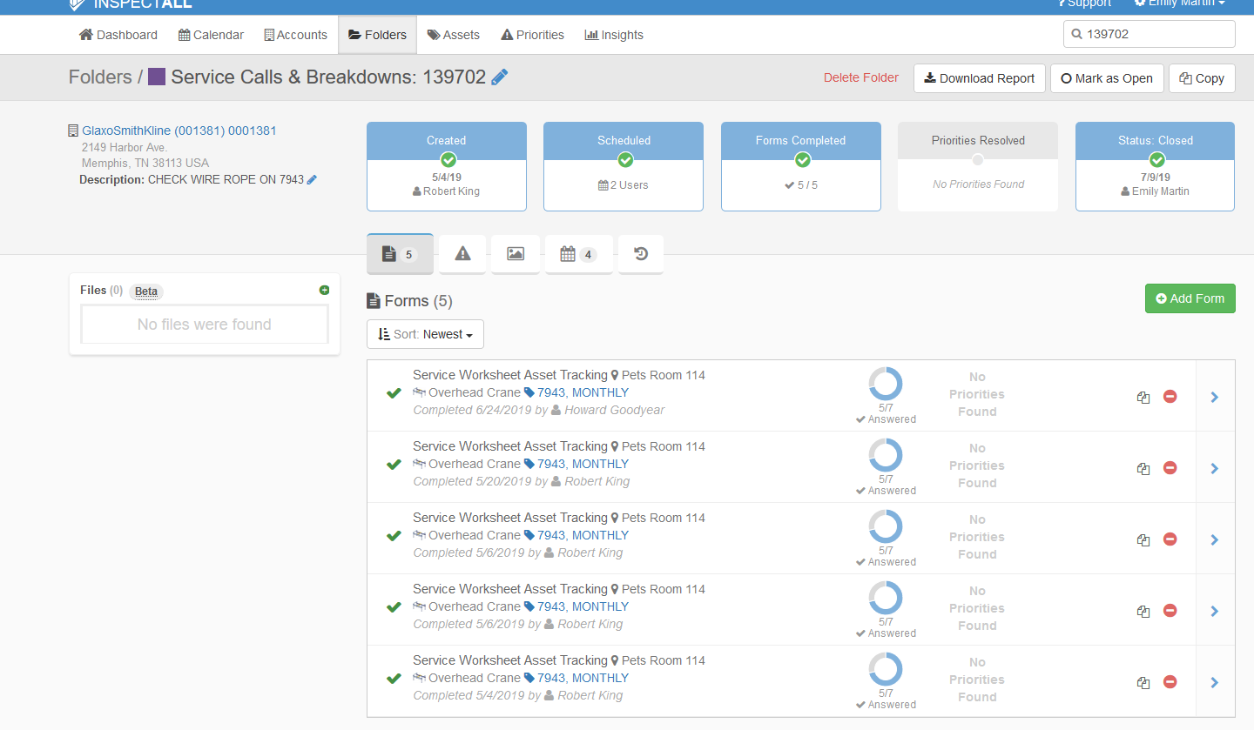

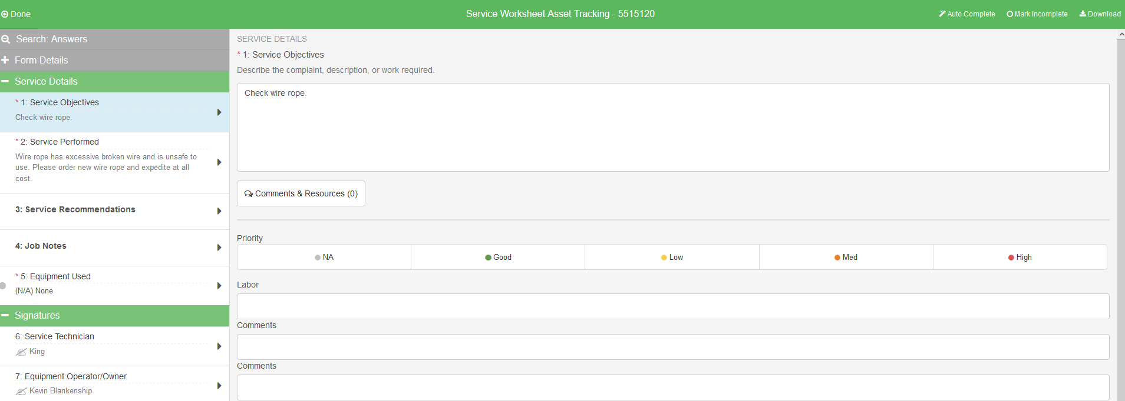

Step 17- Click done to return to the asset tracking- The asset is in blue- this is where you will get all the information needed for quoting parts.

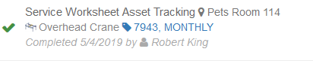

* Example- Need to replace wire rope on asset 7943- Click on the blue 7943

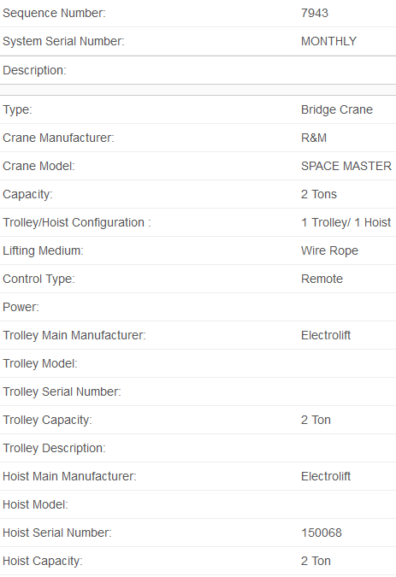

* Contact Electrolift for a quote on the wire rope
* If you do not have that specific vendors email or phone number, William has a white binder that has a lot of information on who to contact for assistance.
* Step 18- Once you have the vendor quote- switch over to ACS job estimates

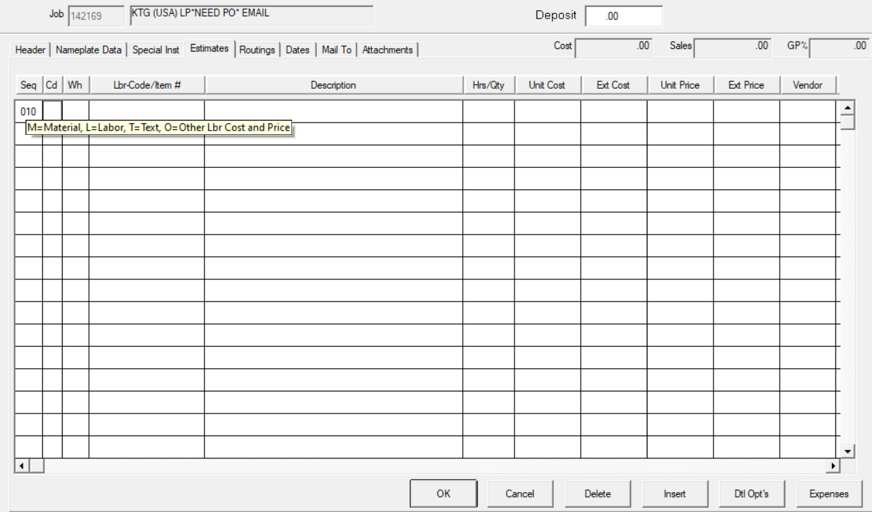

* Step 19- Click on SEQ and type 010 enter
* Step 20- Click on Cd- right click and select M-material and hit enter to go to the next box
* M- Materials
* L-Labor
* T-Text
* O-Other and price
* Step 21- Wh will auto fill with 01, hit enter to go to next box
* Step 22- Lbr-Code/Item #- here you would type in the material number and hit enter to go to next box, it will ask you if this is a non-stock item- click yes- if you are not sure if this is a non-stock item

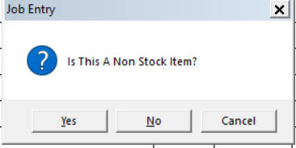

(if you are not sure if this is a non-stock item- go to the main screen for ACS, click on the binoculars, click on distribution, inventory, type in item number- if the item does not come up it is a non-stock item- if the item does come up it is a stock item.

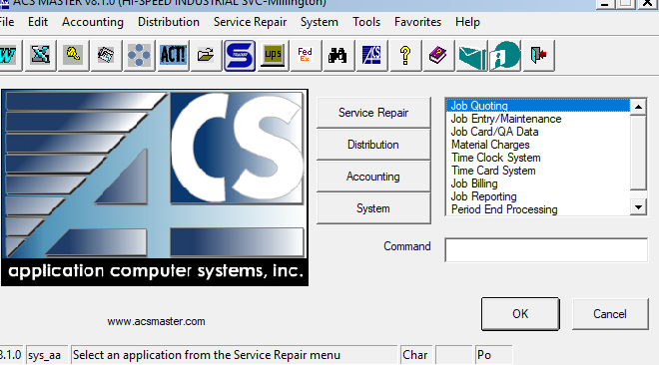

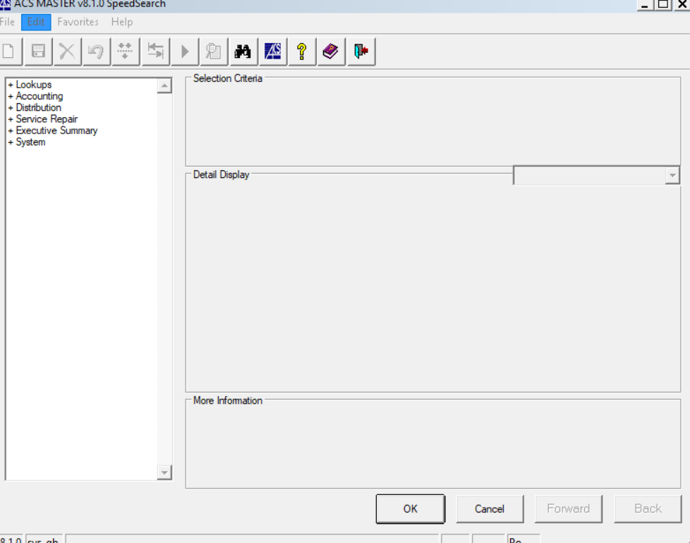

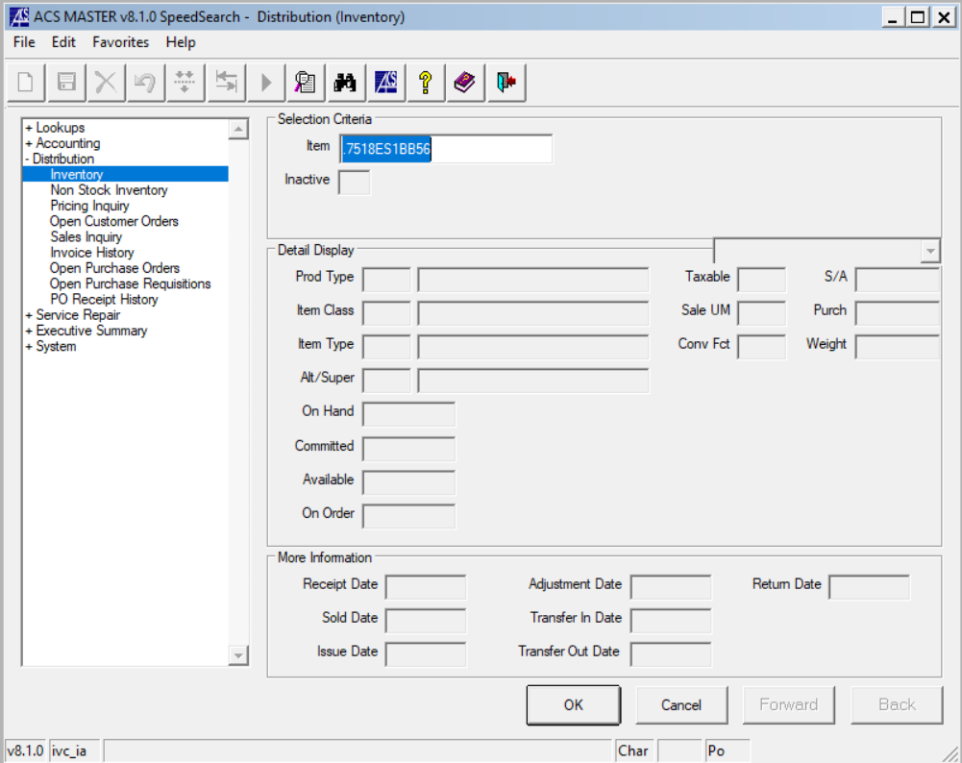NON-STOCK ITEM

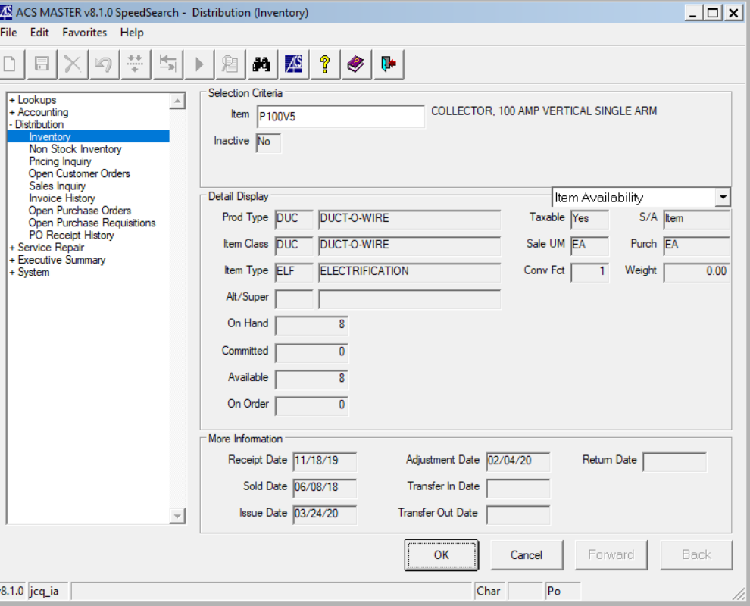 STOCK ITEM

* Step 23- Description- sometimes this autofills, other times you will have to type the description in and press enter
* Step 24- Hrs/Qty- type in how many of this item is needed or the length needed, and press enter
* Step 25- Unit cost- type in our cost from the quote and press enter, it will auto fill the ext cost and press enter, it will auto fill unit price and press enter, and it will autofill Ext price and press enter

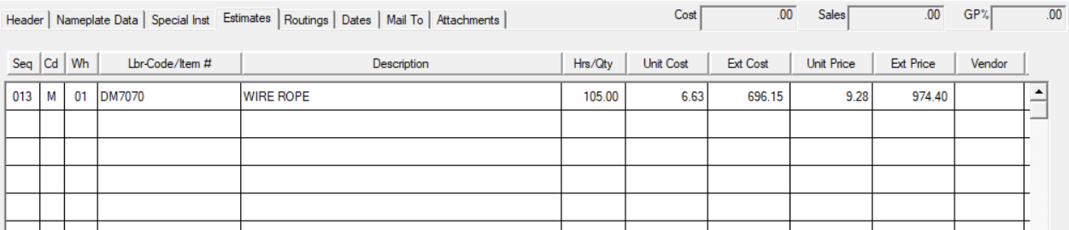

* Step 26- Vendor- Press F3 to look up or right click lookup- type in start with box to find vendor, click on name and it will filter vendors, when you find the correct one double click and it will populate in vendor name and press enter

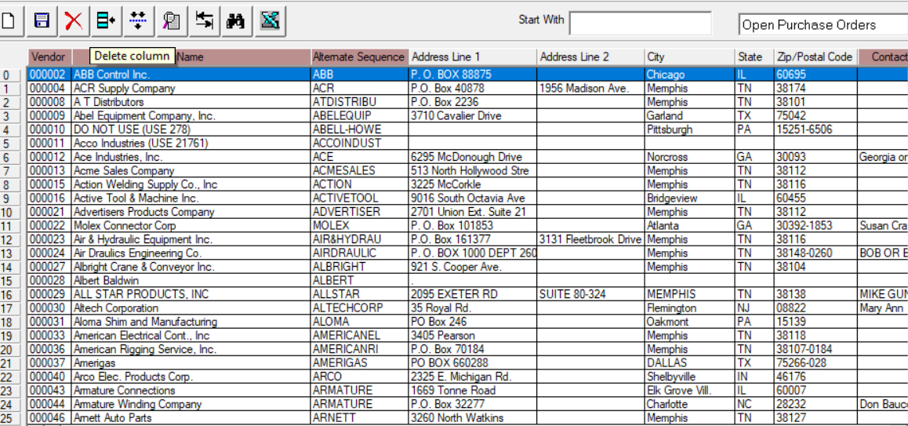

* Step 27- DS- this will autofill and press enter
* Step 28- R/P- this will autofill and press enter
* Step 29- CS/Seq- This information is from the asset tracking in inspectall- and press enter- see step 17 for reference. This is important information to have incase this is a reoccurring issue you can easily pull this up in ACS or when sending a technician out for the repair.

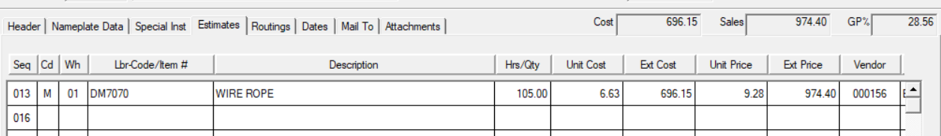

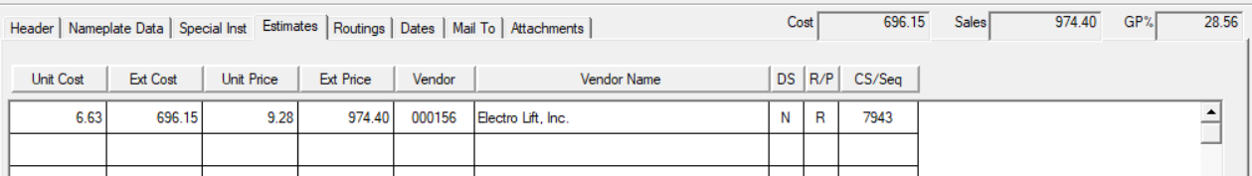

**Adding Labor**

* Step 1- Seq- 020
* Step 2- Cd- L= Labor, then press enter

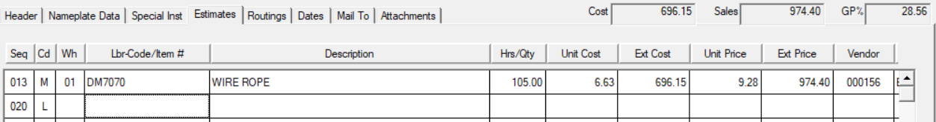

* Step 3- Lbr-Code/Item #- Press F3 or right click – lookup- HSC (hoist service call), then press enter

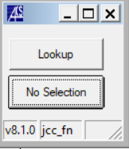 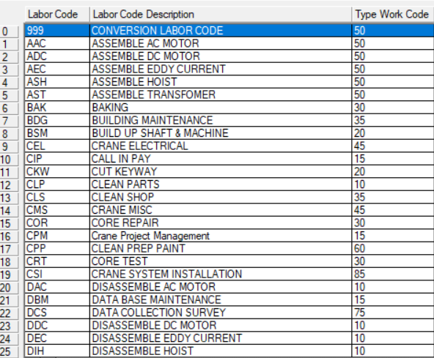

* Step 5- Description- this will autofill, then press enter
* Step 6- Hrs/Qty- how long will this take to install, how many technicians will be needed, then press enter

(the technicians will tell you how long it will take and how many technician’s will be needed in the service worksheet asset tracking in inspectall. If the technician does not provide this information you will have to call and ask.)

* Step 7- Unit Cost- type in 32 for straight time, then press enter, Ext cost will autofill, then press enter
* Step 8-Unit Price- this will autofill, then press enter, ext price- this will autofill then press enter
* Step 9- CS-Seq- Type in asset number/ sequence number, then press enter
* Step 10- Type in 030, then press enter
* Step 11- Cd- L= Labor, then press enter
* Step 12- Lbr-Code/Item #- type in TRT, then press enter- this will autofill description, then press enter
* Step 13- Hrs/Qty- How much time to travel to and from the job site, then press enter
* Step 14- Unit Cost- type in 32 for straight time, then press enter, ext. cost will autofill, then press enter, ext price will autofill, then press enter, ext price will autofill, then press enter
* Step 15- CS/Seq- Type in asset number/ sequence number, then press enter
* Step 16- Seq- type 040, then press enter
* Step 17- Cd- M, then press enter
* Step 18- Lbr-Code/Item #- type in RT MILEAGE, then press enter, is this a non-stock item? Click yes

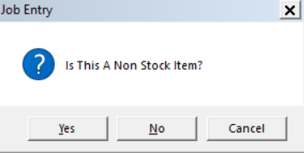

* Step 19- Description- Round trip mileage- (mileage to and from the job site)
* Step 20- Type in how many miles
* Step 21- Unit Cost-type .63, then press enter – Ext Cost will auto fill, then press enter
* Step 22- Unit Price- type .90, then press enter- Ext Price will autofill, then press enter
* Step 23-CS/Seq- Type in asset number/ sequence number, then press enter
* Step 24- Seq- type 050, then press enter
* Step 25- Cd- type in M-Material, then press enter
* Step 26- Lbr/Code/Item #- type in scissor lift (if needed), then press enter, a box will pop up and ask is this a non stock item? Click yes
* Step 27- Description will autofill , then press enter
* Step 28- Hrs/ Qty- type in how many scissor lifts needed to complete job, then press enter
* Step 29- Unit cost- type in 150, then press enter- ext cost will autofill, then press enter- unit price will autofill, then press enter-ext price will autofill, then press enter
* Step 30- CS/Seq- Type in asset number/ sequence number, then press enter
* Step 31- Click the expense tab in the bottom right hand corner

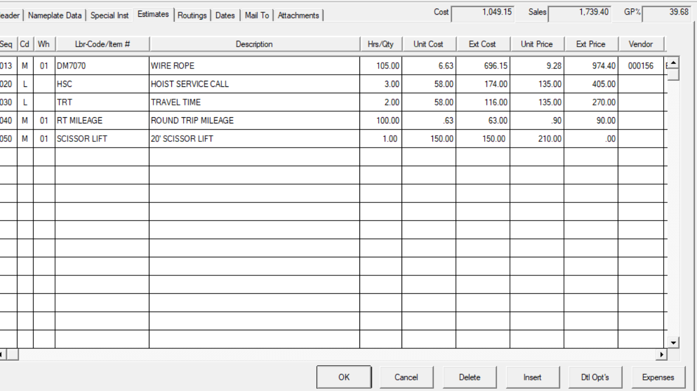

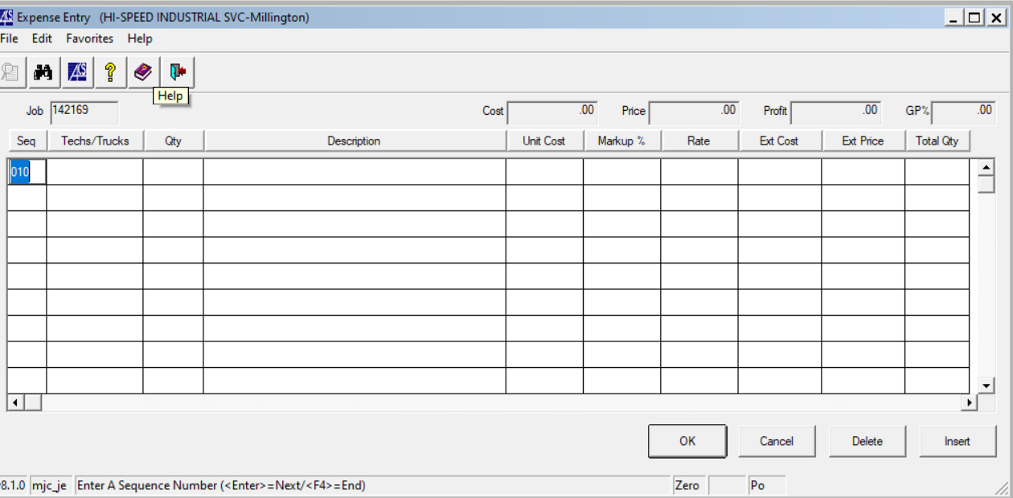

* Step 32- Seq- type in 010, then press enter
* Step 33- Techs/Trucks- enter the number of techs it will take to complete the job, then press enter
* Step 34- QTY- enter in the qty of the item needed, then press enter
* Example:
* 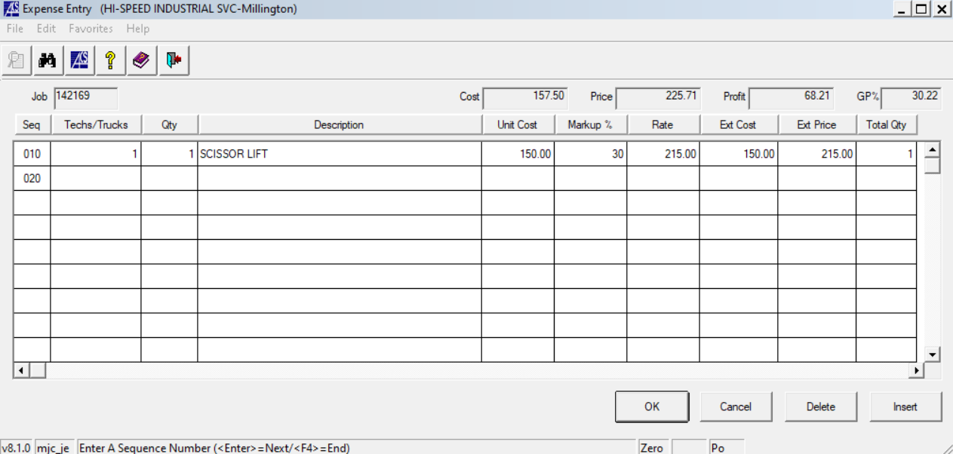
* Step 35- Unit Cost- Type is 150, then press enter
* Step 36- Markup- type 30, then press enter
* Step 37- Rate- will autofill, then press enter
* Step 38- Ext Cost- will auto fill, then press enter
* Step 39- Ext Cost- will autofill, then press enter
* Step 40- Total Qty- will autofill, then press enter
* Step 41- Click OK
* Step 42- Click OK



* Step 43- Click print

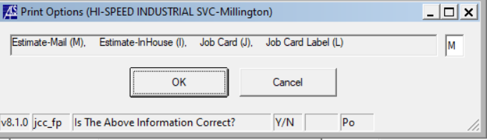

* Step 44- Click ok
* Step 45- Email to customer

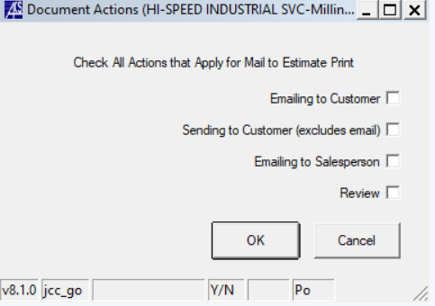

* Step 46- Click emailing to customer, then press ok
* Step 47- Click PDF and execute

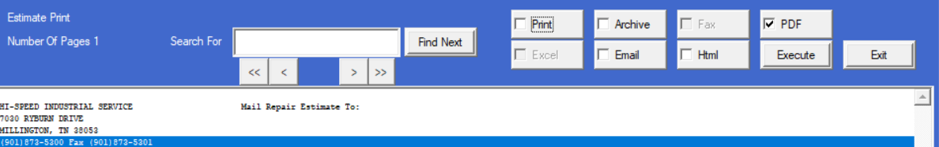

* Step 48- Click file and scroll down to send file and send to customer