**RAI Procedure For CRM & ACS**

**By: Justin Joy**

**Department of Hoist Repair & Crane Systems**

Step 1 – Log in to ACS using your username and password

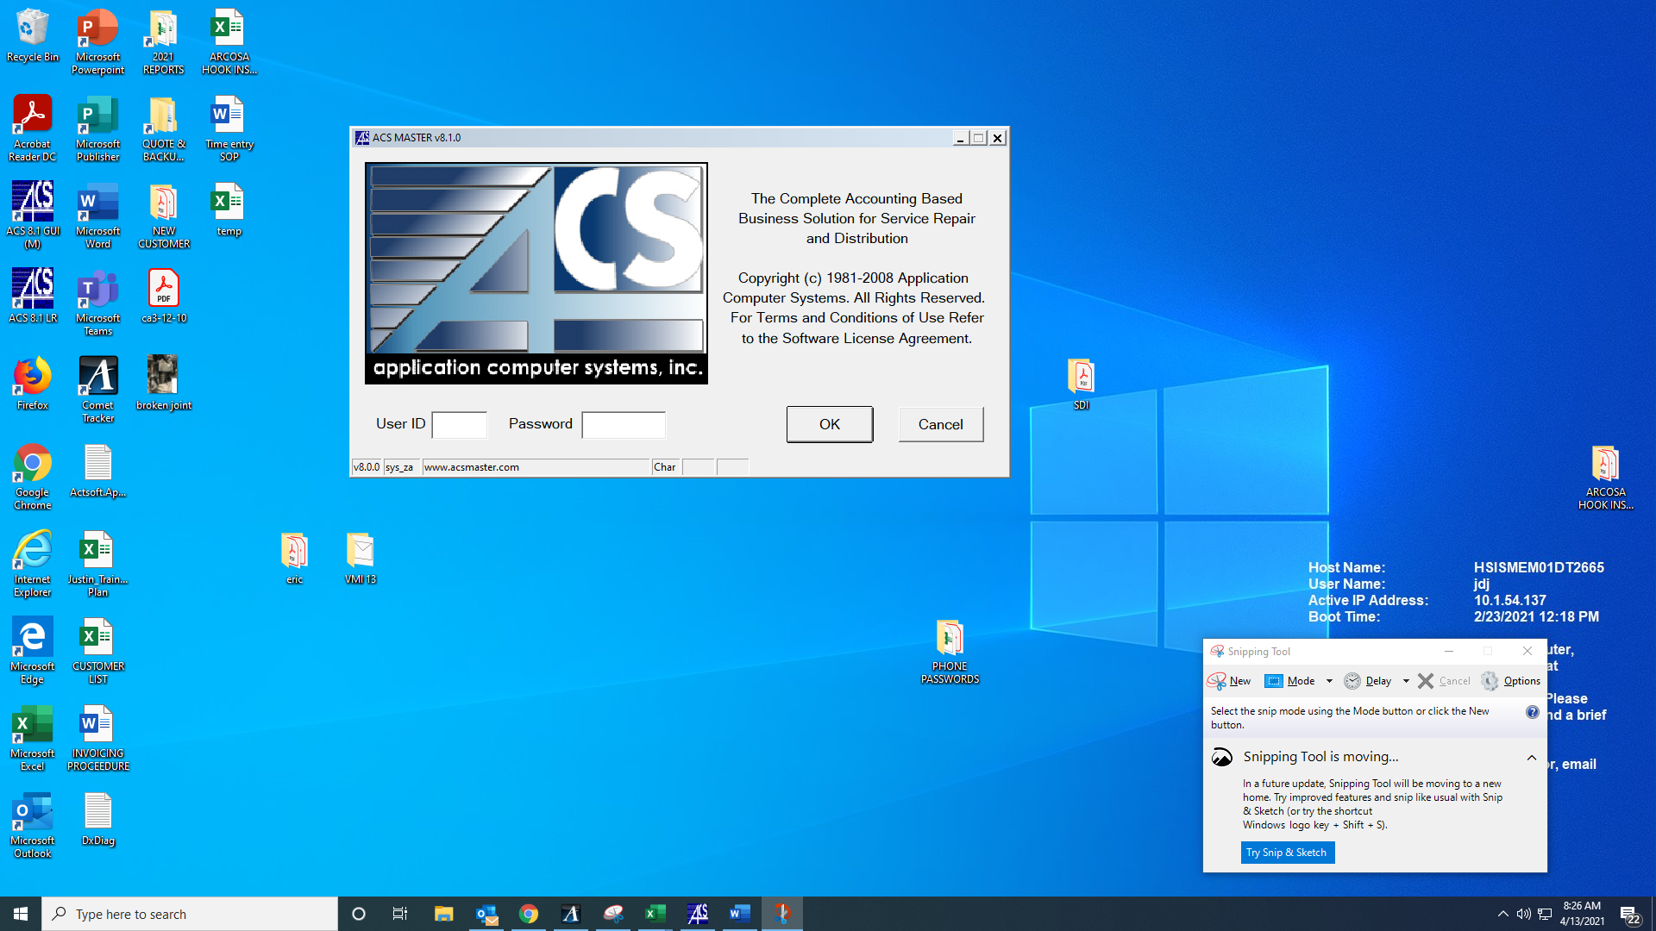

Step 2 – Open a new quote by selecting the “job quoting” on the ACS home page under the “Service Repair” icons options.

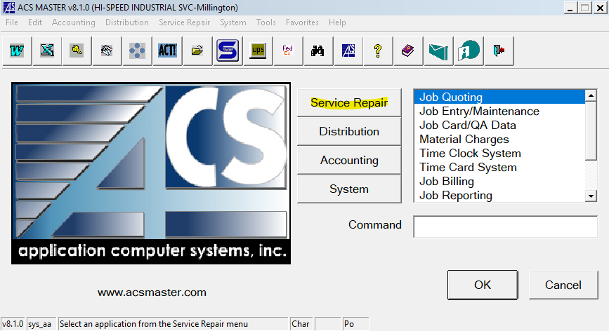

Step 3 – Select “Quote Entry/Maintenance”

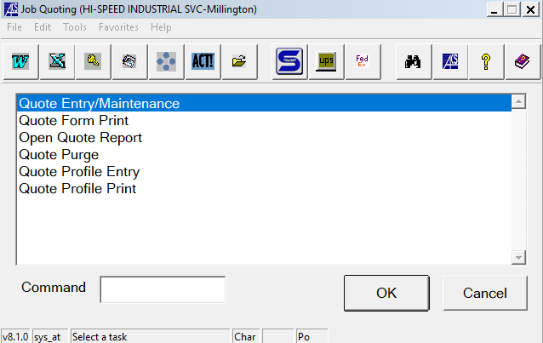

This will open the interface to create a new quote resembling the picture below.

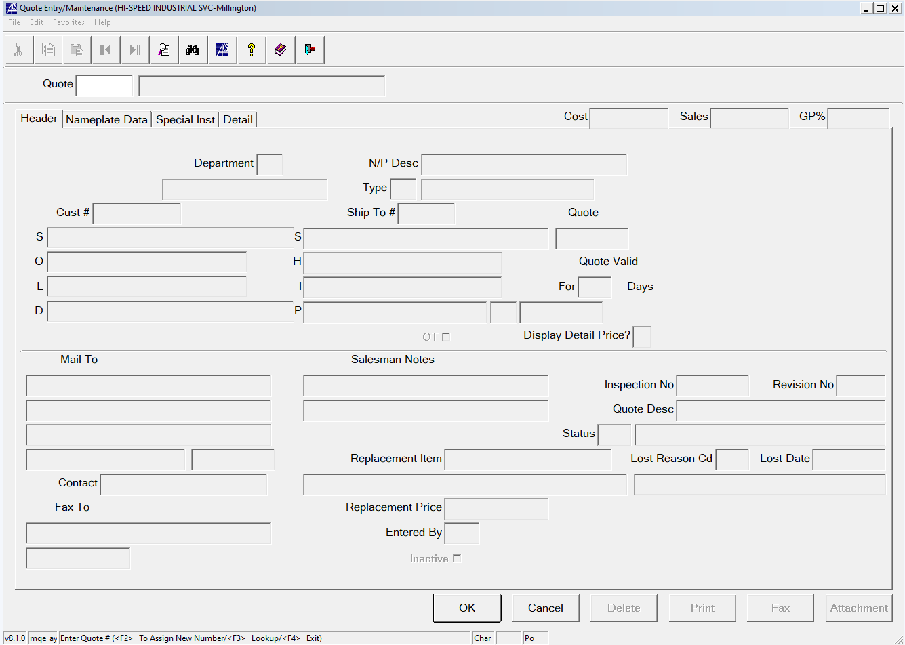

Step 4 – Click the white box next to “Quote” on the top of the page.

From here you can either right click inside the white box or press F2.

Either method will give you the option to assign a new quote number.

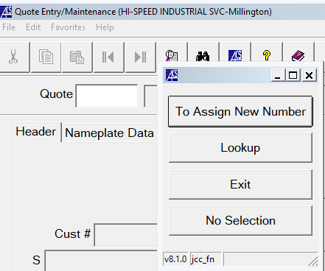

(Right Clicking)

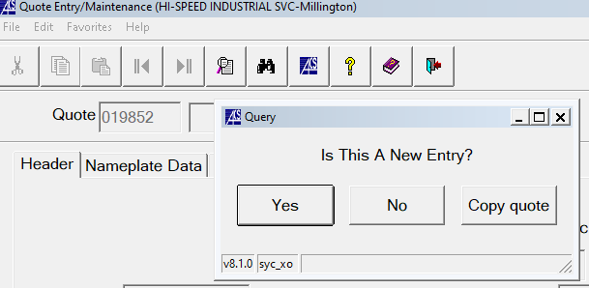

(Pressing F2)

Step 5 – Once a new quote has been opened, fill out the information listed in the bullet points below:

* Department
  + This should be “HR”
* Type
  + This should be “RI”
* Cust #
  + you can look up a customer by right clicking inside this box
* Ship To#
  + Select the corresponding address after right clicking in this box
* Mail To
  + This should be the job contact name
  + You can include the job contacts phone and email in the 2 boxes below this as well but is optional
* Contact
  + This should be the job contact as well
  + This usually auto-populates
* Inspection No
  + This should be the job number of the inspection where the deficiencies were reported.
  + We will use “123456” in this example for the inspection number
* Quote Desc
  + This should be “RAI 123456”
  + The “123456” would be your inspection #

After completing step 5, your form should look similar to the picture below

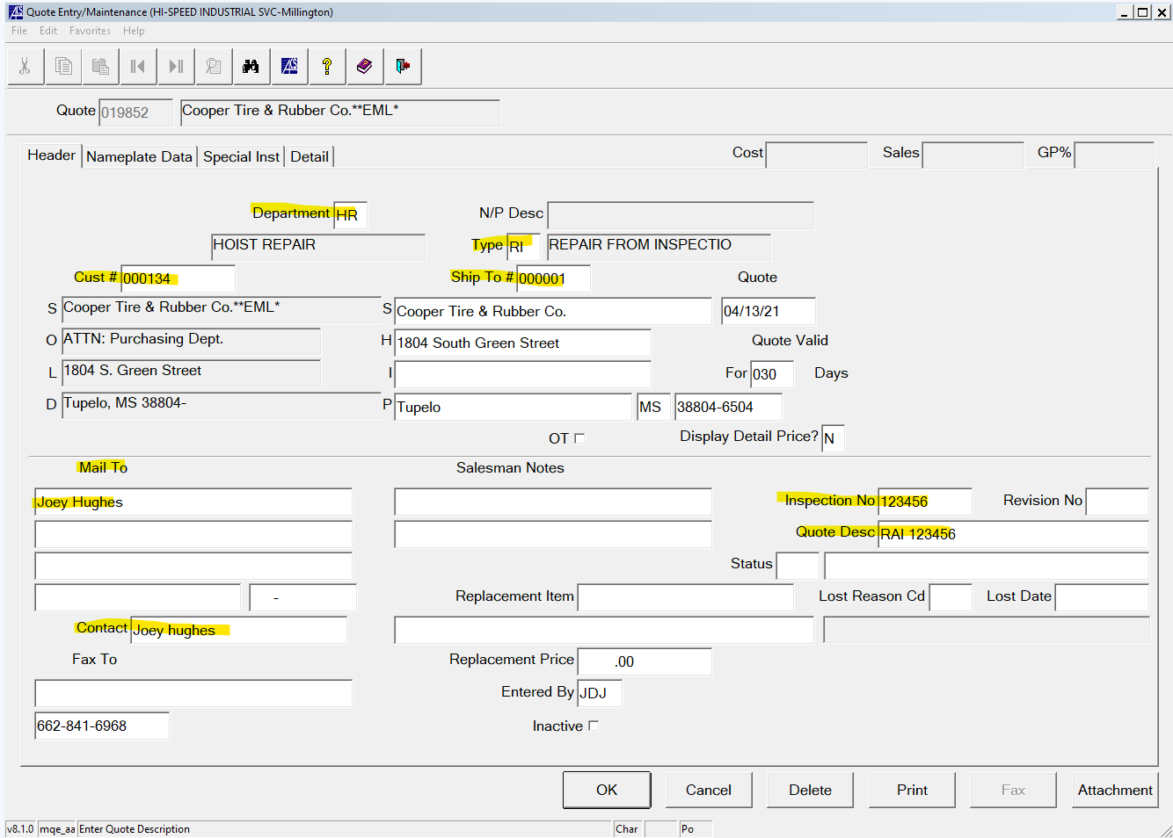

Before continuing, you should print out the deficiencies found in the previous inspection from the inspectall report and write down the quote number on your quote form as well as the job contact information if you have that on hand.

Step 6 will cover how to print the deficiency from inspectall, however, this step could also be completed prior to opening the quote.

Step 6 – Printing the Inspectall deficiency report from your inspection

* Open Inspectall in you web browser @ <https://app.inspectall.com>
  + Enter your username & password to proceed
* Enter the inspection # where the deficiencies were found in to the “quick search” bar on the top right of the screen

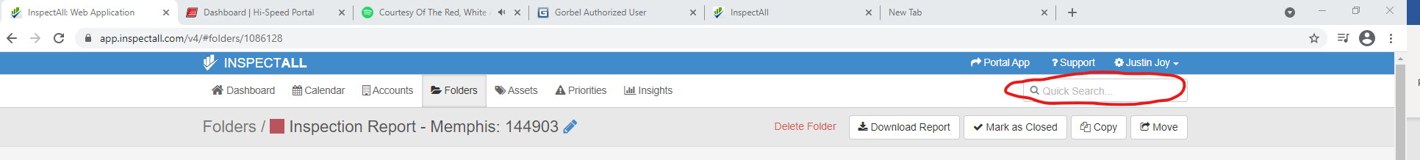

* After entering the inspection number, you might have to click once inside the quick search box for the dropdown menu to appear where you can select the job by clicking on it
* Once you’ve selected your corresponding inspection, you will be brought to the job folder for the completed inspection

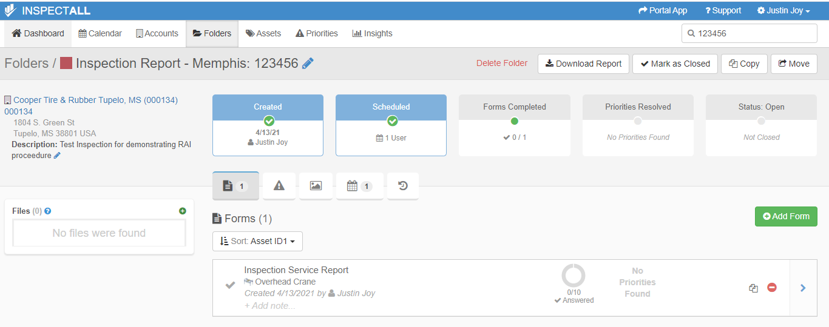

* Click “download report” near the top-right of the folder page to bring up the report options.

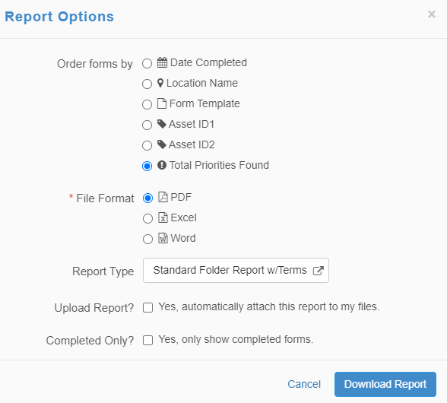

* Select “total priorities found” and “pdf” then click download report
* Once your report has been downloaded, you can open the pdf and print the deficiency report.

Step 7 – Going back to your quote form in ACS, select the “Nameplate Data” tab and enter the type of inspection that was done.

You can right-click inside the white box to select an option or type in the inspection type manually.

The options are “Annual”, “Monthly”, & “Quarterly”

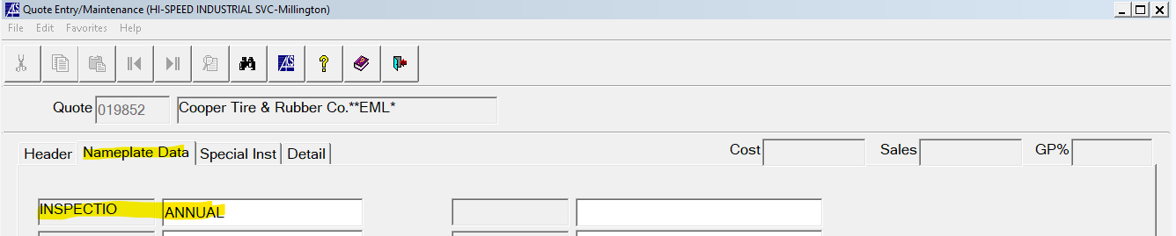

Step 8 – Select the “Special Inst” tab and type in the same info you put into the “Quote Desc” box during step 5.

For this example you should have RAI 123456 in the special instructions.



Step 9 – Go back to the header tab where you put in the job type and corresponding info originally and press OK to create the quote.

This will close out the quote for now and it will be put on que to be uploaded to the CRM “HR RI Process” at the beginning or end of the work day depending on when the quote was created.

You can check to see if your quote has been uploaded to CRM RI reports by following the steps below:

Step 10 – Open your web browser and go to <http://test.portal.gohispeed.com/login.php>

Enter your username and password to proceed

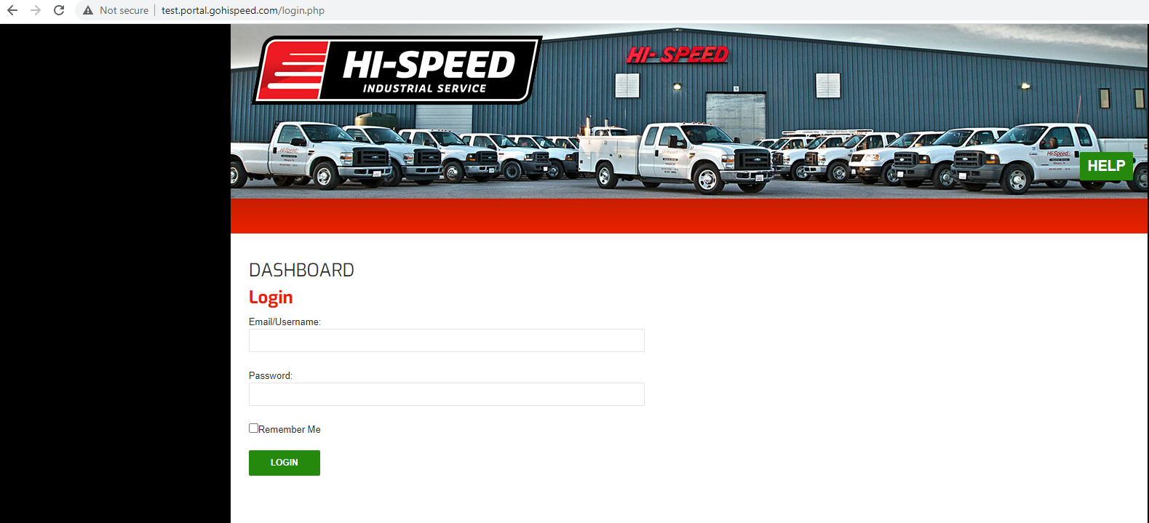

Step 11 – select reports

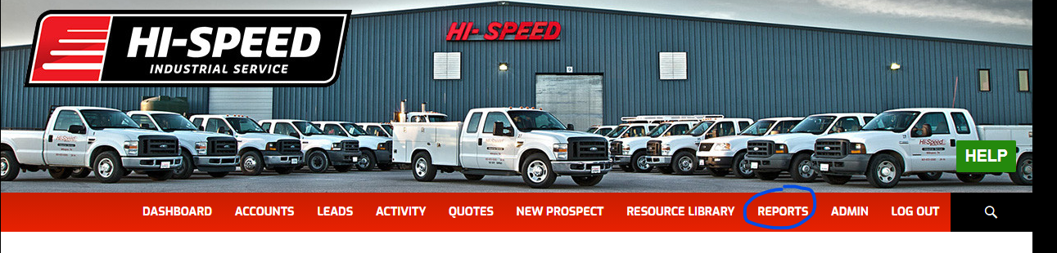

Step 12 – click “select a report” to open the drop-down menu and select “HR RI Process”

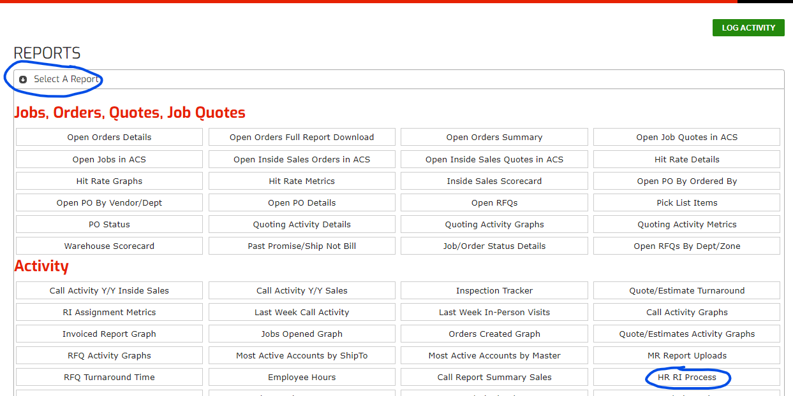

From here you can review open RAIs that have been uploaded to CRM.

Unassigned quotes for RAIs can be reviewed by location.

Step 13 – To review RAIs for the Millington location, click the number corresponding to “All Not Quoted” & “All” on the row/column headers

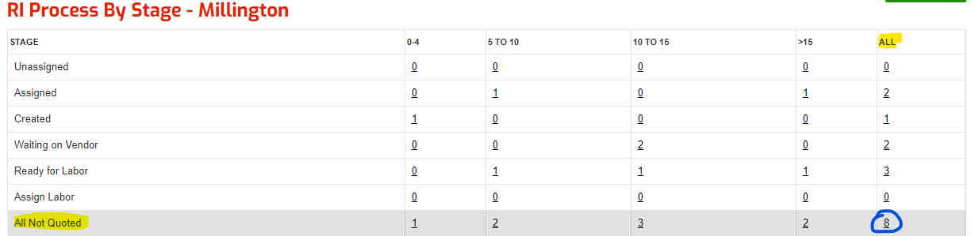

Step 14 – Assign the RAI to by clicking “Assign”

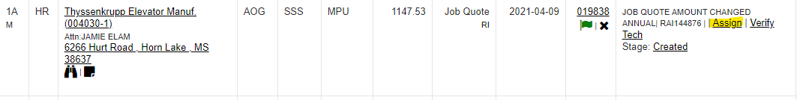

A pop-up box will open where you can select the person to assign from a drop-down menu that looks like this

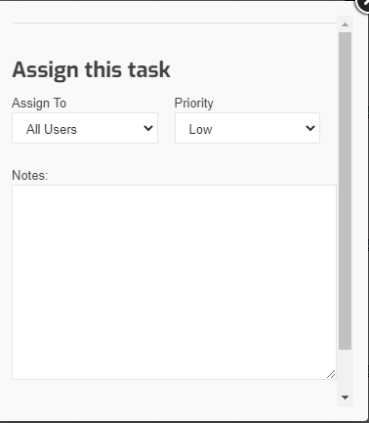

Step 15 – The assigned individual will receive an email notification that they have been assigned to the task to prepare an RAI quote and would then proceed to open the quote we created previously to enter pricing for materials, labor, equipment and anything else that would be necessary to complete the job.

To add/edit pricing on the RAI quote that was created previously, one would follow steps 1-3 to get to the quote form and type in the existing quote number to reopen the created RAI quote.

Step 16 – Adding pricing from vendor quotes

Once you have received pricing from your vendors and reopened the RAI quote, select the details tab.

You will be asked if you want to edit the repair description. Select yes.

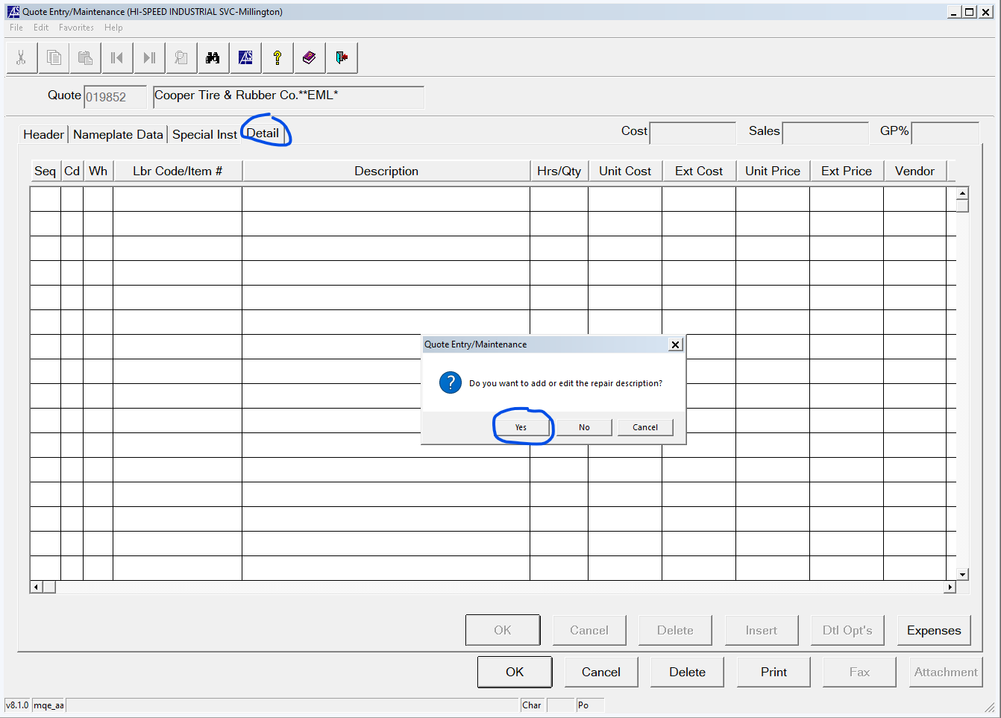

In the blank notepad text file that is opened, you can put a note thanking the customer for the opportunity to quote deficiencies found from the previous inspection. EDIT: “THIS IS WHERE YOUR JOB SCOPE SHOULD GO”

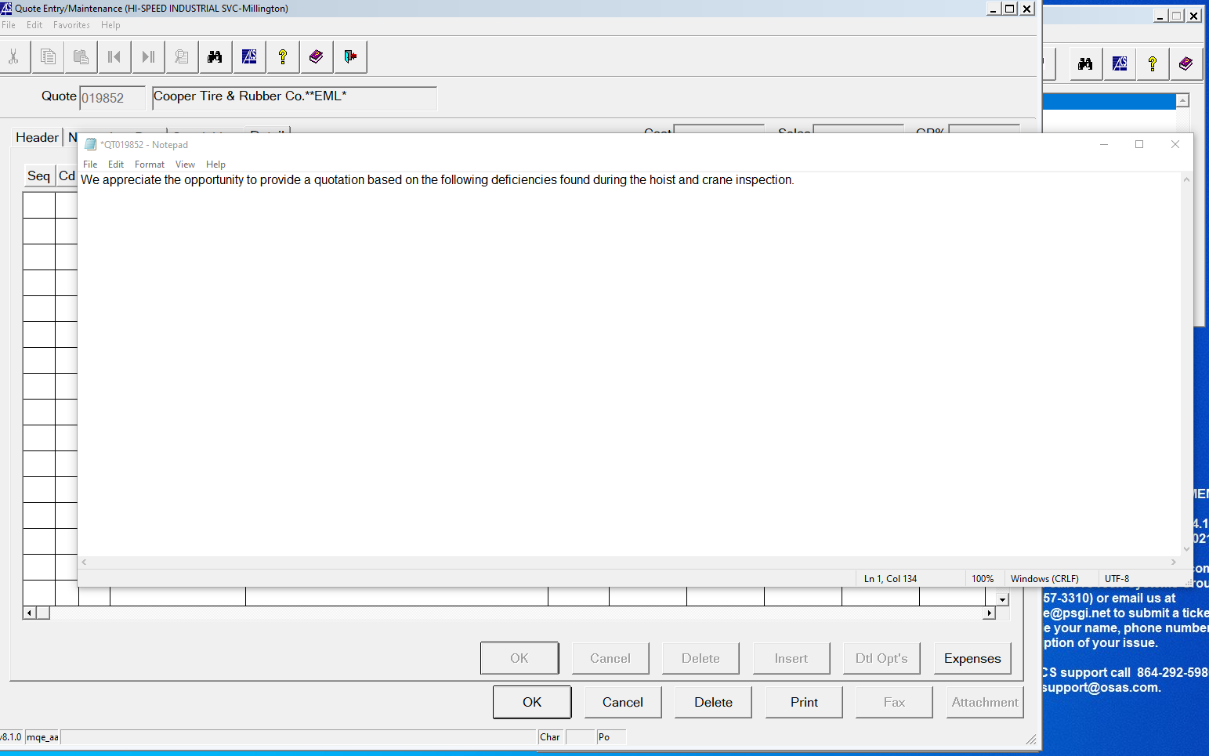

Save the text file and close the text file.

This note will appear at the top of your RAI quote above the pricing when you print the quote later.

Step 17 – Entering the costs and pricing for materials and labor should look like the picture below.

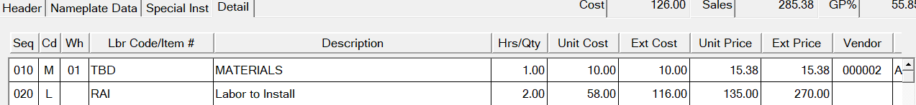

To enter a material line the steps are as follows:

1. Enter a “SEQ #”
2. Enter “M” for Cd
3. Enter the “Lbr Code/Item#” 🡪 This will be the part number from the vendor quote
   1. If the item is not a stock item, you will be asked in a pop-up if the item is non-stock. Select yes.
4. If the item is non-stock you might have to manually type in the item description. For stock items, the item description should self-populate.
   1. Verify that the item description is accurate
5. Enter the quantity of the items you will be ordering for “Hrs/Qty”
6. Enter the unit cost of the item from your vendor quote
7. Ext cost will calculate automatically
8. Enter the unit price by marking up the cost.
   1. See an HR department manager to inquire about how much an item should be marked up
9. The Ext Price will automatically be calculated as well
10. Right click in the vendor box to search for & select your vendor for the materials being quoted.
11. “CS/Seq” should be the asset number from inspectall to which the item being quoted is being applied to in the repairs

To enter a labor line the steps are as follows:

1. Enter a Seq number
2. Type “L” for Cd
3. Type “RAI” for “Lbr Code/Item #”
4. Description should autopopulate
5. Enter hrs estimated to install the material(s) for “Hrs/Qty”
6. Type in the standard technician labor rate “32” for unit cost
   1. ACS will automatically add $26 for low value when you enter this
7. Tab across until you get to “CS/Seq”
8. Enter the same asset number you entered in the previous material line for “CS/Seq”

Once you’ve entered all necessary materials, labor, travel time, mileage and equipment. Your quote is complete and you can print the quote to send to your customer requesting repairs.

Step 18 – Selecting the quote print layout

Hit the print button. In the ‘Display Detail Price?’ box, “N” will display the total price. “3” will display the price of each line item.

A box will pop up asking you if you want to add or edit the repair description. Click no to continue.

In the print options popup box, make sure “M” is selected to format for sending to the customer. Hit OK.

IMPORTANT:

In the Document Actions popup, click the box that says “Emailing to Customer” ONLY when you are completely done with the quote. When you select this option and hit OK, it will take the quote off of the HR RI Process list on the CRM website.

For our example, we will select the “Emailing to Customer” option. But if you were not done with your quote and just wanted to print the quote to review, you should select the “Review” box on the Document Actions popup.

Finally in the ACS Output Manager popup, select the “pdf” box to open the file as a pdf so you can review & save the quote. You should save the quote in the quote folder which will be in one of two locations:

1. If you are quoting out of the Millington ACS program,
   1. Z:\firms\firm01\images\quotes\”Your Quote #”
2. If you are quoting out of the Little Rock ACS program,
   1. Z:\firms_lr\firm02\images\quotes\”Your Quote #”

For our example, we are quoting out of the Millington ACS program.

The quote file location should be Z:\firms\firm01\images\quotes\022984

The format of the quote name you save the file as will depend on a few different things. If this is the first repair quote to the customer the format for the file name would be “Customer Name + RAI + Inspection # + ACS + Quote #”

If this is the second quote to the customer, lower priority parts/repairs and parts which took a longer time to get pricing on, the file name would be “Customer Name + RAI + Inspection # + Remaining Parts + ACS + Quote #”

Personally I like to include the quote # and the date I printed the file in the file name itself but did not include that in the formatting above for the purpose of simplicity. We want this to be easily duplicated.

Our file name for the example above would be “Lauderdal CO RAI 149991 ACS 22984”

Once you have reviewed the file and everything looks good, this is ready to be sent to the sales rep and team members so the sales rep can deliver the quote to the customer and start following up to get PO’s.

When the quote is sent to the sales rep the territory manager, planner & In Shop Coordinator should all be cc’ed on the email.