PURCHASE REQUISITION ENTRY

FROM MAIN ACS SCREEN: Distribution > Purchase Orders > Processing > Purchase Requisition Entry

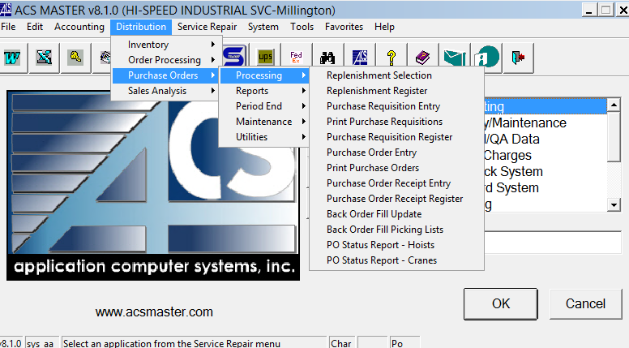
Enter Vendor number or Press F3 key to perform search.
In the Req# field: Press F3 key to search for open requisitions.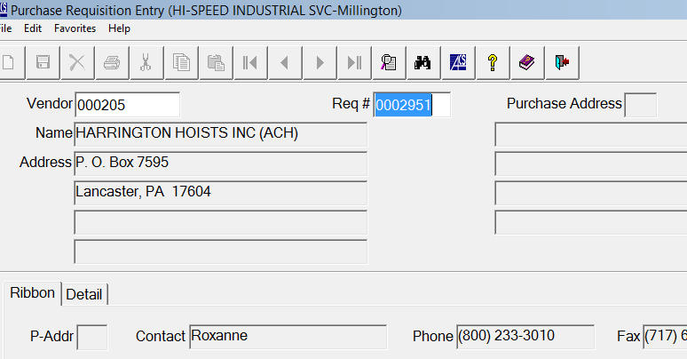
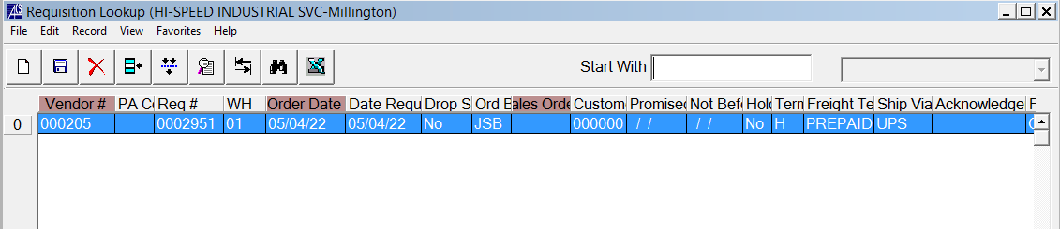
Select the open Requisition.

If no open requisition exists, cancel out of session.
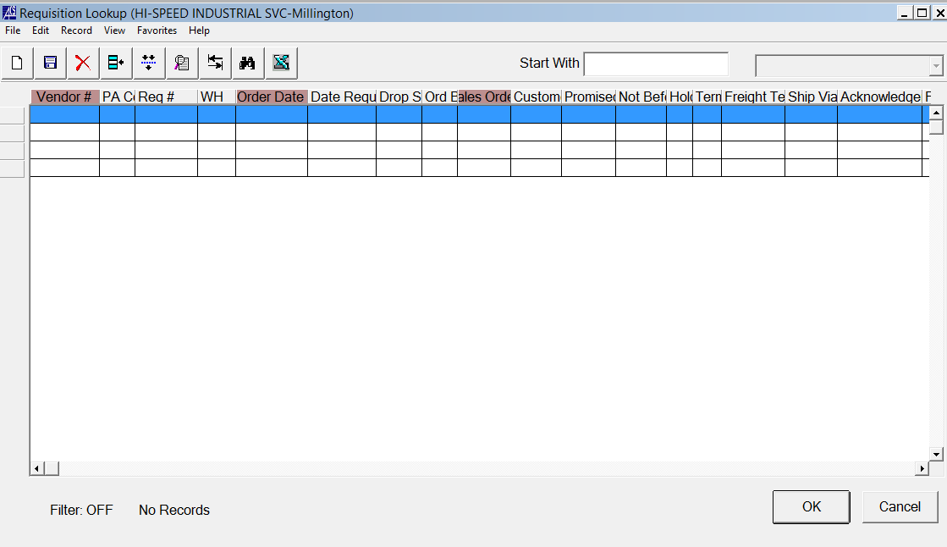
Press F1 button to assign a Requisition.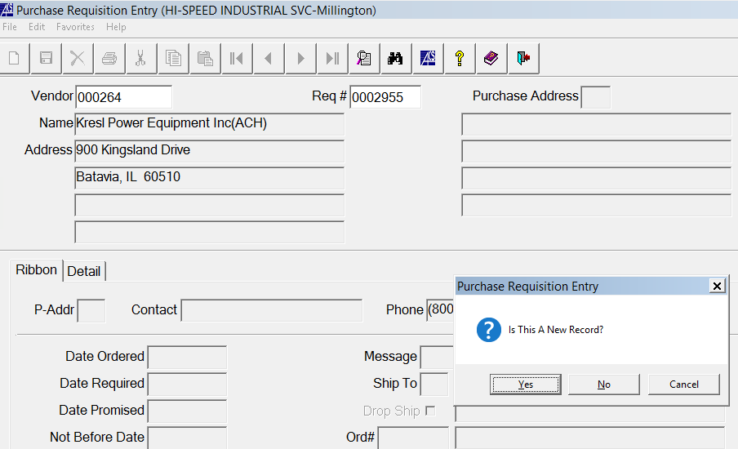

Click Yes.

Click detail page tab.
Enter your item on the next available line.
Cd = S for Stock Item or N for Non-Stock Item

Enter the Item Number:
Stock items: The description and cost will auto populate. Enter the Qty, JOB # and required date.
Non-Stock Items: Enter the description, Qty and cost for item. Enter the JOB # and required date.
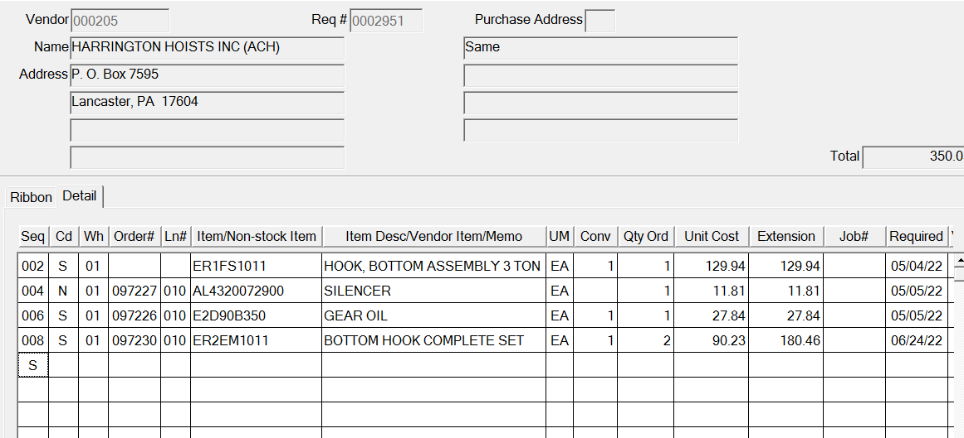

Click “OK” when complete
