PROCEDURE FOR WRITING A PURCHASE ORDER

ACS

1. Select Distribution
2. Select Purchase Orders

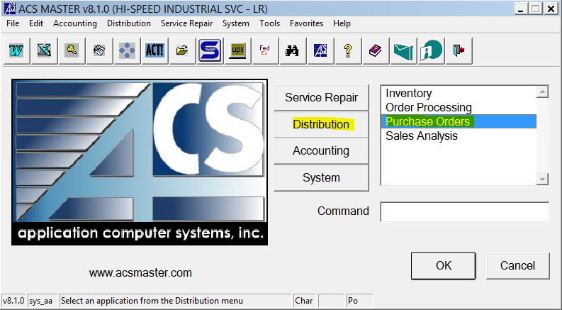

1. Select Purchase Order Entry

1. F3 on Vendor Box to search and select Vendor. Press Enter
2. PO# - F1 for next available number. Press Enter
3. Req# - Press Enter
4. Ribbon Tab
   1. Date Ordered – Current Date
   2. Date Required – Expected delivery date
   3. Ship Via – UPS for almost everything, except for heavy
   4. Terms – Enter payment terms from quote
   5. FOB – Optional FOB info (Origin, Destination)
   6. Message – STD
   7. Ship To – 02
   8. Ordered By – Your Initials

1. Detail Tab
   1. Cd – S for Stock, J for Job…
   2. Wh – 02 for stock items, Z2 for consignment (bearings, etc., for job)
   3. Select Print
      1. Prints a vendor copy and an accounting copy. Acctg copy goes in job folder