PROCEDURE FOR WRITING A DELIVERY TICKET

1. In the ACS Service Repair menu, select Job Billing

1. Select Delivery Ticket Entry

1. Job – Enter the Job number

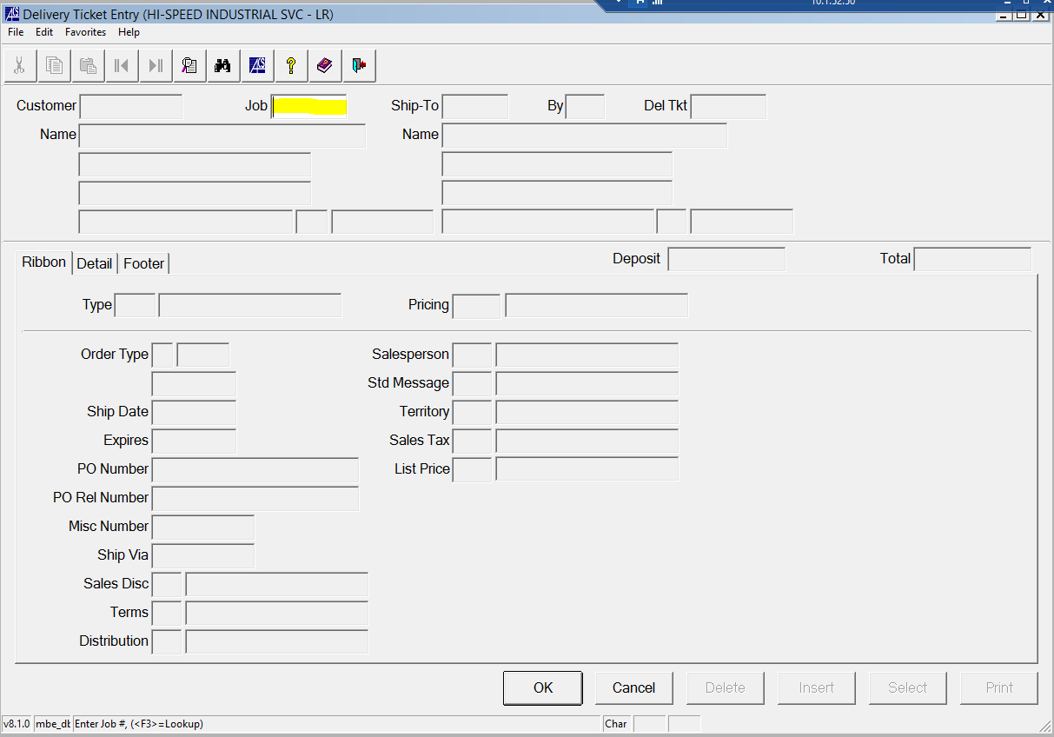

1. Verify the Customer and Ship-To are correct, and then select yes when prompted “is this the correct Del Tkt?”
2. Review to ensure that the PO Number, Order and Ship dates are correct. Select OK

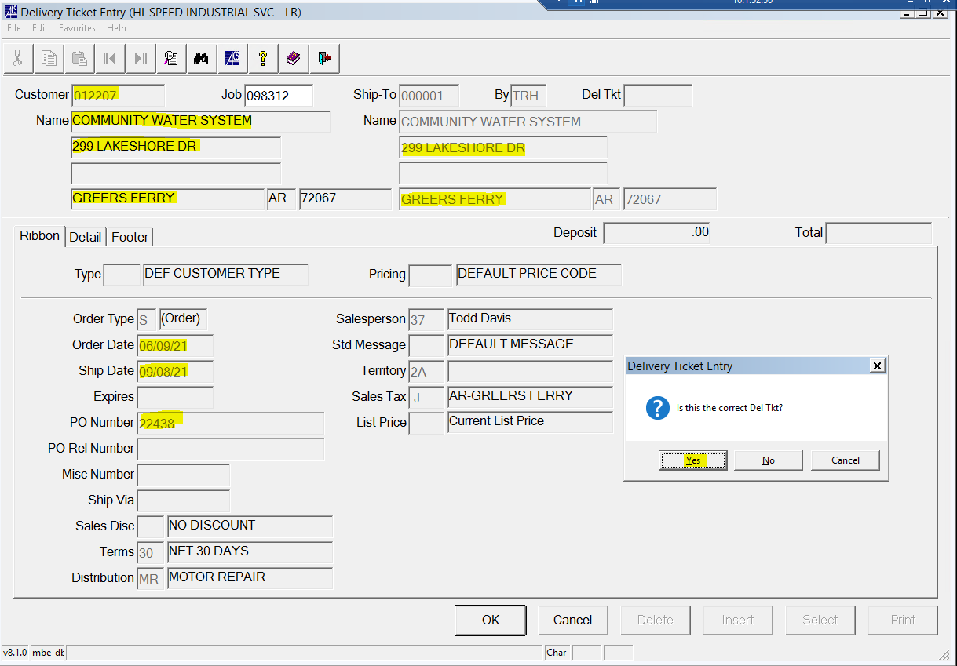

1. Review the Detail Tab
   1. Ensure all nameplate info, labor completed, and other info necessary is in the descriptions
   2. Remove the word “Labor” so that the amount listed is just specified as “Total”
   3. Select OK

1. Review the Footer
   1. Ensure that the subtotal is correct

1. Select Print
2. Select Yes to “Print Prices on the Delivery Ticket”
3. Execute
4. There will be two copies, a customer copy and file copy. The delivery driver will take both copies, and the file copy will be signed and returned to us upon receipt by the customer.