PROCEDURE FOR WRITING UP A MOTOR JOB ORDER:

Hi-Speed White Tag

1. Customer Name
2. Contact Information (Name, Phone #, Email)
3. Work to be done
4. Job # (After ACS)

ACS

1. In the Service Repair menu, select Job Entry/Maintenance

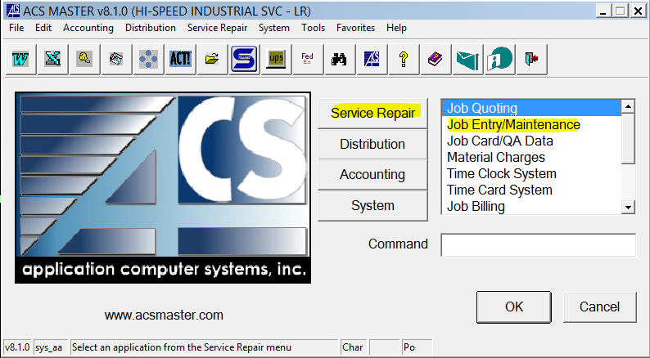

1. In the Processing menu, select Job Entry

1. In the Job box, press F2 to assign new job number
2. Header Tab
   1. Department – press F3 and select Motor Repair (or type MR)
   2. Quote – *if this is a quoted job, you can enter the quote number and it will auto fill the customer details and estimates tab*
   3. Type – press F3 and select type (AC/DC etc.)
   4. Cust # - press F3 and look up customer name
   5. Ship To # - press F3 and select the correct shipping address
   6. Job Desc – Important info about motor and job (HP, Make, Type, Rush)
   7. Contact – Type contact name (contact email in
   8. Priority – press F3 to select priority
   9. Click OK

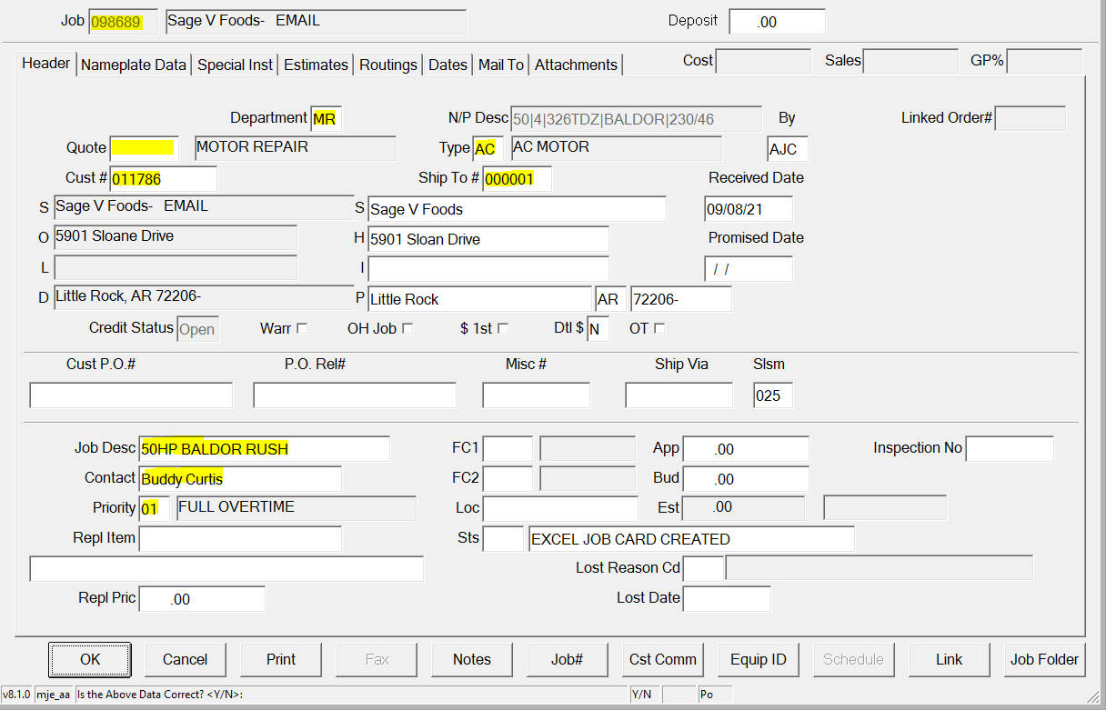

1. Nameplate Data Tab
   1. HP/KW
   2. RPM
   3. Poles (=7200/Synchronous RPM)
   4. Frame
   5. MFG (Manufacturer)
   6. Voltage (Low/High)
   7. Amperage (High/Low)
   8. Model
   9. Serial
   10. Enclosure
   11. RPM
   12. Phase (3)
   13. Hz (60)
   14. SF (Service Factor)
   15. Ter Box – press F3 for None/Half/Complete
   16. Lead Side – press F3 for F1/F2/F3/Both/L/R

1. Special Inst Tab
   1. Type in any special instructions about the job

1. Mail To Tab
   1. Click No for Default Mail-To Ship-To info
   2. Name – Type Contact name
2. Click Print

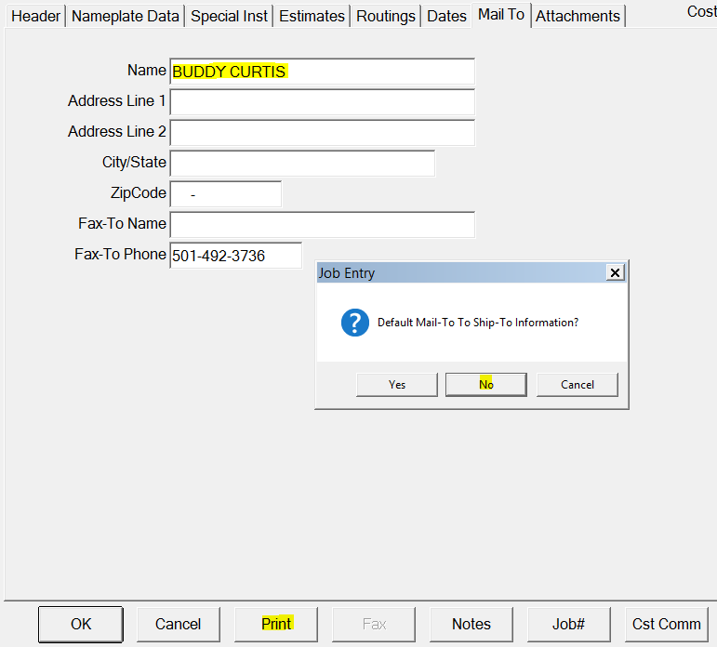

1. Change Estimate-Mail (M) to Job Card (J)
2. Click OK

1. Click Yes for Excel QA Sheets
2. Click Enable Content
3. Click Yes for Trusted Document
4. Go to “AC Main” Tab

1. File -> Print -> Pages 1 to 1

Inspectall

1. Click Folders tab

1. Click Add Folder

1. Click Create New

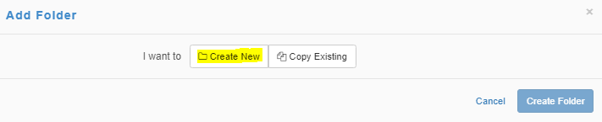

1. Select Folder Type – Motor Shop Repars
2. Account – Enter Customer # from ACS Printout and select the customer from the dropdown
3. User – Add 3 rows and select Motor Shop LR 1, 2, and 3 as the users
4. Click Create Folder

1. Click the pencil icon in the header to Edit Folder

1. Change the auto-generated ID to the ACS Job number and select Update Folder

1. Click Add Form

1. Click Pick Forms



1. Select the type of form from the Motor Repair dropdown (AC/DC/Recond/Rewind)

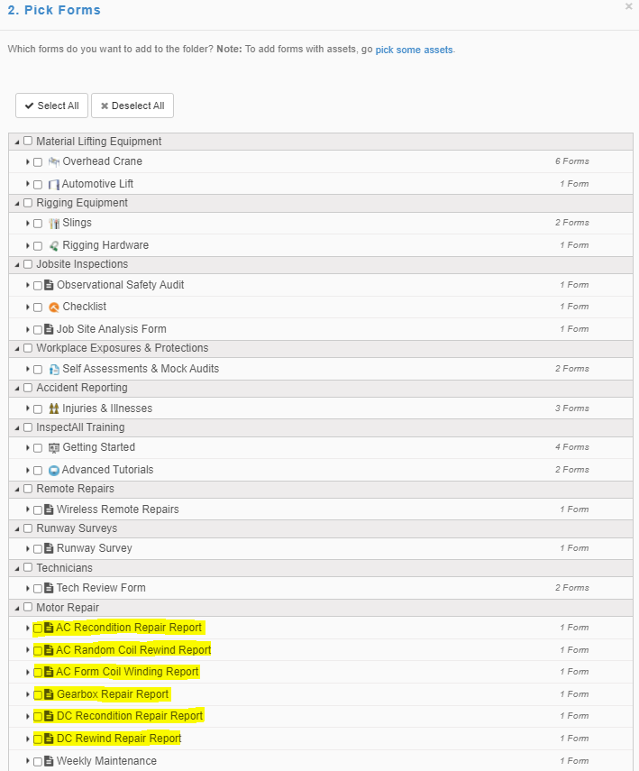

1. Open the Form to input data by clicking the blue arrow

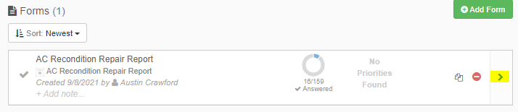

* 1. Job number – Enter ACS Job Number
  2. Report Date – Enter today’s date
  3. Customer – Type customer name
  4. Manufacturer – Type manufacturer name and upload nameplate photo
  5. Model #
  6. Serial #
  7. HP
  8. KW (Optional)
  9. Volts (High)
  10. Amps (Low)
  11. RPM
  12. Frame
  13. Enclosure
  14. Cycles (60)
  15. Phase (3)
  16. Service Factor
  17. Click Done in the top left

