**JOB QUOTING PROCESS**

BY JOHN CURA

**STEP 1**: OPEN ACS. FROM THE MAIN SCREEN SELECT THE “SERVICE REPAIR” TAB. THEN SELECT

“JOB QUOTING” AND PRESS “OK”

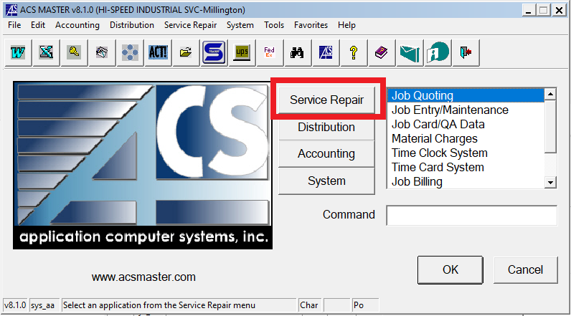

**STEP 2**: A NEW WINDOW WILL OPEN UP. SELECT “QUOTE ENTRY/MAINTENANCE” AND PRESS

“OK”

**STEP 3**: IN THE “QUOTE” SECTION PRESS “F2” TO ASSIGN NEW QUOTE NUMBER

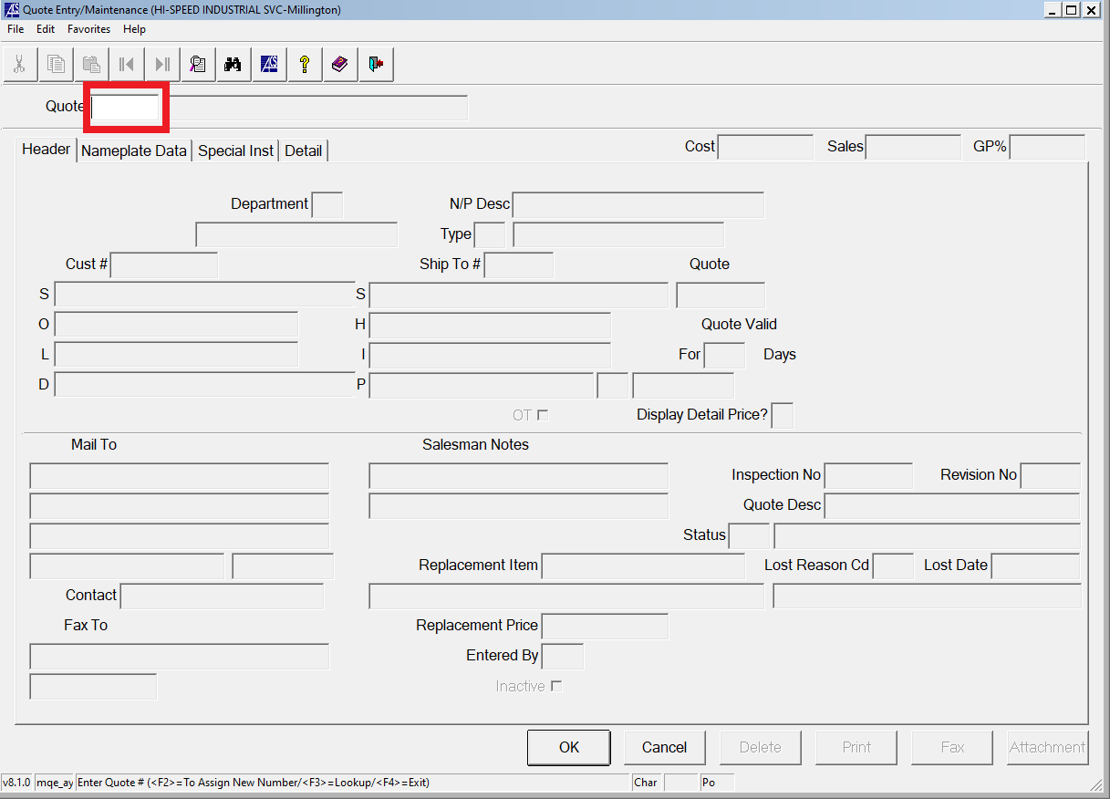

**STEP 4**: NEW WINDOW WILL OPEN UP. SELECT “TO ASSIGN NEW NUMBER” AND ACS WILL AUTOMATICALLY

ASSIGN NEW NUMBER. A NEW WINDOW ASKING IF IT IS A NEW ENTRY WILL ALSO OPEN UP. SELECT

“YES”

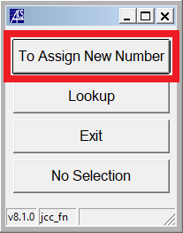

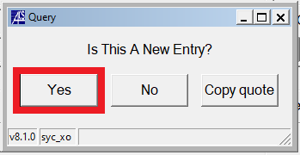

**STEP 5**: FROM THIS PAGE, FILL OUT ALL REQUIRED INFORMATION. ONCE DONE, HIT THE “DETAIL” TAB.

**\*NOTE**: AN EXAMPLE WILL BE PROVIDED WITH DATA ENTERED INTO THE REQUIRED FIELDS.

SHOULD ONLY BE USED AS A REFERENCE

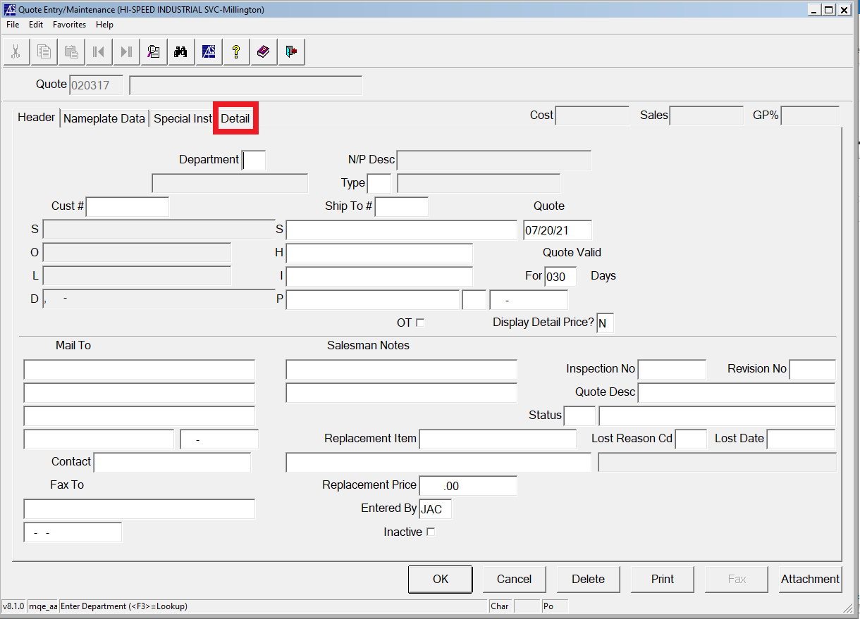

**REFERENCE**

**STEP 6:** ONCE IN THE “DETAIL” TAB, A WINDOW WILL POP UP ASKING IF YOU WANT TO “ADD OR EDIT THE

REPAIR DESCRIPTION”, SELECT “NO”. FROM THERE, ENTER NECESSARY DATA IN THE “DETAIL”

SECTION. ONCE DONE PRESS “OK”



