How to apply cost to a job.
- Start at the main screen in ACS.
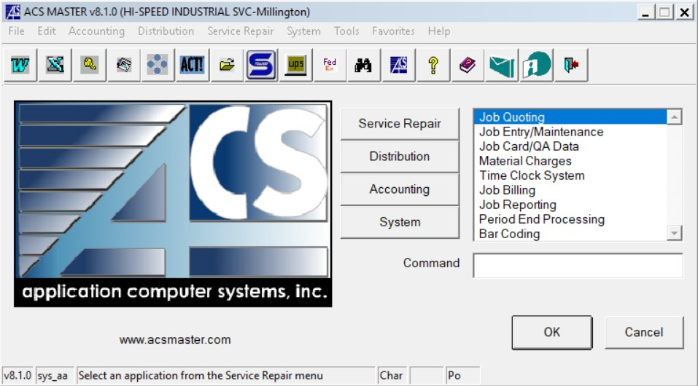

- Double click on Material charges.

- The material charges screen comes up.
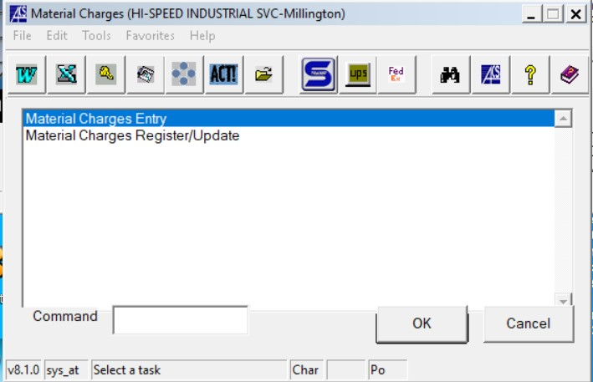

- Double click on the Material charges entry.

- The material charges entry screen comes up.
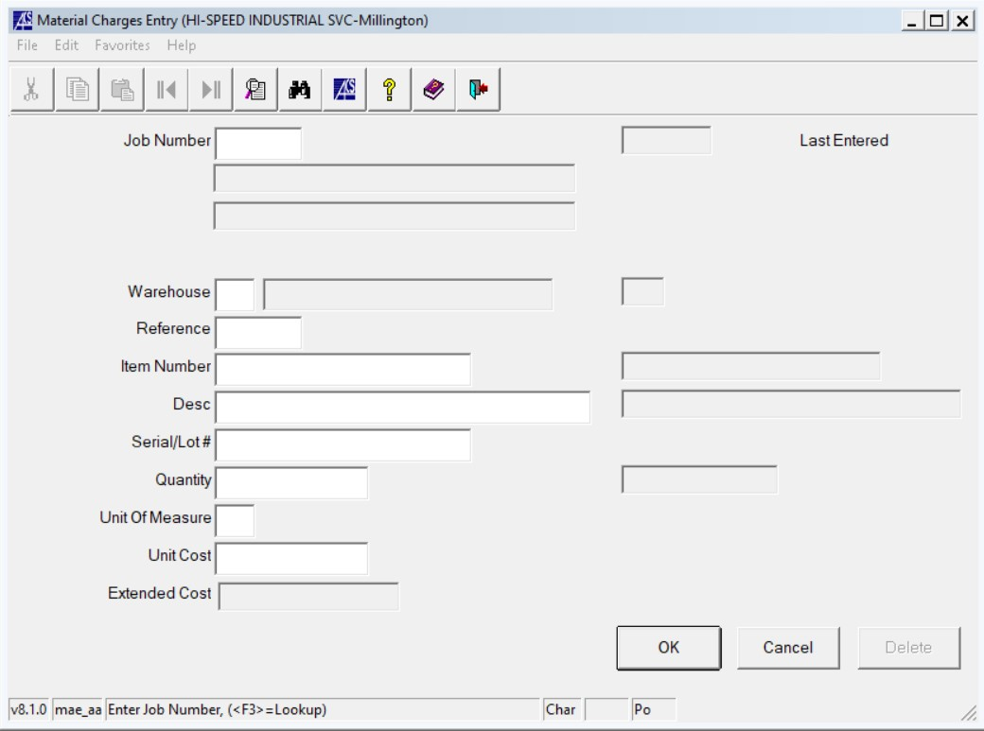
- Enter the job number you wish to add cost to.
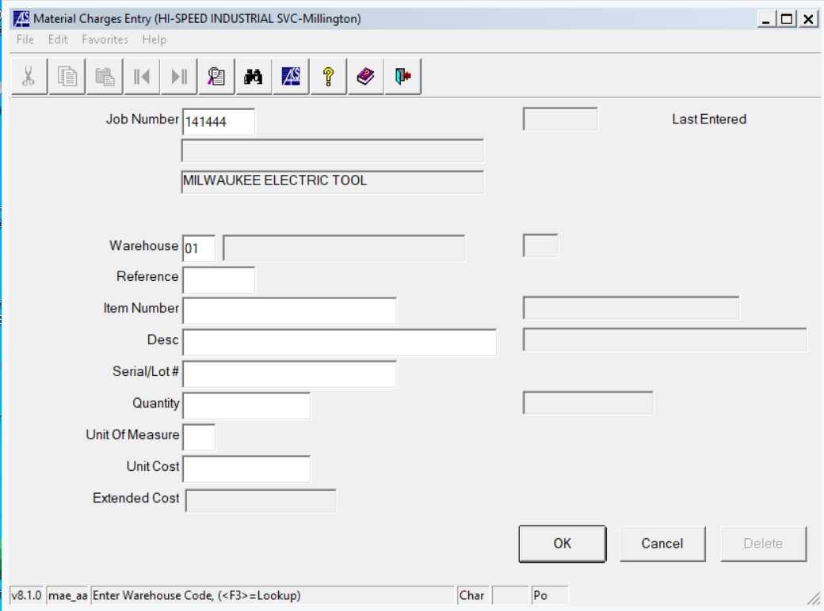
- Warehouse number auto populates.
  - 01 Millington warehouse
  - Right click in box to choose different warehouse, such as a service truck inventory.
- Enter reference id. This will be your three initials.
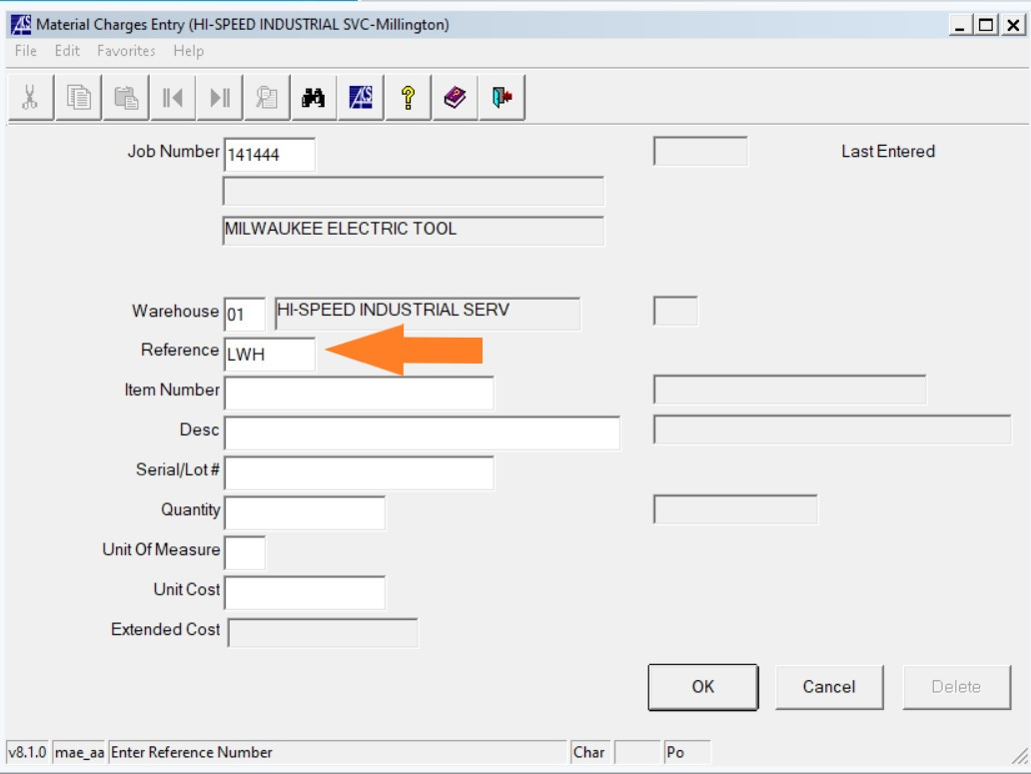
- Enter item number.
  - Enter the known stock item number or right click in the box to search
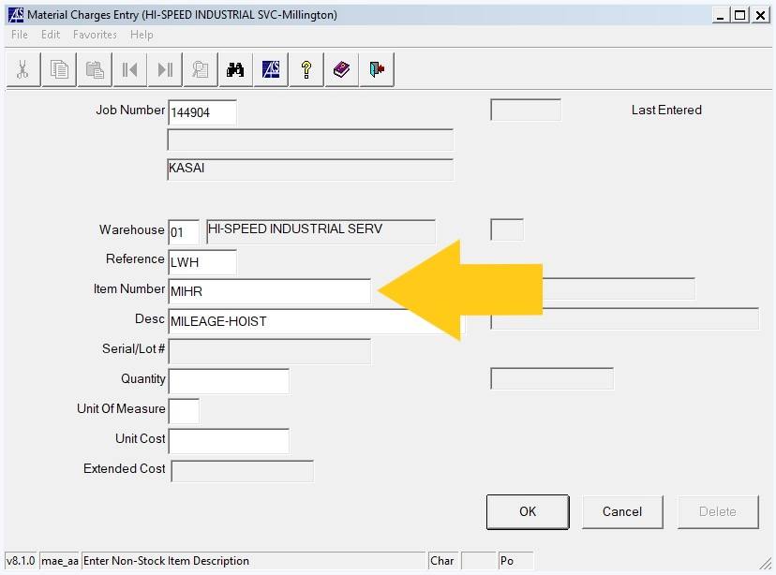
- Enter the quantity
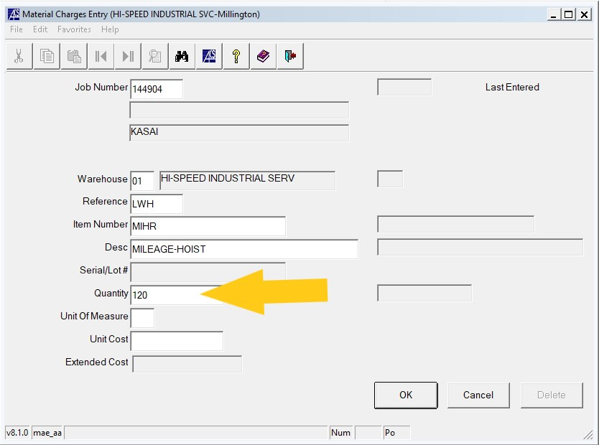

- Enter the cost per each unit.
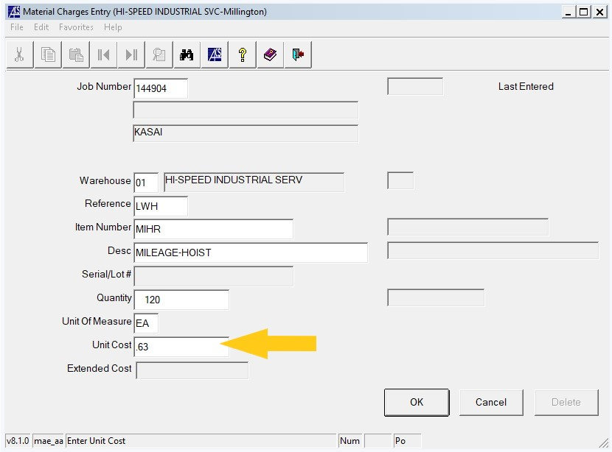
- Extended cost will auto populate with the total cost to be applied to the job.
- Click OK
- If you have more cost to apply start over at the top.
- If you are needing to apply cost to a different job, start over at the top changing the job number.
- If you are done click cancel.

