**How to Create a New Job in ACS from an ACS Quote**

1. Begin at the ACS title screen and click on Job Entry/Maintenance.

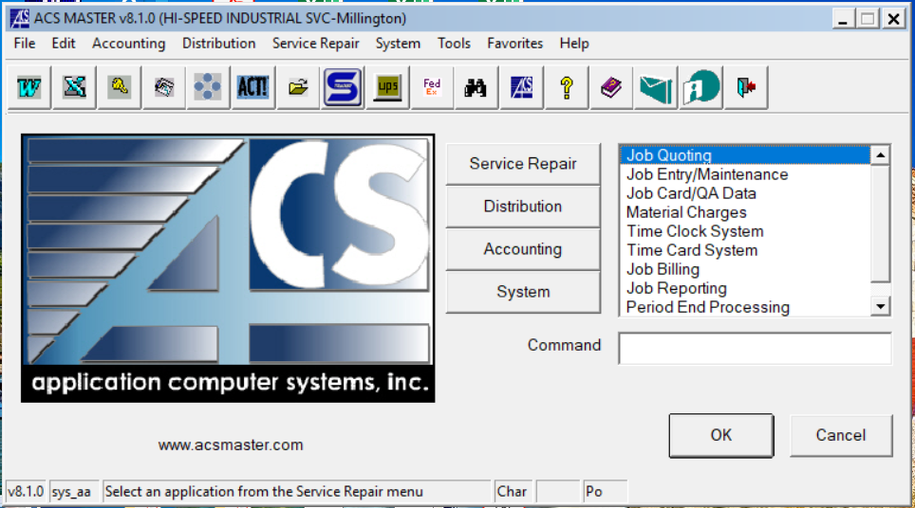



1. Then double click on Job Entry

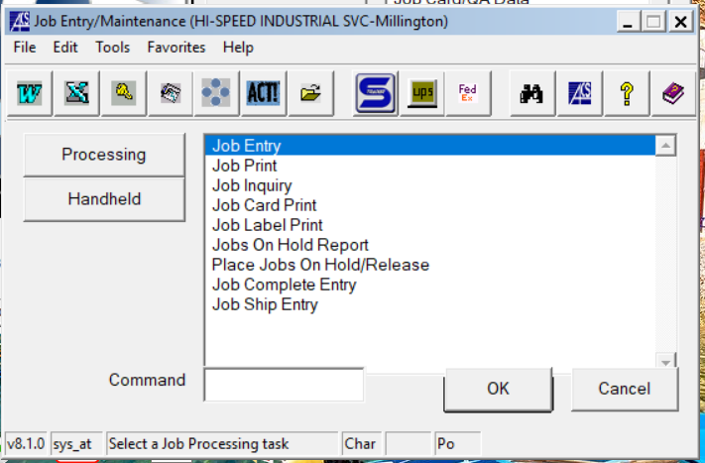



1. Once in the Job Entry screen you will first need to hit F2 in the “Job” field to assign a new job number.

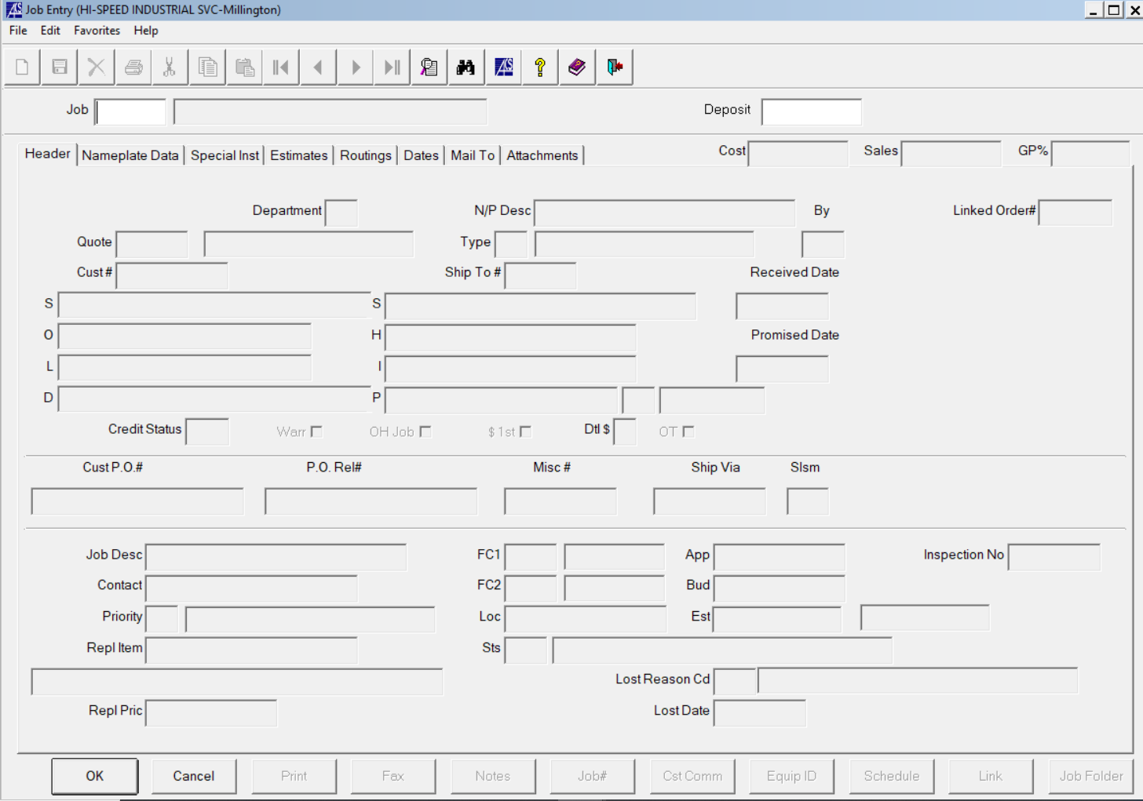



1. Confirm a new job by then clicking “Yes” when prompted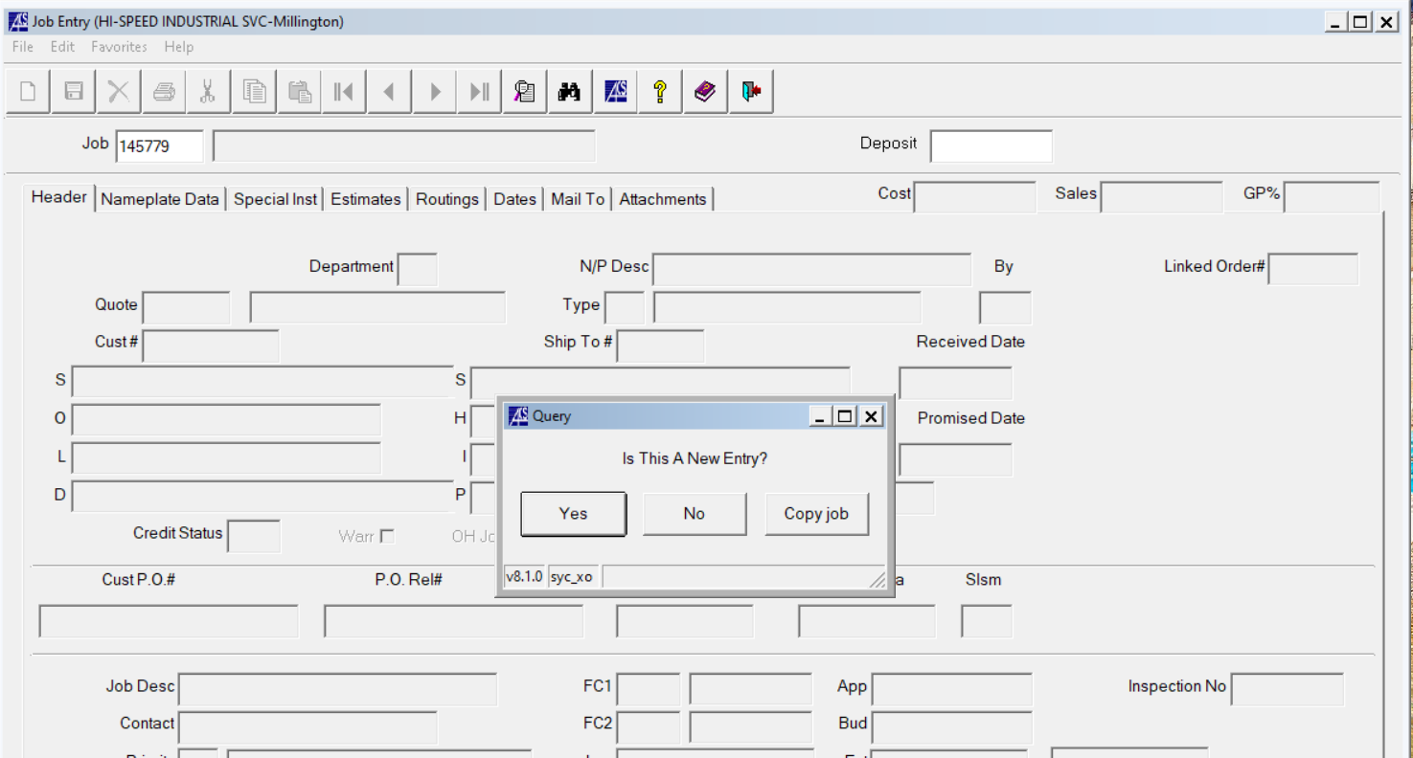



1. You should then type in your respective ACS quote number into the “Quote” field

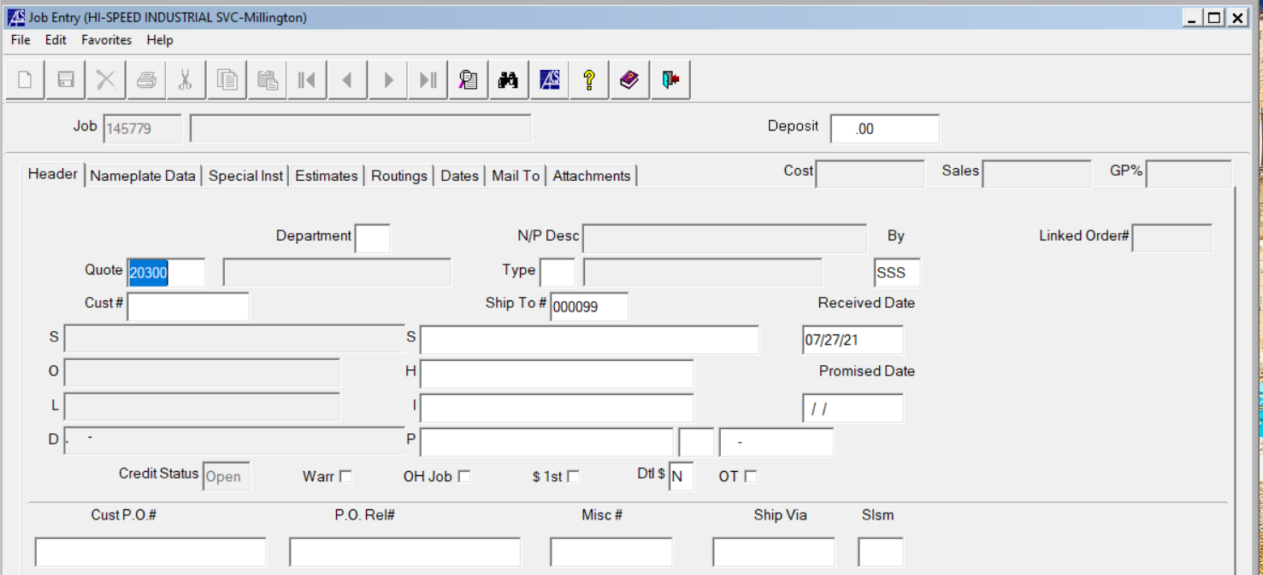



1. This will then auto populate all pertinent information from your quote into your job file under the new job number ACS assigned from steps 3 and 4.

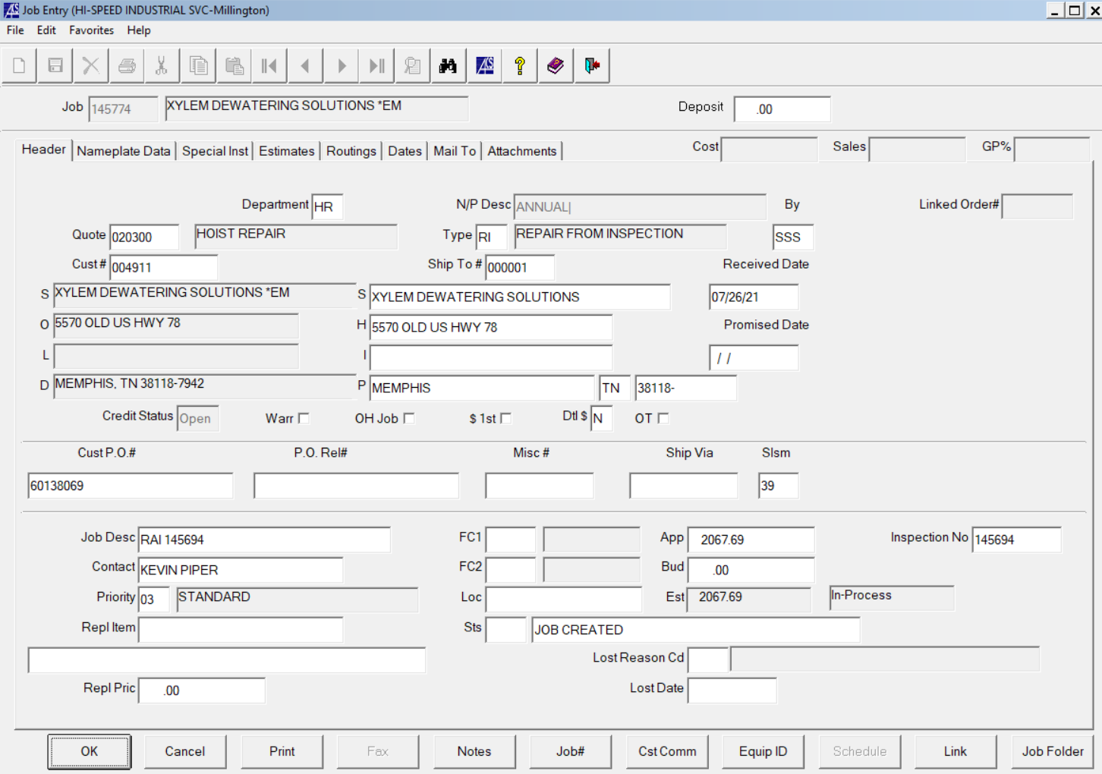



1. You will then have the chance to add a PO, Job description, and priority level. Note: Priority denotes labor hours with 1= FULL OVERTIME, 2=RUSH, and 3=STANDARD. The vast majority of jobs will be priority 3.



