- Purpose
  - The purpose of this procedure is to provide guidance to assure a schedule is available to the technicians prior to the start of the day.
- References
  - NA
- Precautions
  - NA
- Frequency
  - A Schedule should be made everyday before the EOD for the following day.
- Responsibility
  - The coordinators are responsible for making a schedule and updating it as needed.
  - Department Managers are to act as backup to the coordinators.
- Making a Schedule
  - Log-in to InspectAll

  - Enter the job number of the job that needs to be scheduled. 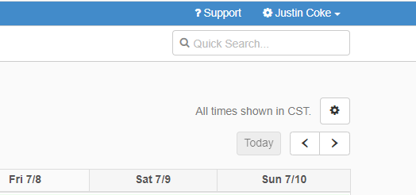
  - Click on the job report
  - Click the Calendar button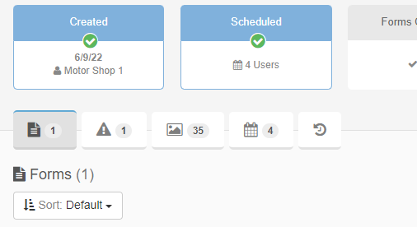
  - Click Add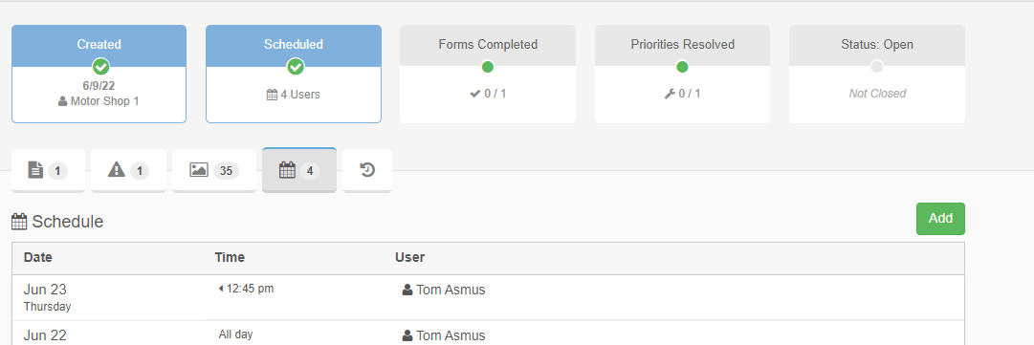
  - Select the user, start & end time, and any notes they might need.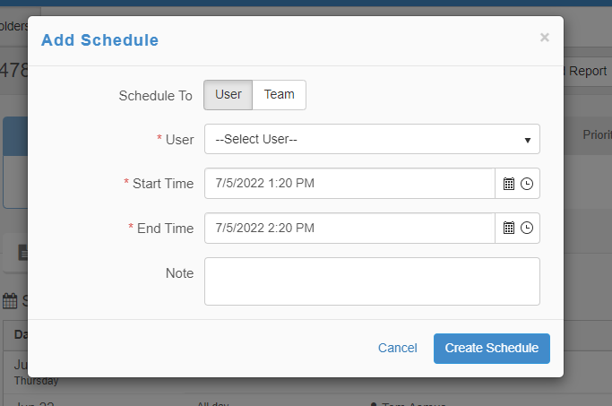
  - Click Create Schedule.
  - Repeat steps 6.2 – 6.7 for all technicians.

- Revision Changes
REVISION # | DCO # | EFF. DATE | Location of Changes | SUMMARY OF CHANGES
0 |  | 07/05/2022 |  | New Instruction
1
2
3
4
5
6

