- Purpose
  - The purpose of this procedure is to provide guidance on how to properly schedule jobs on the outlook calendar.
- References
  - NA
- Precautions
  - NA
- Frequency
  - Jobs should be scheduled on the outlook calendar as often as they are scheduled with customers in order to ensure that jobs are not overlooked or missed.
- Responsibility
  - For most departments, the coordinators are responsible for scheduling jobs.
  - Department Managers are to act as backup to the coordinators in the event a coordinator is out, and a manager schedules a job with a customer.
- Scheduling a job in Outlook
  - Open the Outlook Calendar 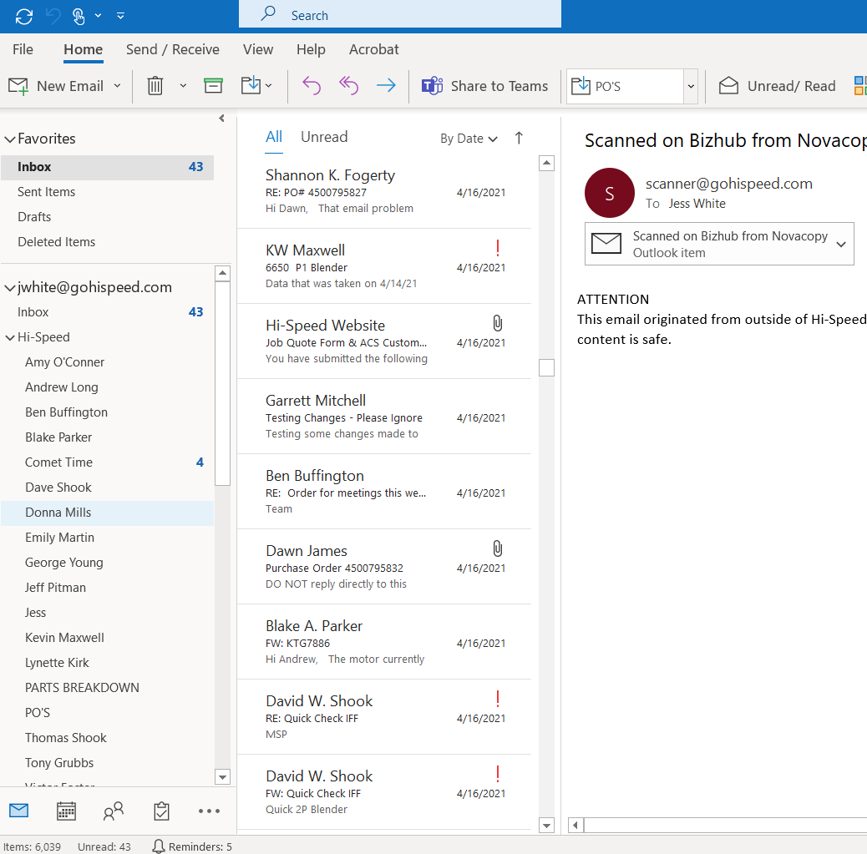

  - Double Click on the date you would like to schedule a job on and fill out the information on the event tab that pops up. Be sure to include a title for the job (Customer and short job description), change the duration of the job to the desired length of time, finally in the notes section include the address, customer name and contact information, and any other relevant information pertaining to the job.
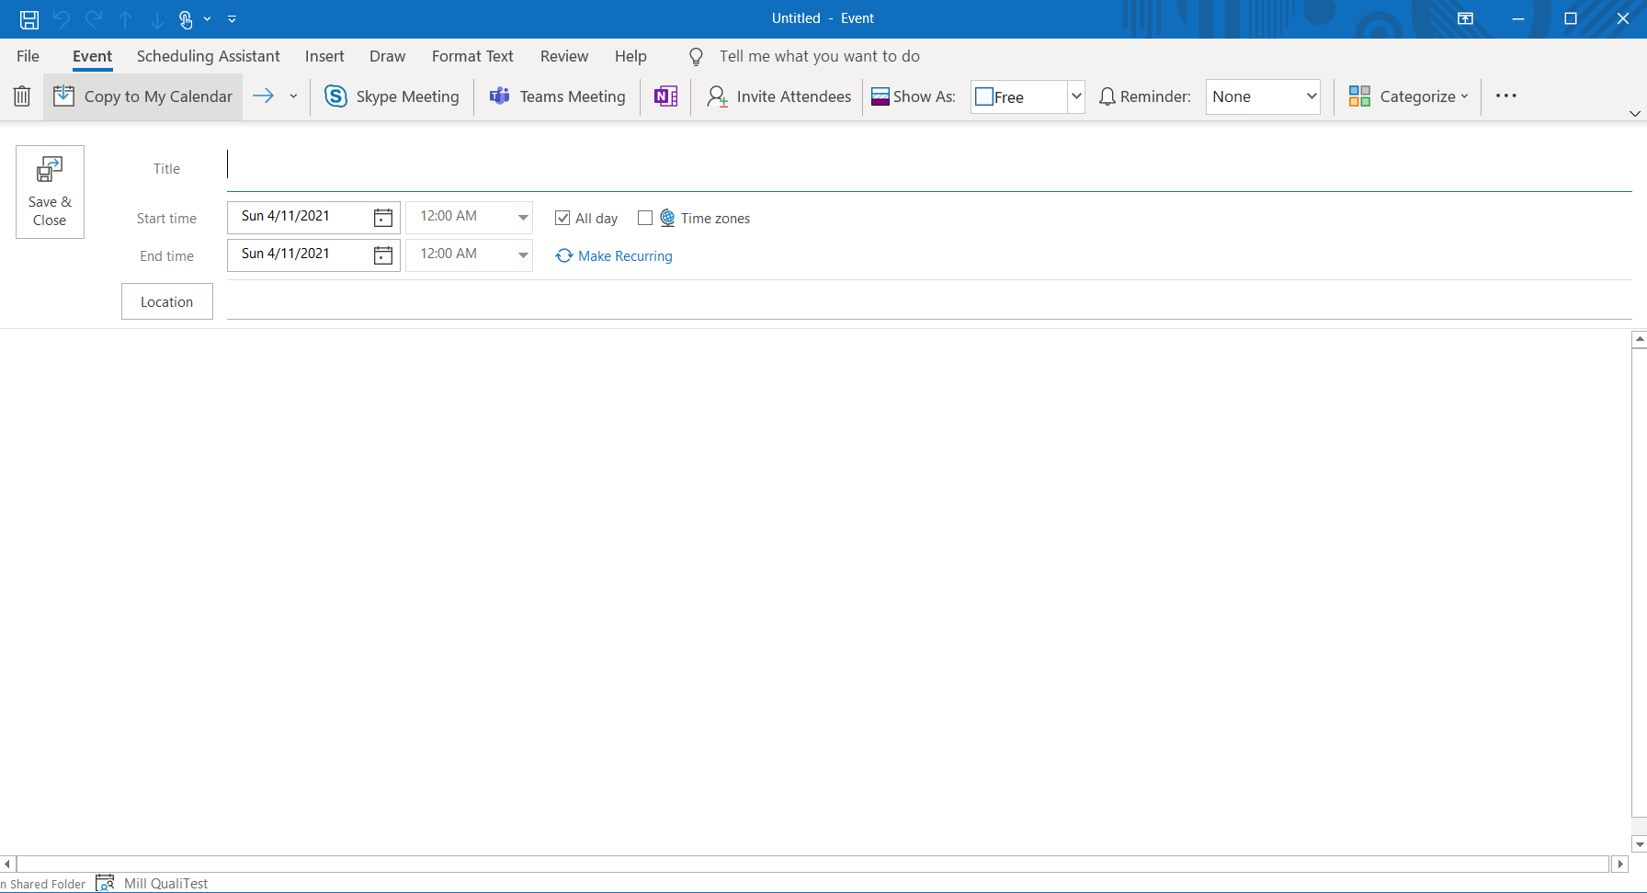

  - Once finished click “Save & Close”. The event will populate to your outlook calendar.

- Revision Changes
REVISION # | DCO # | EFF. DATE | Location of Changes | SUMMARY OF CHANGES
0 |  | 5/21/21 |  | New Instruction
1
2
3
4
5
6

