- Purpose
  - The purpose of this procedure is to provide guidance to assure proper submission of jobs to the accounting department for accurate billing.
- References
  - NA
- Precautions
  - NA
- Frequency
  - Jobs should be turned in for billing throughout the month as they are completed, and all expenses are recorded.
- Responsibility
  - For most departments, the coordinators are responsible for monthly billing submissions.
- Billing submissions
  - After a job has been opened and completed, all time is recorded, and all expenses are added to a job it can be turned in for billing.
  - Throughout the process of opening a job and tracking its progression, it is recommended to keep a labeled folder with job information inside in order to expedite the process of billing when the time comes.
Job Cost Detail Report Process:
  - Open ACS and log-in
    - Double click “Job Entry/Maintenance”
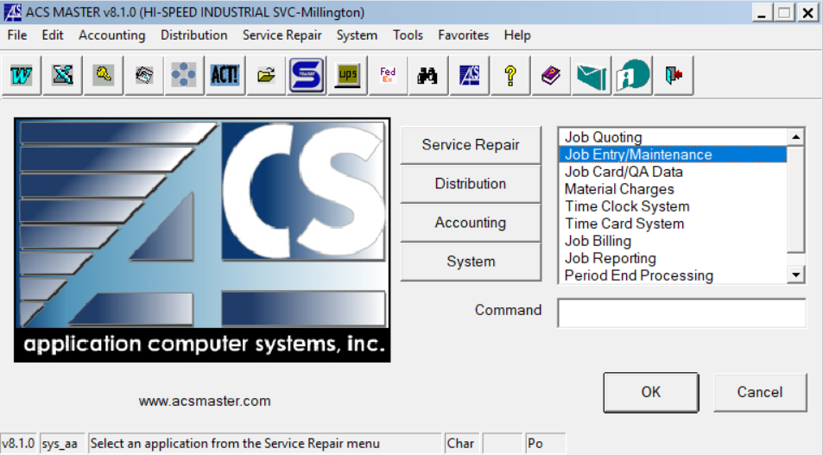

  - Double click “Job Inquiry”
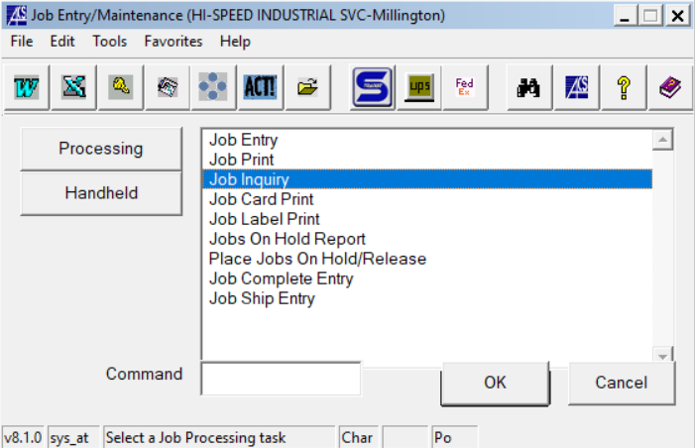
  - Select “Active”
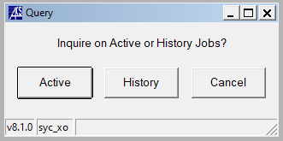
  - Enter the job number that you wish to bill and click “OK”.
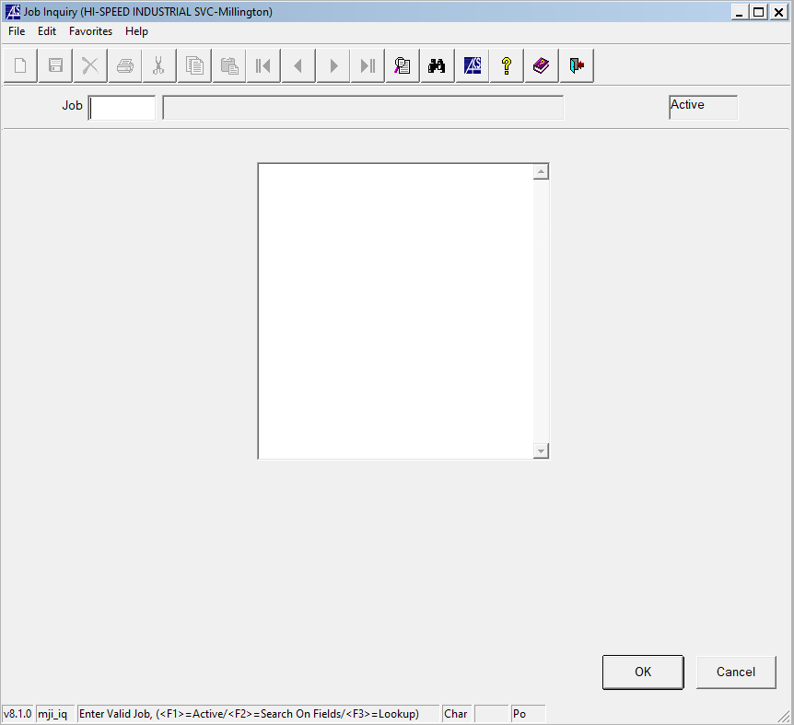
  - Ensure that all information for the job is correct and click “OK”.
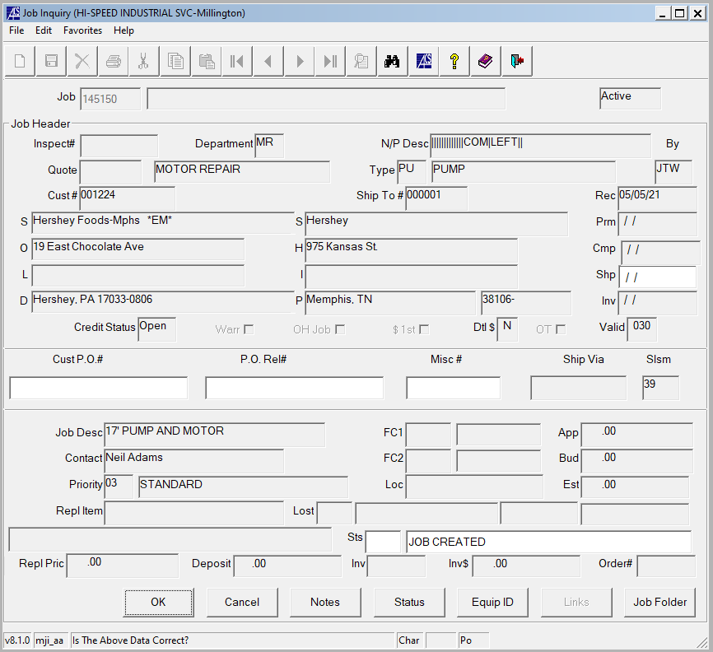

  - Double click “Job Cost Detail Report”
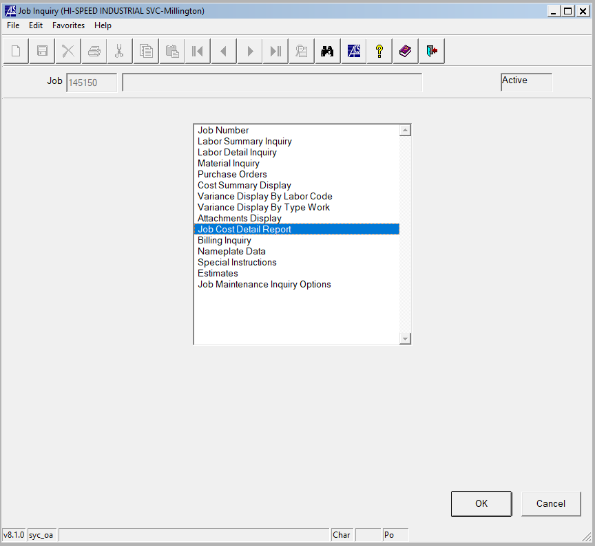
  - Click “OK”
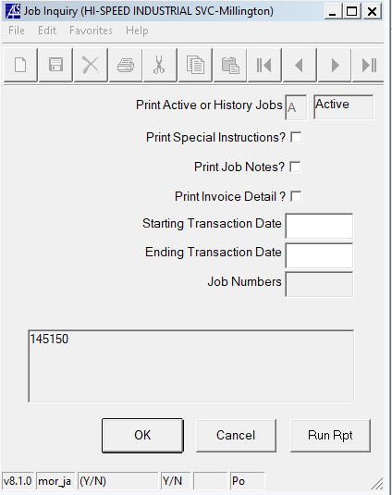
  - Convert to a PDF
    - Check the “PDF” box.
    - Click “Execute”
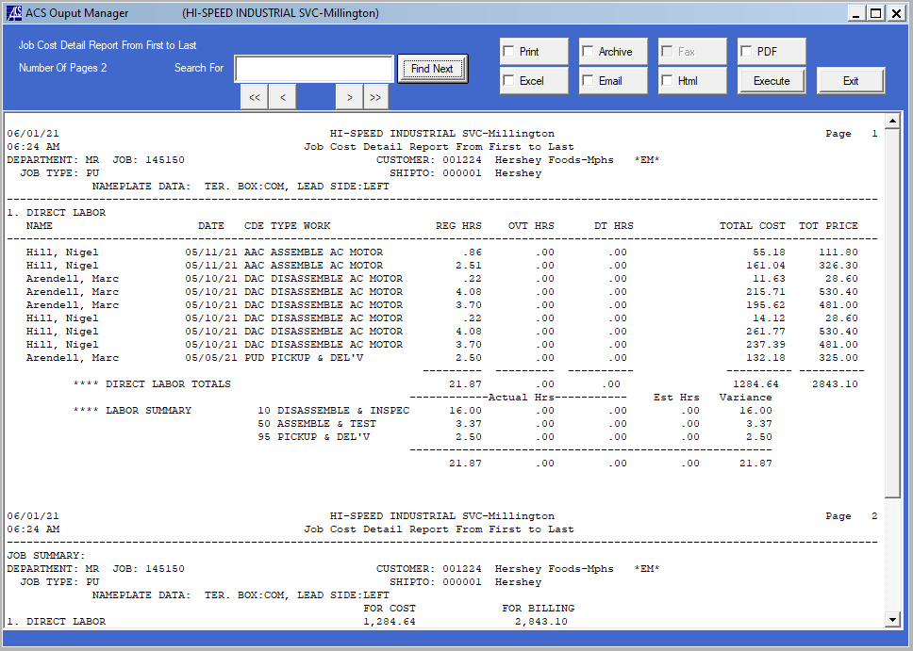
  - Ensure that all cost charges are on the job. (All jobs with labor should have a “Low Value” charge for consumables/ all jobs where a company vehicle was driven should have a milage charge of $0.65 per mile.)

  - Print a copy of the PDF and file the copy in the job folder.

  - Use the below job billing check list to double check for items required for billing.
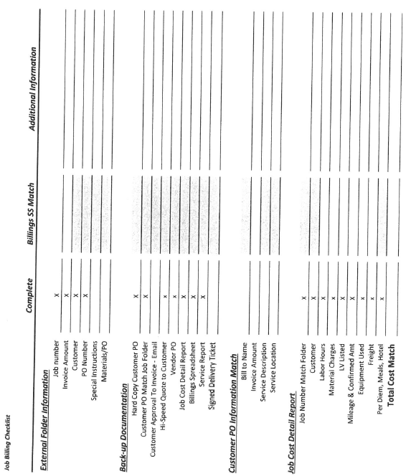
  - Items in the folder should include: Job Cost Detail Report, Quote that was sent to customer, Customer PO, Delivery/Service Ticket, any reports or documents received from the customer or sent to the customer from Hi-Speed during the process of this job.

  - Scan the entire contents of the folder to your email address

  - Save the scanned PDF in the job folder in the Z Drive.
    - Follow route; Z:\firms\firm01\images\jobs
    - Enter job number in the search bar.
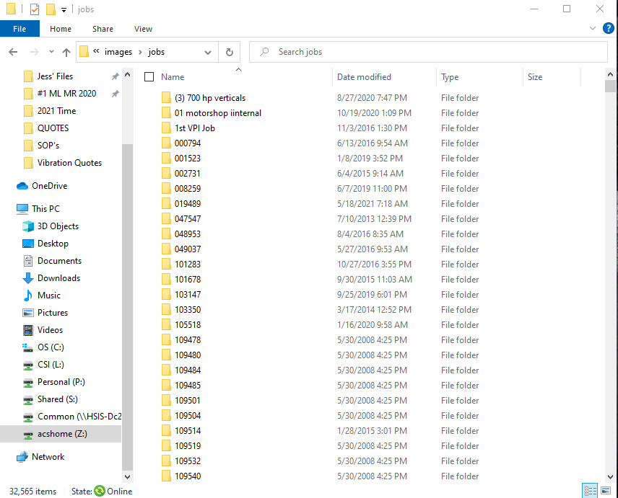

  - Drag and drop the PDF from the email to the job folder in the Z Drive.
  - Send a list of jobs that have been scanned in to accounts receivable. (AR@gohispeed.com)
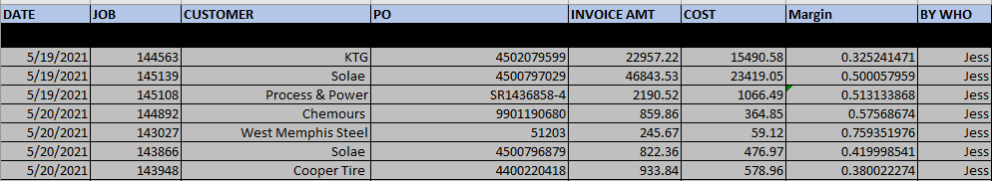
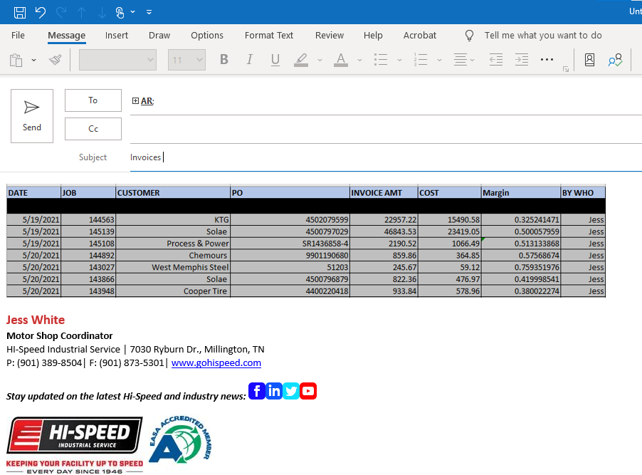

- Revision Changes
REVISION # | DCO # | EFF. DATE | Location of Changes | SUMMARY OF CHANGES
0 |  | 4/20/21 |  | New Instruction
1
2
3
4
5
6

