- Purpose
  - The purpose of this procedure is to provide guidance towards the correct method for an employee to enter time in ACS. (Clock-in and clock-out)
- References
  - NA
- Precautions
  - NA
- Frequency
  - Time is to be entered daily upon arriving at work and departing from work (even for lunch).
  - Also, time should be entered if an employee is transitioning from one customer job to another, in order to properly record cost on customer jobs.
- Responsibility
  - In all departments it is the responsibility of each individual employee to record their time in ACS. If mistakes are made it is the responsibility of the employees to inform their managers or coordinators to ensure that time is fixed correctly before it is submitted the following day.
- Entering time
  - Log into ACS
  - Double click “Time Clock System”
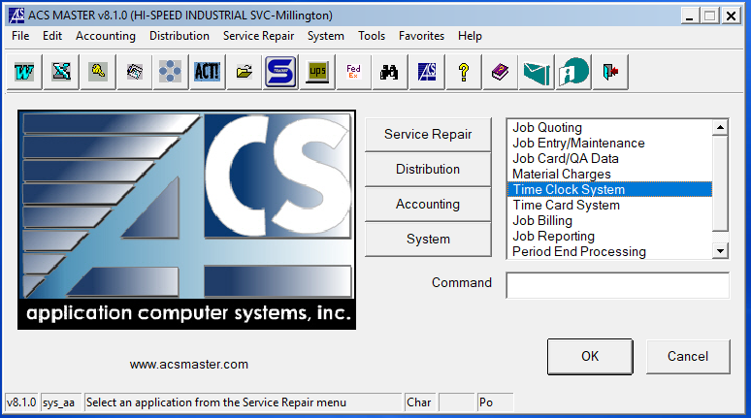

  - Double Click “Time Clock Entry”
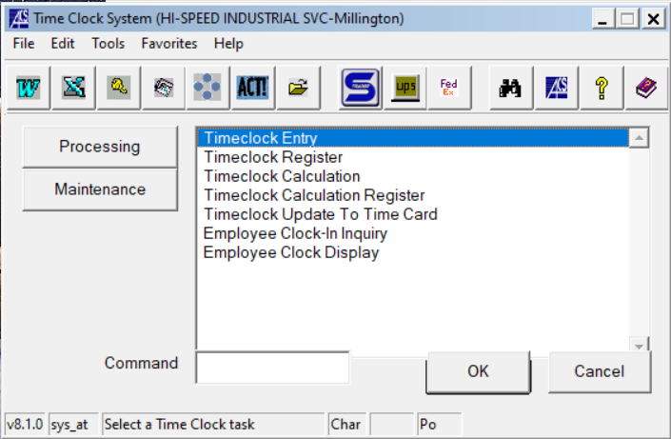
  - Enter your employee number (Department Code/ 1st and 2nd initial of first name/ 1st and 2nd initial of last name/ followed by “1” in most cases) If you do not know your employee code speak with your manager/HR dept.
Ex. 01JEWH1
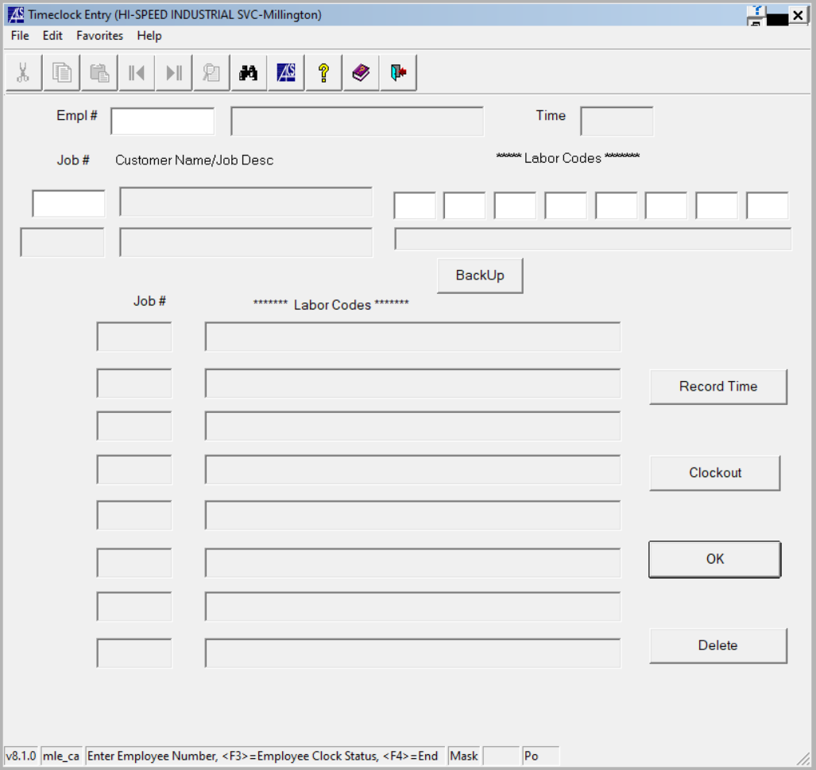

  - To clock-in simply click enter after inputting your employee number and you will get a message saying that “you have successfully clocked in”.

To Clock Out-
  - Refer to 6.4 to enter employee number.
  - Enter job number if your time is billable to a specific customer job or enter IND (indirect) if your time is not directly billable to a specific job.

  - Enter the three-digit labor code for the work that was performed. (There is a list of the three-digit labor codes on both computer stations in the shop. The list is also available via the shared drive or your manager.)

  - Click record time. If there is more than one job you are clocking off of, repeat the 2 previous steps with the different job numbers (this will split your time evenly between all entered jobs).
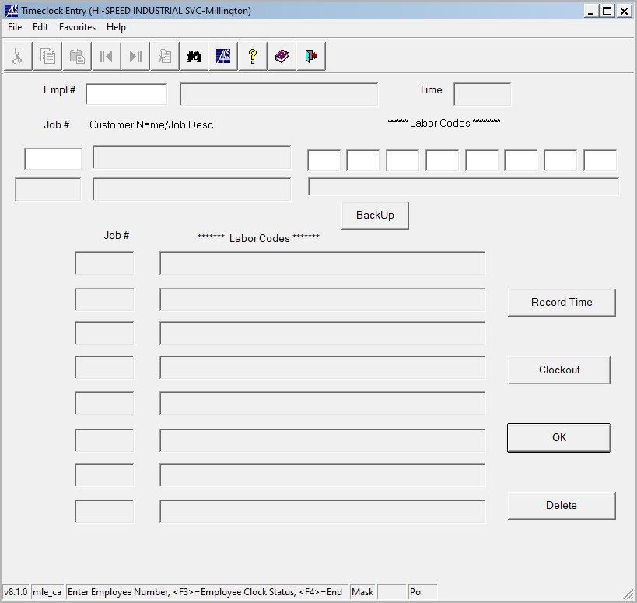

  - Once finished click “Clock out”. You will receive a pop-up message saying that you have successfully clocked out.
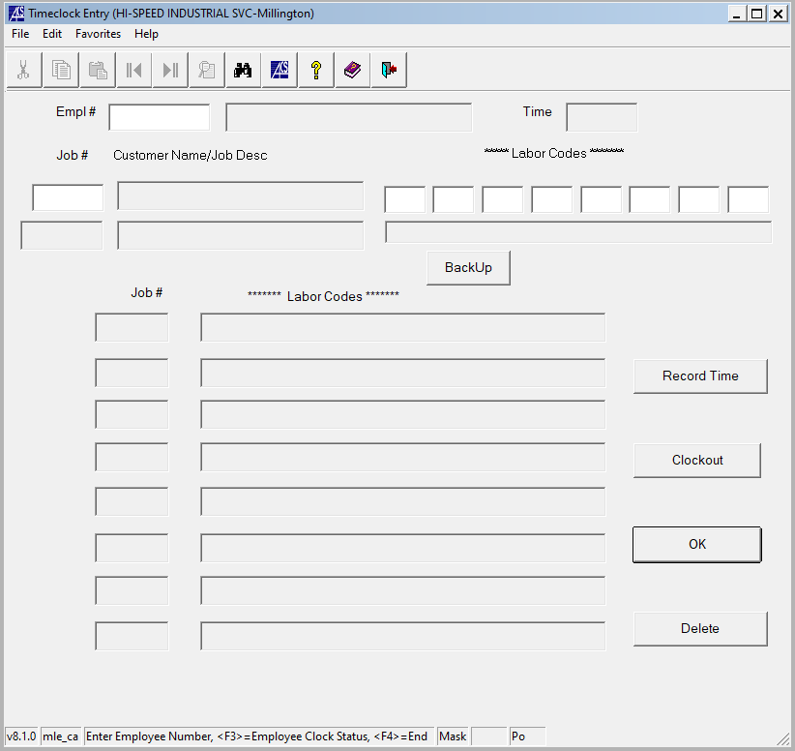

- Revision Changes
REVISION # | DCO # | EFF. DATE | Location of Changes | SUMMARY OF CHANGES
0 |  | 5/7/21 |  | New Instruction
1
2
3
4
5
6

