- Purpose
  - The purpose of this procedure is to provide guidance on how to view all SDS files in CRM.
- References
  - NA
- Precautions
  - NA
- Frequency
  - NA
- Responsibility
  - NA
- Accessing the SDS
  - Find the CRM Logo on the desktop

  - Double Click on the logo
  - Login to CRM
    - Username: (Three Initials)
    - Password: (GoHispeed2022/ personal password)
  - Click on Resource Library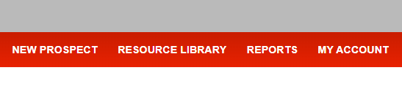
  - Scroll down to the bottom of the page
  - Click the drop-down box under “Safety Data Sheets” and select the desired SDS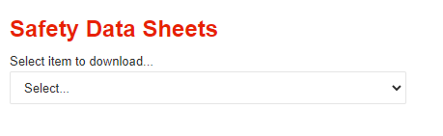
  - Once you select a SDS, this screen will appear.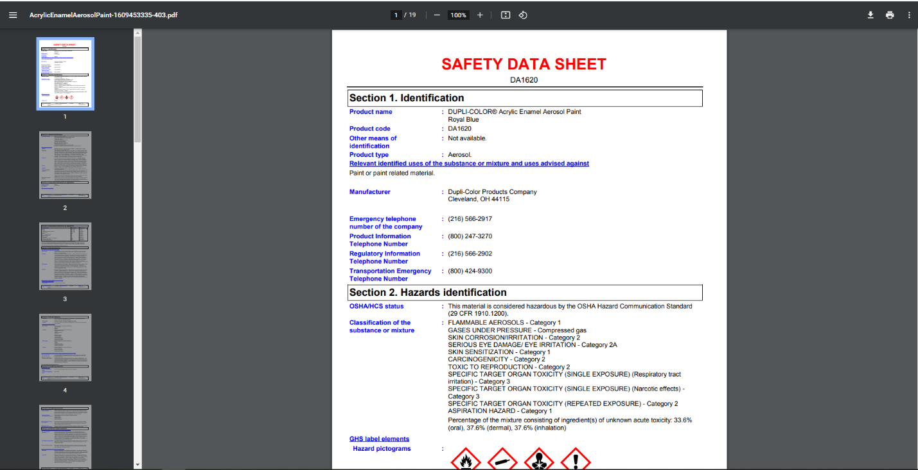
  - From here you can scroll down to find the section you are looking for.
- Revision Changes
REVISION # | DCO # | EFF. DATE | Location of Changes | SUMMARY OF CHANGES
0 |  | 7/7/22 |  | New Instruction
1
2
3
4
5
6

