1. **Purpose**
   1. This procedure discusses the steps necessary to modify inspection forms in Inspectall. The same steps will work for other forms as well.
2. **References**
   1. **NA**
3. **Precautions**
   1. **NA**
4. **Frequency**
   1. As Needed
5. **Responsibility**
   1. Coordinators or managers may required to modify forms depending on time frame, and or the nature of the request.
6. **Modifying the form** 
   1. Log in to Inspectall and select the Form Builder option from the drop-down menu below your profile.

1.

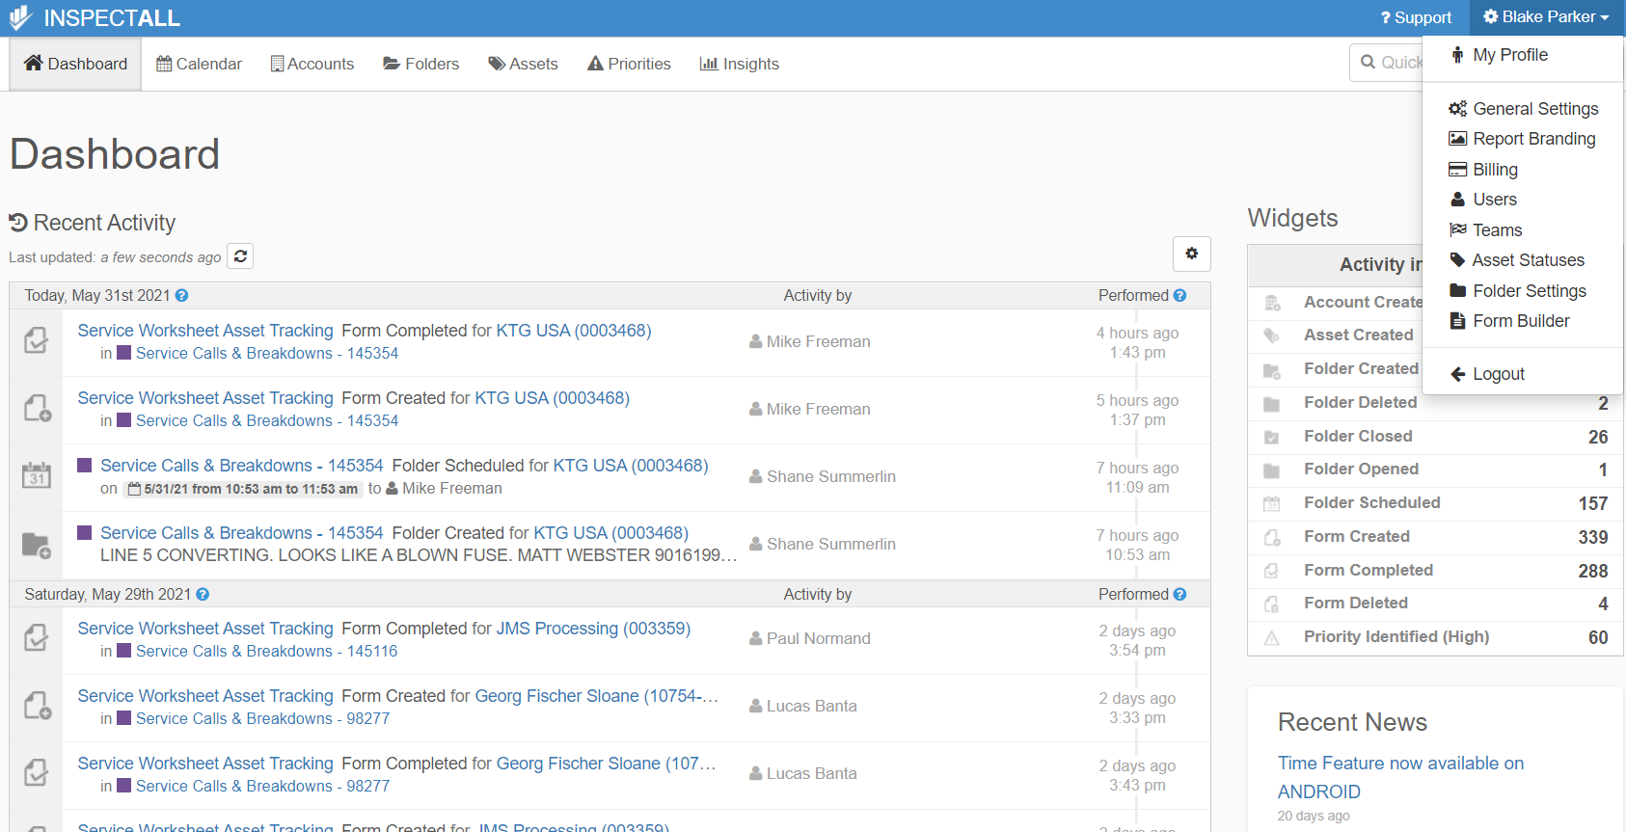

2.

* 1. Select the report to be modified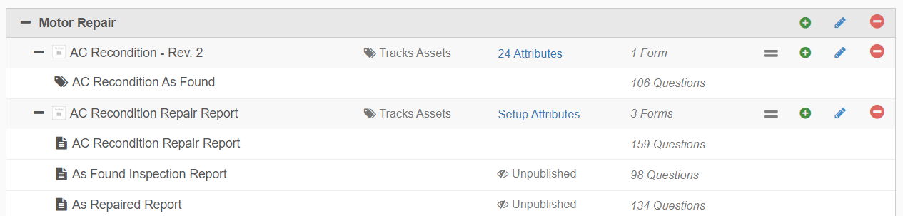
  2. Change the report from published to unpublished. **Caution- this will make the form unavailable to techs who many wish to open it. A help section is available as shown by arrow 2.**

1.

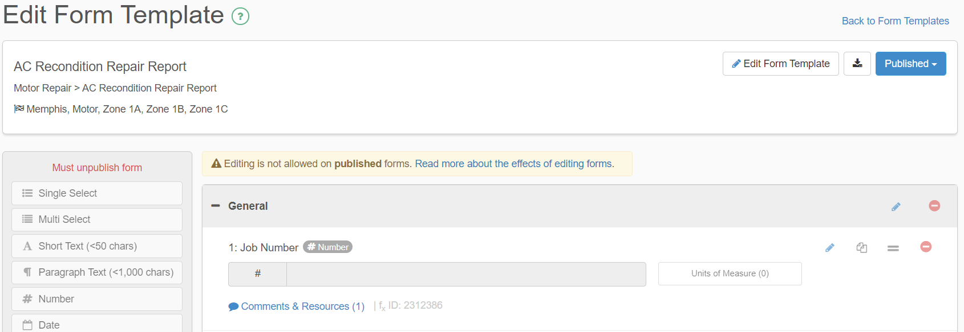

2.

* 1. Once the report is unpublished you will have the option to do the following:

1. Edit the question by clicking on the pencil icon
2. Copy the question clicking on the icon to the left
3. Move the question by clicking on the equal sign and dragging it to the desired point.
4. Delete the question clicking the icon to the left.
5. 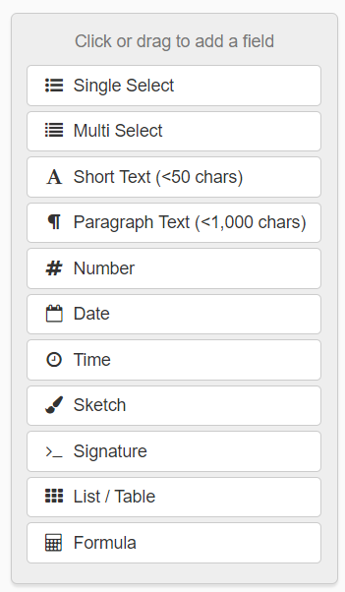 Add questions from the menu on the left. They will automatically drop to the bottom of the list but can be moved using the equal sign as indicated above.
   * 1. After editing the form return the selection to Published. 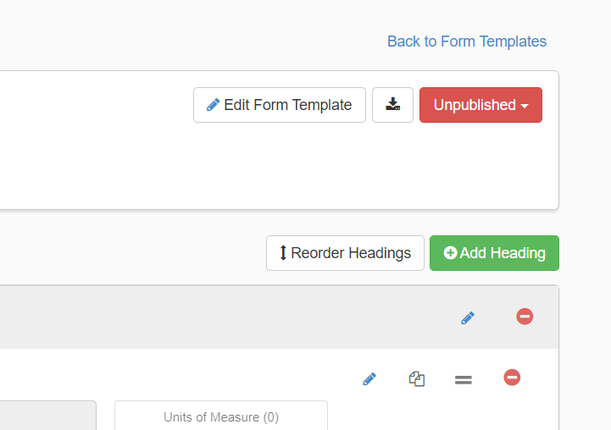
     2. The form is now available to the technicians for use during inspections etc.
6. **Revision Changes**

|  |  |  |  |  |
| --- | --- | --- | --- | --- |
| **REVISION #** | **DCO #** | **EFF. DATE** | **Location of Changes** | **SUMMARY OF CHANGES** |
| **0** |  | 4/14/21 |  | New Instruction |
| 1 |  |  |  |  |
| 2 |  |  |  |  |
| 3 |  |  |  |  |
| 4 |  |  |  |  |
| 5 |  |  |  |  |
| 6 |  |  |  |  |