- Purpose
  - The purpose of this procedure is to provide guidance on how to adjust the settings on the conference room computers for presentations.
- References
  - NA
- Precautions
  - NA
- Frequency
  - This is to be completed before town halls, EOS meetings, Lunch and Learns, etc.…
- Responsibility
  - The meeting organizer is responsible for making sure everything is ready at the meeting start time.
- Adjusting Settings (Extended Display)
  - Log-in to the computer
  - Go to settings
  - Click on system settings
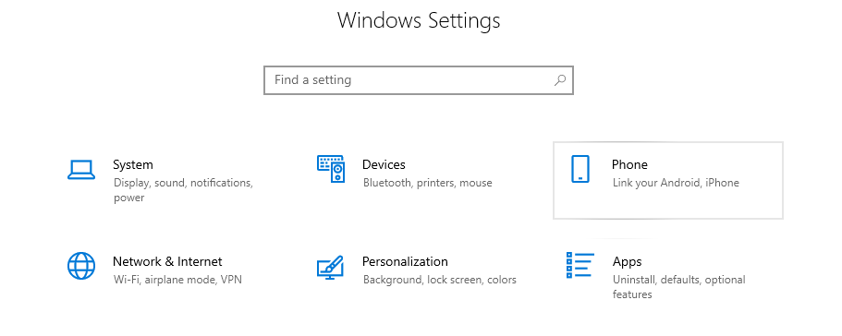

  - Scroll down until you see “Multiple Displays”
  - Click the drop-down box and select “Extend Desktop to this Display”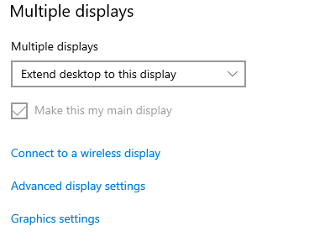
- Microsoft Teams
  - Login to Microsoft teams
  - Go to calendar
  - Click “Join” on for the desired meeting
- PowerPoint
  - Open the presenters PowerPoint
  - Click “Share your screen” on the Microsoft Teams Meeting
  - Click on the PowerPoint
  - Click “Present on the PowerPoint”

- Revision Changes
REVISION # | DCO # | EFF. DATE | Location of Changes | SUMMARY OF CHANGES
0 |  | 11/8/2022 |  | New Instruction
1
2
3
4
5
6

