1. **Purpose**
   1. The purpose of this procedure is to provide guidance to assure proper submission of ACS recorded time.
2. **References**
   1. **NA**
3. **Precautions**
   1. **NA**
4. **Frequency**
   1. Time is to be submitted daily prior to 9 PM except on Tuesdays
   2. On Tuesday time cannot be submitted until the message is received that the previous weeks’ time has been purged.
5. **Responsibility**
   1. For most departments the coordinators are responsible for daily time submission.
   2. Department Managers are to act as backup to the coordinators and ultimately responsible for accurate timely submission.
6. **Time Submission**
   1. Log-in to ACS
   2. Double Click on Time Clock System

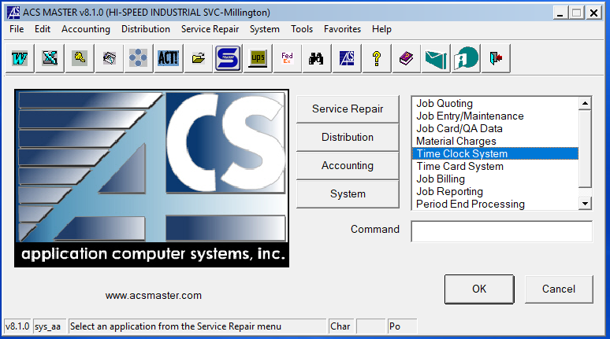

* 1. Double Click on Timeclock Register

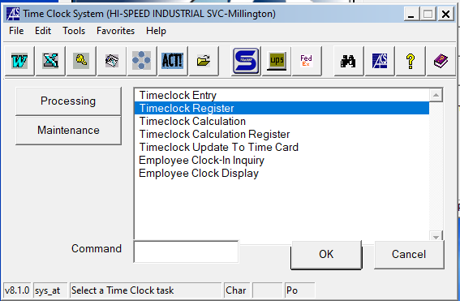

* 1. Enter the department number, hit enter and click OK

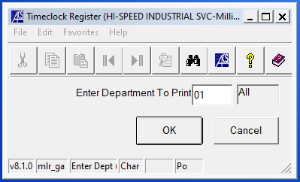

* 1. Selecte PDF, then click Execute

1.

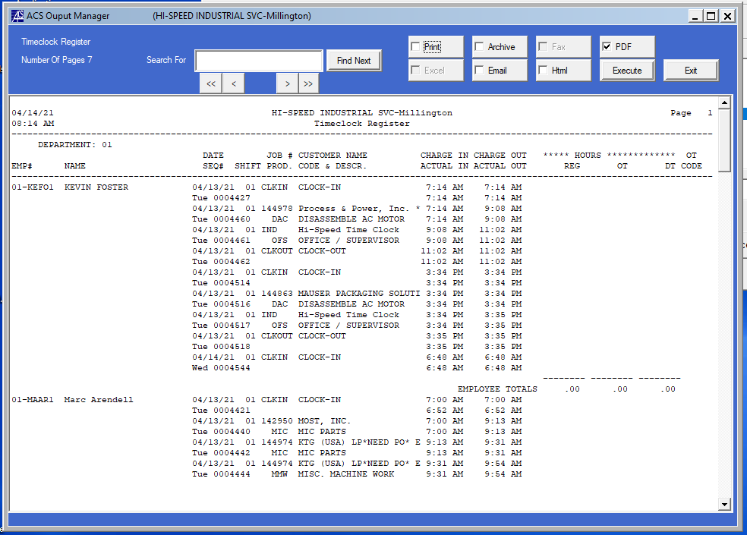

2.

* 1. The previous step generates a PDF of the Timeclock Register. Save the PDF with the Date of the time being submitted for submission at the end of this process.

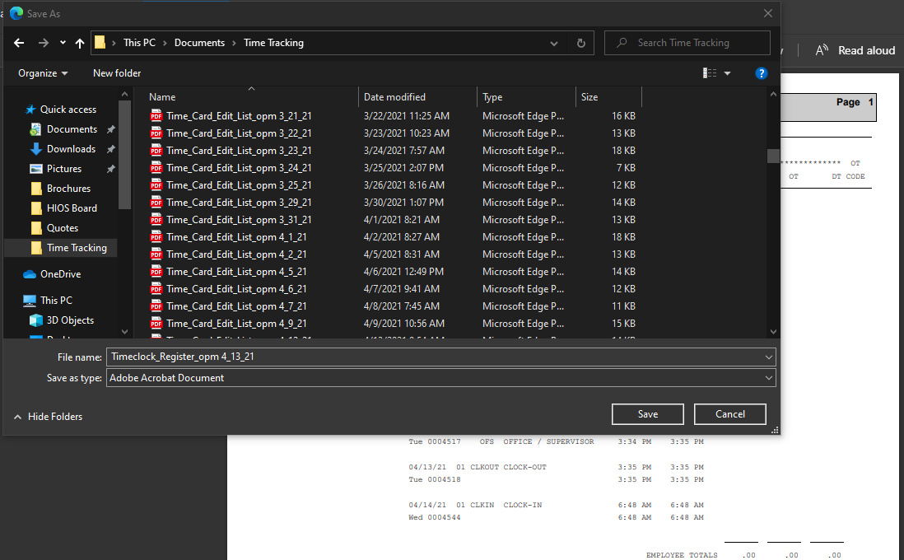

* 1. You can then exit the Timeclock Register screen.
  2. Double click on Timeclock Calculation

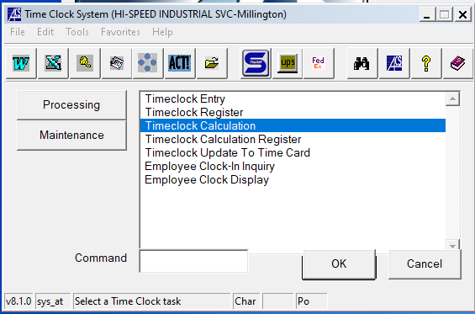

* 1. Select the date for the time to be submitted (typically the prior day, the prior day will auto populate). Click OK

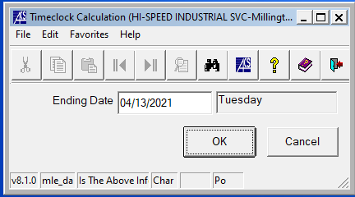

* 1. Double click the Timeclock Calculation Register

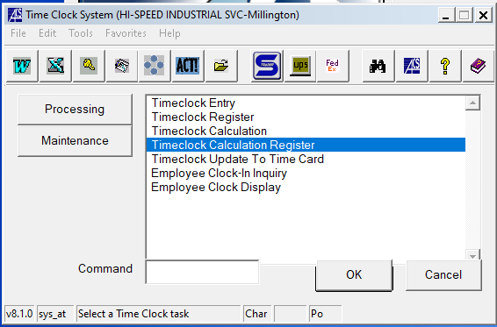

* 1. DO NOT enter the department number, hit enter and click OKGraphical user interface, text, application

     Description automatically generated

* 1. Select PDF, then click execute

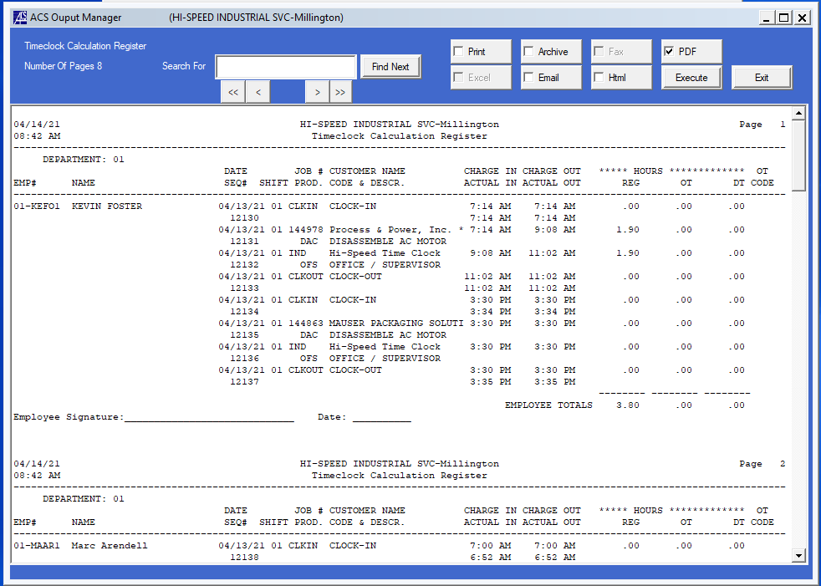

2.

1.

* 1. The previous step generates a PDF of the Timeclock Register. Save the PDF with the Date of the time being submitted.

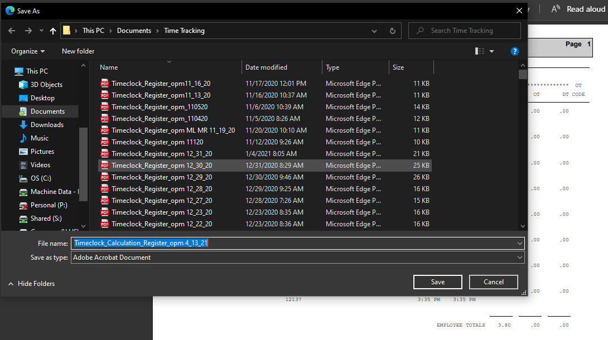

* 1. You can now exit the Timeclock Calculation Screen.
  2. Double-click on the Timeclock Update To Time Card

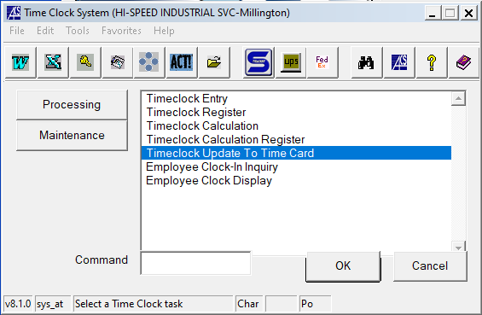

* 1. Click on the check box to updated time to the labor entry file, then click OK.

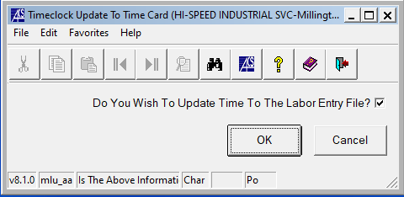

2.

1.

* 1. Review the times for accuracy on the Timeclock Calculation Register. If they need to be changed that can be done in the Time Card System. Refer to SOP2 Modifying time in ACS for further instruction.
  2. Submit the saved PDF Timeclock Register along with the Time Card Edit List (Instructions in SOP2) via email to [Time@gohispeed.com](mailto:Time@gohispeed.com), include Comet time if applicable.

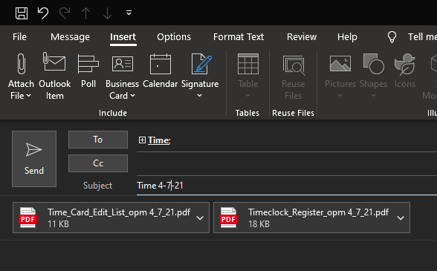

1. **Revision Changes**

|  |  |  |  |  |
| --- | --- | --- | --- | --- |
| **REVISION #** | **DCO #** | **EFF. DATE** | **Location of Changes** | **SUMMARY OF CHANGES** |
| **0** |  | 4/14/21 |  | New Instruction |
| 1 |  | 1/18/22 | Calculation register | DO NOT enter dept #  (per. Donna) |
| 2 |  |  |  |  |
| 3 |  |  |  |  |
| 4 |  |  |  |  |
| 5 |  |  |  |  |
| 6 |  |  |  |  |