- Purpose
  - The purpose of this procedure is to provide guidance on how to find and save a service or delivery ticket
- References
  - NA
- Precautions
  - NA
- Frequency
  - A delivery or service ticket should be put into the job folder as it is completed.
- Responsibility
  - The coordinators are responsible for making sure the delivery/ service ticket is saved in the job folder.
- Service/ Delivery tickets
  - Login to CRM
  - Search the job number in the search bar. 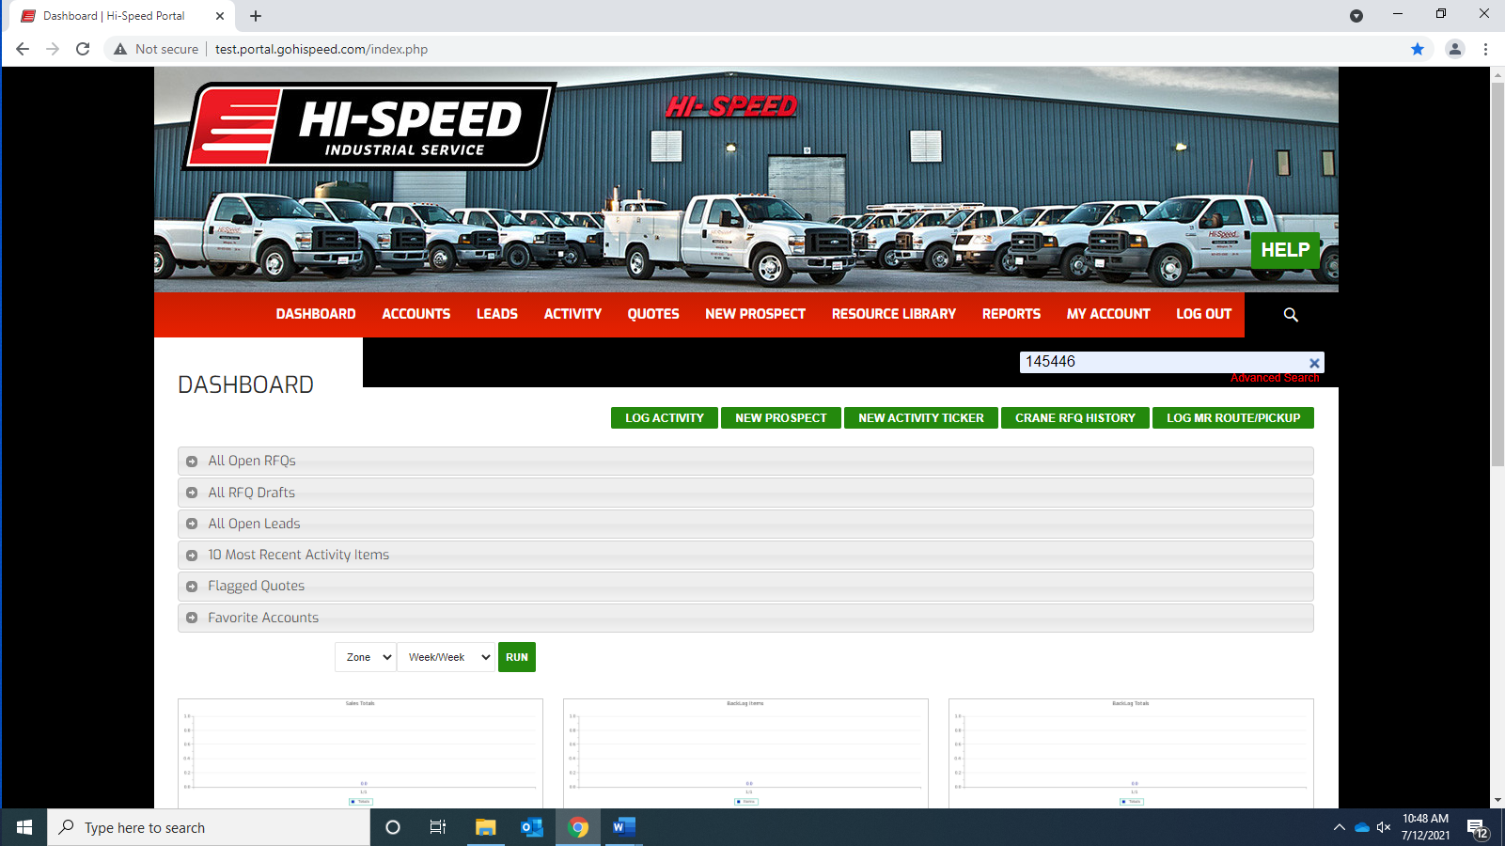
  - Under “Quote Results” find the latest corresponding Job “Quote #” and click on it.
  - Under Recent Activity, click “View all” 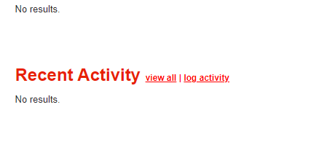
  - Click the “View delivery/service ticket icon” 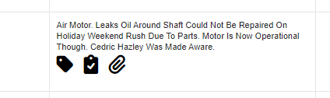
  - Click the word file that downloaded. 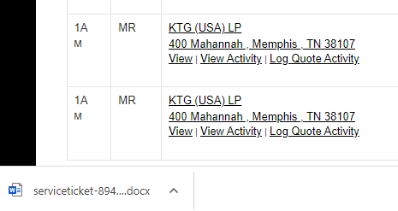
  - Click “Enable Editing”
  - Click “File – Print”
  - Select the appropriate printer and click print.

- Revision Changes
REVISION # | DCO # | EFF. DATE | Location of Changes | SUMMARY OF CHANGES
0 |  | 7/6/2022 |  | New Instruction
1
2
3
4
5
6

