PROCEDURE FOR WRITING UP A MOTOR JOB ORDER:

Hi-Speed White Tag

1. Customer Name
2. Contact Information (Name, Phone #, Email)
3. Work to be done
4. Job # (After ACS)

ACS

1. In the Service Repair menu, select Job Entry/Maintenance

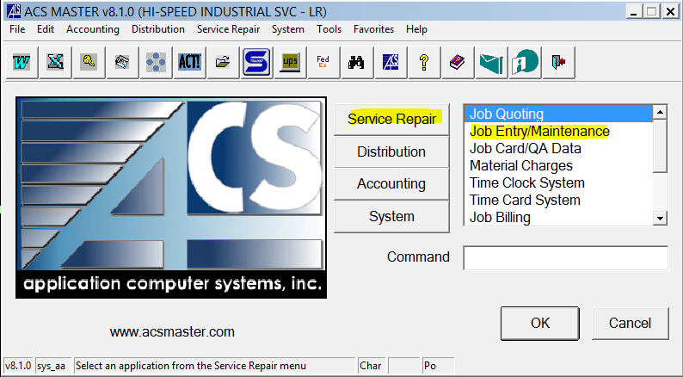

1. In the Processing menu, select Job Entry

1. In the Job box, press F2 to assign new job number
2. Header Tab
   1. Department – press F3 and select Hoist Repair (or type HR)
   2. Quote – *if this is a quoted job, you can enter the quote number and it will auto fill the customer details and estimates tab*
   3. Type – press F3 and select type (EH/AH/HM etc.)
   4. Cust # - press F3 and look up customer name
   5. Ship To # - press F3 and select the correct shipping address
   6. Promise Date – When you think the job will be complete
   7. Customer PO
   8. Job Desc – Important info about job
   9. Contact – Type contact name (contact email in
   10. Priority – put 3 for standard
   11. Approved amount – will be different
   12. Click OK

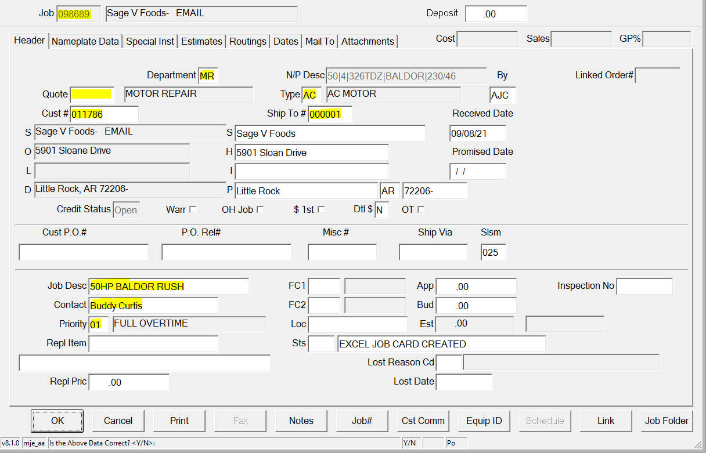

1. Nameplate Data Tab
   1. MFG (Manufacturer)
   2. Voltage (Low/High)
   3. Model
   4. Serial
   5. Phase (3)
   6. Hz (60)

1. Special Inst Tab
   1. Type in any special instructions about the job
2. Mail-To Tab
   1. Select default mail-to information
   2. Change Name to customer contact name

# Inspectall

1. Click Folders tab

1. Click Add Folder

1. Click Create New

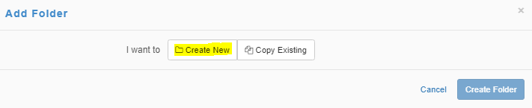

1. Select Folder Type – In Shop Hoist Repair
2. Account – Enter Customer # from ACS Printout and select the customer from the dropdown
3. User – Select your user name
4. Click Create Folder

1. Click the pencil icon in the header to Edit Folder

1. Change the auto-generated ID to the ACS Job number and select Update Folder

# IN HOUSE TAGGING & SCHEDULING PROCESS

1. Write the ACS job number down on a tag and tag the item that has been sent in for inspection/repair or replacement
2. Notify customer of inspection fee and get verbal or written approval before scheduling the inspection
3. Schedule a technician to inspect or start working on replacement quote
4. One Inspection has been completed notify customer of repair/replacement cost
5. Get PO before proceeding