**HOW TO RUN THE OPEN RFQs REPORT IN THE CRM**

1. BEGIN AT THE HI SPEED CRM HOMEPAGE CLICK ON THE “REPORTS” TAB

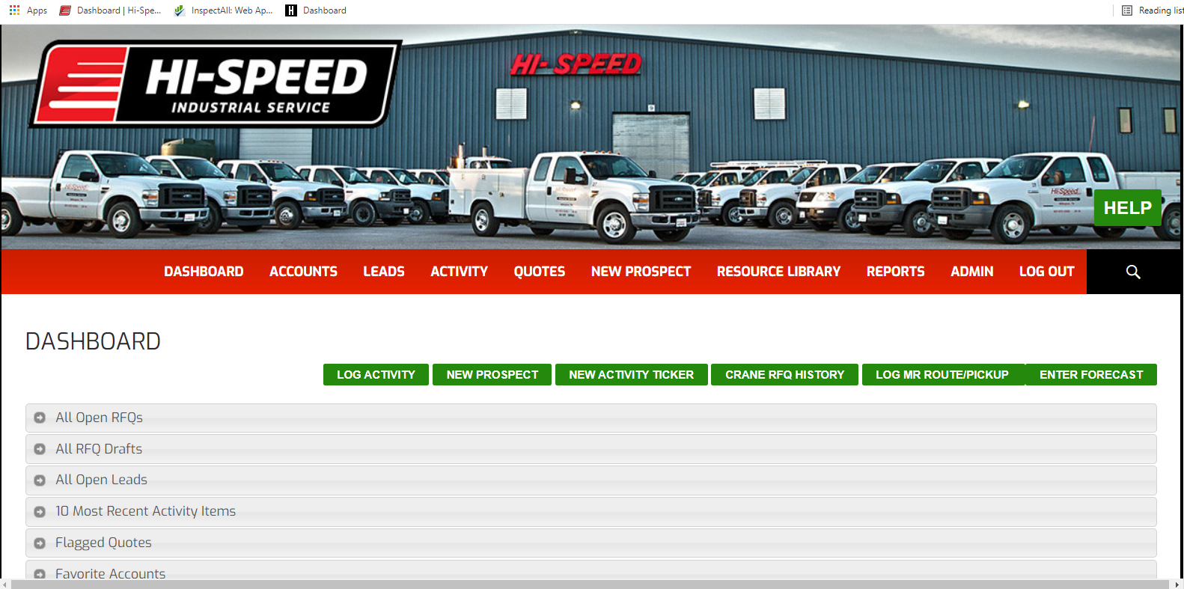



1. CLICK ON THE “SELECT A REPORT” DROP DOWN TAB

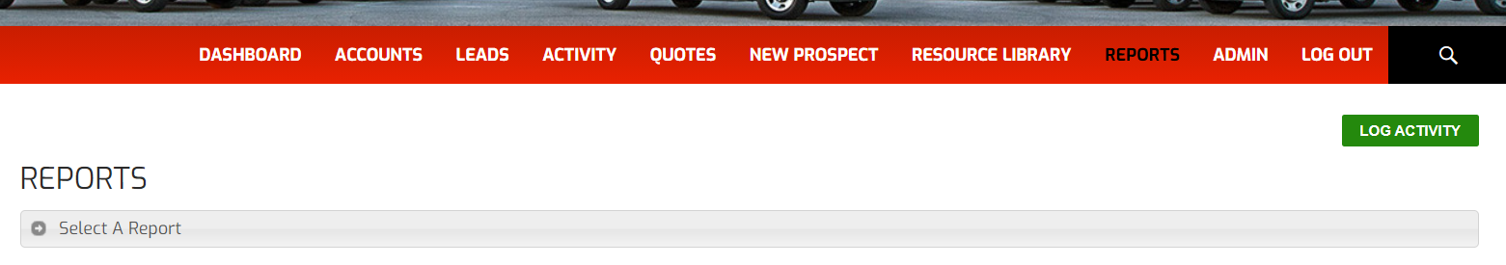



1. TO CHECK THE STATUS OF OPEN RFQ’S SELECT THE “OPEN RFQs” OPTION

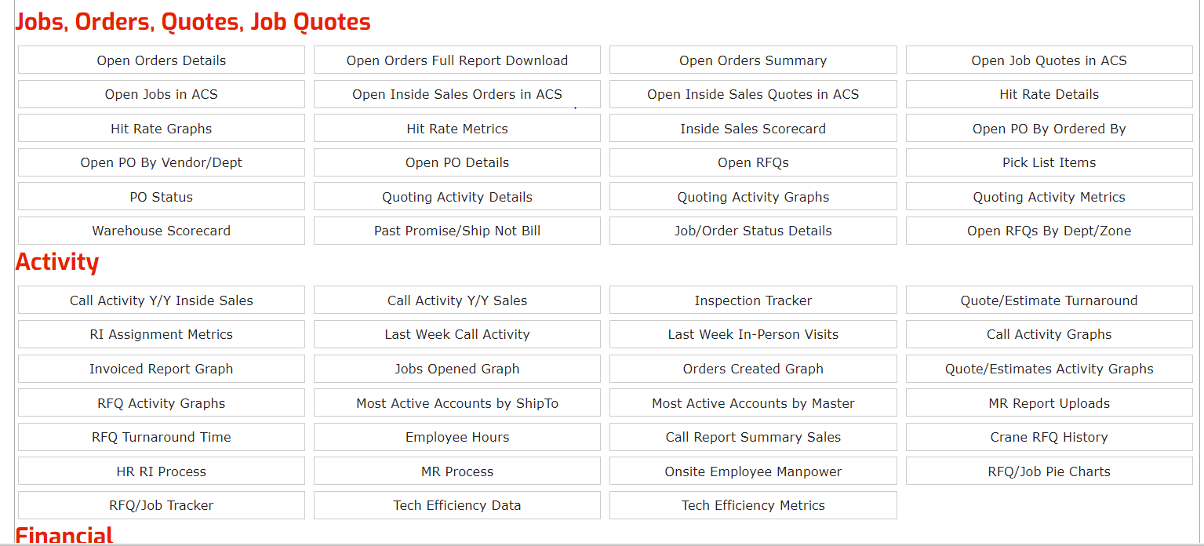



1. YOU CAN NOW FILTER YOUR RESULTS FOR EASE OF USE BY CLICKING THE “FILTER OPTIONS” DROP DOWN TAB. IT IS SUGGESTED TO FILTER “BRANCH”, “ZONE”, AND “DEPARTMENT”.

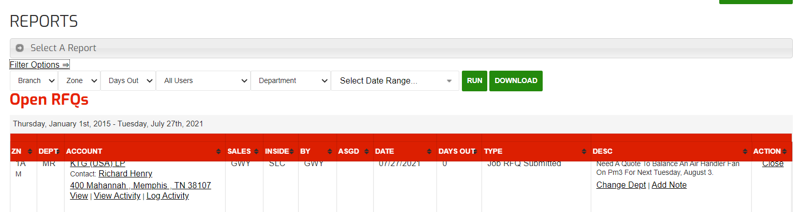



1. YOU CAN NOW VIEW PERTINENT INFORMATION REGARDING THE OPEN RFQs IN YOUR DEPARTMENT, ZONE, AND BRANCH.

