**HOW TO RUN THE OPEN RAI’S REPORT IN THE CRM**

1. BEGIN AT THE HI SPEED CRM HOMEPAGE CLICK ON THE “REPORTS” TAB

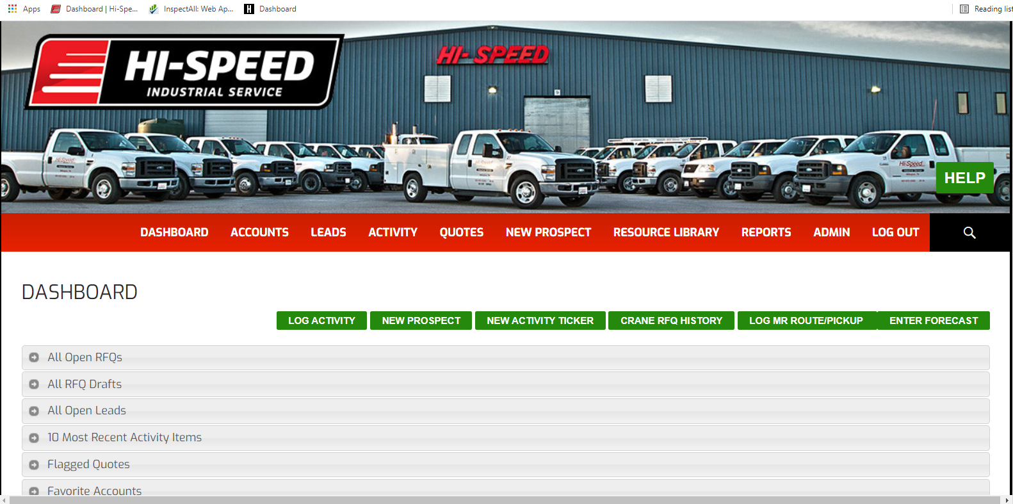



1. CLICK ON THE “SELECT A REPORT” DROP DOWN TAB

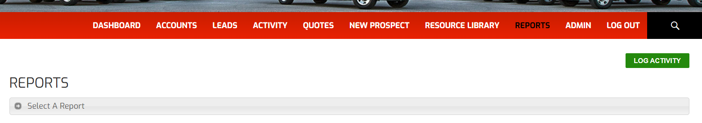



1. TO CHECK THE STATUS OF OPEN RAI’S SELECT THE “HI RI PROCESS” OPTION

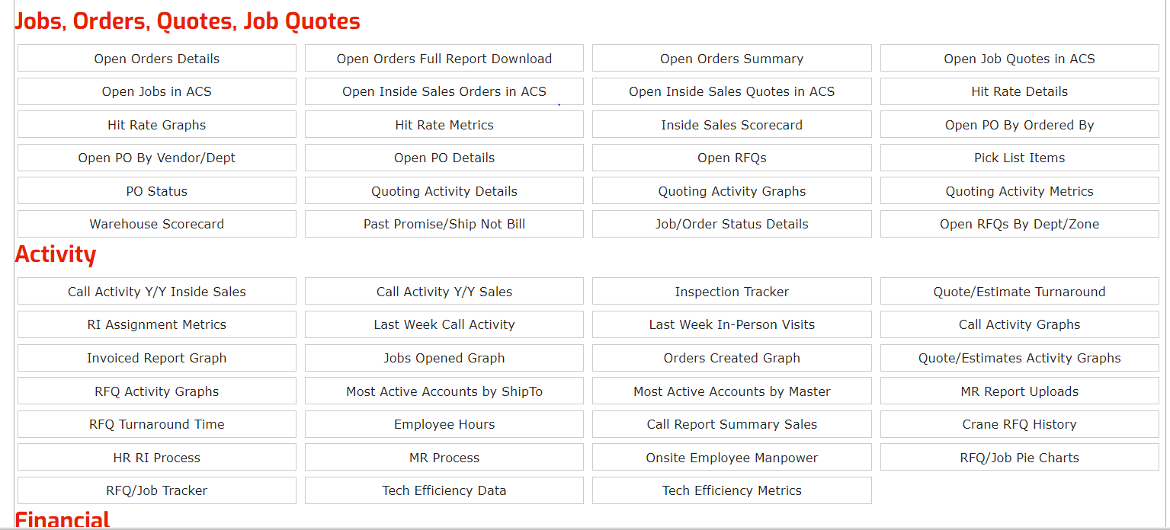



1. YOU CAN NOW VIEW YOUR OPEN RAI’S FOR YOUR LOCATION SORTED BY HOW MANY DAYS THEY HAVE BEEN OPEN FOR. THE GOAL WOULD BE TO HAVE ZERO GREATER THAN 10 DAYS.

