**HOW TO RUN THE OPEN PO REPORT IN THE CRM**

1. BEGIN AT THE HI SPEED CRM HOMEPAGE CLICK ON THE “REPORTS” TAB

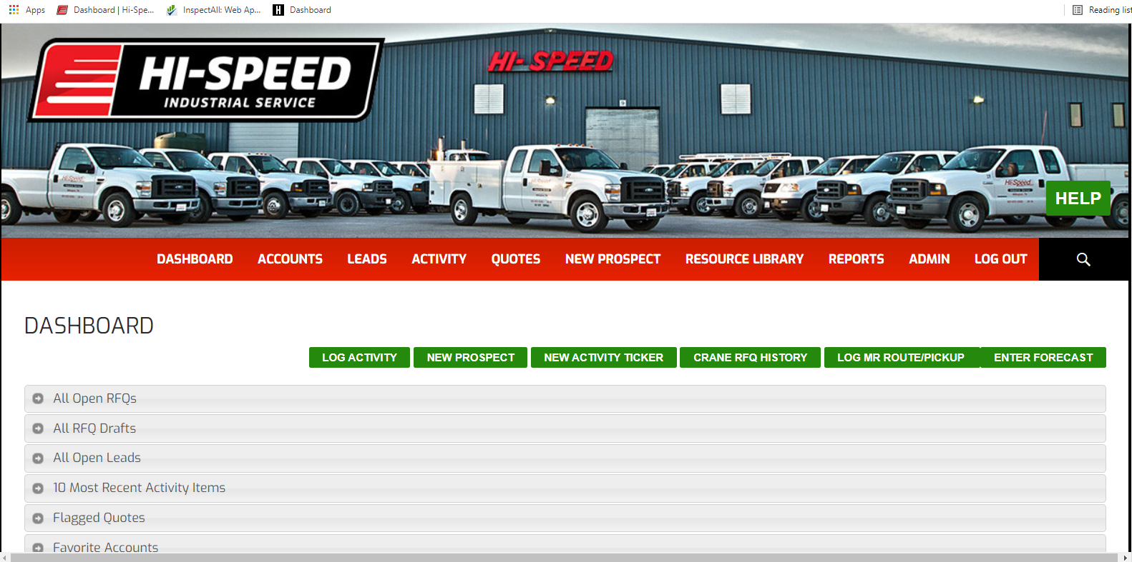



1. CLICK ON THE “SELECT A REPORT” DROP DOWN TAB

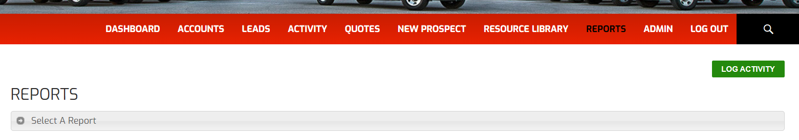



1. TO CHECK THE STATUS OF OPEN PO’S SELECT THE “OPEN PO DETAILS” OPTION

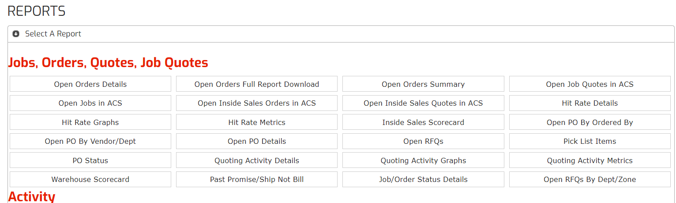



1. ONCE SELECTED YOU WILL WANT TO FILTER THE REPORTS USING THE “FILTER OPTIONS” DROP DOWN TAB.

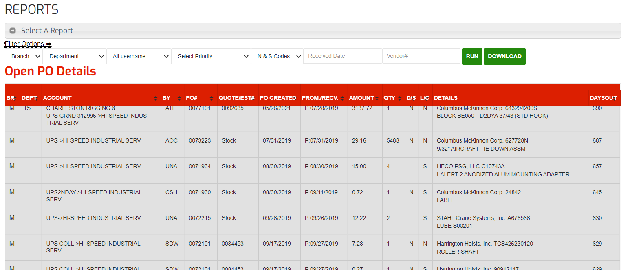



BEST PRACTICE: FILTER BY “BRANCH” AND “DEPARTMENT” FOR BEST ORGANIZATION

1. SORT YOUR RESULTS BY THE “DAYS OUT” OPTION WHICH WILL SHOW HOW MANY DAYS THE PO HAS REMAINED OPEN SINCE THE GIVEN “PROMISED DATE”. THE GOAL IS TO HAVE NO PO’S OPEN PAST THE PROMISED DATE.

