ACS PROCEDURE: FINDING AND PRINTING JOB COST DETAIL REPORTS

By: Seth Blanton

Department of Inside Sales

Step 1 – Click on the ACS Icon.
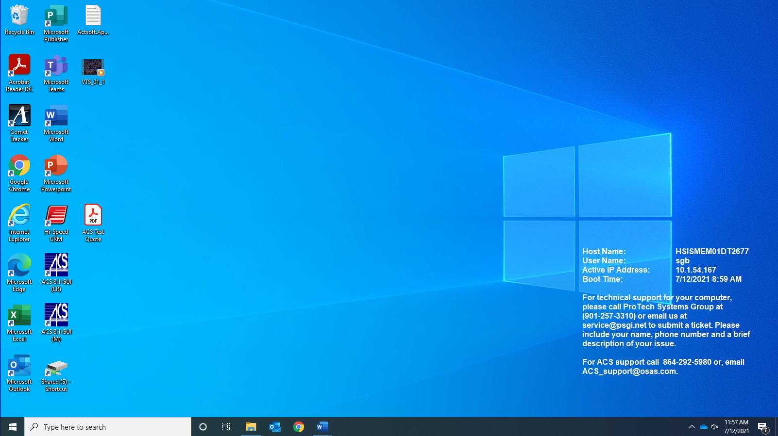

Step 2 – Log into ACS.
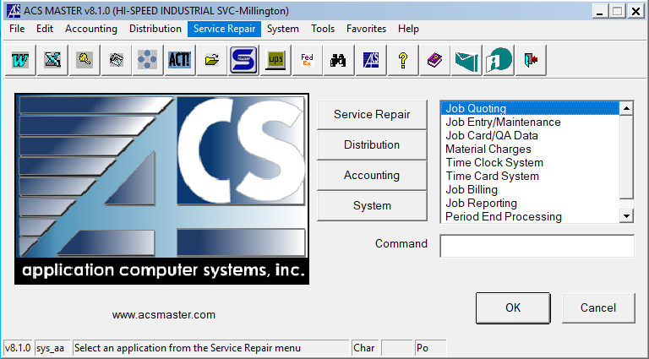
Step 3 – Click on the “Service Repair” option at the top of the screen.
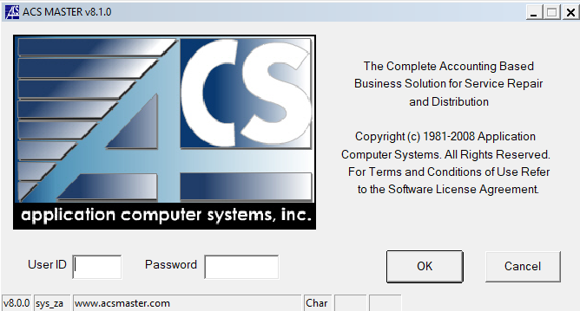

Step 4 – Follow the drop-down menu to “Job Entry/Maintenance”.
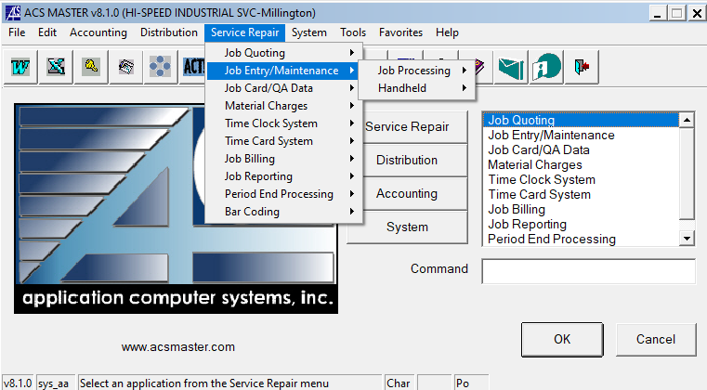
Step 5 – Follow the arrows & drop-down menu to “Job Processing” then “Job Inquiry”. Click on “Job Inquiry”.
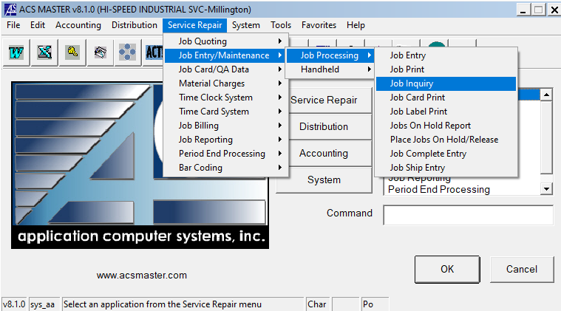

Step 6 – Depending on the Job you will either click “Active” or “History”. Normally “Active” will be clicked & used.
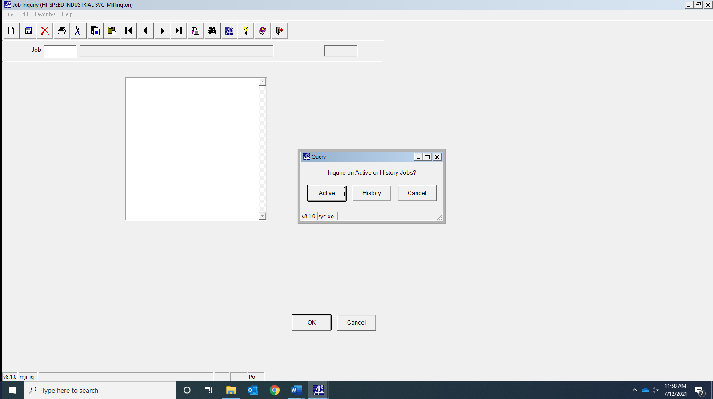

Step 7 – Type in a Job # and press “OK”.
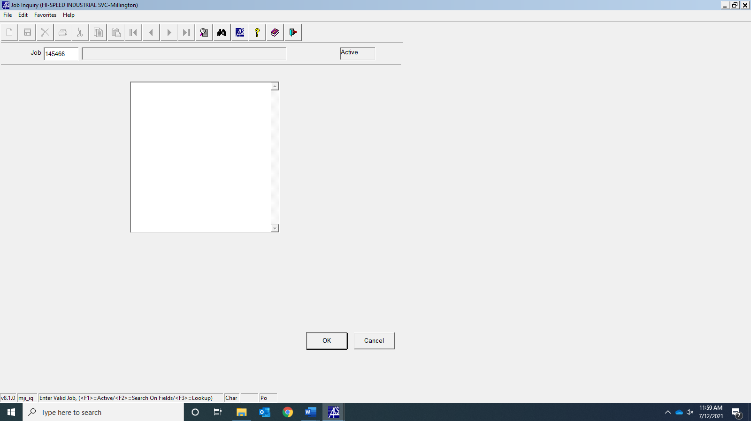

Step 8 – Once the Job is pulled up press “OK”.
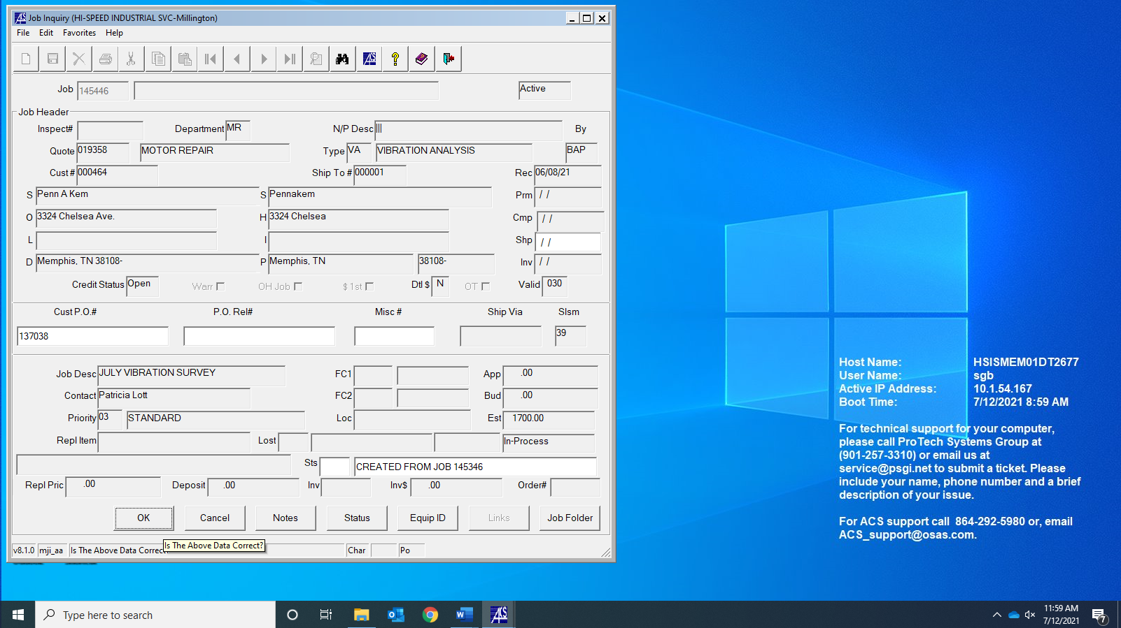
Step 9 – On the menu click on the “Job Cost Detail Report” option & click “OK”.
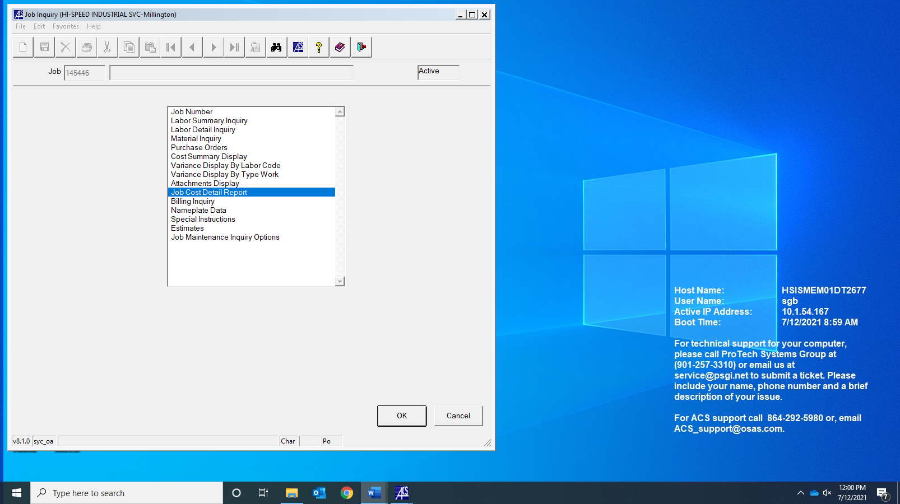

Step 10 – Click “OK”.
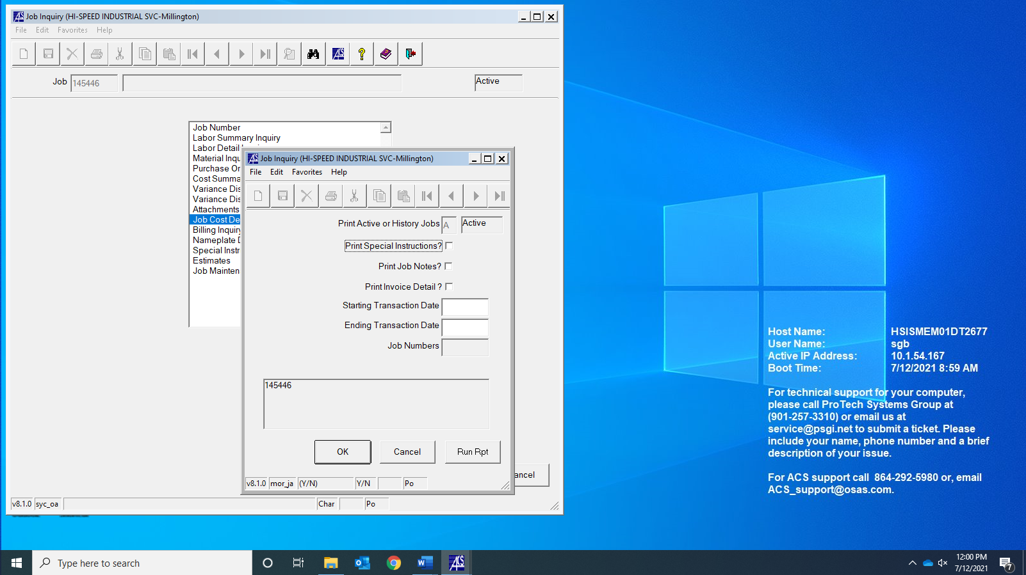
Step 11 – Check to make sure the report has all needed sections. Once this is completed click “PDF” & then click “Execute”.
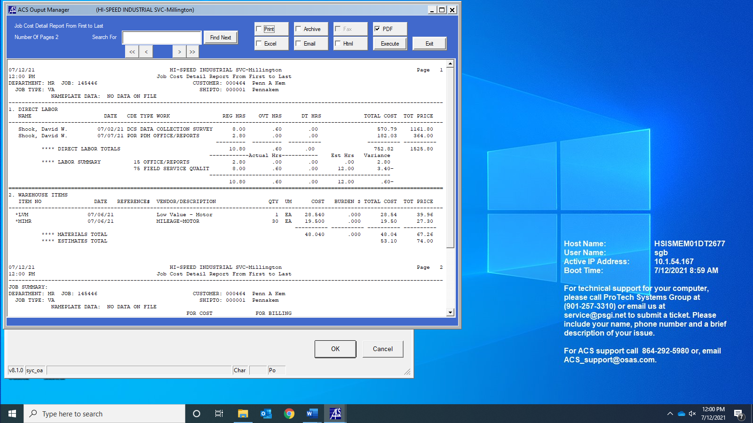

Step 12 – Change File name to Appropriate name & put it into the Appropriate Folder.

Step 13 – Go to the Printing option & click it.
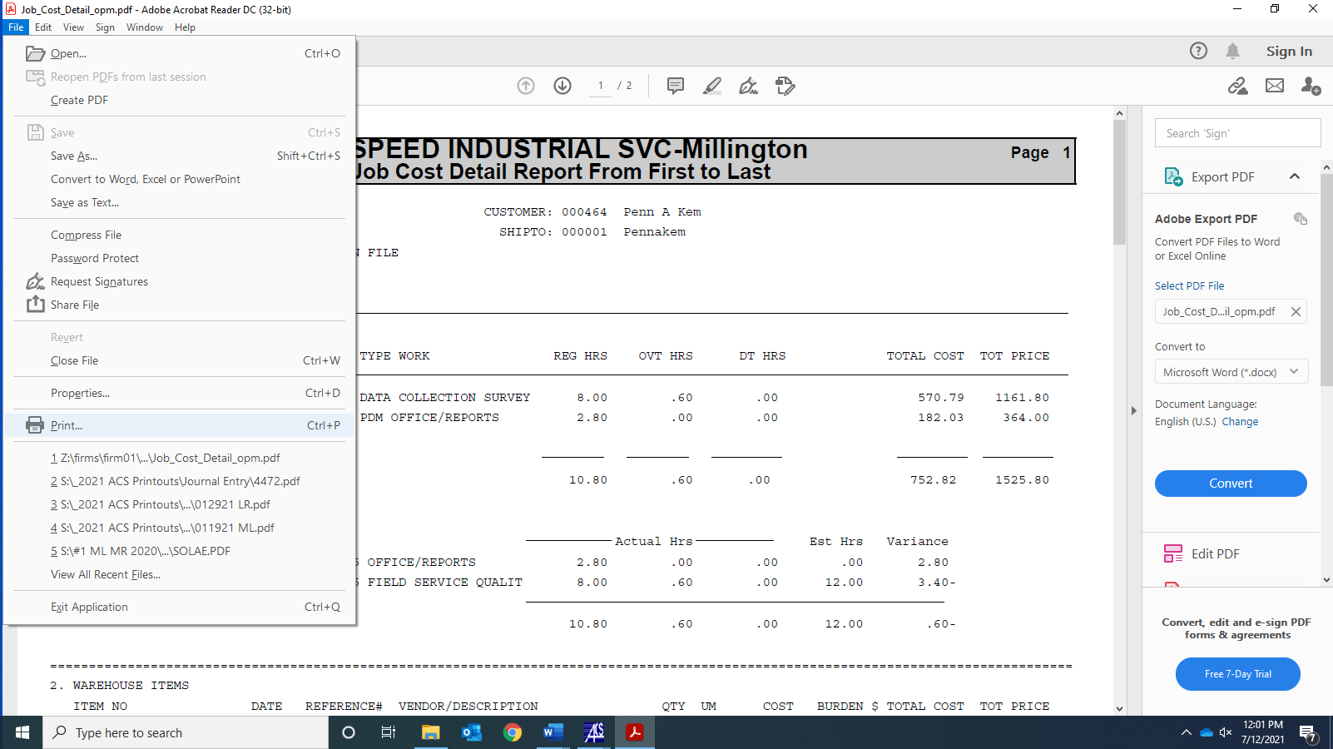

Step 14 – Click on the correct Printer option & print the Job Cost Detail Report.
