**Finalizing Open Jobs**

* **Send inspection reports to customer**
* **Step 1- Log into inspectall**

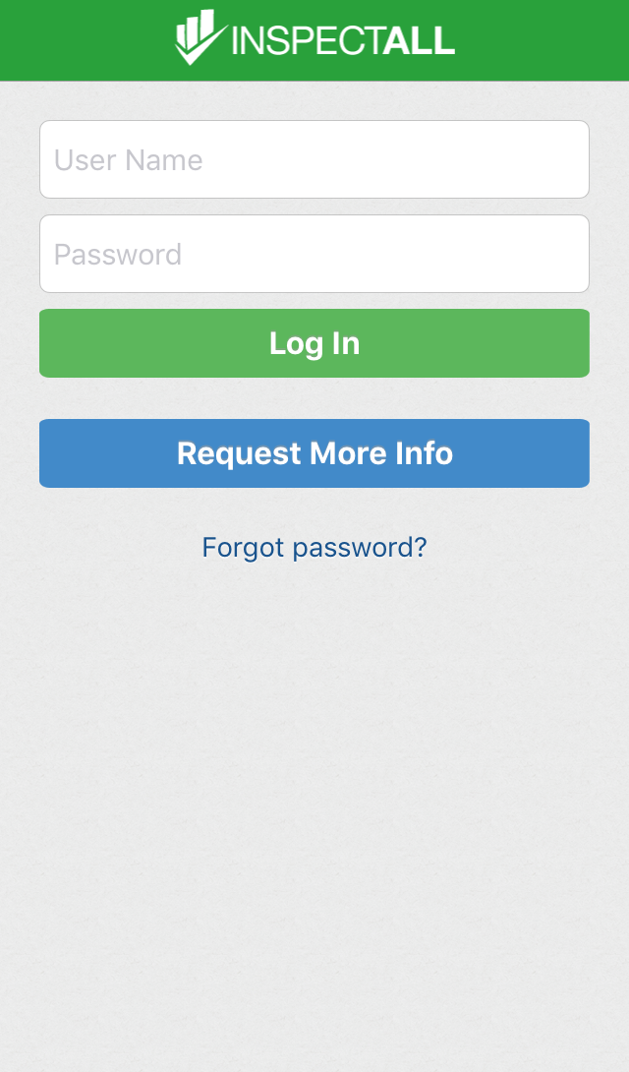

* **Step 2- Type job number into quick search box and click on the job that pops up**

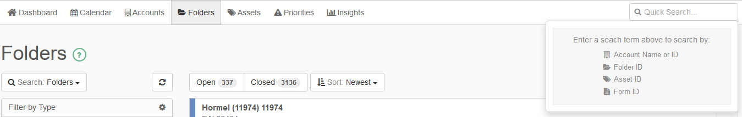

* **Step 3- Proof read inspection/service report for spelling errors by clicking on each blue arrow**
* 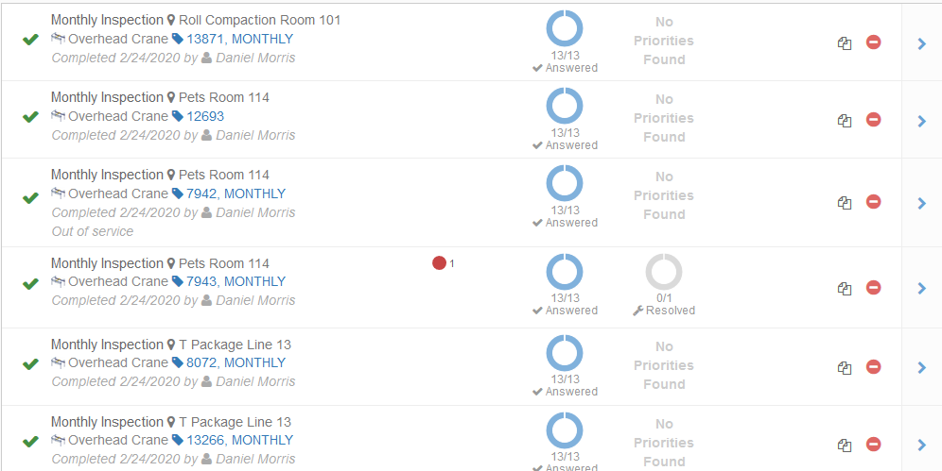
* **Step 4- Print off inspection service report**

**Step 5- Scroll down to inspection service report and click blue arrow**



**Step 6- Click download**

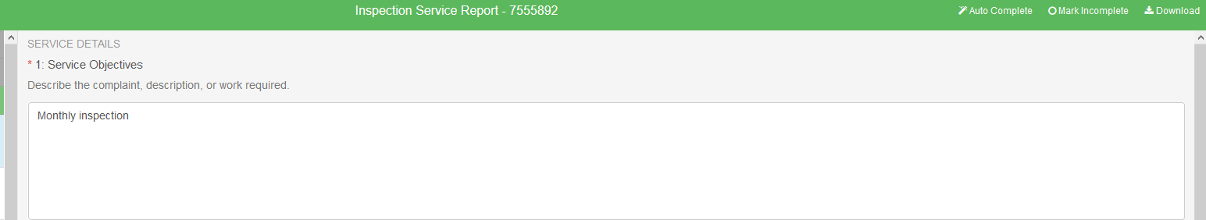

**Step 7- File Format-PDF, download report, print, and put in job folder and click done.**

**Step 8- Mark folder as close**



**Step 9- Click the pencil to change to report type**

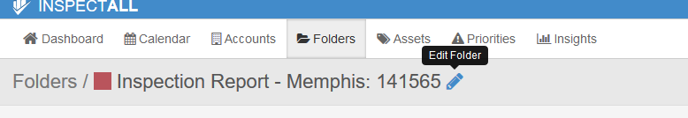

**Step 10- Click on type**

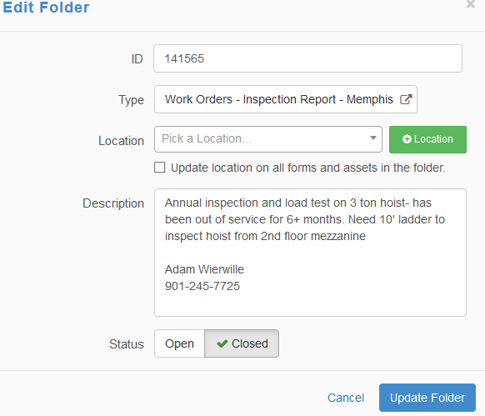

**Step 11- Full Report, done, and update folder**

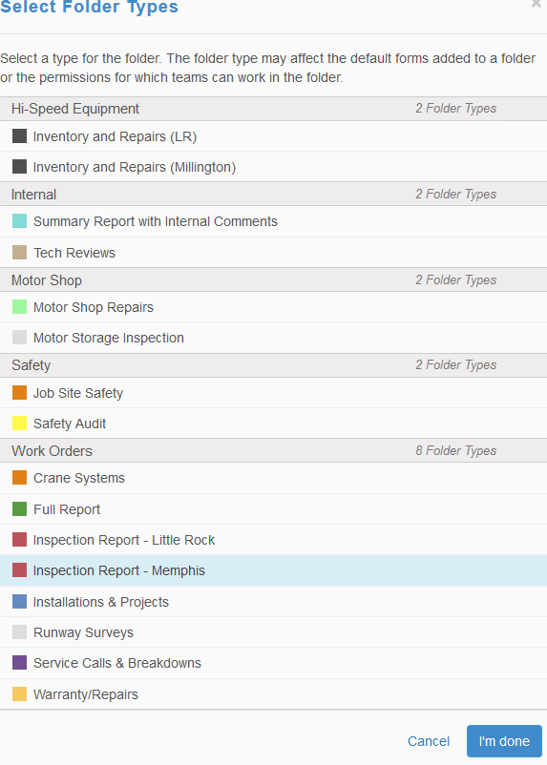

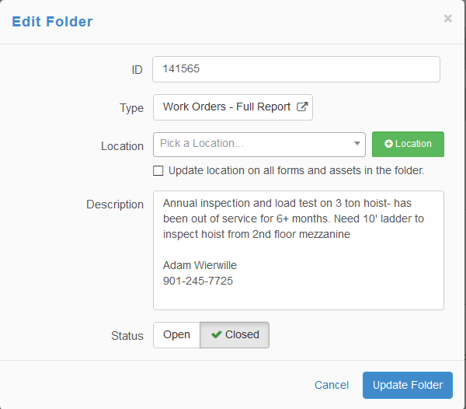

**Step 12- Download report**



**Step 13- Click asset ID1**

**File Format- PDF**

**Report Type- Standard Report w/ certificate**

**Then download report**

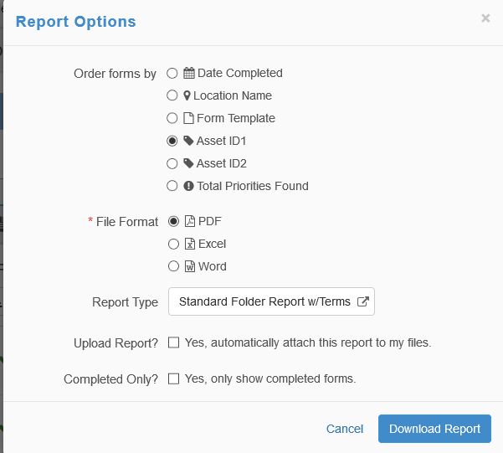

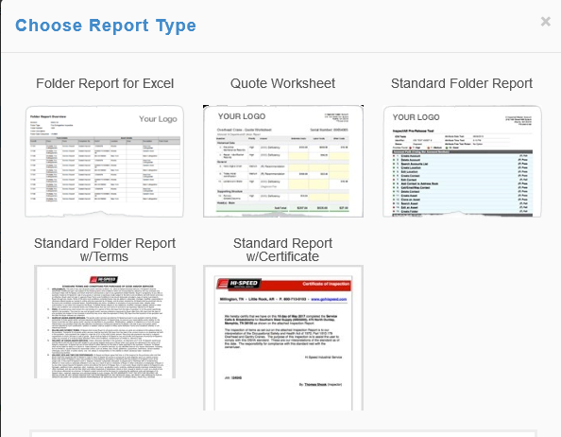

**Step 14- Click ok to open the downloaded file**

**Step 15- Click file**

* **save as**
* **Shared Drive (S Drive)**
* **scroll down to hoist inspection backup file**

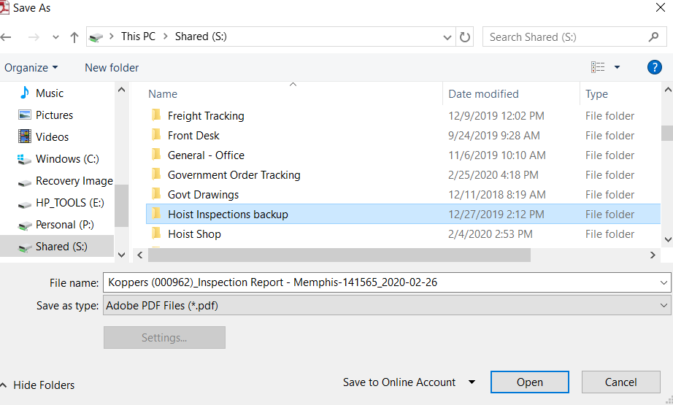

* **Find the year if the inspection and click on folder**
* **Find the first letter of the customer and double click**

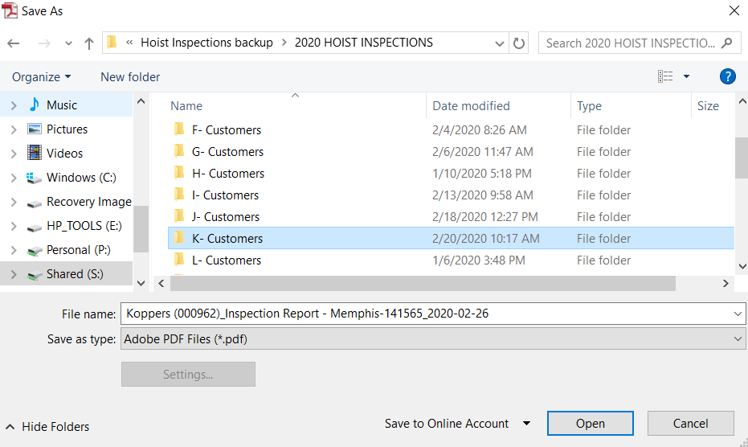

* **Scroll down to customer and double click to save**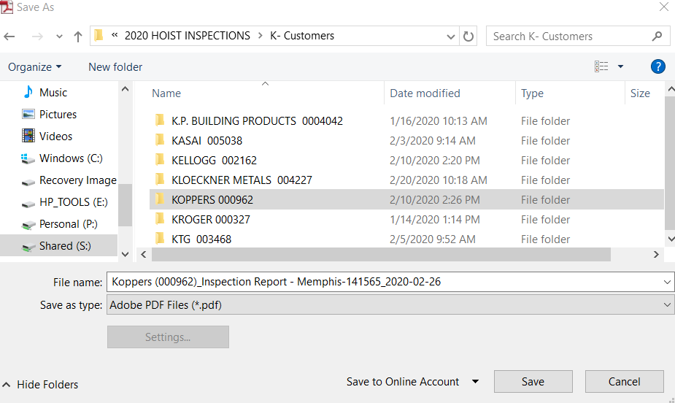

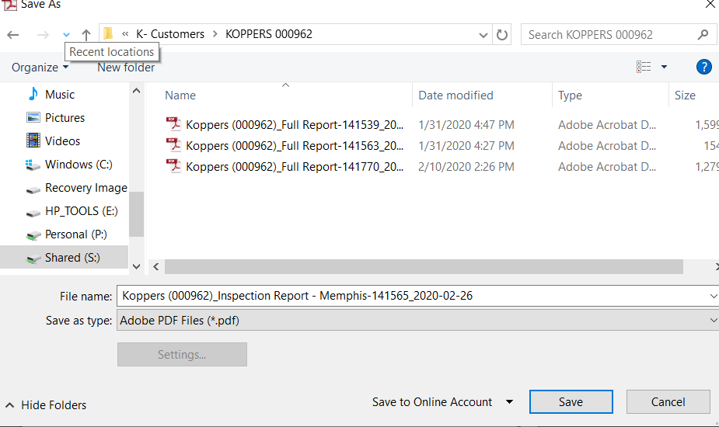

* **Step 16- Send Full Report to customer**

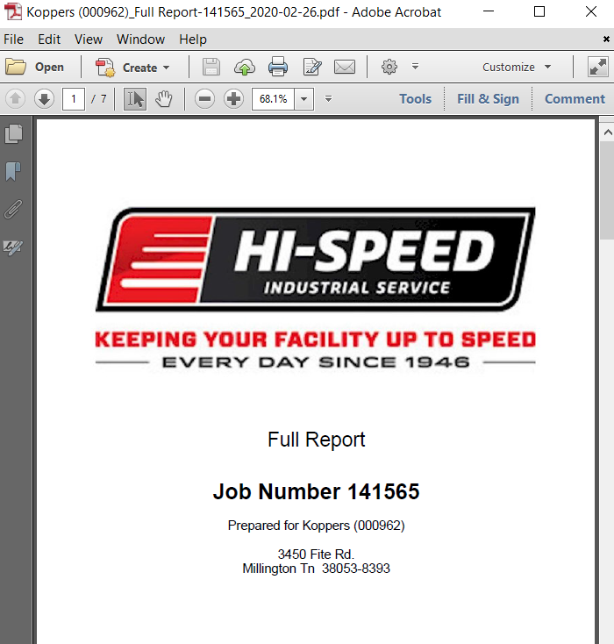

* **File**
* **Send File**
* **Send full inspection report to contact from job folder, outside salesman, hoist service superintendent, and coordinator.**
* **Subject Line (Monthly, Quarterly, Semi-Annual, or Annual inspection)**
* **Body- Dear (Customer)**
* **Please see attached inspection report from the most recent**

**(monthly, quarterly, semi-annual, or annual) inspection.**

**RAI Procedure**

**Step 1- Log into inspectall**



**Step 2- Type Job number into quick search box**



**Step 3- Click on the pencil**



**Step 4- Click on type**



**Step 5- Click on summary with internal comments**



* **Click done**
* **Update folder**

**Step 6- Click download report**

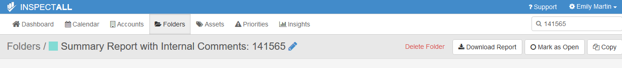

**Step 7- Click asset ID1**

* **File Format- PDF**
* **Report type- standard folder report**
* **Download report**
* **Print report**
* **Keep the top pg (Summary Report w/ Internal Comments)**
* **Keep everything that has the red dot which means 3-high important**

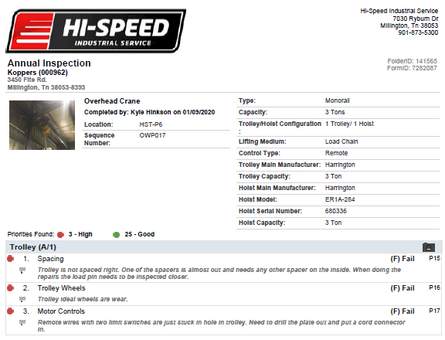

**Step 8- Log into ACS**

**Step 9- Click on job quoting**

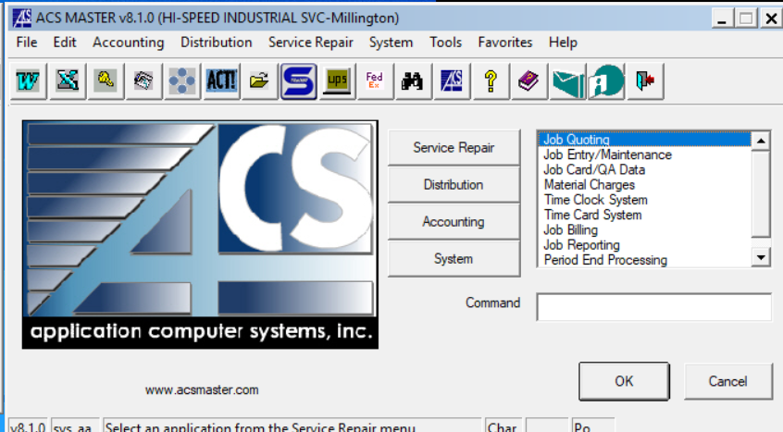

**Step 10- Click on quote entry maintenance**

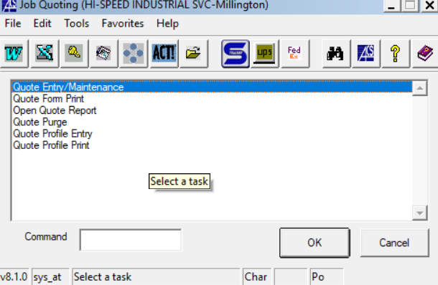

**Step 11- Right click in quote box**

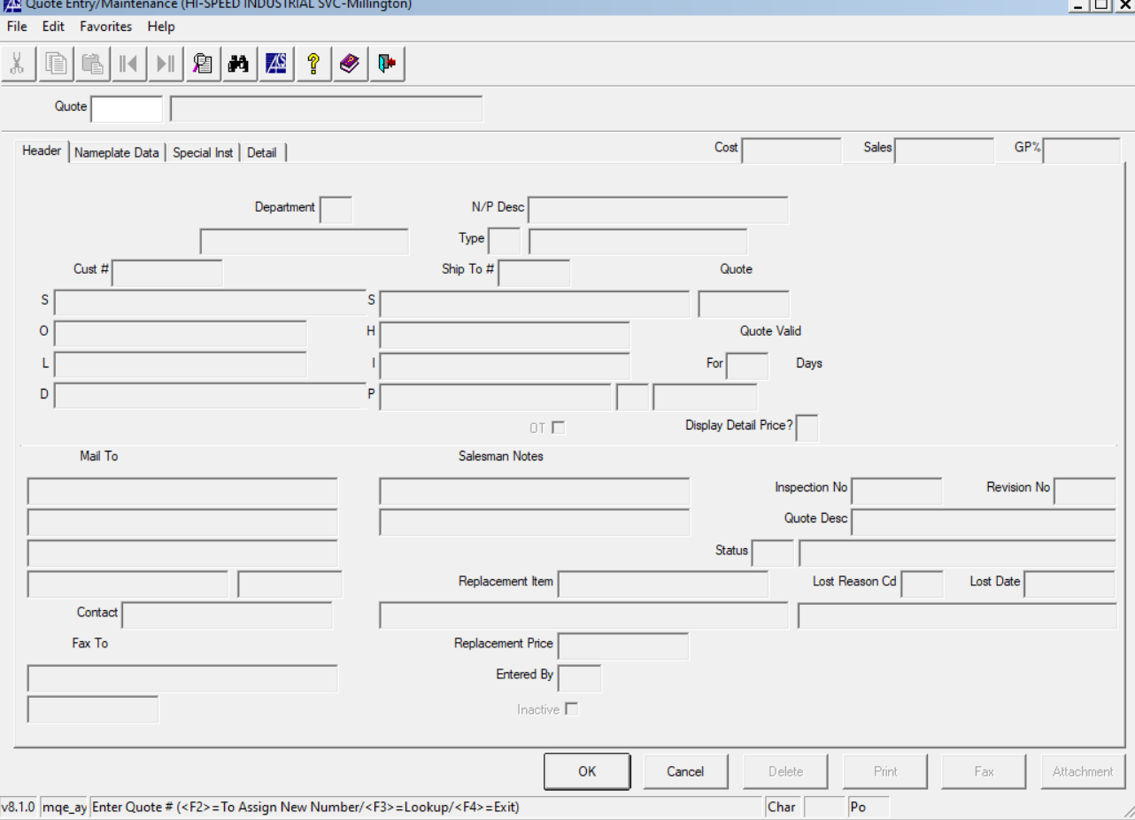

**Step 12- Assign new number**

**Step 13- Write the quote number on the deficiency report from inspectall**

**Step 14- All white boxes will need to be filled by right clicking in box**

* **Cust #**
* **Department**
* **Type**
* **Ship to #**
* **Mail to- will be the customer contact**
* **Quote Desc- RAI (monthly, quarterly, semi-annual, or annual) inspection**

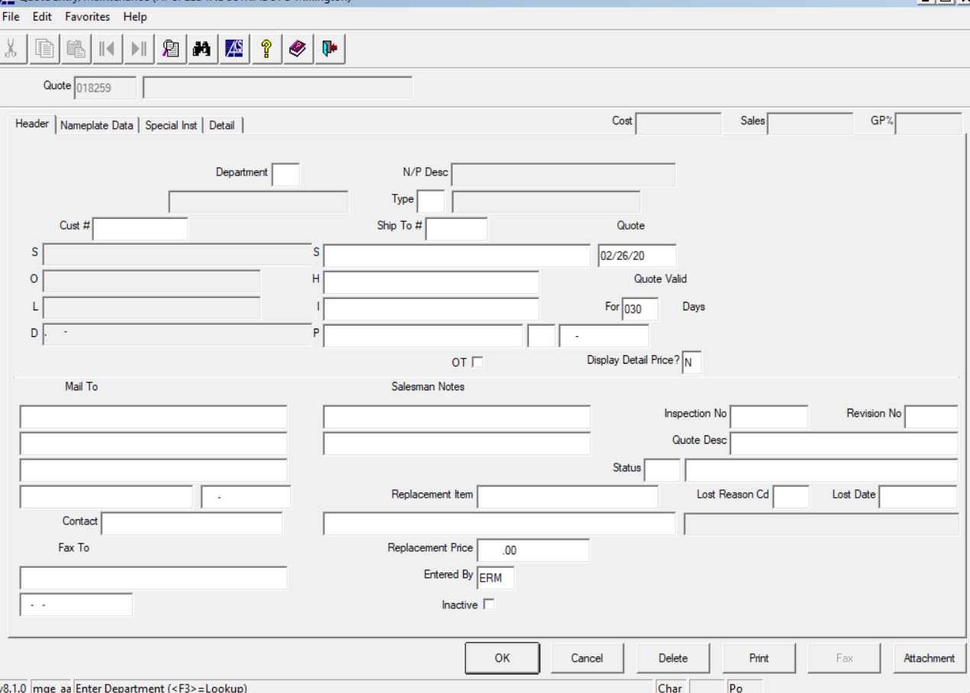

**Step 15- Click on Special Instruction tab- same as the quote desc**

**Step 16- Click on Detail tab**

* **A box will pop up and ask if you want to add or edit the repair description- click no- and then click ok**

**Step 17- Log into CRM**

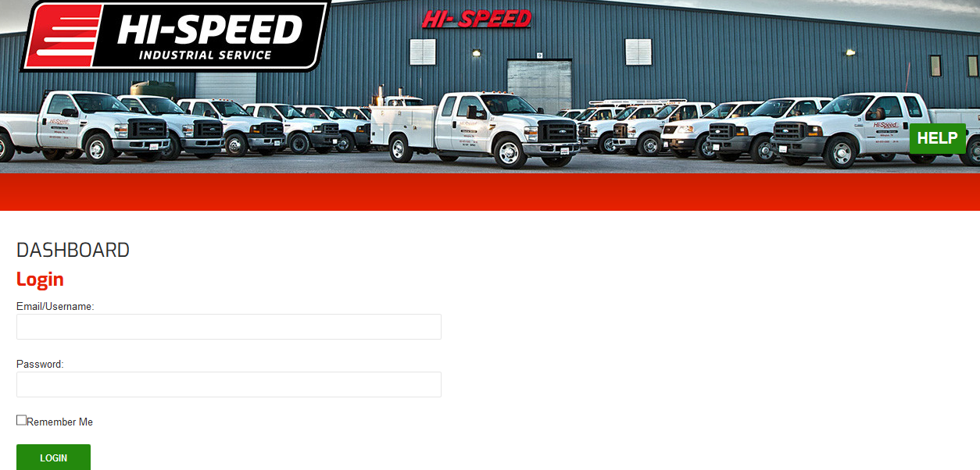

**Step 18- Click on reports**

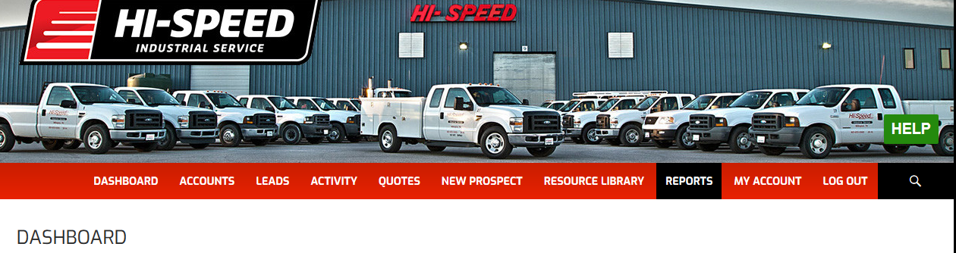

* **Select a report**

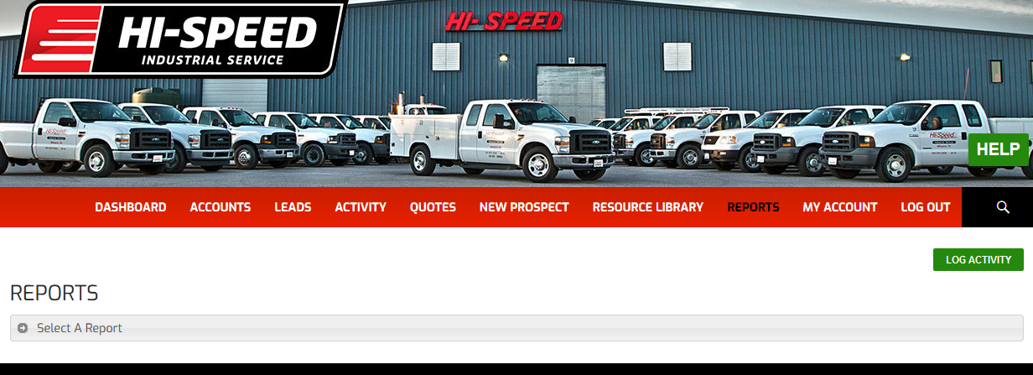

* **Click on HR RI Process**

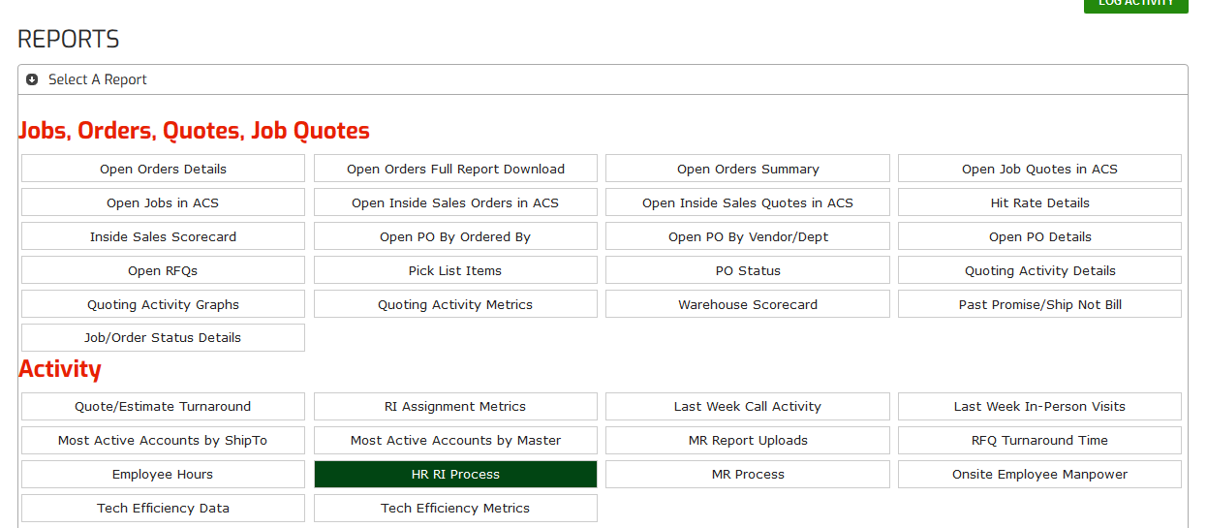

**Step 19- once the repairs are ready to be assigned to a team member for quoting parts click on created for the correct location**

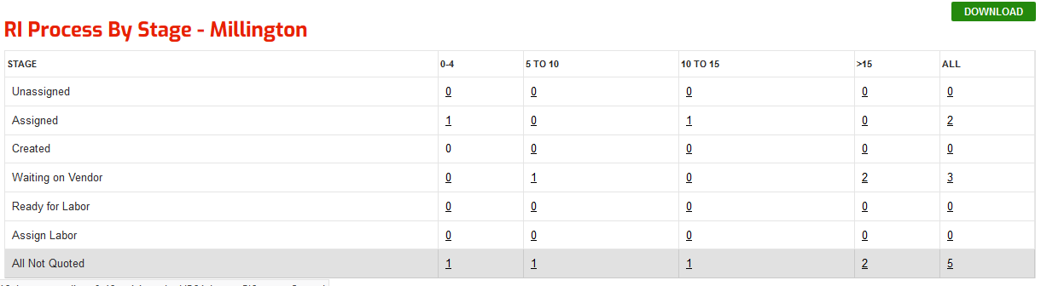

**Step 20- In the column Last Status, click assign**

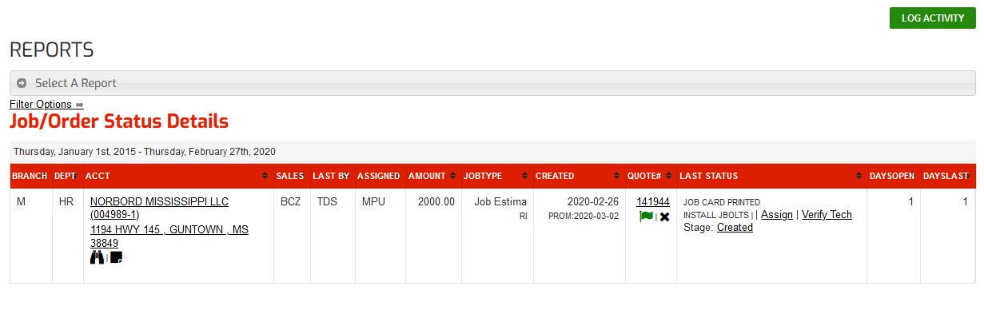

**Step 21- Click in the box all users, pick from the drop-down menu and set the priority of the repair**

