Creating an Inspection folder in InspectAll

John Harmeier

STEP 1: Open and log into InspectAll on your browser

STEP 2: Select the “Calendar” tab at the top of the window.

STEP 3: Click on the corresponding date and user box to open the following pop-up, and select “Create New”

STEP 4: Select “Inspection Report – [LOCATION]”

STEP 5: Enter the account that the Job is for using the name or account number.

STEP 6: Create a not in the “Note” section including if a lift is needed, what type of inspection, and who the contact is and their email/phone. It is good practice to ensure that the date is also correct in this window.

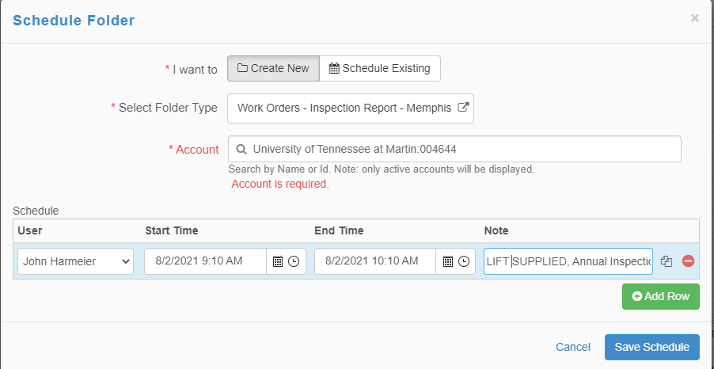

STEP 7: Select the save schedule button. The job should appear on the calendar under the correct date and next to the appropriate user.

STEP 8: Click on the job and add to the “Job Description” the type of inspection, if a lift is needed and what size, and the contact’s name and information.

Lastly, adjust the job number on the folder to match the job number in ACS by clicking the blue pencil.

You have now created a folder in InspectAll!

Congratulations!