**Dispatching Proceedure in Comet**

**By: Justin Joy**

**Department of Hoist Repair & Crane Systems**

Step 1 – Log in to Comet software using your username and password

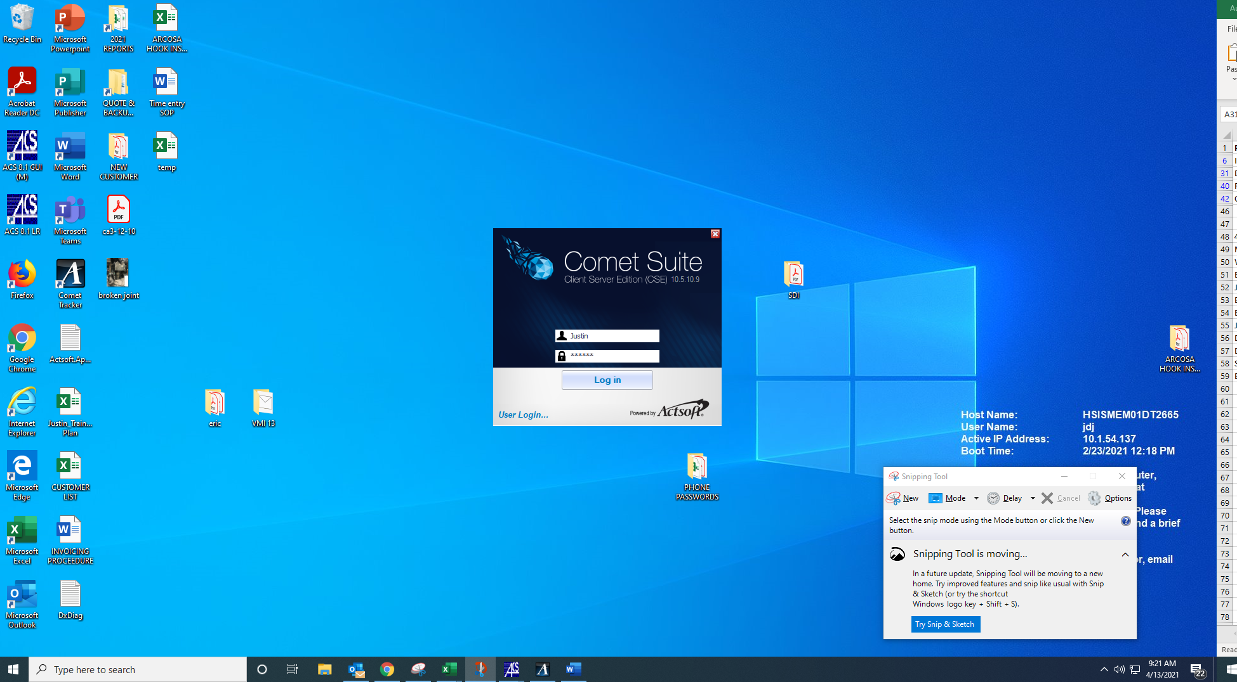

Step 2 – Select “Orders & Dispatching”. The options associated with this tab will pop-up on the left-hand sidebar.

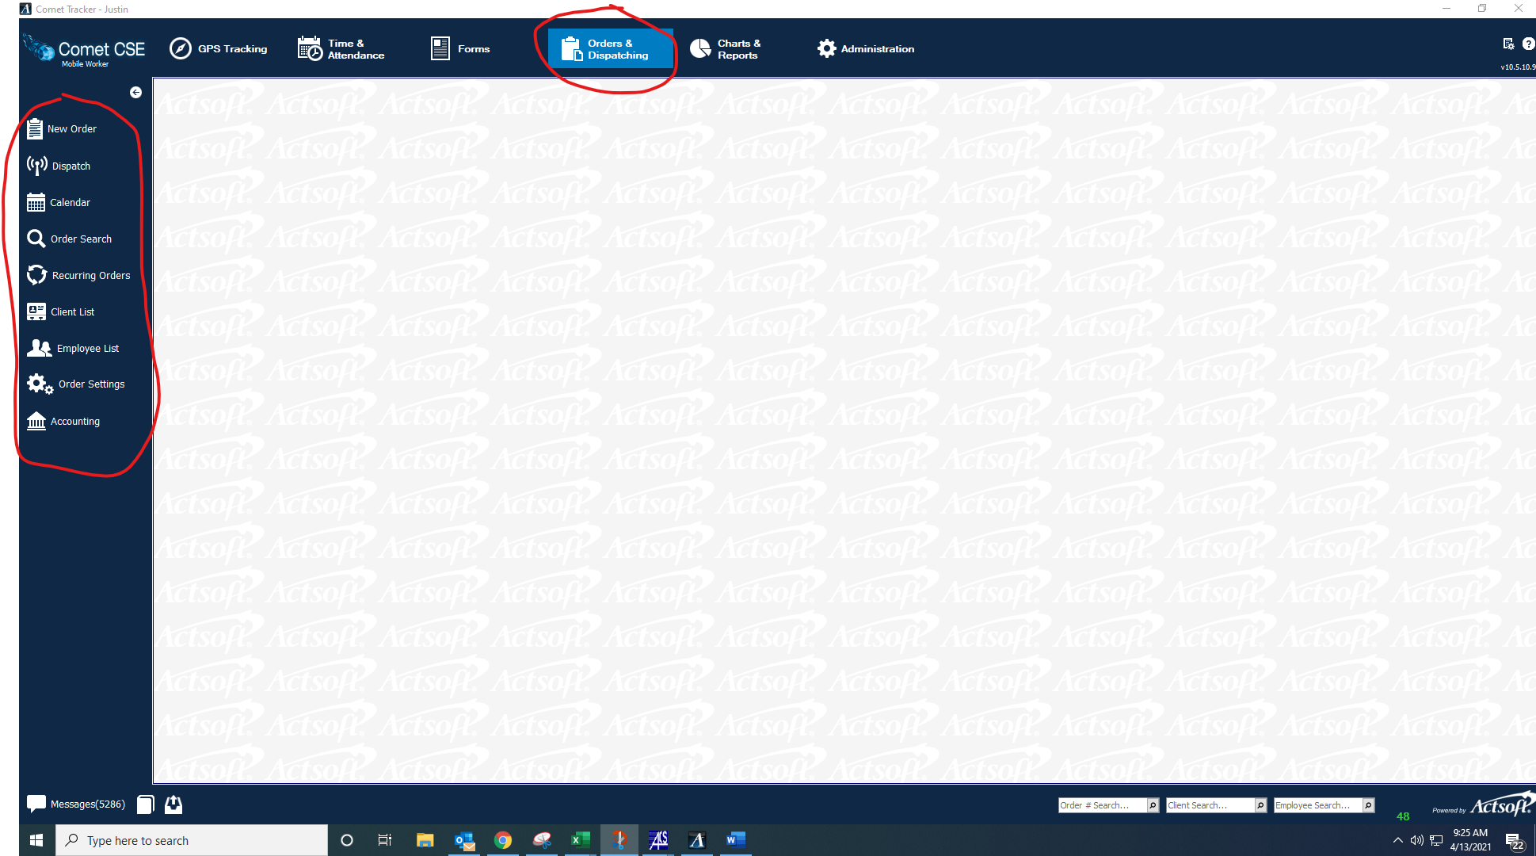

Step 3 – Select “New Order” to create a new dispatch

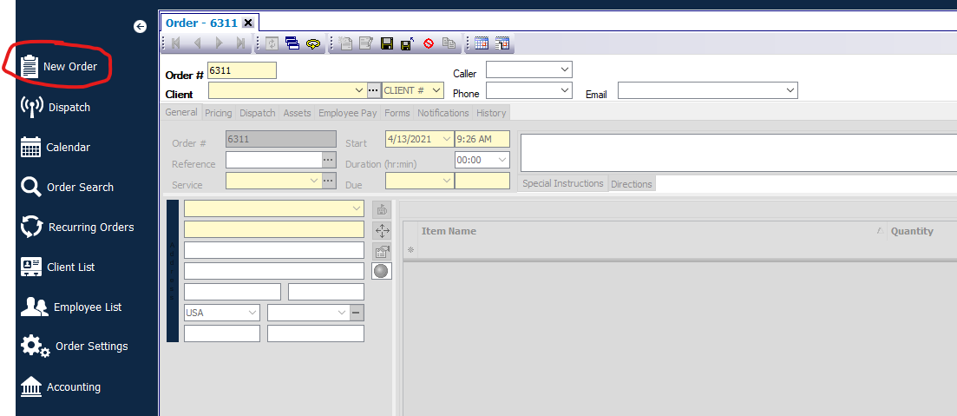

Step 4 – Fill out or select the information needed for the job.

This includes:

* Order# (job number goes here)
* Client (Customer name goes here)
* Service (type of job you are creating)
* Caller/Phone/Email
  + This is the job contacts name/phone/email
* Employee (the employee being assigned to the job)
* Vehicle type (Type of lift if needed)
* Special Instructions
  + This should include the job scope, # of assets, hours assigned (if the job is quoted) and if any additional materials are needed to complete.

If the job is T&M, that info should be relayed in the dispatch.

If the job is quoted for straight time only, relay that in the dispatch as well.

* Start & Due Dates (The time the job will start and the time the job is due to complete)

The picture below shows what it should look like when all information has been filled out.

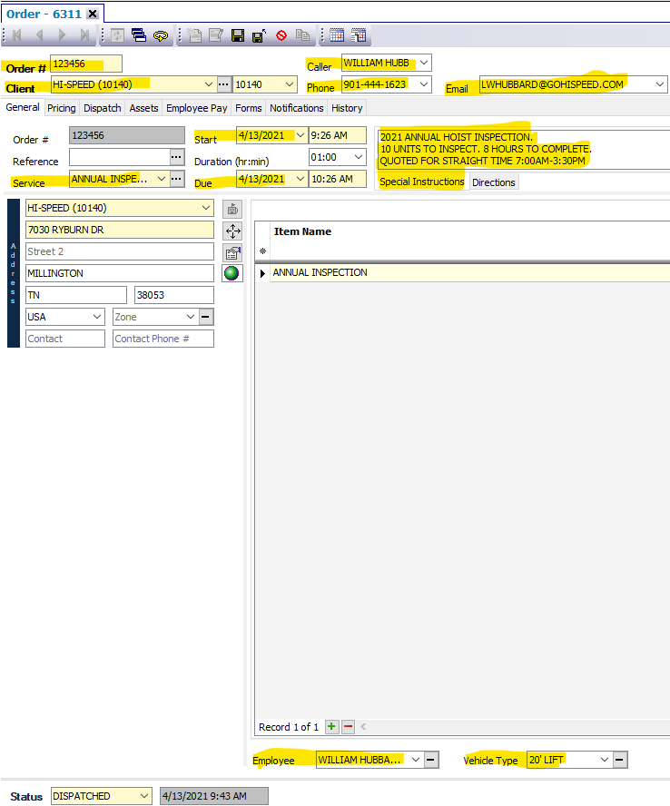

Note: The address info will automatically populate when a client is selected. This info needs to be verified before dispatching the user.

Step 5 – Once all necessary information has been added and verified, click the CD icon to save the dispatch. This will send the dispatch to the selected employee.

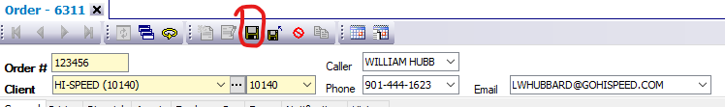

Step 6 – As a check you can click the dispatch button on the left-hand sidebar to lookup your created dispatch

