**Closing Inspection Reports & Sending to Customer**

**By: Justin Joy**

**Department of Hoist Repair & Crane Systems**

Step 1 – Log into inspectall

In your web browser, go to <https://app.inspectall.com/v4/#login>

Enter your email and password to proceed

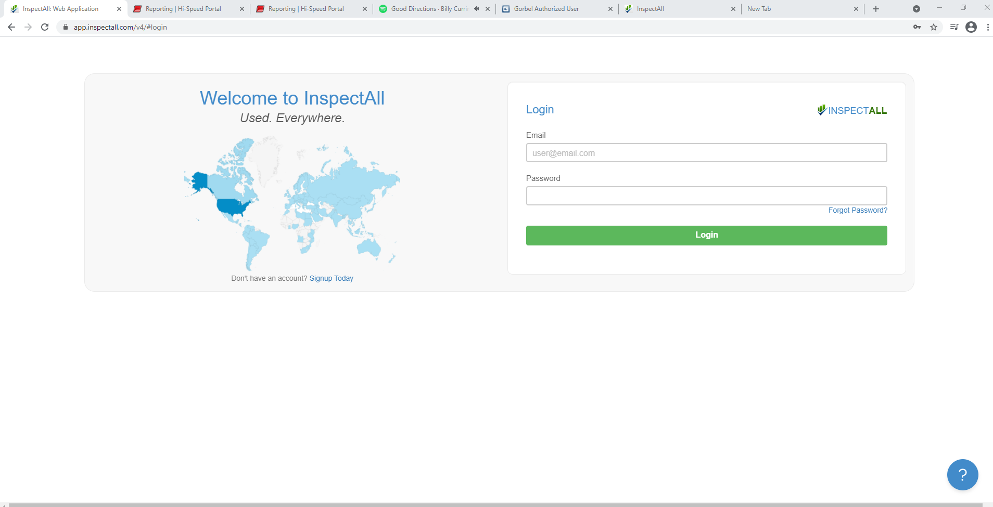

Step 2 – Enter the job number of the completed inspection in the “quick search” bar near the top right-hand side of the page

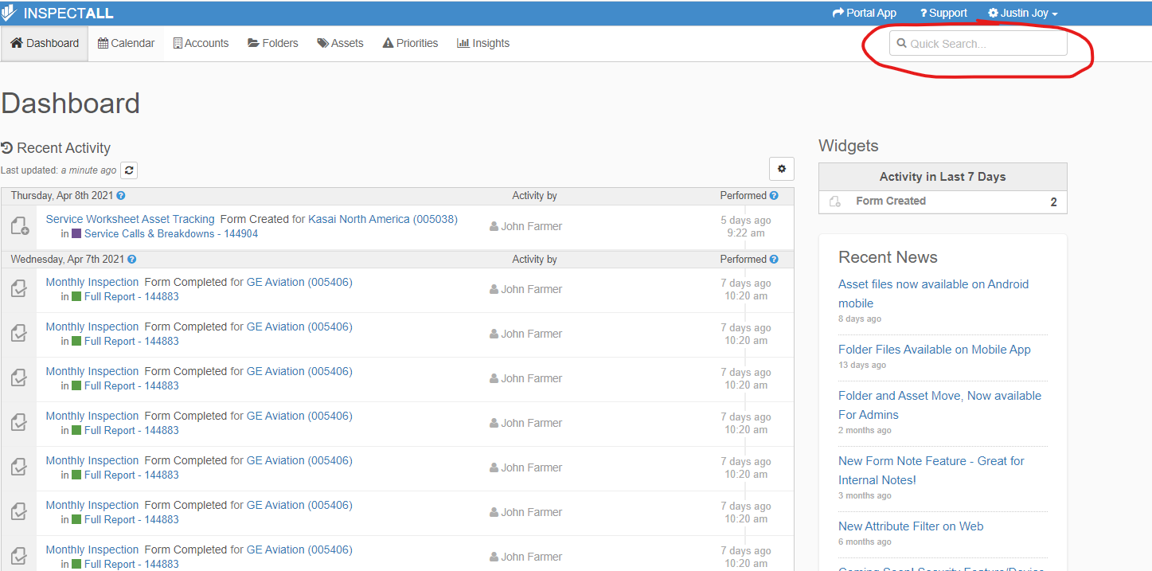

Once you type in the job number you might have to click once in the quick search bar for the drop down menu to appear where you can select the job number you just typed in.

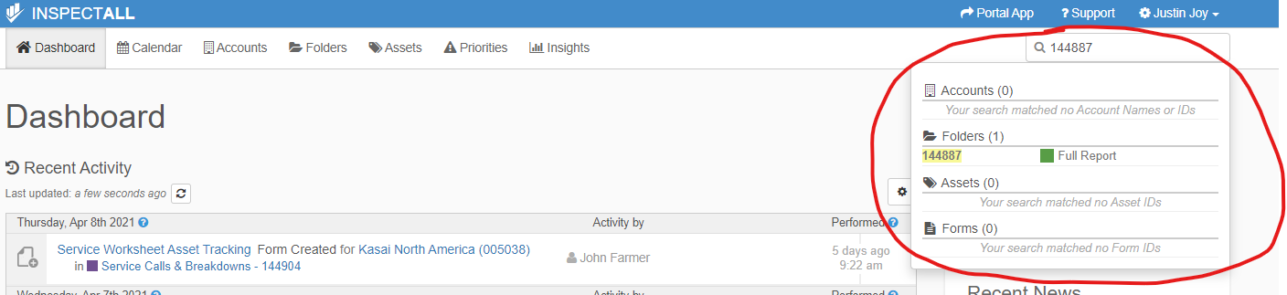

Step 3 – Closing the job folder

From here you want to close the report.

To do so, follow the steps below:

* click the pencil icon next to the job number

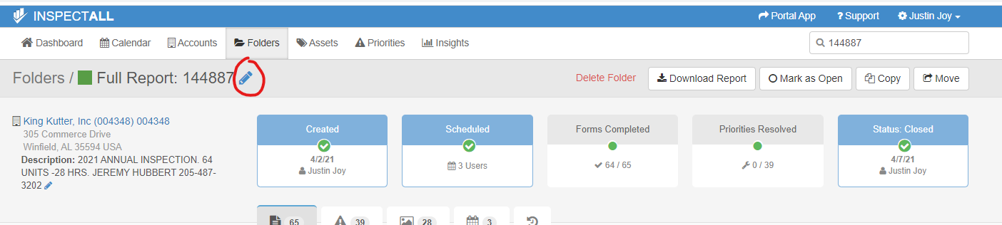

* click “type” and select “full report” then click “im done”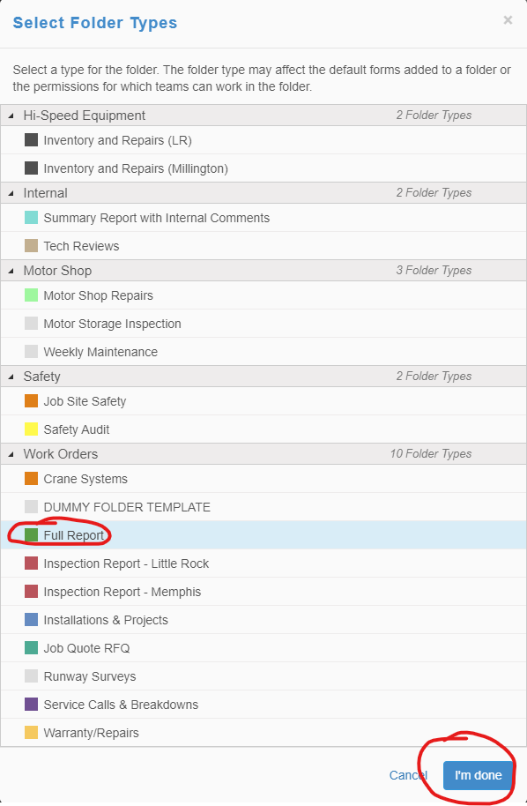
* Next, click closed to change the status to closed. Then click update folder to save your changes

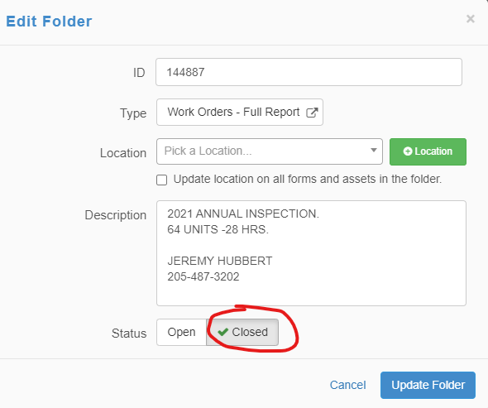

Step 4 – downloading the inspection report to send to the customer

From the inspection folder page, click download report

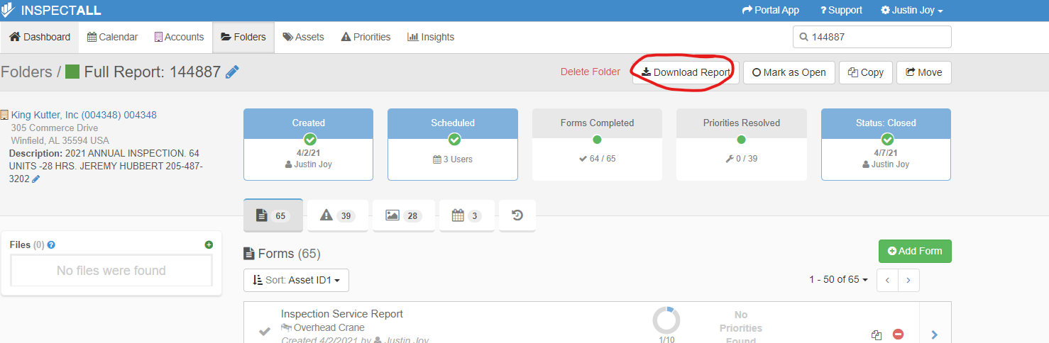

Next you will want to select “Asset ID1”, “PDF”, and “Standard Report w/Certificate” from the report type drop down menu. Then click “download report”

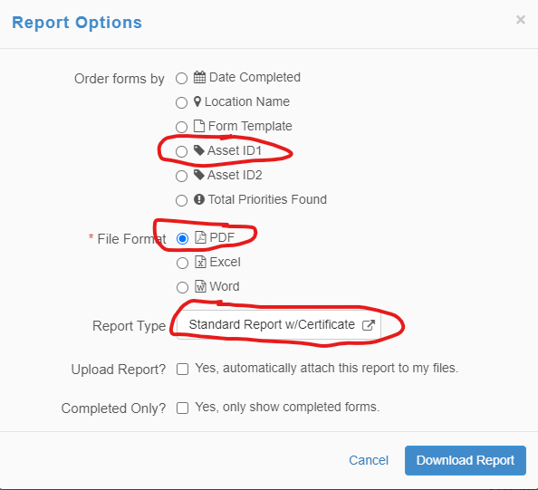

Once your inspection report has been downloaded, you’ll want to save/copy the file to 2 different locations.

1. Save to **S:\Hoist Inspections backup\2021 HOIST INSPECTIONS**
   1. From the location above youll need to manually navigate to the customer folder. They are all alphabetized

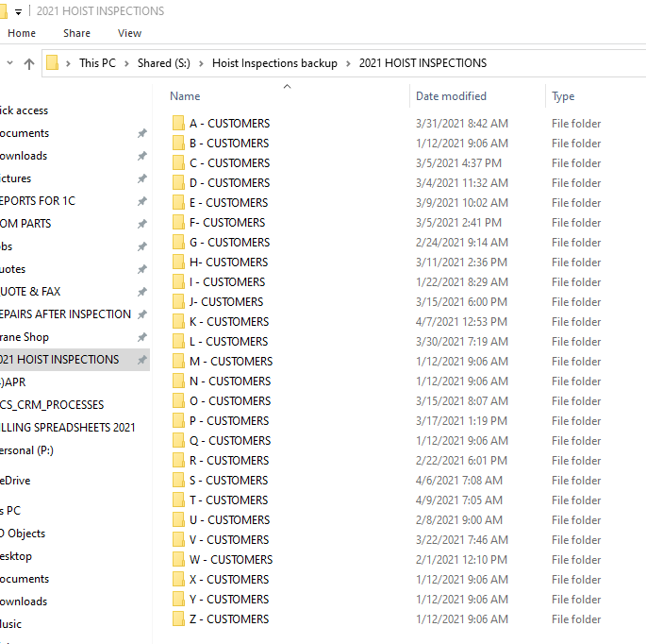

1. **Z:\firms\firm01\images\jobs\”Inspection Job #”**

Step 5 – Sending the inspection report to the customer

Once the inspection report has been saved in the inspection backup file and the job folder, you can attach the inspection report to an email and send to the customer.