INVOICE PROCESS
By John Harmeier

STEP 1: Open the “HR Billing Checklist” found at S:\Hoist Shop\2021 BILLING
*NOTE* It is recommended to save this to personal drive to have easier access.
STEP 2: Use the checklist to follow the steps, marking an “X” after checking each section.
STEP 3: “External Folder Information” will be the physical folder, which should have each item on the front.
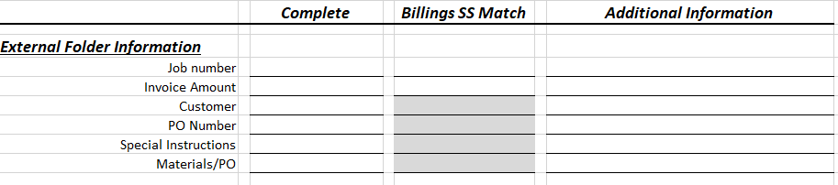
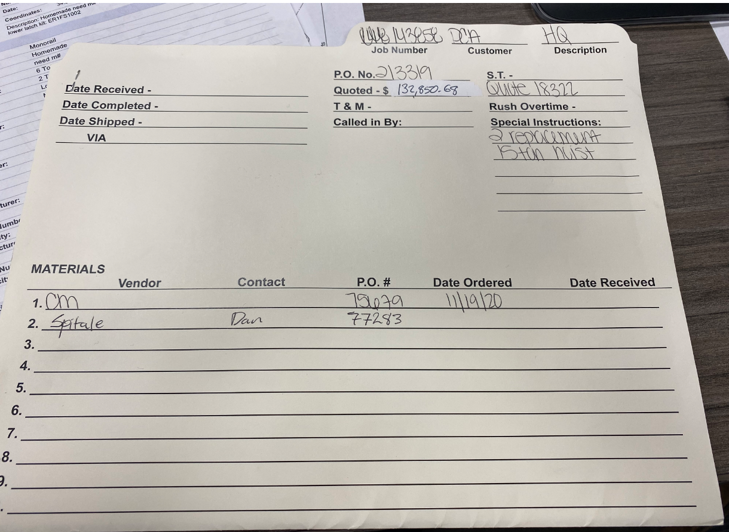
STEP 4: The next section will be the “Back-up Documentation” section. This section refers to the physical papers inside the folder. This should include hard copies of the Customer PO, Vendor PO, Billings Spreadsheet, Service Report, Job Cost Detail Report, Hi-Speed Quote to Customer, Customer Approval to Invoice (Email), and a Signed Delivery Ticket.
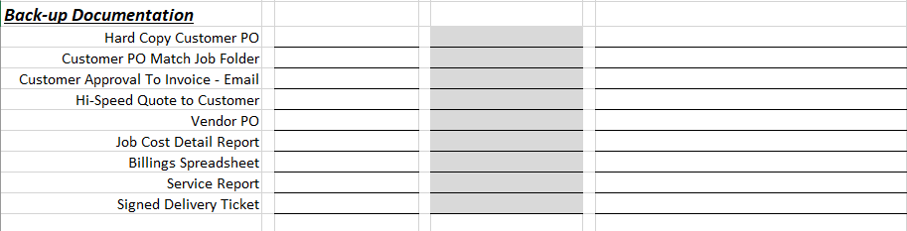
STEP 5: Open ACS, then open the job (Job Entry/Maintenance>Job Inquiry> *Active*> *Enter Job Number)
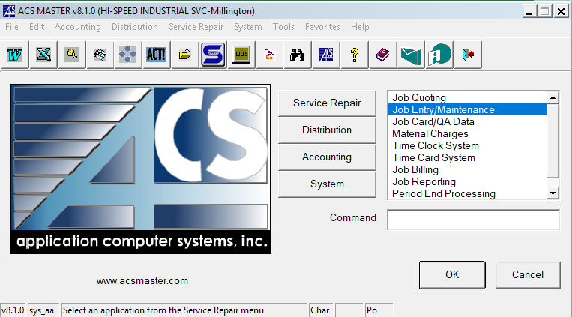
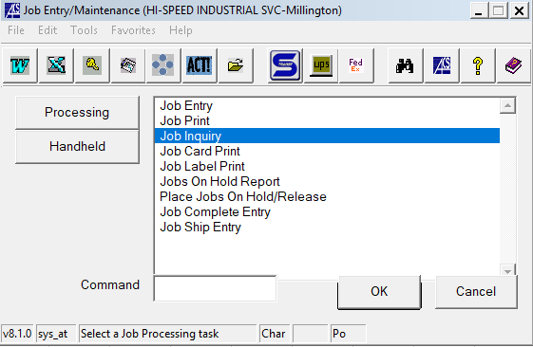
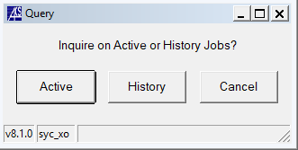
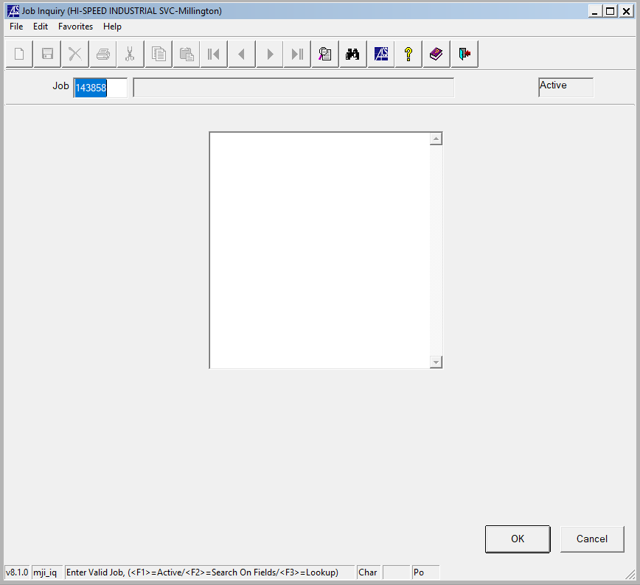
STEP 6: Press “OK” and “Job Cost Detail Report” on the next window.
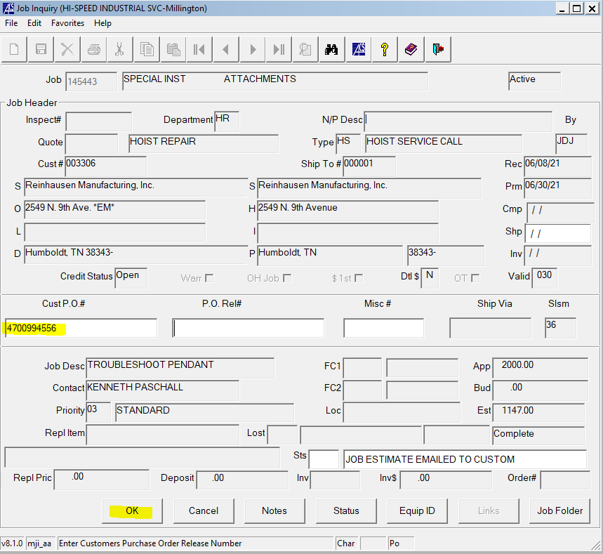
STEP 7: Fill in the “Cust P.O.#” box with the customer PO found in the folder (if it is not already there).
Press “OK” again and the report will populate in the next window.
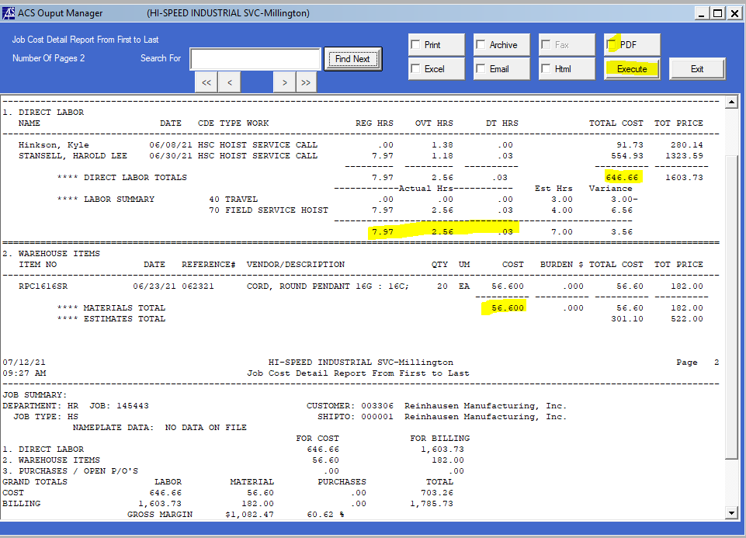
STEP 8: Open the “Billing Spreadsheet - Original” with path S:\Hoist Shop\2021 BILLING.

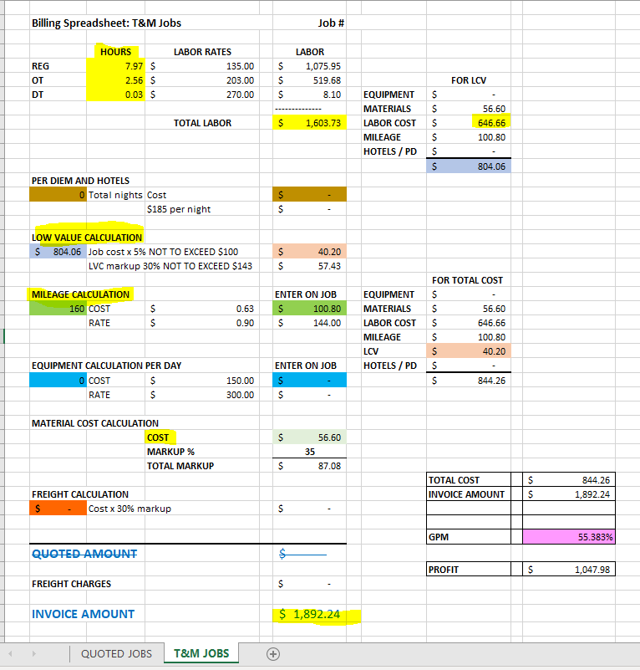
For T&M Jobs, use the T&M Jobs tab at the bottom of the excel sheet.
First thing you need to do is enter the job number circled near the top of the worksheet and save the worksheet in a file labeled “billing spreadsheets 2021” that may or may not have already been created under your personal cp hard drive.
Pulling from the Job Cost Detail Report, enter the hours (REG/OT/DT), the material cost in the light green box under “Material Cost Calculation”, the mileage cost in the green box under “Mileage Calculation” (This is calculated by mapping to the location), for “Low Value Calculation” enter the value in the blue box on the right in the blue box on the left (In this case $804.06), if there is any equipment used from Hi-Speed enter the number of days it is used in the bright blue box under “Equipment Calculation Per Day”, and to add the per diem, if necessary, enter the total number of nights in the brown box under “Per Diem and Hotel”, then add the hotel costs in the brown box to the right.

If you have any freight costs enter them in the orange box next to freight near the bottom of the worksheet.

For quoted jobs, include the quoted amount next to “Quoted Amount”.
The Invoice amount in automatically calculated and displayed at the bottom of the spreadsheet.

STEP 8: Put the material charges on the job. This is for stock items only. Accounting & Warehouse Ops are supposed to receive and apply materials that are ordered non-stock.
Go to the ACS main window, select Material Charges>Material Charges Entry> and enter Job Number, warehouse 01 (for stock), and your initials in caps under the reference box.
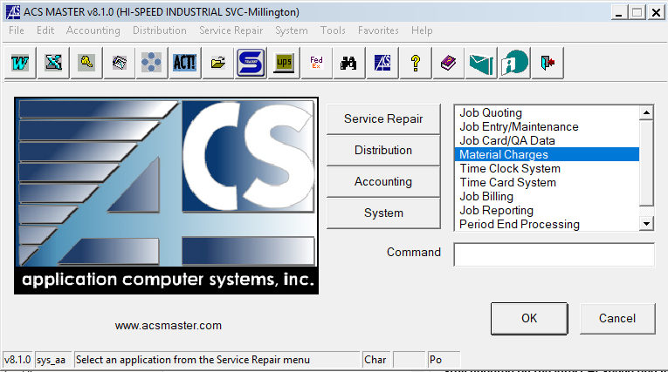
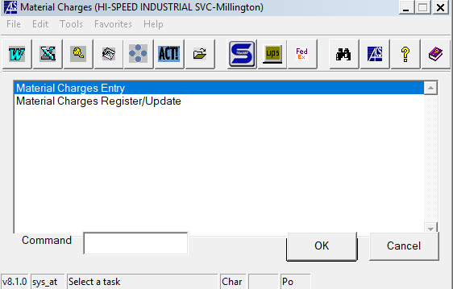
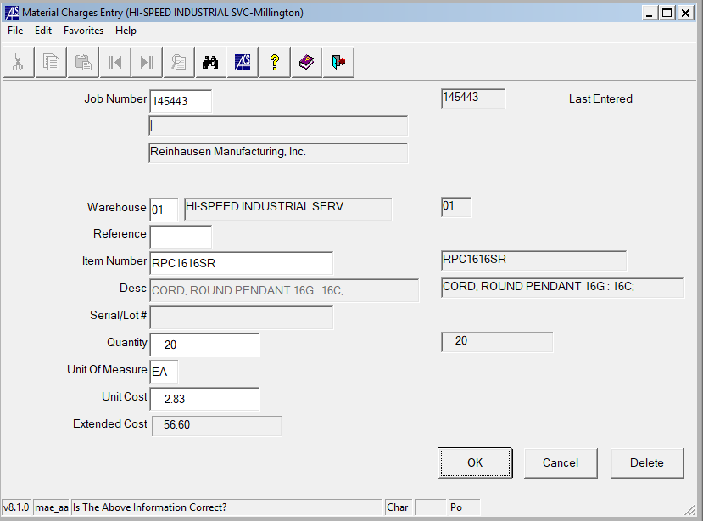
The information to fill in this window is found on the Job Cost Detail Report. Include the Item Number and Quantity. The item cost will self populate after this and cannot be changed. It is important to check the warehouse item cost against the cost given by the vendor because sometimes they can be different.
Use this same process for including Material Charges such as Low Value Cost, Per Diem, Mileage, and Equipment (For hoist repair). Each uses its own code in the Item Number box.
**To search through the codes click on the Item Number box and press F3.
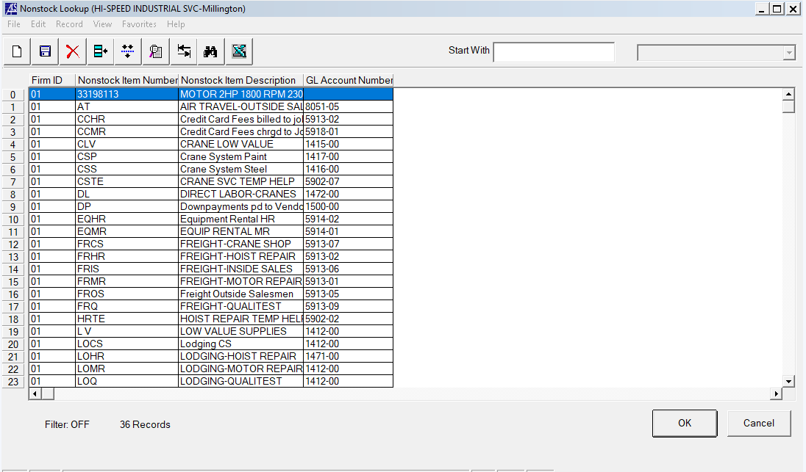
STEP 9: Register the material charges and update the job cost detail report.
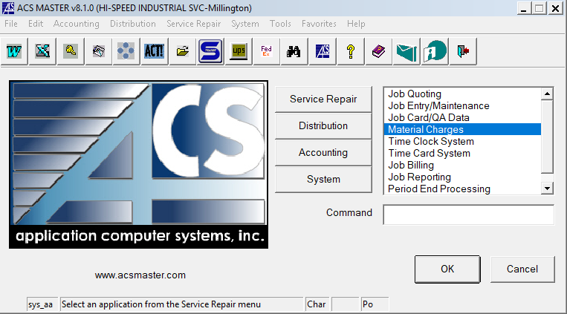
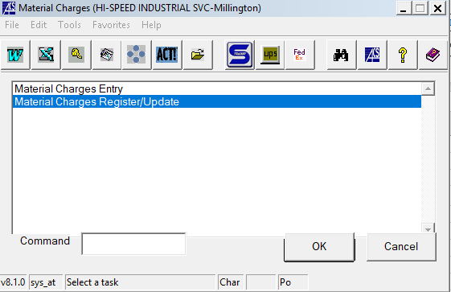
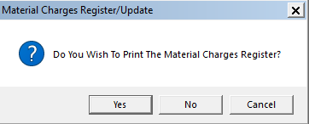
Select “Yes”
Then, select PDF and Execute to open the Material Charges Registration/Update Report
Save this pdf to “S:_2021 ACS Printouts\Material Charges”
- Make the filename the audit # found on the top right of the pdf
- Do not include the first 2 zeros of the audit number in the filename
Then, select exit and “Yes” to apply the updates to the job.
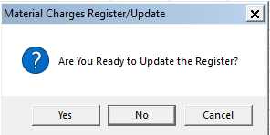
STEP 10: Reopen the Job Cost Detail Report and ensure the updated material charges are included.
The Job Cost Detail Report should match the Billing Spreadsheet.

STEP 11: (T&M ONLY) Create Delivery Ticket
On the ACS main window, select “Job Billing” in the Service Repair section.
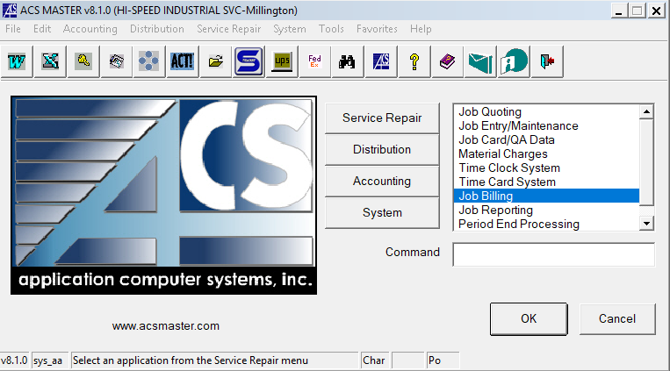
On the next window select “Delivery Ticket Entry”
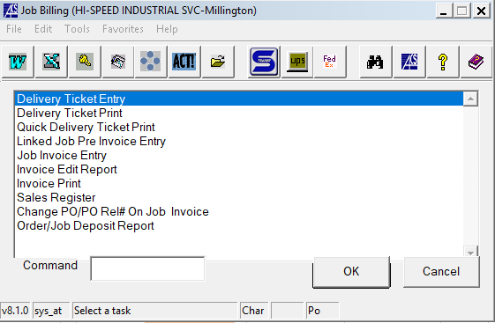
Enter the Job Number in the following window and press “OK”
The rest of the boxes should auto-populate, and press “OK” again
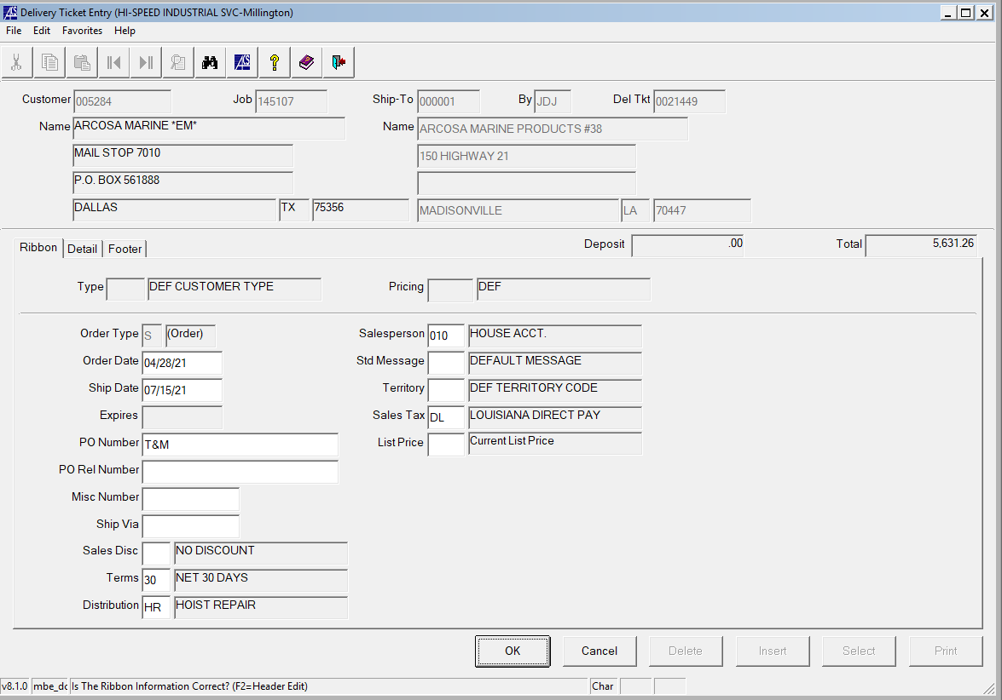
The “Detail” tab will open and each line should be deleted.
Once all lines are deleted write in a short description of what service was done using “M” under the “Cd” column.
On the next line enter “1” under “Cd” and write “LABOR TOTAL” or “SERVICE TOTAL” and enter the total invoice amount under the “Extension” column.
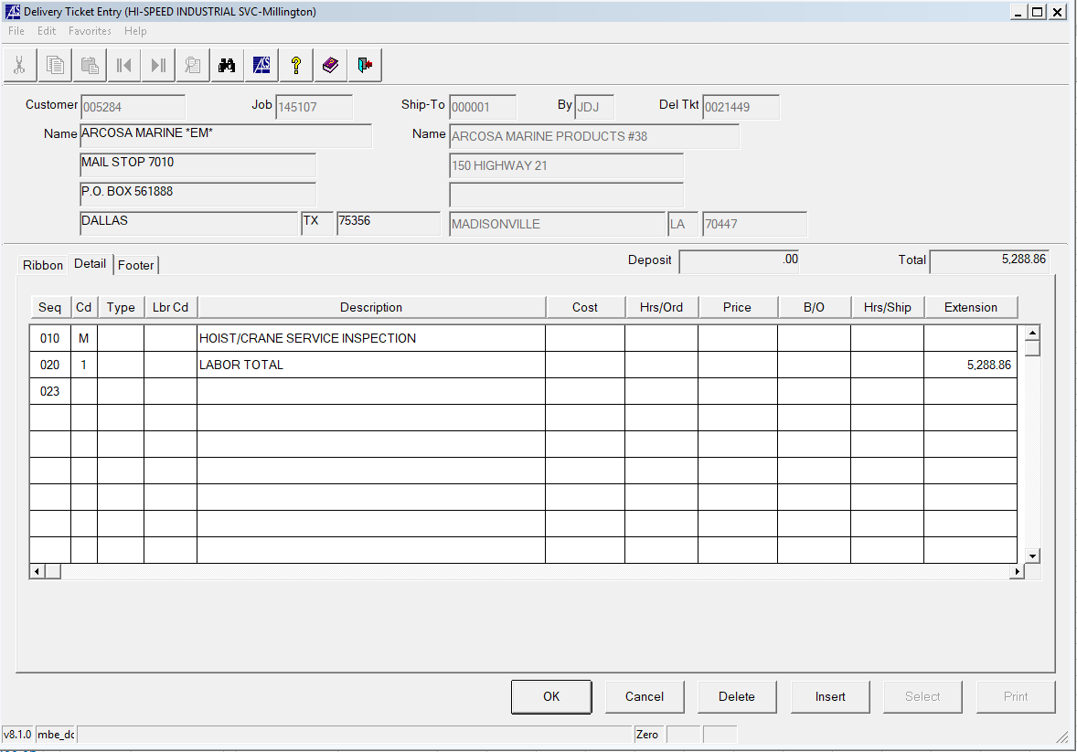
Press “OK” and then click “Print” on the next window.
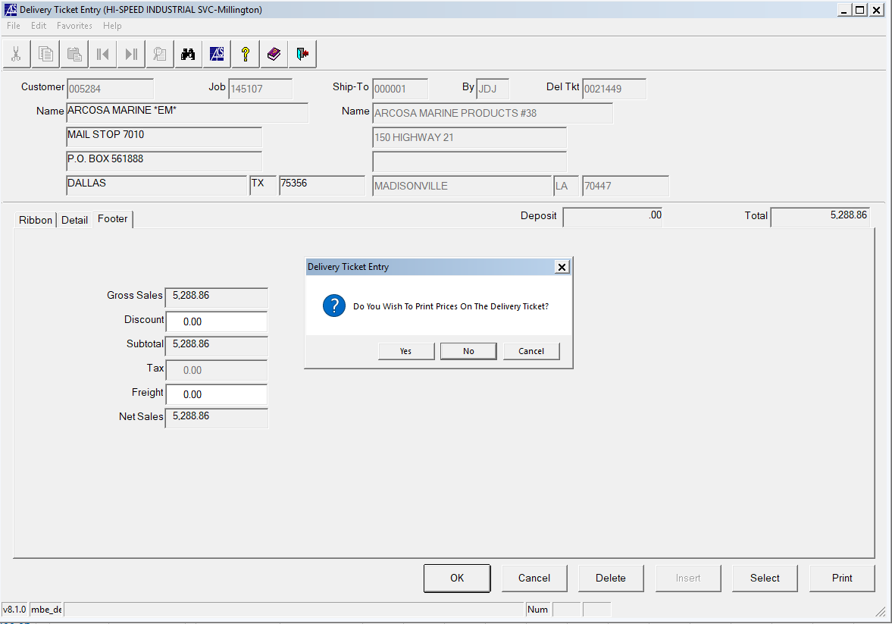
Select “Yes” to printing the prices on the delivery ticket, then select PDF and “Execute” to import as a PDF.
Then save the PDF Delivery Ticket to the job folder using pathway “Z:\firms\firm01\images\jobs\(JOB#)”
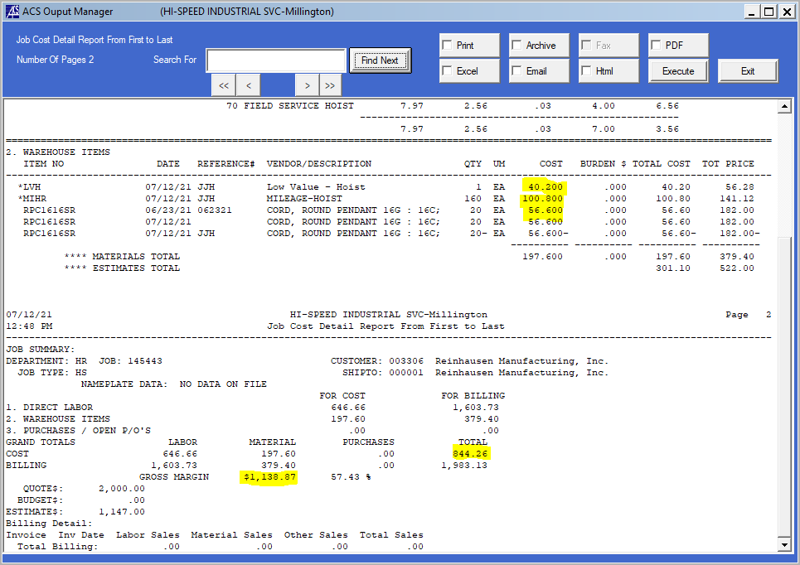
Save both the Job Cost Detail Report and the Billing Spreadsheet to the job folder if you are not using a physical job folder. If you do have a physical job folder, print both of these and place them in the folder to be scanned into one file upon submission to AR.
Check the rest of the boxes on the HR Billing Checklist and save to job folder or print and place in physical job folder.
STEP11: Enter the invoice in the “JOB INVOICE REPORT ZONE 1B” file. (If your job is for zone B)
Follow path: S:\Hoist Shop\2021 REPORTS\REPORTS FOR 1B
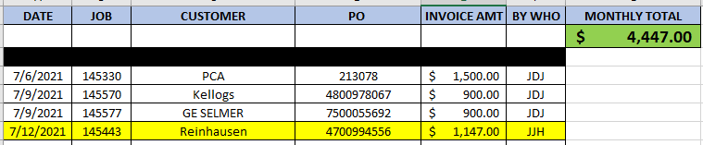
Enter the corresponding information (Date, Job#, Customer, PO, Invoice Amt, and Author) and screenshot to send to accounting via email.
The email for accounting is ar@gohispeed.com.
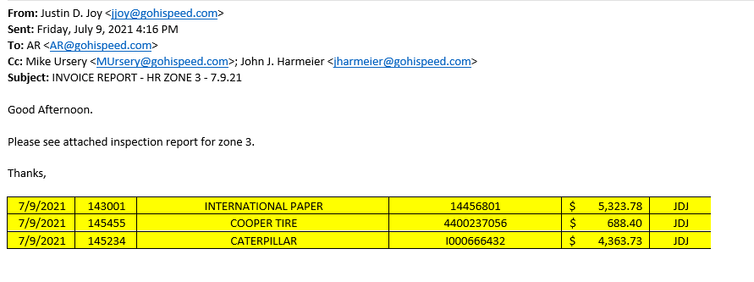
In the subject line write “INVOICE REPORT – HR ZONE ‘X’ – MM.DD.YY” and expect a confirmation.
JJH

