CALL TRANSFER PROCEEDURE

- Gather basic info of customer calling
  - Customer facility address
  - Customer facility name
Example: Facility Name: Modine
Facility Address: 3984 Hwy 51 S., Grenada, MS
- Enter customer facility name into CRM search bar like shown & press enter
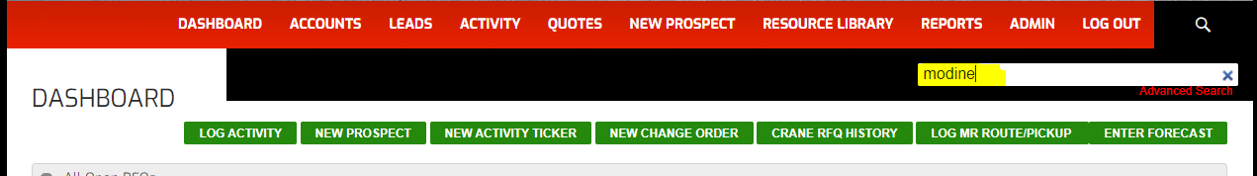
- Match the name & address you were given earlier with the name and address shown on the CRM search results page
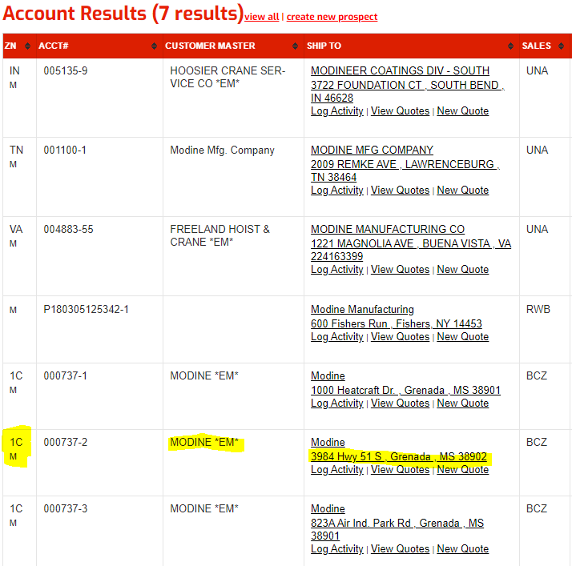

The highlighted information indicates this is a customer for zone 1C.
For Zone 1A – Transfer to John Cura (primary)/Shane Summerlin or Mike Ursery
For Zone 1B&1C – Transfer to John Harmeier (primary)/Justin Joy (secondary)
For Zone 2A – Transfer to Danielle Jackson/David Williams/Tina Thompson
For other zones – Transfer to Justin Joy or Mike Ursery (unless otherwise noted)

