**APPLYING PARTS/MATERIAL(S) TO A JOB**

BY JOHN CURA

**STEP 1:** OPEN ACS. FROM THE “SERVICE REPAIR” TAB, SELECT “MATERIAL CHARGES” AND PRESS “OK”.

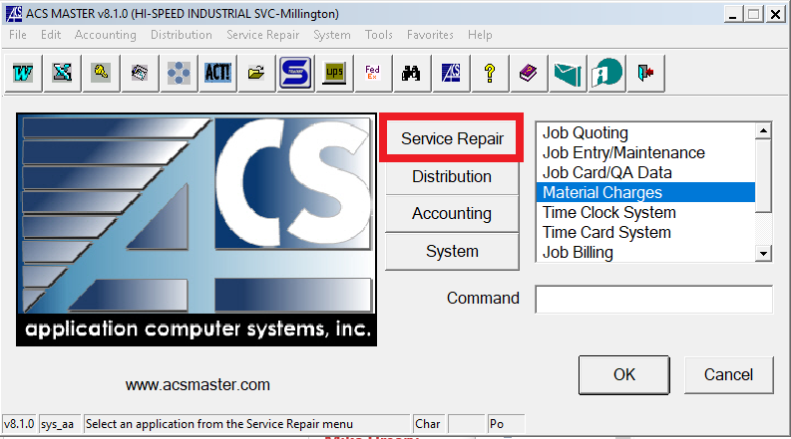

**STEP 2:** NEW WINDOW WILL OPEN UP. SELECT “MATERIAL CHARGES ENTRY” AND PRESS “OK”.

**STEP 3:**  ENTER THE CORRECT JOB NUMBER, FOLLOWED BY FILLING IN THE REST OF THE DATA. AFTER EACH

ENTRY IS COMPLETED PRESS “OK”. ONCE ALL THE MATERIAL(S)/PARTS ARE ENTERED, SIMPLY EXIT

OUT OF THE WINDOW.

*NOTE: AN EXAMPLE IS PROVIDED WITH ALL FIELDS FILLED FOR REFERENCE.

**STEP 4:** AFTER EXITING THE PREVIOUS WINDOW, ON THE “MATERIAL CHARGES” SCREEN, NOW SELECT

“MATERIAL CHARGES REGISTER/UPDATE” AND PRESS “OK”

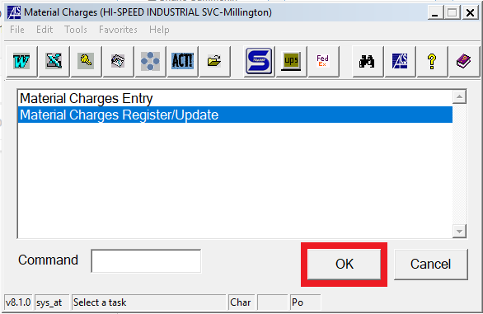

**STEP 5:** WHEN PROMPTED TO “PRINT THE MATERIAL CHARGES REGISTER” SELECT “YES”

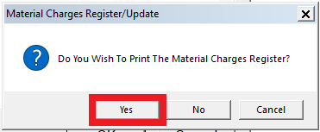

**STEP 6:**  WAIT FOR THE AUDIT PAGE TO DISPLAY, THEN CHECK THE “PDF” BOX AND PRESS “EXECUTE”

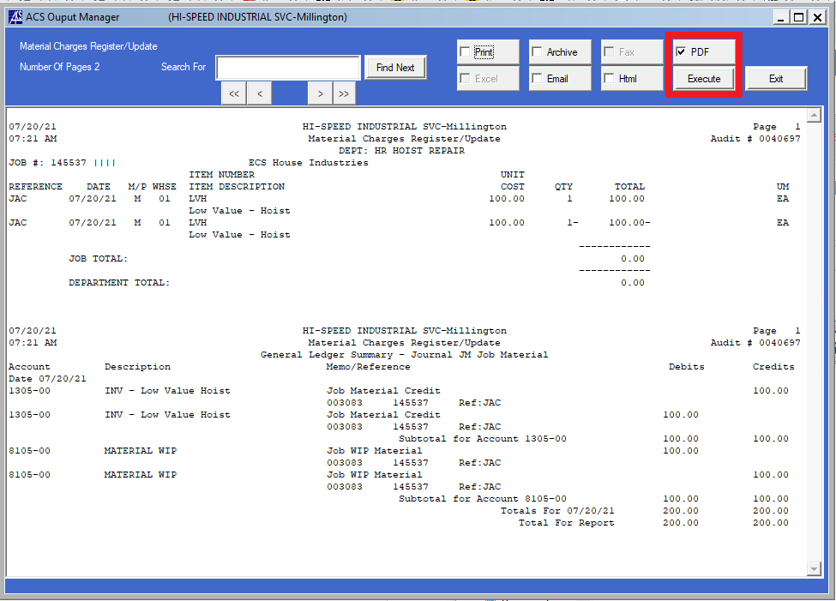

**STEP 7:** FROM THE PDF FILE, CLICK “SAVE AS” AND SAVE IN THE SHARED FILE:

*Shared (S:) > _2021 ACS Printouts > Material Charges*

SAVE THE FILE AS THE AUDIT #, IN THIS EXAMPLE IT WILL BE “40697”

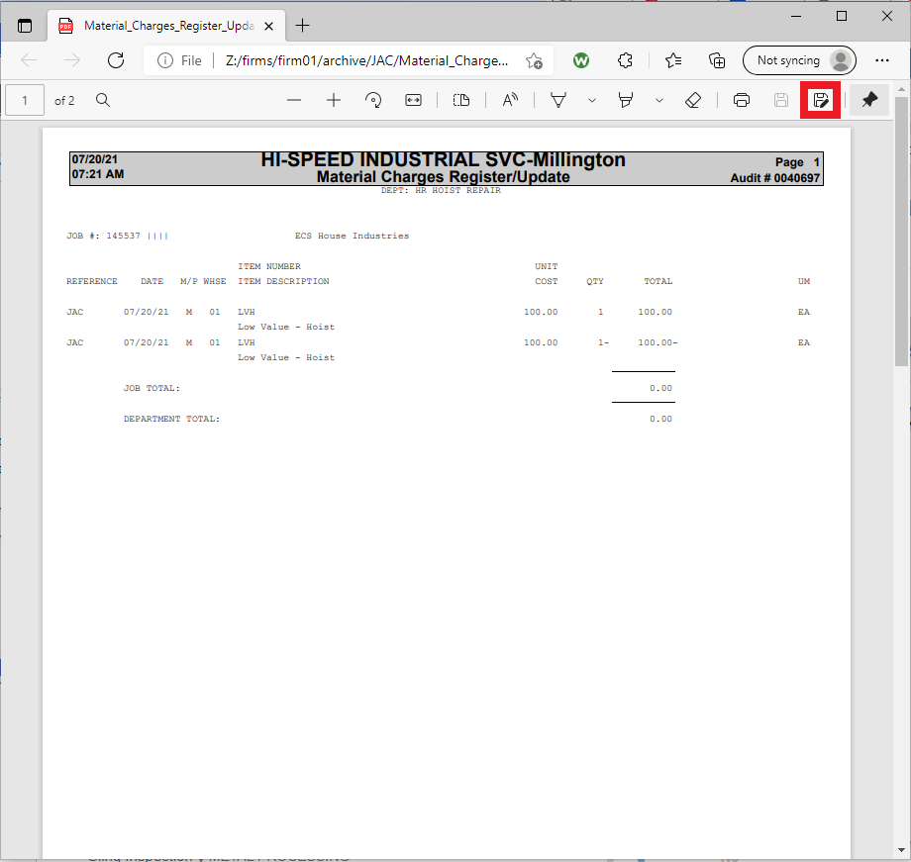

**STEP 8:** ONCE FILE IS SAVED IN SHARED DRIVE, SIMPLY PRESS “EXIT” ON ACS FILE

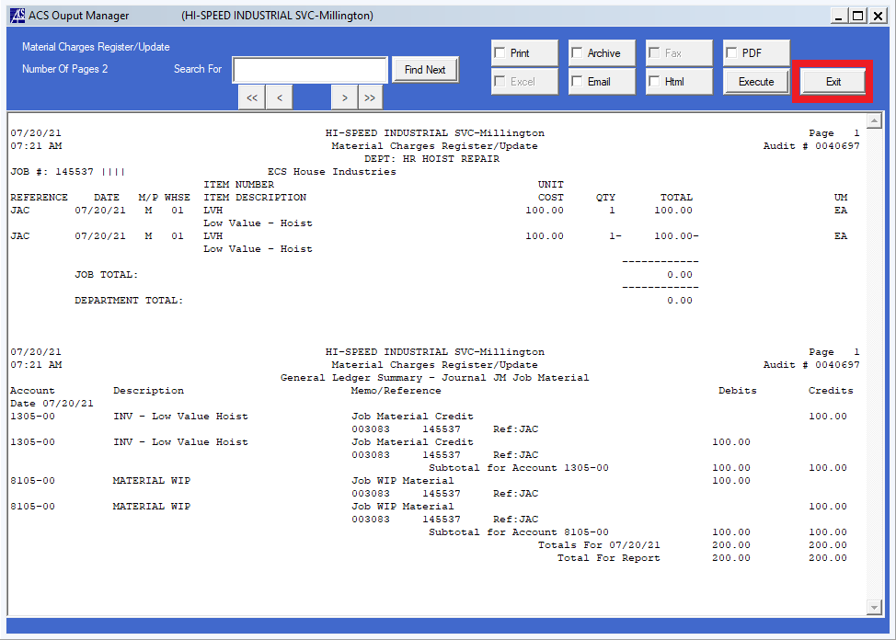

**STEP 9:** AFTER EXITING SCREEN, ON THE WINDOW THAT ASKS “ARE YOU READY TO UPDATE THE REGISTER”

PRESS “YES”. YOU ARE NOW DONE WITH ADDING PART(S)/MATERIAL(S) TO A JOB

