**ACS Inventory Search Procedure**

By: Justin Joy

Department of Hoist Repair & Crane Systems

Step 1 – Log in to ACS using username & password

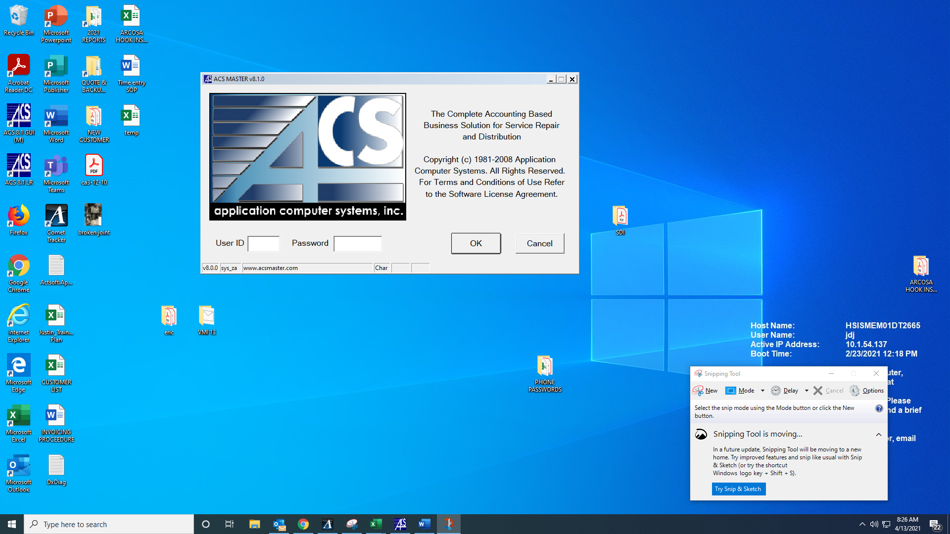

Step 2 – Open “Speed Search” by clicking on the binoculars

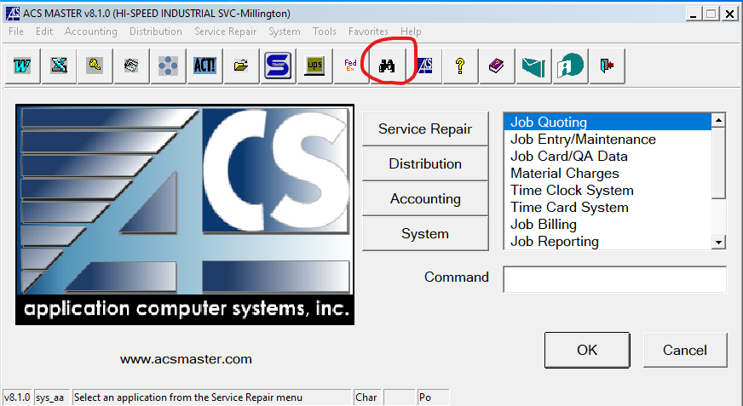

Step 3 – Expand the “Distribution” tab by clicking to reveal the option to review inventory.

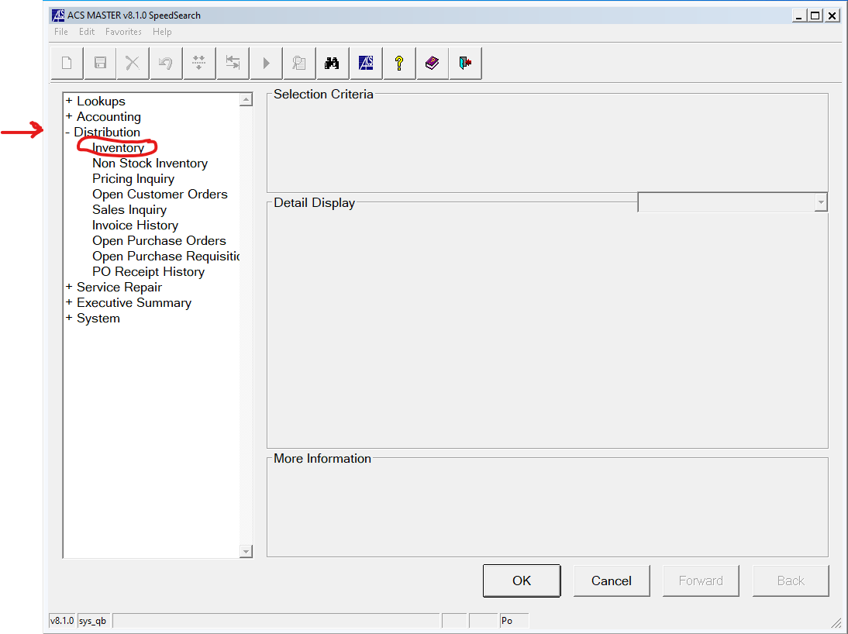

Step 4 – Select the inventory option and press F3 once the “item” is highlighted. This will open up the inventory search directory.

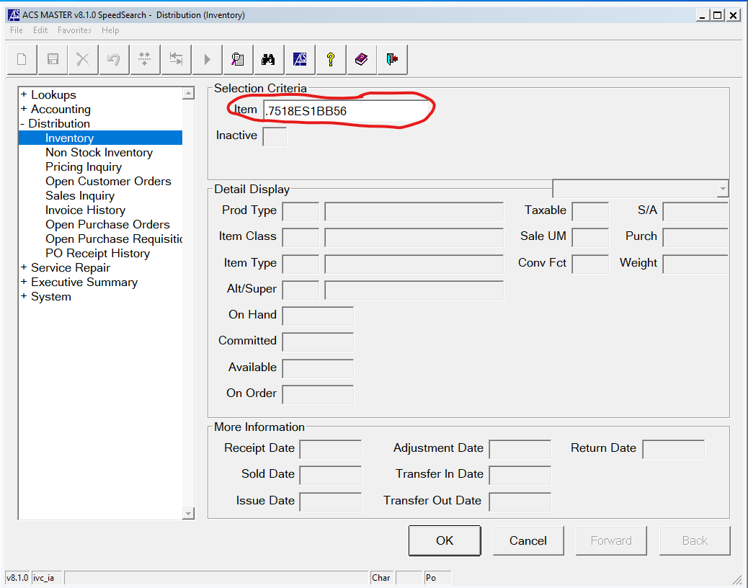

The inventory search directory will look like the picture below

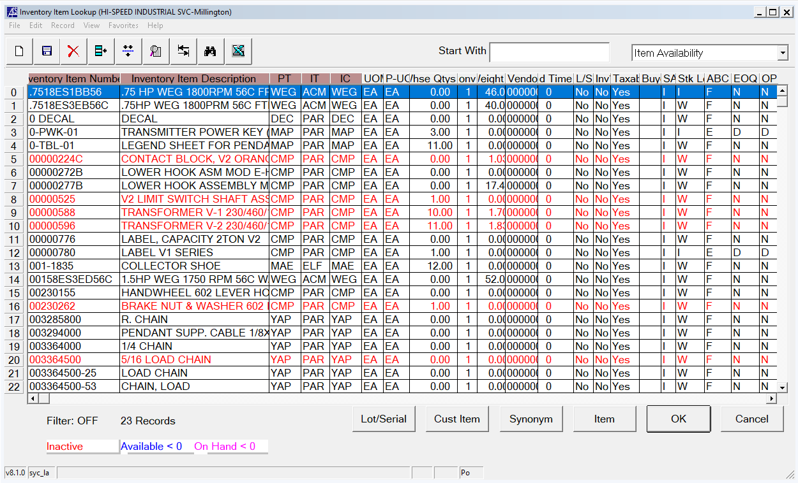

Step 5 – If you know the item number, type it directly into the “Start With” box on the top right of the directory then click on the “Inventory Item Number” tab

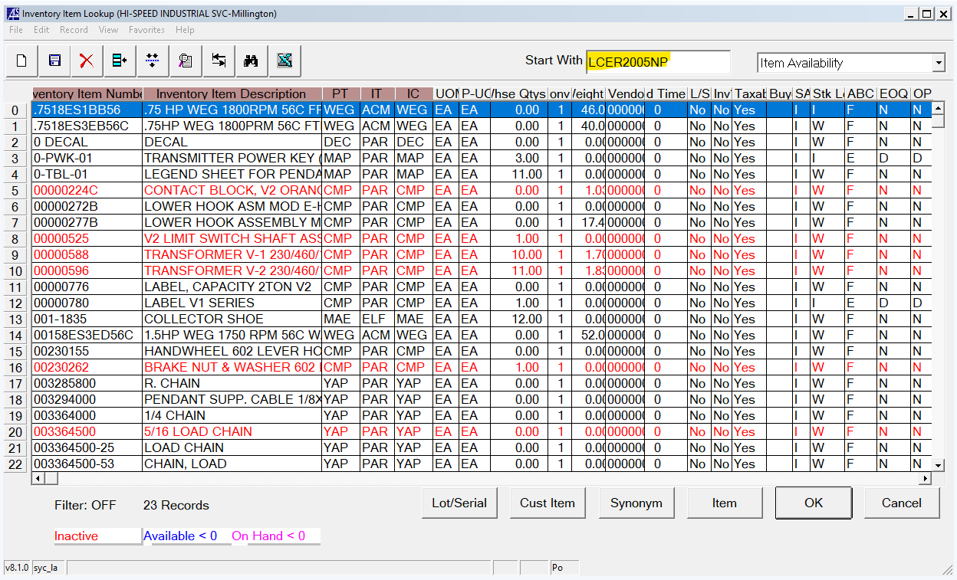

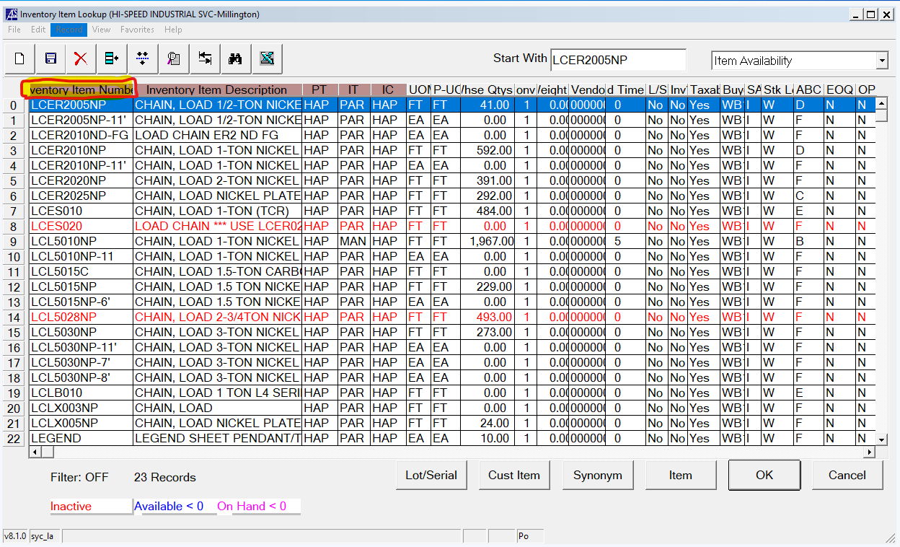

Step 6 – Double-click the item to review the material detail display.

Here the detailed display shows 55 units are committed and 1,019 ordered.

The number of items available is determined by subtracting the number of committed items from the number of items that are “on hand”.

i.e. 🡪 #available = #on hand - #commited

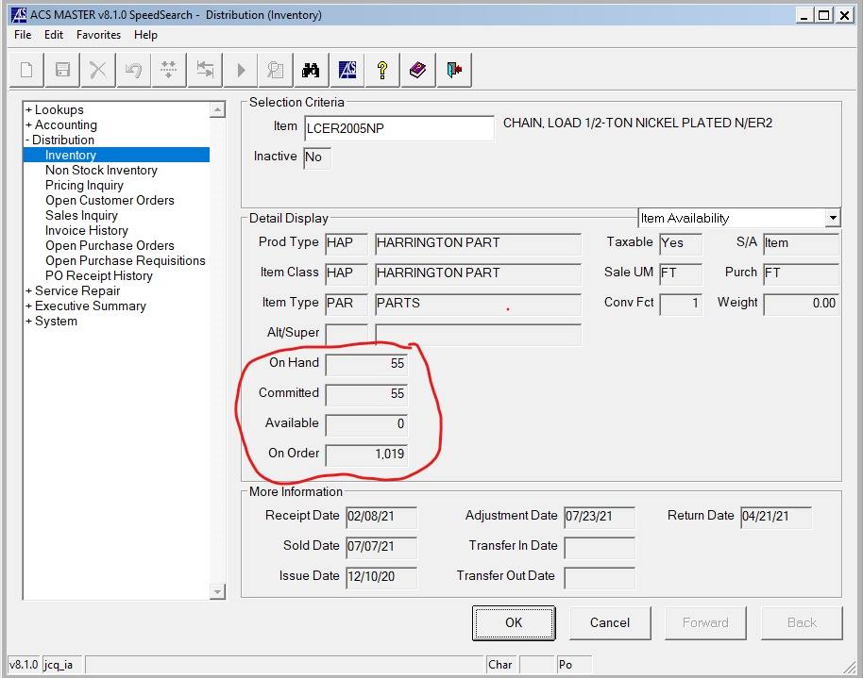

Note: Item availability should always be verified by consulting with a warehouse operations employee if possible because there are times when ACS inventory data might not be up-to date.

Step 7 – Click on the drop-down tab labeled “Item Availability” to view “Open Customers Orders”, “Pricing Inquiry”, “Open Purchase Orders”, etc. of the Item.

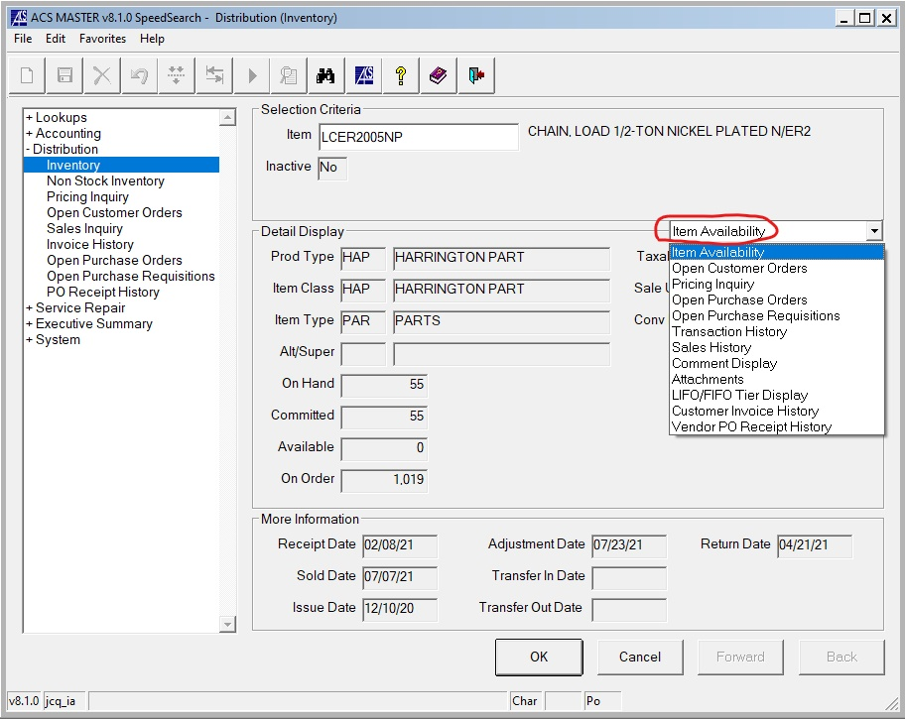

Step 8 – Example: Looking at “Price Inquiry” of an item. We are given “MPD LEVEL 1 & 2” and the prices those customer levels get. The “List Price” and “Unit cost” are also shown.

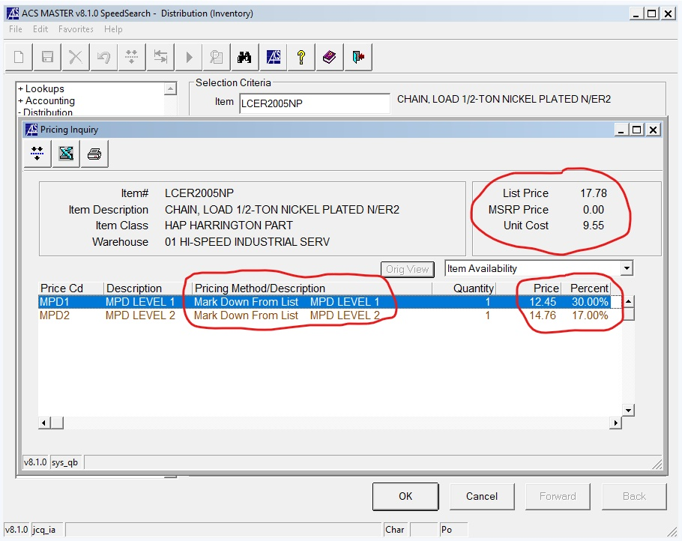

Step 9 – As an alternative method to Step 5, you can also lookup inventory items by entering details about the item into the “Start With” box and clicking the “Inventory Item Description” tab.

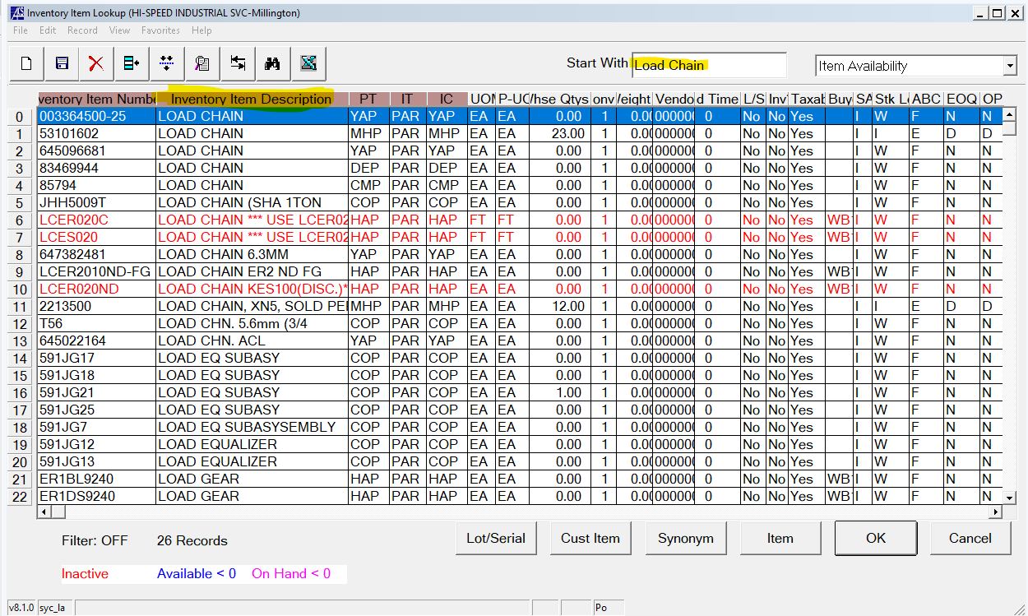

Here we obtained different search results because less info was provided in the item lookup. This makes this option of inventory lookup less preferable than the method used in step 5.

Once again, by consulting with an employee in warehouse operations, you can verify and find most items and verify availability to double-check your search results.