New Item Set-Up example for Motors with Synonyms:

Setting up a US Motors / Nidec new World Motor in Little Rock as item H10P2E World Motor HOSTILE DUTY Premium Efficient 10HP USM 1800RPM 230/460-3-60 215T TEFC motor.

MotorBoss US Motors screen shots of the HD10P2E we will be setting up:

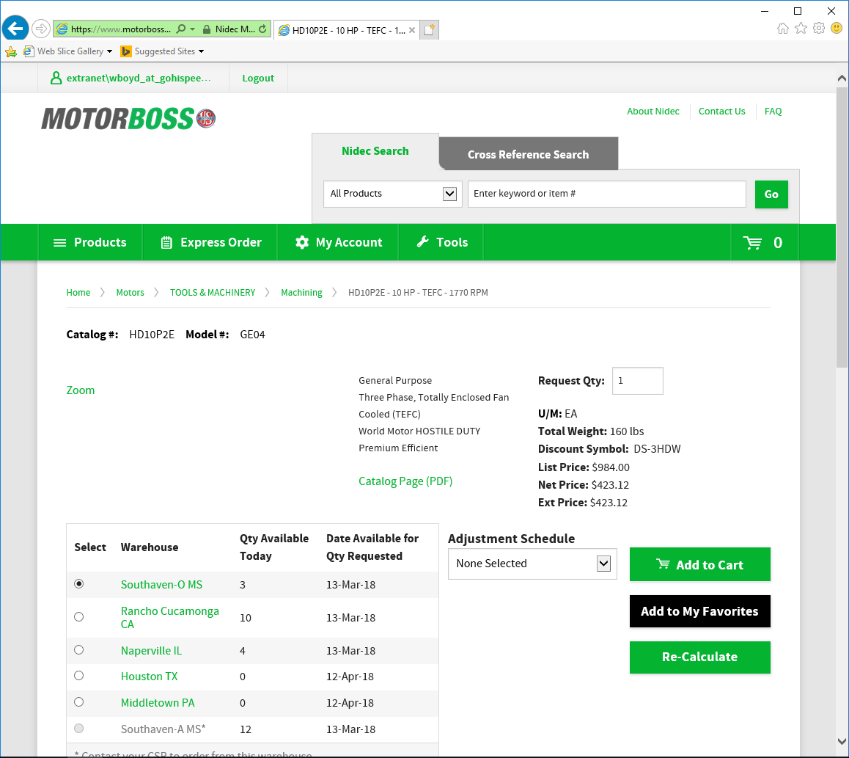

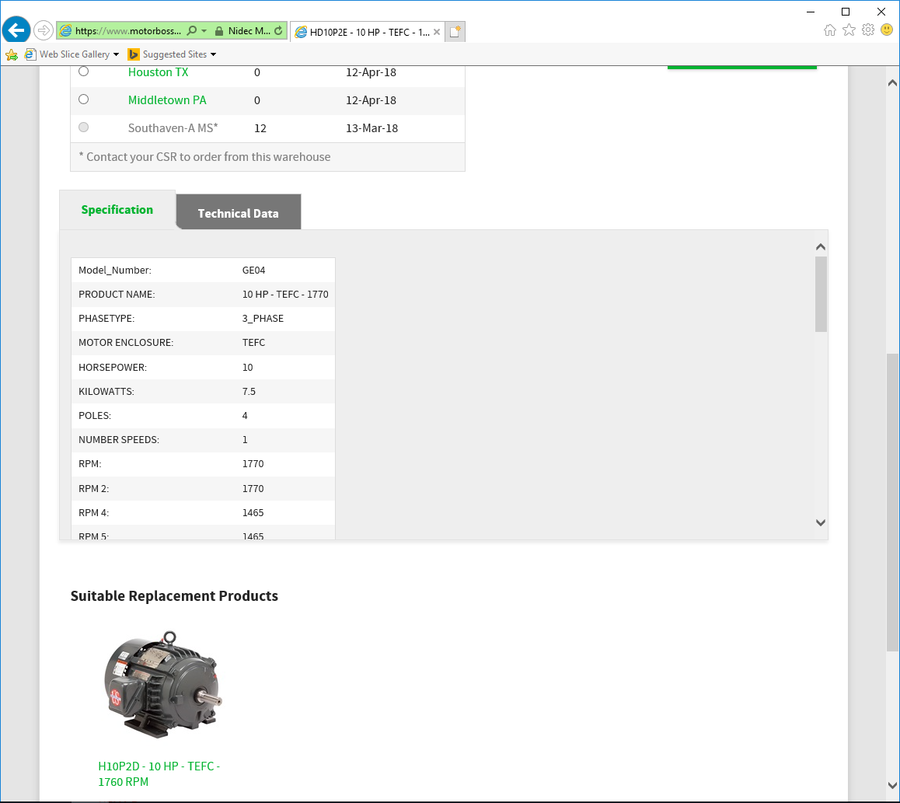

As you can see on this screen the “Specification” tab has a lot more data to show that can be scrolled down to help clarify additional information that will be needed in the set-up process. Also, on the “Technical Data” tab there may be additional information that would be needed.

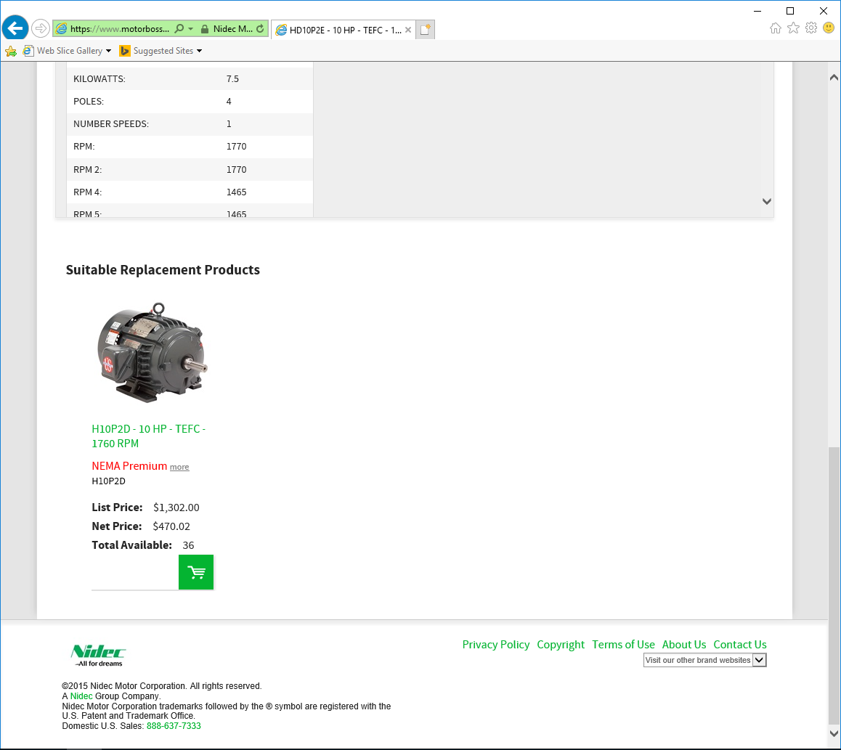

Once logged into ACS, initially click on the “Distribution” button:

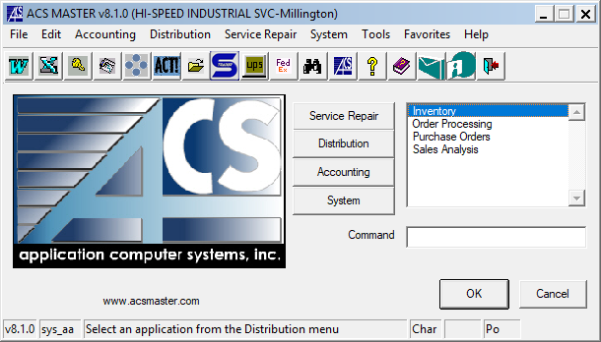

Then click on “Inventory” and click “OK” or double click “Inventory”.

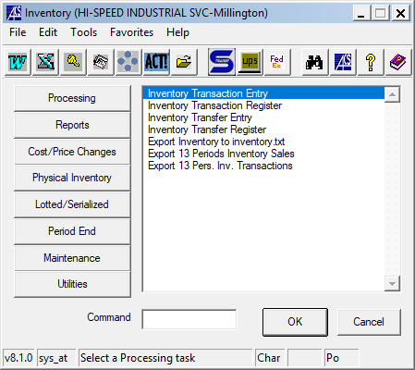

Then click on the “Maintenance” button.

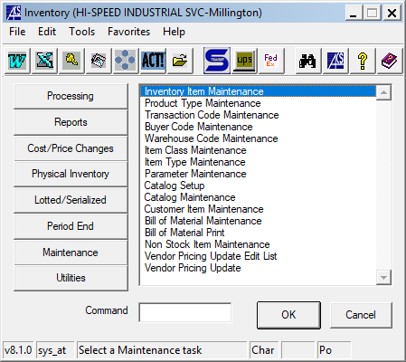

Then click on “Inventory Item Maintenance” and click “OK” or double click “Inventory Item Maintenance”.

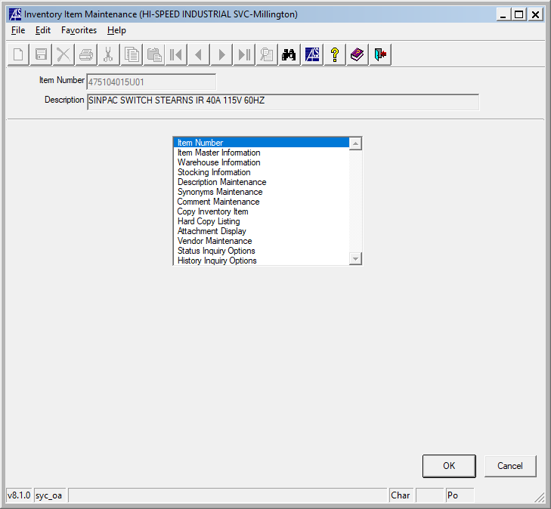

Then click on “OK” to open up the “Item Number” entry field.

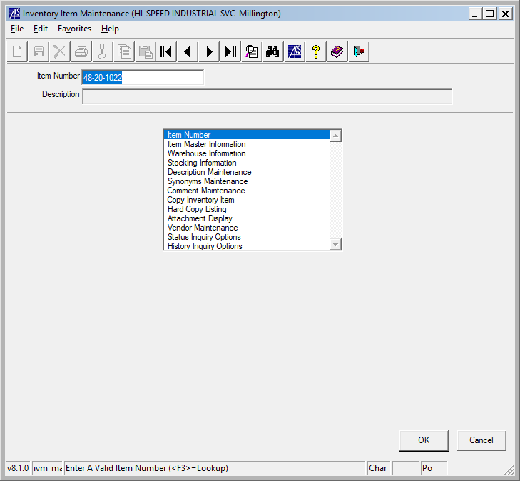

Enter the new item number (exactly as the original manufacturer’s stock number, if at all possible – even if will be purchasing from a different vendor).

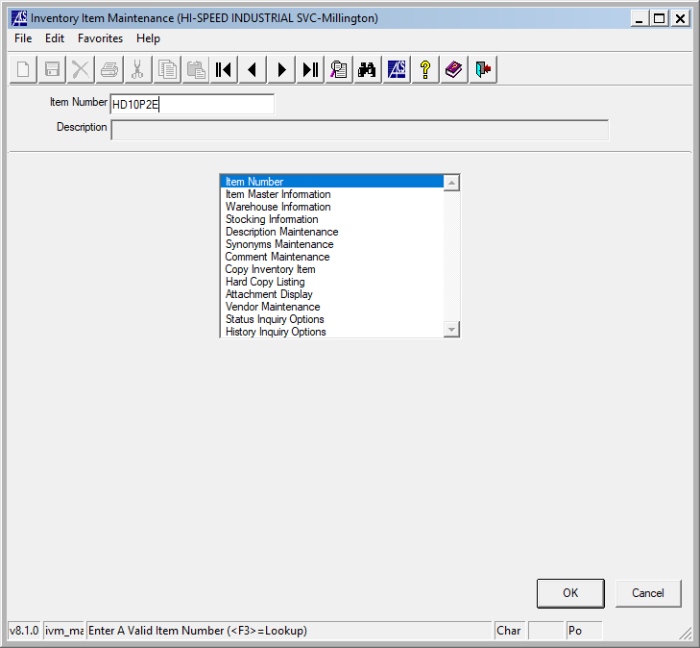

Then click “OK”. You will be asked:

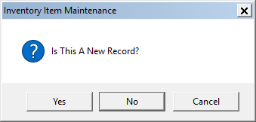

Verify the item number is entered correctly, then click “Yes”.

The next screen will pop up to start entering the data within the set-up process. The first screen:

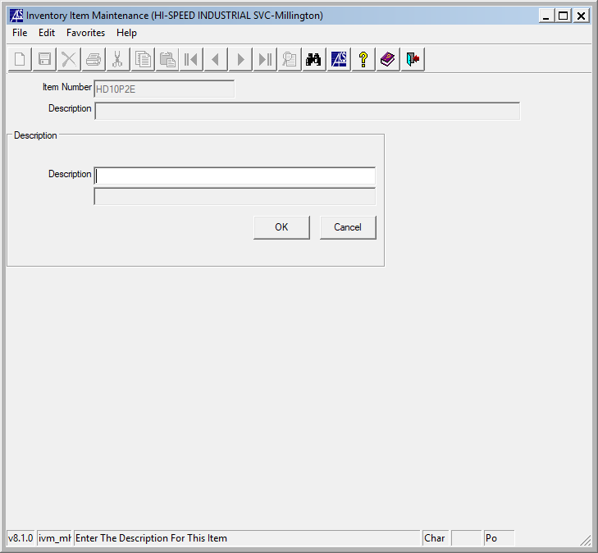

Enter the full description of the item. If possible make it as clear as possible. Use standard abbreviations for that line of product when necessary. Utilize the available data from the original manufacturer whenever possible.

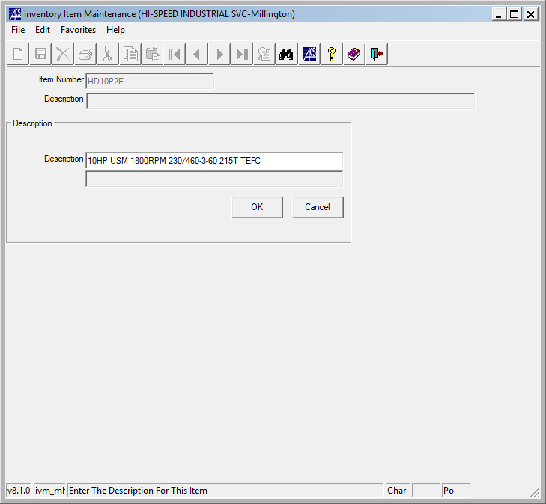

Then click “OK”. Then next screen will automatically pop up.

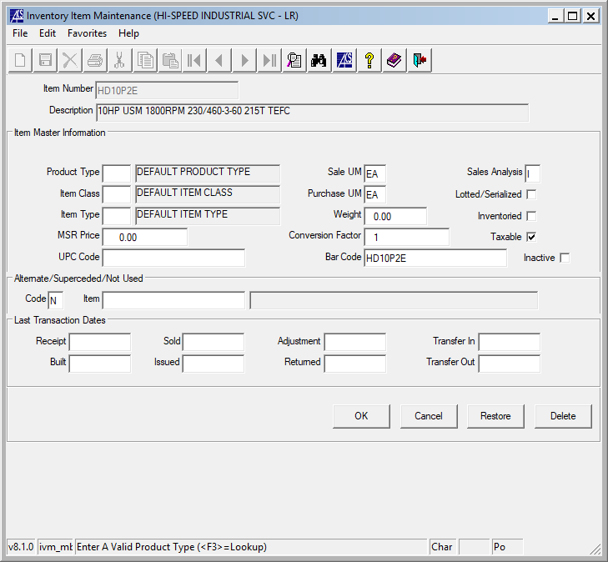

Fill in as follows:

**Product Type**: (F3 gives you all of your choices) is USM – US MOTOR UNITS for this case. But other motor product types include: ABM – ABB MOTORS, AOS – A.O. SMITH MOTORS, BAL – BALDOR MOTORS, MMU – MISC. MOTOR UNITS, NAE – NORTH AMERICAN MOTORS, TEC – WESTINGHOUSE MOTORS (TECO), WEG – WEG, and WWM – WORLD WIDE MOTORS.

**Item Class**: (F3 gives you all of your choices) is USM – US MOTOR UNITS for this case. But other motor product types include: ABM – ABB MOTORS, AOS – A.O. SMITH MOTORS, BAL – BALDOR MOTORS, MMU – MISC. MOTOR UNITS, NAE – NORTH AMERICAN MOTORS, TEC – WESTINGHOUSE MOTORS (TECO), WEG – WEG, and WWM – WORLD WIDE MOTORS.

**Item Type**: (F3 gives you all of your choices) is ACM – AC MOTOR. This is how the sale is captured and reported.

**MSR Price**: is 984.00 for this case. See screen shot above under List Price: $984.00. Enter the List Price here for whatever item you are setting up, if you have this information available.

**UPC Code**: is <BLANK> and may be left that way. This field is not currently used.

**Sale UM**: is EA for “Each”. This is how the item is sold. It may by EA – Each, FT – Foot, GL – Gallon, etc.

**Purchase UM**: is EA for “Each”. This is how the item is sold. It may by EA – Each, FT – Foot, GL – Gallon, etc.

**Weight**: is 160 for 160 Lbs. as seen in the “Specification” tab.

**Conversion Factor**: is 1. This may change if the item is purchased by the dozen but entered into inventory as each. Verify that anything other than 1 correctly addresses how you determine it should after initial receipt.

**Bar Code**: is automatically filled in as the item number. No need to do anything else here.

**Sales Analysis**: is I for Item Level. Other options available; but we do not use them.

**Lotted/Serialized**: is <BLANK> and may be left that way. Currently, we use this field to track Serial Numbers on Harrington Hoists going out at time of shipping and invoicing.

**Inventoried**: is <BLANK> and may be left that way. This field is not currently used. It makes each item’s serial number to be tracked from receiving to shipping and invoicing. At this time, this is more than we need.

**Taxable**: is left “checked”. Unless specifically identified, all of our items should be taxable. If the customer has a resale tax certificate on file with us, ACS will drop the tax when necessary.

**Inactive**: is <BLANK> and may be left that way. This is used later when and item has been discontinued by the manufacturer or superseded by the manufacturer.

**Code**: is left “N” for not superseded nor alternate item in our systems. Use “A” for alternate item when it is a directly alternate for another item, then enter that item in the next field “Item”. Use “S” for superseded item when it is directly superseded by another item, then enter that item in the next field “Item”. Otherwise “Item” is left <BLANK>.

The rest of the fields are intentionally left <BLANK>, as these are populated as individual transactions happed to the item over the life of the item.

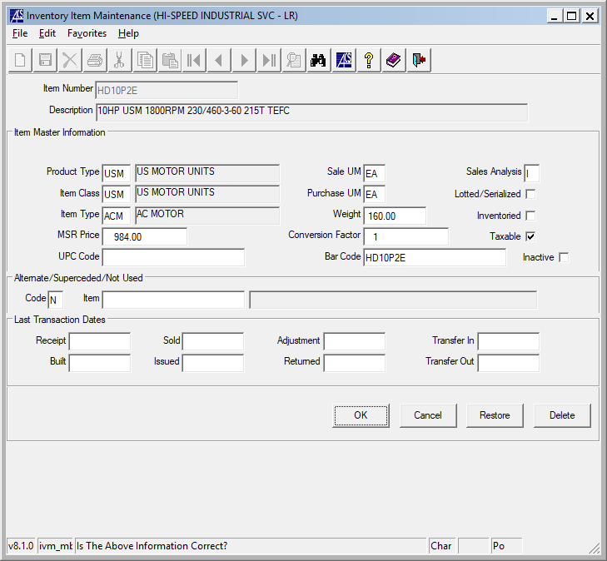

Then click “OK” to go to the next set-up screen.

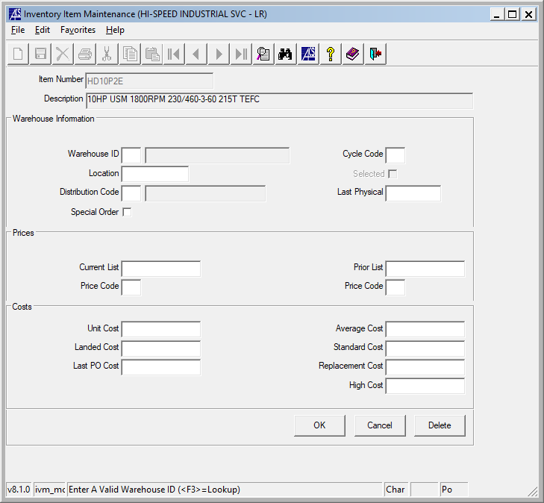

Warehouse ID: is 02 for the Little Rock main warehouse. (01 is for Millington main warehouse.) Other warehouses are available at each facility and would depend on the situation, if they would be needed to be added or included. Most items will never be added to other warehouses than 01 and / or 02.

You will be asked:



Click the “Yes” button. Then continue filling in as follows:

**Location**: is MOTOR RACK. Enter a meaningful location name. If know, enter a specific location. If not know, enter one that would help someone looking up the inventory find it (like MOTOR RACK, HOIST RACK, HARRINGTON, MAGNETEK, YALE, etc.) See location codes for Millington and Little Rock appended to the end of this file.

**Distribution Code**: (F3 gives you all of your choices) is MS – MOTOR & DRIVE SALES. This is how the sale is captured and reported.

**Special Order**: is <BLANK> and may be left that way. This field is not currently used.

**Cycle Code**: is US for US Motors. Please use the current two digit abbreviation for the group of items being set-up. You may need to look at similar items to determine what this would be. This allows for Cycle Reports to be run for specific groups of items at any time.

**Last Physical**: is <BLANK> and may be left that way. This field is not currently used.

**Current List**: is 984.00 for this case. See screen shot above under List Price: $984.00. Enter the List Price here for whatever item you are setting up, if you have this information available.

**Price Code**: is <BLANK> and may be left that way. This field is not currently used.

**Prior List**: is <BLANK> and may be left that way. This field is used when updating the List Price on an existing item and is manually entered from the previous “Current List”.

**Price Code**: is <BLANK> and may be left that way. This field is not currently used.

**Unit Cost**: is 423.12 for this case. See screen shot above under Net Price: $423.12. Enter the Net Price here for whatever item you are setting up. Entering here will populate the rest of the “Cost” fields at this time. If this step is skipped, then the other “Cost” fields will be <BLANK> until historical references fill these in over the history of the item.

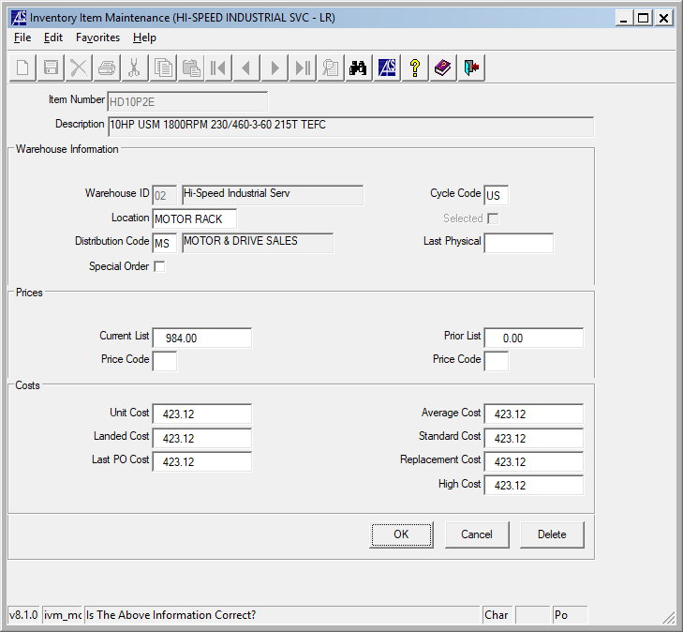

Then click “OK” and then click “Cancel” to go to the next set-up screen.

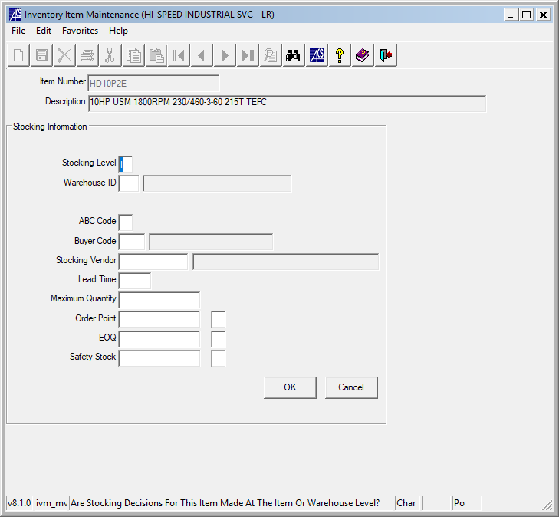

**Stocking Level**: (F3 gives you all of your choices) is W for warehouse. We only use “W” for inventory reordering purposes.

**Warehouse ID**: is 02 for the Little Rock main warehouse. (01 is for Millington main warehouse.) Other warehouses are available at each facility and would depend on the situation, if they would be needed to be added or included. Most items will never be added to other warehouses than 01 and / or 02.

**ABC Code**: is D for this case. Most new items will have a slow start to sales. Currently we are using the following ABC Codes:

A – Fastest Moving Items D – Slow Moving / Initial Set-Up Items

B – Fast Moving Items E – Planned On No Longer Stocking Items

C – Medium Moving Items F – Discontinued / Superseded Items

**Buyer Code**: is <BLANK> and may be left that way. This field is not currently used.

**Stocking Vendor**: is 014333 – Nidec Motor Corp for this case. Lookup vendor by using F3 if it is not known.

**Lead Time**: is 7 in this case. Use 7, 14, 21, etc. for most vendor lead times. Round up to the next week for purposes of estimating the approximate lead time. If unknown use 21 as the default. This will eventually be used in the reordering process.

**Maximum Quantity**: is 3 in this case. Using the reference of H10P2D as the item that it is replacing and using the Order Levels for this and the next order level entries. Most cases it will be 1 or 2 depending on the expected usage of the new item or use historical reference if it is an alternate or superseding item.

**Order Point**: is 2 in this case. This is the point at below which, it triggers to show up on the reorder report when running it based on “Order Point” to review to reorder the item.

**EQO**: is 1 in this case. This is the usual quantity multiple in which to order to get the item back to “In Stock” level status. It may be a case or package quantity, unit usage quantity, or some other multiple that makes sense to stock and not be reordering weekly.

**Safety Stock**: is 1 in this case. If we plan on keeping stock of the item we use “1”. If we do not plan on keeping stock of the item we use “0”. This field may be used on the reorder report and run based on the   
“Safety Stock”. But we are currently not using this version of the reorder report.

The field after each “Order Point”, “EOQ”, “Safety Stock” defaults to “D”. If entering anything in these fields other than “0” Zero please enter “E” for manually “entered”. If stocking for a specific customer request, enter “N” or if the item is discontinued or superseded. “D” allow “E” allow for the ACS report generator recommend new stocking levels when run (“N” does not).

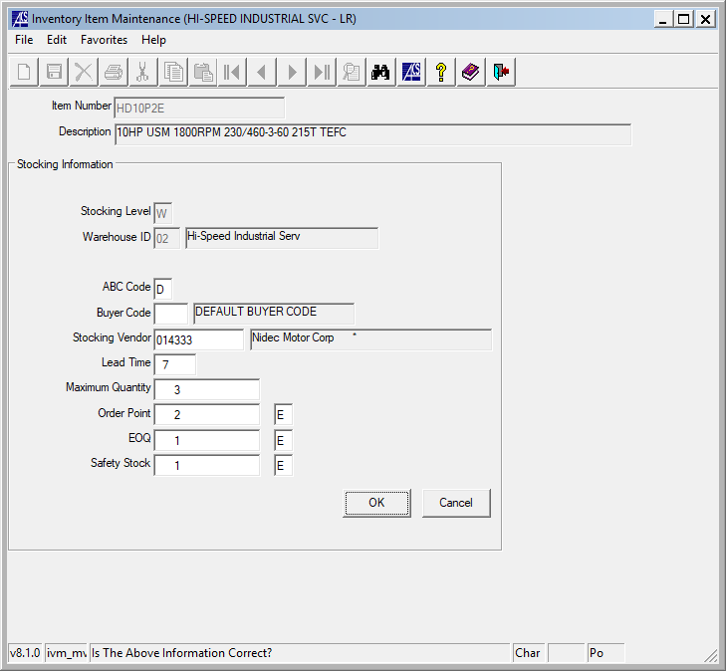

Then click “OK” and then click “Cancel” to go to the next set-up screen.

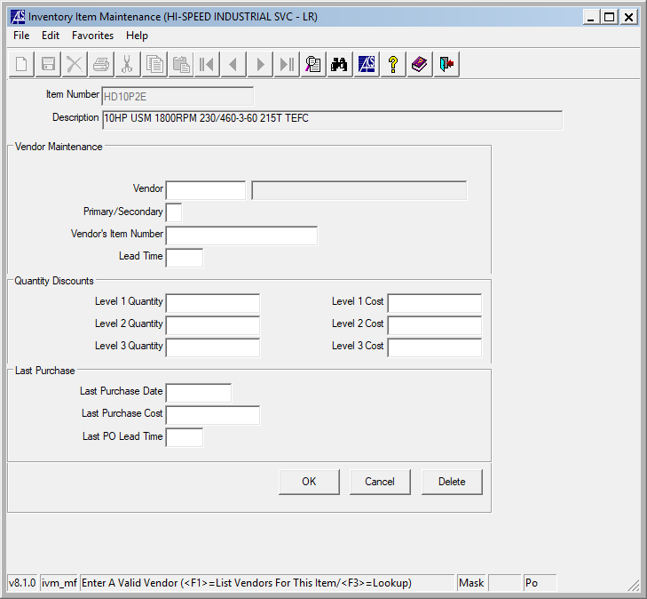

**Vendor**: is 014333 – Nidec Motor Corp for this case. Lookup vendor by using F3 if it is not known.

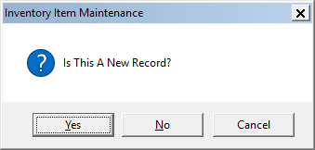

Click the “Yes” button. Then continue filling in as follows:

**Primary/Secondary**: is P for this case. Nidec is the primary vendor for this item.

**Vendor’s Item Number**: is HD10P2E for this case. Enter the actual vendor item number for that specific vendor.

**Lead Time**: is 7 in this case. Use 7, 14, 21, etc. for most vendor lead times. Round up to the next week for purposes of estimating the approximate lead time. If unknown use 21 as the default. This will eventually be used in the reordering process.

The rest of the fields are intentionally left <BLANK>, as these are not currently used or populated as individual transactions happed to the item over the life of the item.

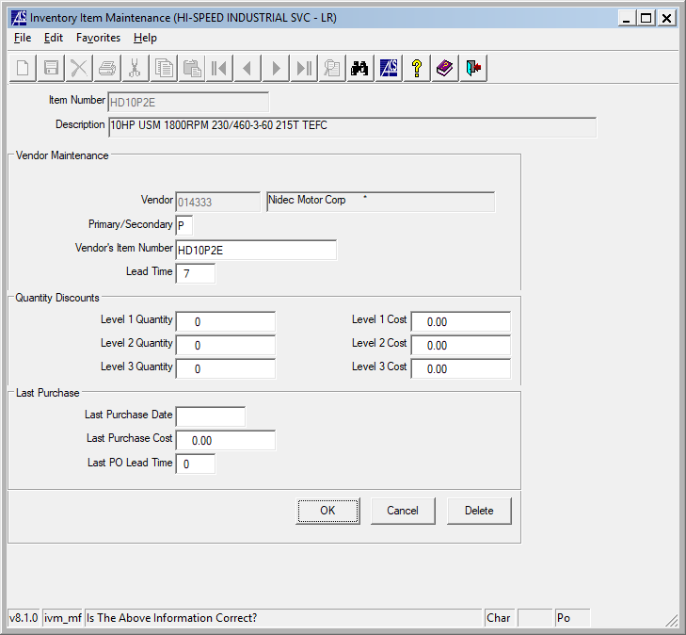

Then click “OK” and then click “Cancel” to go to the next set-up screen.

And this screen pops up:

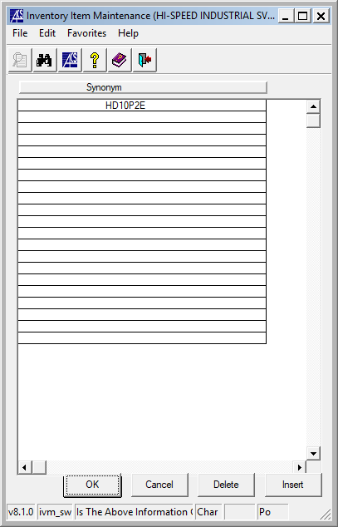

For Motors and Hoist Units, you will need to fill in Synonyms to reference to find this item easier. If parts, then skip this next section and just click “OK” and you are done.

Enter one at a time the information related to the Motor as seen below:

Example of H10P2D:

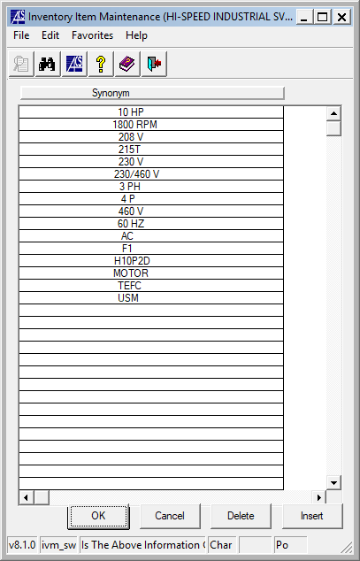

So, the HD10P2D would end up looking like:

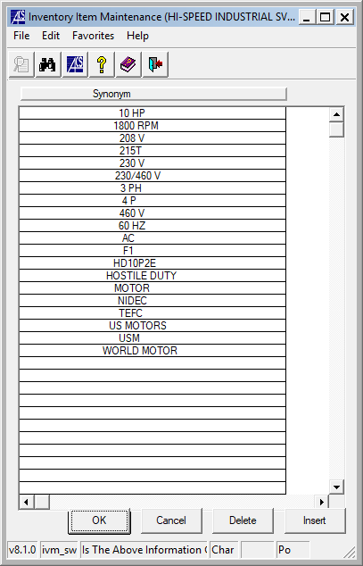

Hoist Units would be similarly identified except with Hoist references.

Then click the “OK” button and you are complete.

If there is something specific about the item that needs notes, please enter them with the date and initials and in the Item Master Screen change the “N” to “A” and enter the related item number to be “See Comments” to identify that there are comments to review on the item.

Appendix A: Inventory “Location” Standards

