Climate Controlled Storage in C1 CLIMATE CONTROL WHSE #1 Initial Set-Up Example:

|  |  |  |  |  |  |  |  |  |  |  |
| --- | --- | --- | --- | --- | --- | --- | --- | --- | --- | --- |
| **Job#** | **Sap #** | **Location** | **HP/KW** | **RPM** | **Frame** | **Volts** | **Enclosure** | **Manufacturer** | **C1 Item Number** | **C1 Item Description** |
|  |  | B36 | 30 | 1760 | 284/6T | 460 | TEFC | WEG | CCS000001 | 30HP WEG 1760RPM 460V 284/6T TEFC |
| New | 5009538 | C19 | 60 | 1780 | 364T | 460 | TEFC | BALDOR/RELIANCE | CCS000002 | 60HP BAL 1780RPM 460V 364T TEFC |
| New | 5009538 | C11 | 60 | 1780 | 364T | 460 | TEFC | BALDOR/RELIANCE | CCS000003 | 60HP BAL 1780RPM 460V 364T TEFC |
| 135411 |  | MSBP | 74 | 1000 | 280 | 480 | TEFC | ABB | CCS000004 | 74HP ABB 1000RPM 480V 280 TEFC |
|  |  | WFLOOR | 74 | 891 | IP55 | 480 | TEFC | ABB | CCS000005 | 74HP ABB 891RPM 480V IP55 TEFC |

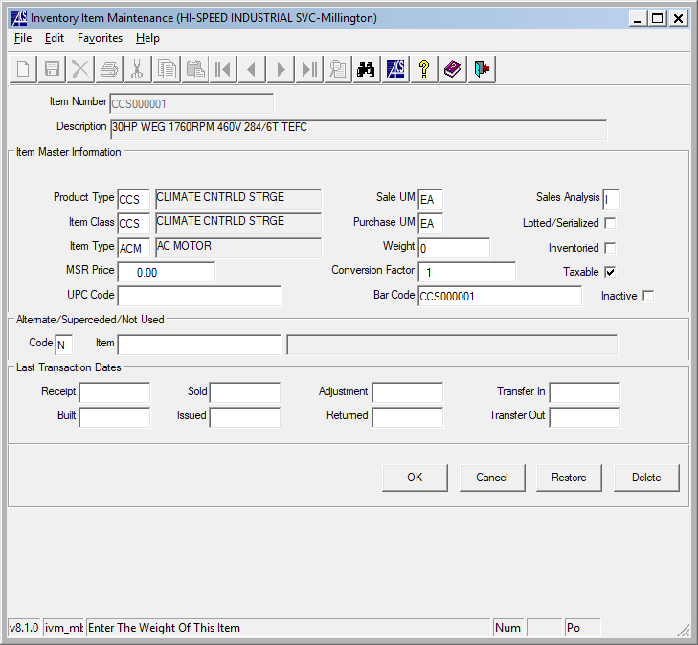 Product Type / Item Class: CCS (New)

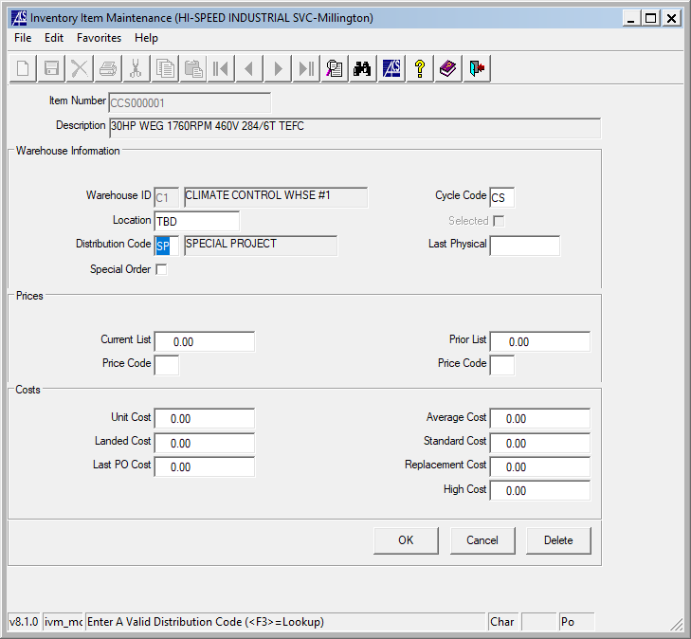

Need Location, Need ***Distribution Code***

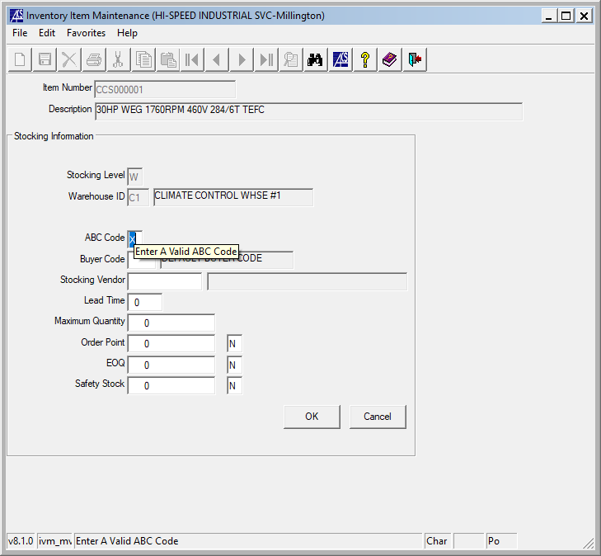

ABC Code: X Non Stock Climate Controlled Storage

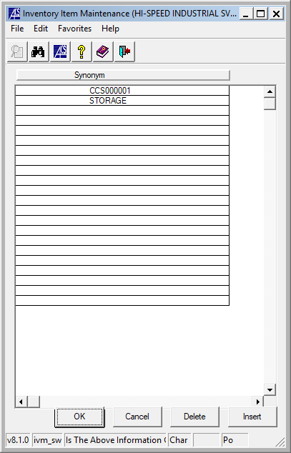

Add “STORAGE”

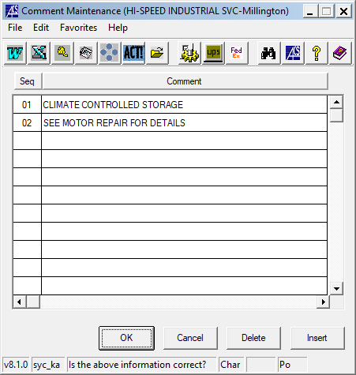

Add Comments above.

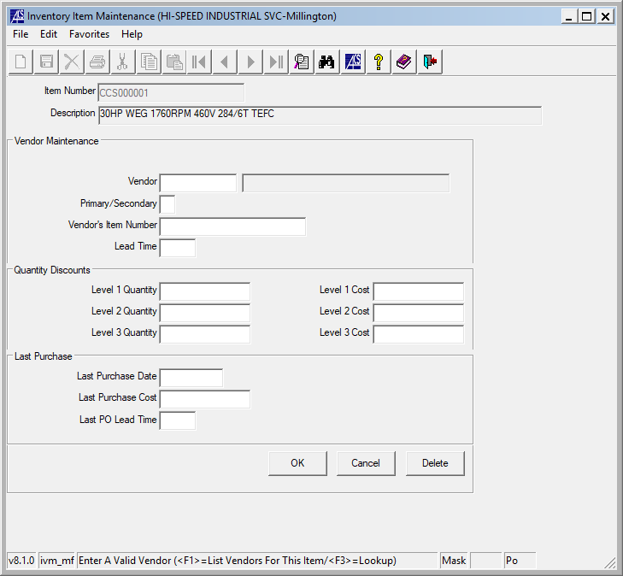

These are motors stored with us by our customers. There are no vendors. This screen will remain blank.