- STEP 1
  - FROM THE ACS HOME SCREEN, GO TO DISTRIBUTION>ORDER PROCESSING>PROCESSING>ORDER ENTRY
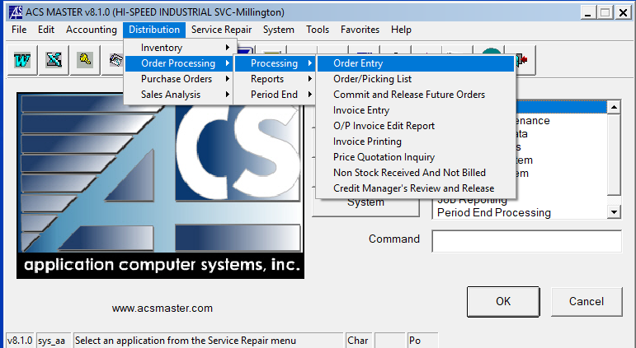

- STEP 2
  - USE YOUR CURSOR TO CLICK INSIDE THE CUSTOMER BOX NEAR THE TOP LEFT AND PRESS F3 TO LOOKUP THE CUSTOMER REQUESTING A QUOTE
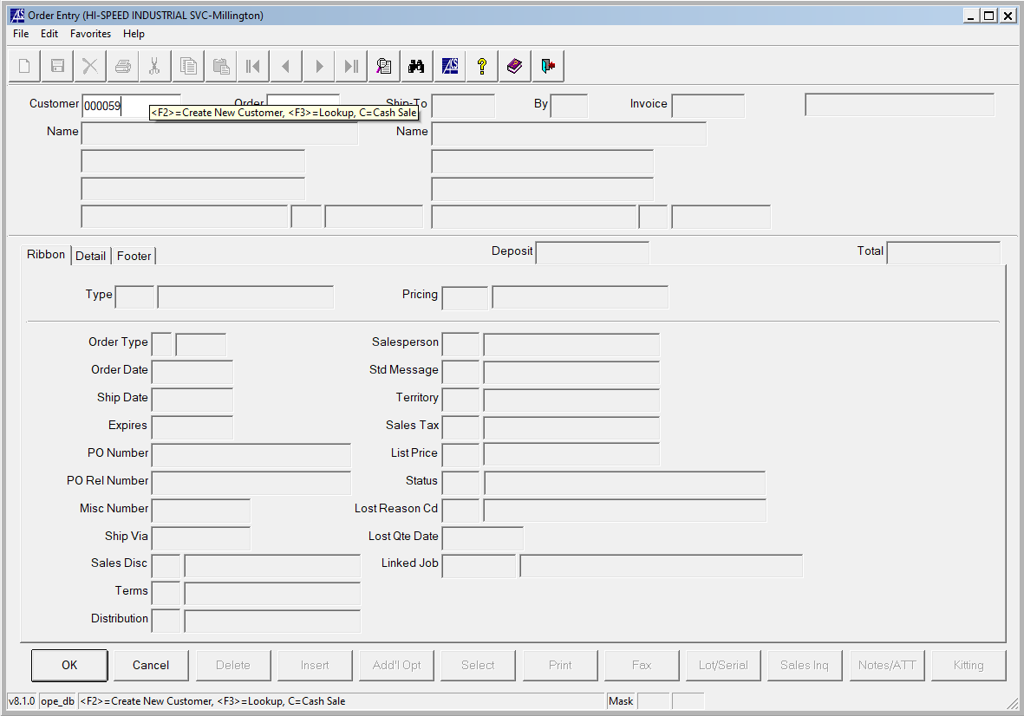

- STEP 3
  - TYPE THE CUSTOMER NAME IN THE “START WITH” BOX AND THEN CLICK THE “NAME” OR “ALTERNATE SEQUENCE” TABS TO PERFORM THE SEARCH.
  - NOTE: IT MAKES A DIFEFRENCE WHETHER OR NOT YOU TYPE THE CUSTOMER NAME IN CAPS OR LOWER CASE. BOTH SITUATIONS MAY PROVIDE DIFFERENT SEARCH RESULTS
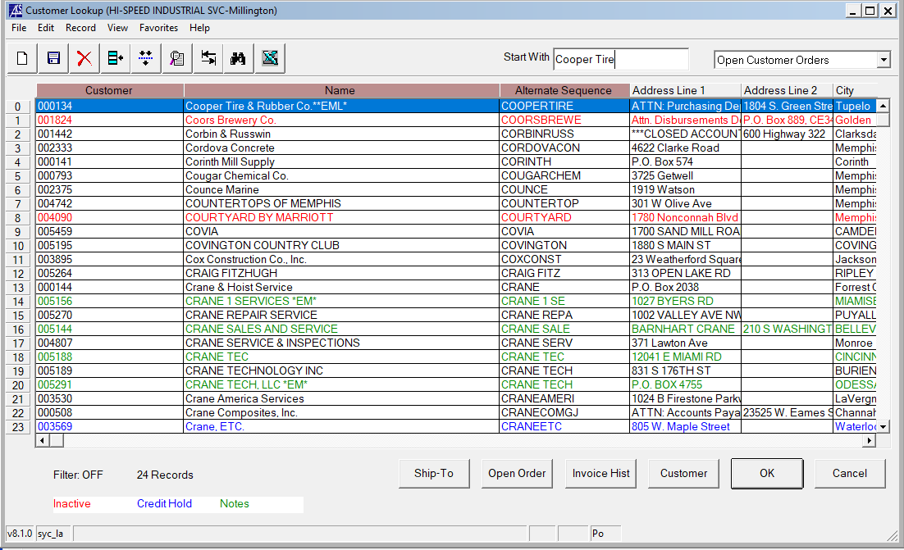

- STEP 4
  - AFTER CLICKING “OK” AND SELECTING YOUR CUSTOMER FROM THE CUSTOMER LOOKUP BOX, YOU WILL SEE THE “CUSTOMER COMMENTS” WINDOW POPUP
  - IN THE CUSTOMER COMMENTS POPUP YOU CAN FIND USEFUL INFORMATION, LIKE THE PARTS DISCOUNTS WE PROVIDE TO THAT CUSTOMER THAT ARE VENDOR SPECIFIC AND SOMETIMES THE FREIGHT ACCOUNT NUMBERS AND PREFFERED CARRIER
  - NOTE: THERE ARE MANY CASES WHERE THERE IS NO DISCOUNT STRUCTURE OR FREIGHT INFO IN THIS COMMENTS BOX. IF THAT INFORMATION DOES NOT POPULATE, CONTACT THE INSIDE SALES REP FOR THAT CUSTOMER TO INQUIRE ABOUT WHAT DISCOUNT THEY SHOULD RECEIVE ON CERTAIN PARTS
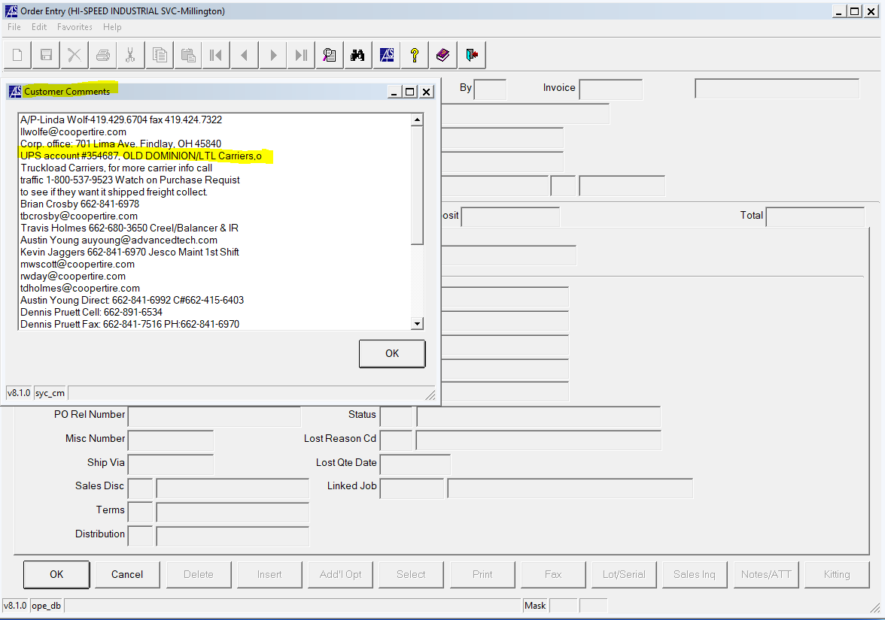

- STEP 5
  - USE YOUR CURSOR TO CLICK INSIDE THE “ORDER BOX” AND PRESS THE F1 KEY TO CREATE A NEW QUOTE NUMBER. ALTERNATIVELY, YOU CAN ALSO SEARCH EXISTING QUOTES BY PRESSING THE F3 KEY.
- STEP 6
  - USE YOUR CURSOR TO CLICK INSIDE THE “SHIP-TO” BOX AND PRESS THE F3 KEY TO SEARCH FOR THE CUSTOMER SHIP-TO ADDRESS TO SELECT FOR THE QUOTE.
  - NOTE THAT IN MANY CASES THIS IS NOT AVAILABLE ON THE FRONT END AND USUALLY HAS TO BE CHANGED WHEN CONVERTING A QUOTE TO AN ORDER. YOU CAN USUALLY PICK SHIP-TO #1 FOR DEFAULT
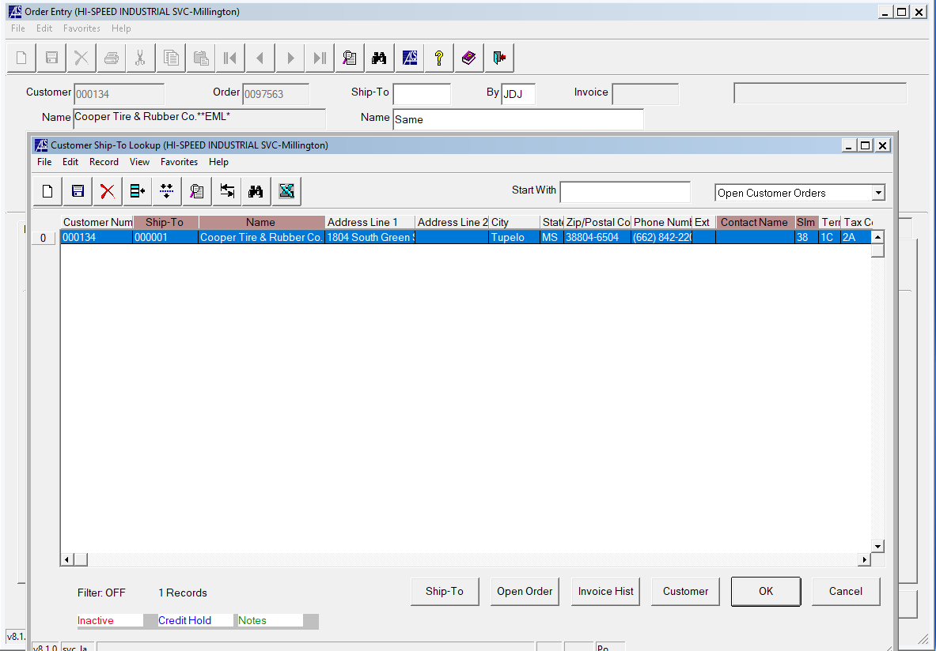

- STEP 7
  - USE YOUR CURSOR TO CLICK THE DETAIL TAB TO GO TO THE SCREEN WHERE YOU WILL CREATE YOUR QUOTE. YOUR SCREEN SHOULD LOOK LIKE THE BELOW PICTURE.
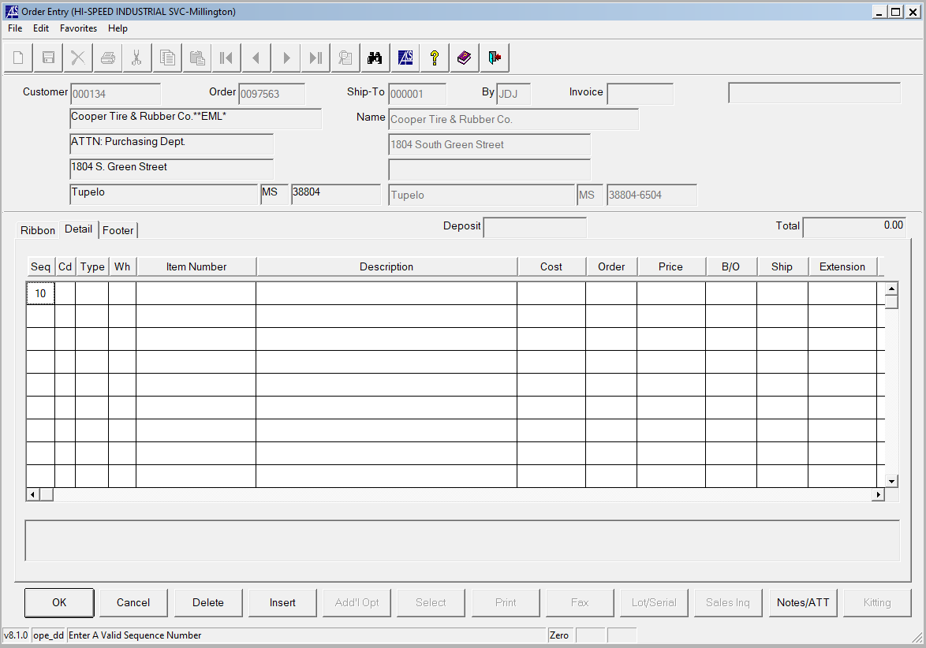

- STEP 8
  - DOUBLE CLICK LINE 010. IN THE “CD” COLUMN, PRESS F3. THE LINE CODE LOOKUP SCREEN SHOULD POPUP ALLOWING YOU TO CHOOSE WHAT APPLIES TO THE PART YOU ARE QUOTING
  - BY DEFAULT IT IS USUALLY EASIER TO SELECT “S” FOR STOCK PARTS. WHEN YOU PUT THE PART NUMBER IN THE “ITEM NUMBER” BOX AND TRY TO ADVANCE BY HITTING THE TAB KEY, THE PART DESCIPTION SHOULD POP UP IN THE “ITEM DESCRIPTION” BOX IF IT IS STOCK. IF THE PART IS NOT STOCK, YOU WOULD SELECT “G” FOR NON-STOCK PARTS.
  - NOTE: SOMETIMES YOU WILL GET A POP-UP WINDOW WHEN ENTERING STOCK PARTS, SAYING THAT THE STOCK PART IS A SLOW MOVER. IN THIS CASE, GO BACK TO THE CD COLUMN TO CHANGE THE “S” TO A LINE CODE THAT HAS “(SMP)” IN THE DESCRIPTION WHICH STANDS FOR SLOW MOVING PART.
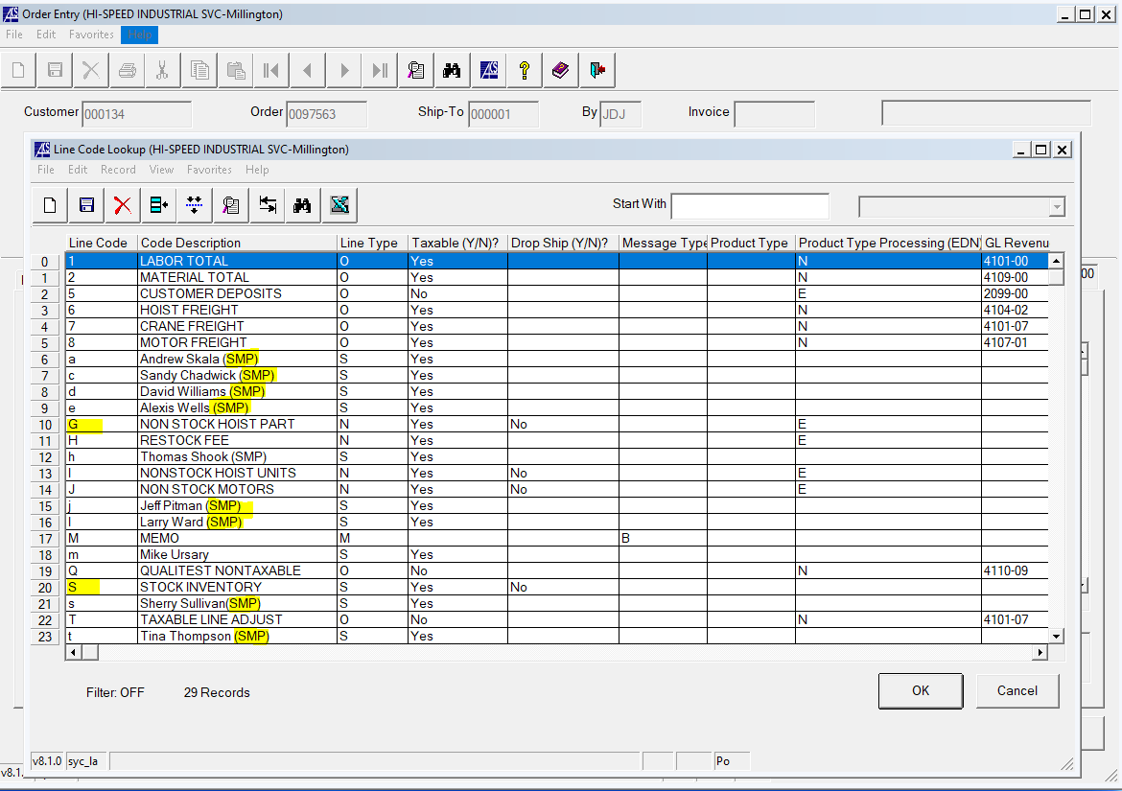

- STEP 9 – NONSTOCK PARTS
  - IF THE PART IS NON-STOCK, THE CD COLUMN SHOULD BE “G”
  - IN THE “TYPE” COLUMN, HIT THE F3 KEY TO LOOKUP DIFFERENT PART TYPES
    - EXAMPLE: HARRINGTON PARTS ARE (HAP) AND HARRINGTON UNITS ARE (HAU)
  - ONCE YOU HAVE SELECTED YOUR APPLICABLE PART TYPE, PUT YOUR PART NUMBER IN THE ITEM NUMBER BOX
  - ENTER THE PART DESCRIPTION IN THE DESCRIPTION BOX
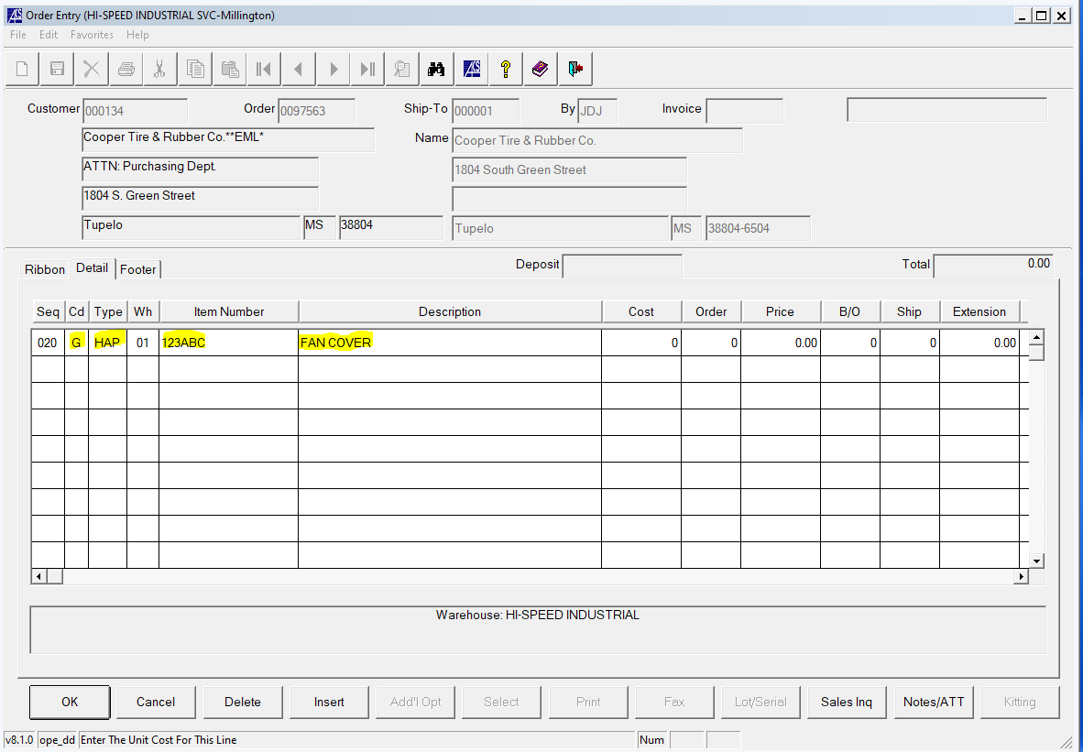

- STEP 10 – NONSTOCK PARTS
  - ENTER THE COST TO HI-SPEED IN THE “COST” COLUMN
  - IN ORDER TO DETERMINE OUR COST, YOU WILL HAVE TO CALL THE VENDOR TO CONFIRM OR USE THE VENDOR WEBSITE TO CONFIRM
  - IN THIS STEP IT IS IMPORTANT TO ALSO NOTE THE LEAD TIME ON THE PART SO THAT CAN BE COMMUNICATED TO THE CUSTOMER (THIS WILL BE SHOWN IN A LATER STEP)
  - ALSO MAKE SURE TO NOTE THE LIST PRICE OF THE ITEM SO THAT THE DISCOUNTED PART PRICE TO THE CUSTOMER CAN BE CALCULATED
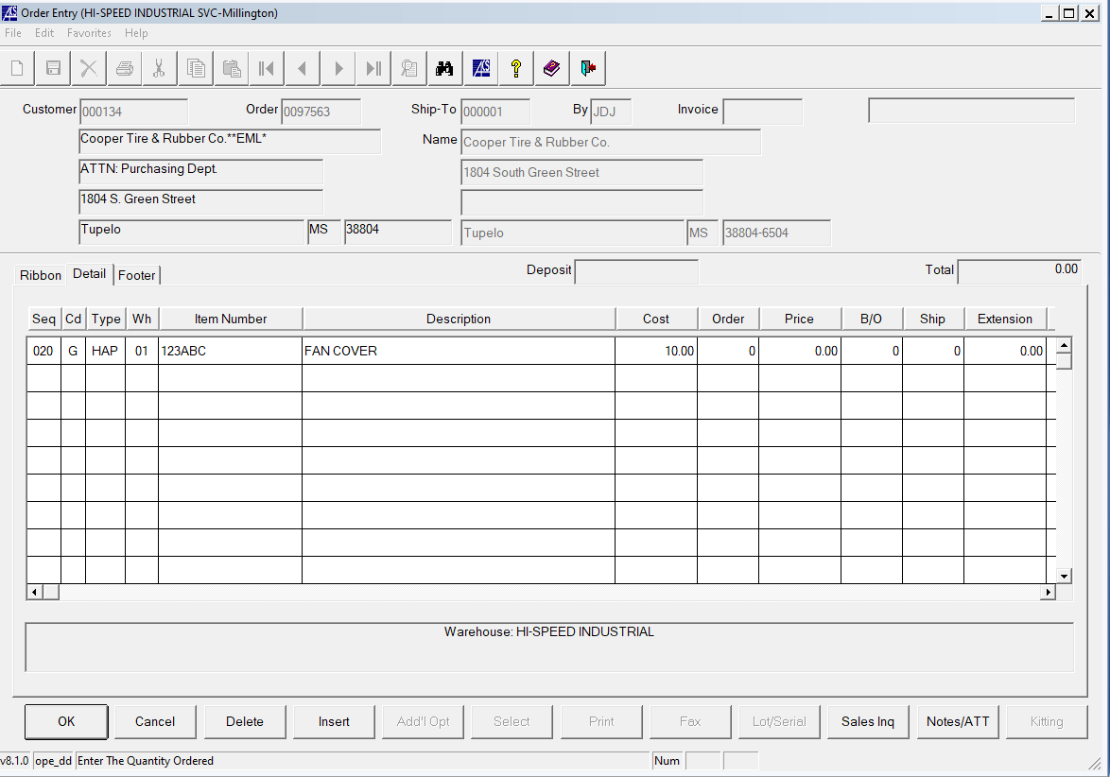

- STEP 11 – NONSTOCK PARTS
  - IN THE “ORDER” COLUMN, ENTER THE QUANTITY THAT YOU ARE QUOTING FOR THAT LINE ITEM, IN THIS CASE WE WILL USE 2
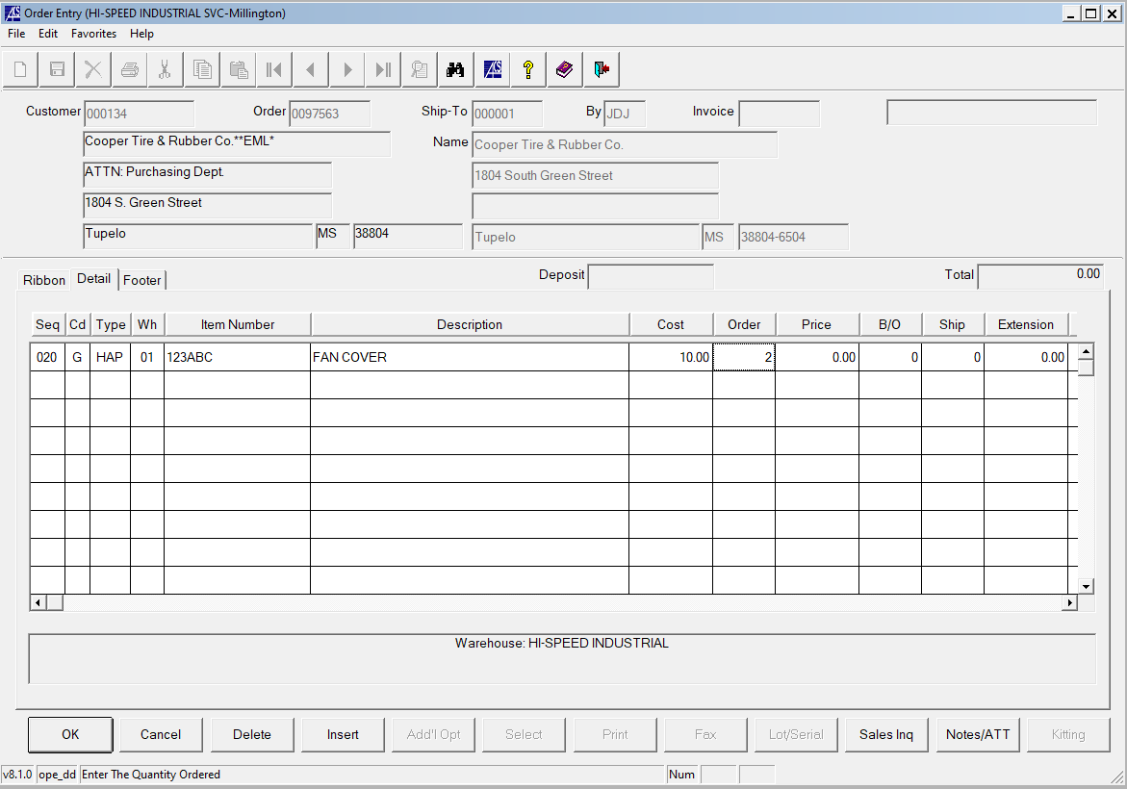

- STEP 12 – NONSTOCK PARTS
  - IN THE “PRICE” COLUMN ENTER THE PRICE TO THE CUSTOMER
  - THIS IS CALCULATED AS A PERCENTAGE DICOUNT FROM THE VENDOR LIST PRICE
  - IN THIS EXAMPLE, WE WILL USE AN ARBITRARY LIST PRICE OF ($20) AND WE WILL ASSUME A DISCOUNT OF (15%)
  - NOTE: IN STEP 4 WE SHOULD HAVE NOTED THE DISCOUNT PERCENTAGE THAT WE USUALLY OFFER TO THAT CUSTOMER
  - NOTE: IN STEP 10 WE SHOULD HAVE ALREADY NOTED THE LIST PRICE
  - WITH A 15% DISCOUNT THE PRICE SHOULD BE PRICE=20*0.85=17
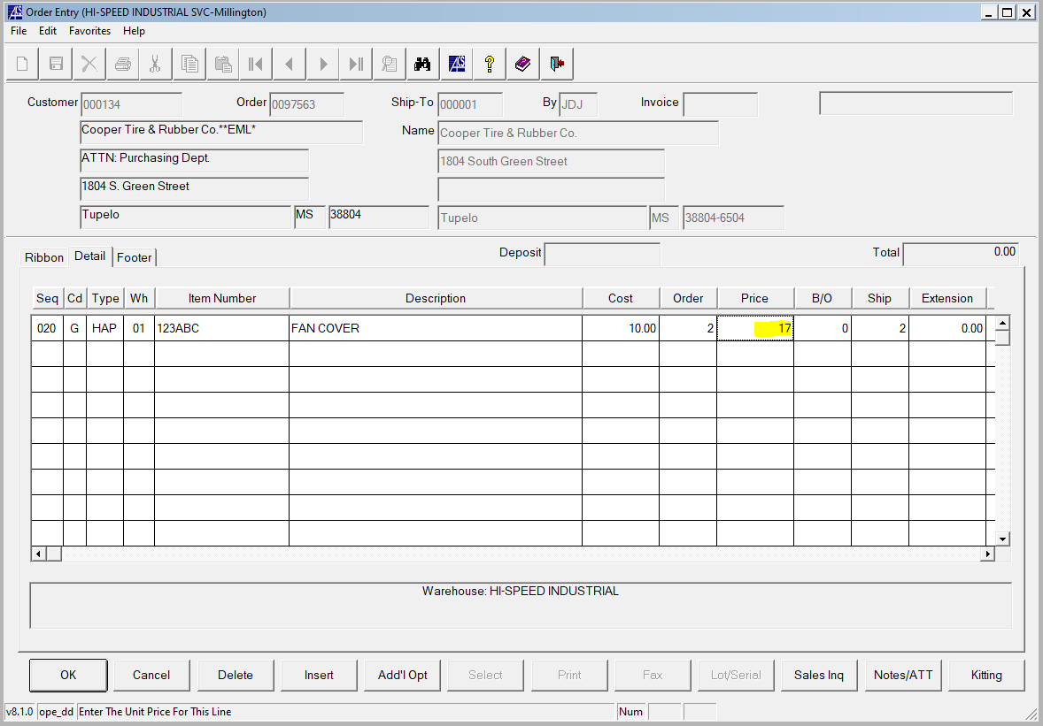

- STEP 13 – NONSTOCK PARTS
  - IN THE VENDOR BOX, HIT THE F3 KEY AND LOOKUP THE VENDOR THAT YOUR PURCHASING HE PART FROM

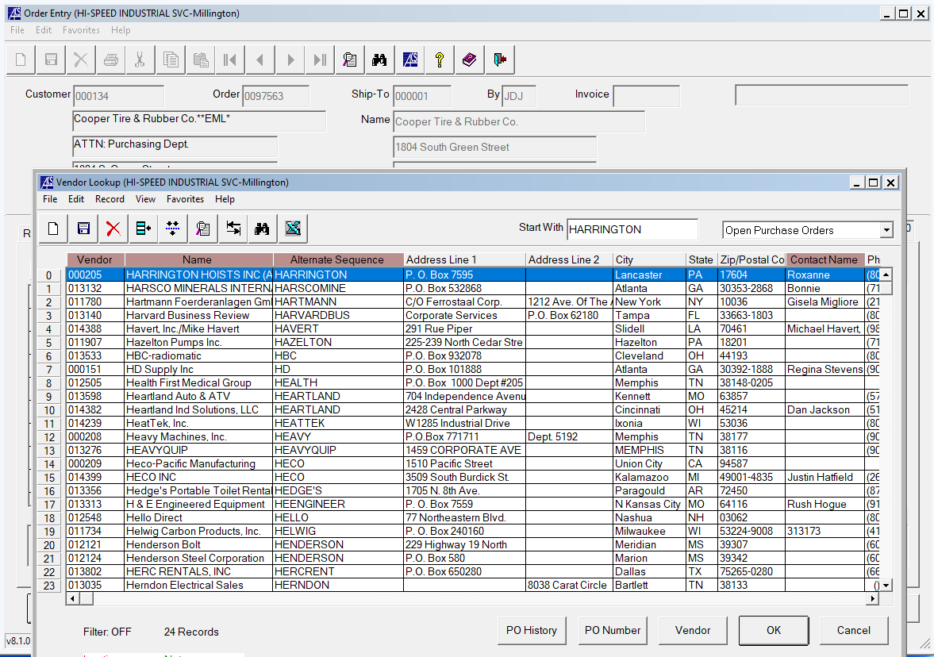

- STEP 14 – NONSTOCK PARTS
  - IN THE “D/S” COLUMN, TYPE “Y” FOR DROPSHIP OR “N” WHICH HAS THE PART COME TO THE SHOP. IN THIS EXAMPLE WE WILL USE “N” FOR NO DROPSHIP.
  - NOTE: IN SOME CASES IT IS PREFFERABLE TO DROPSHIP LIKE ON HARRINGTON UNITS BECAUSE WE CAN PROVIDE A SHORTER LEAD TIME. IT’S A GOOD IDEA TO CONFIRM WITH THE CUSTOMER BEFORE DROPSHIPPING.
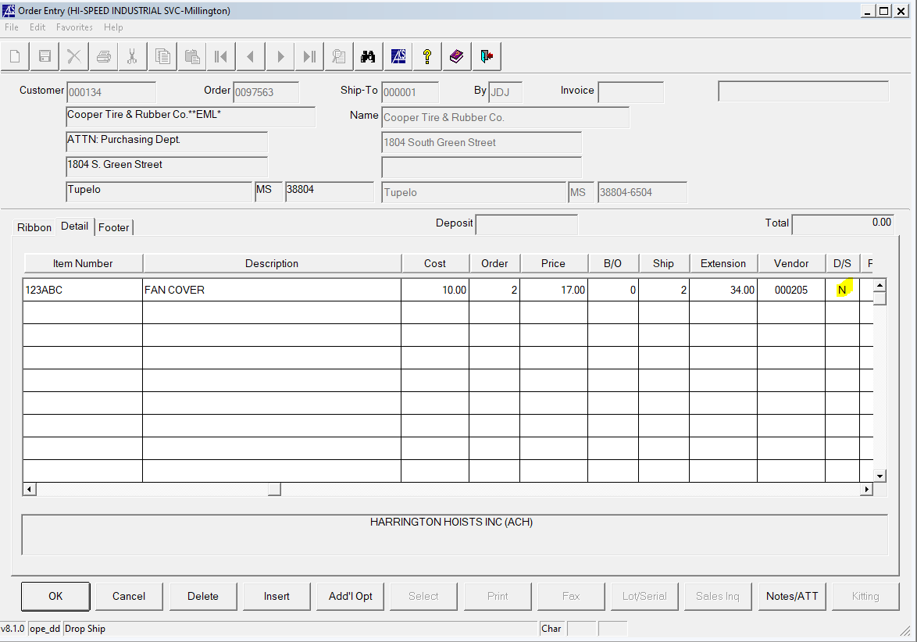

- STEP 15 – NONSTOCK PARTS
  - SCROLL OVER TO THE RIGHT AND IN THE “R/P” BOX, SELECT “R” FOR REQUISITION AND “P" FOR PURCHASE ORDER. OUR WAREHOUSE USUALLY DOES REQUISITIONS FOR PARTS FROM HARRINGTON AND SOME CM PARTS. IF YOU ARE UNSURE IF THE WAREHOUSE DOES REQUISITIONS FOR A CERTAIN VENDOR IT IS BEST TO ASK JEREMY FROM THE WAREHOUSE.
  - NOTE: IF THE WAREHOUSE DOES NOT DO REQUISITIONS FOR THE VENDOR OF THE PART THAT YOU ARE NEEDING YOU WILL NEED TO SELECT “P” AND CREATE YOUR OWN PURCHASE ORDER TO SEND TO THE VENDOR TO GET YOUR OWN PART.
  - IN THIS EXAMPLE WE WILL SELECT “R” SINCE THIS IS A NONSTOCK HARRINGTON PART IN OUR CASE.
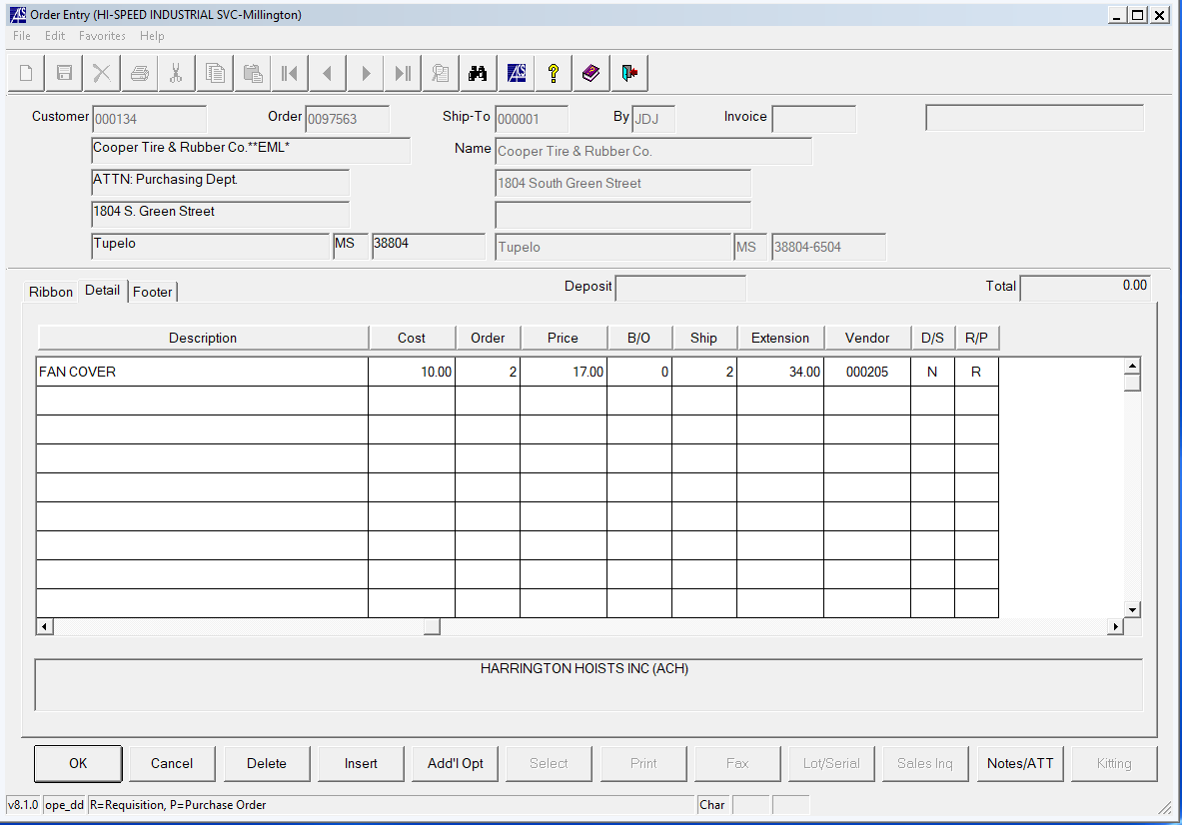

- STEP 16 – NONSTOCK AND STOCK PARTS
  - USE YOUR EMPTY CURSOR TO CLICK IN THE EMPTY BOX UNDER LINE 020 IN THE SEQ COLUMN. LINE 030 SHOULD POPULATE
  - IN THE “CD” BOX TYPE “M” AND HIT THE TAB KEY
  - IN THE DESCRIPTION BOX TYPE THE LEAD TIME OF THE ITEM THAT YOU INQUIRED FROM THE VENDOR OR VENDOR WEBSITE
  - SOME MAY DO THIS PART SLIGHTLY DIFFERENT BUT THE MAIN IDEA IS TO COMMUNICATE THE AVAILABILITY TO THE CUSTOMER
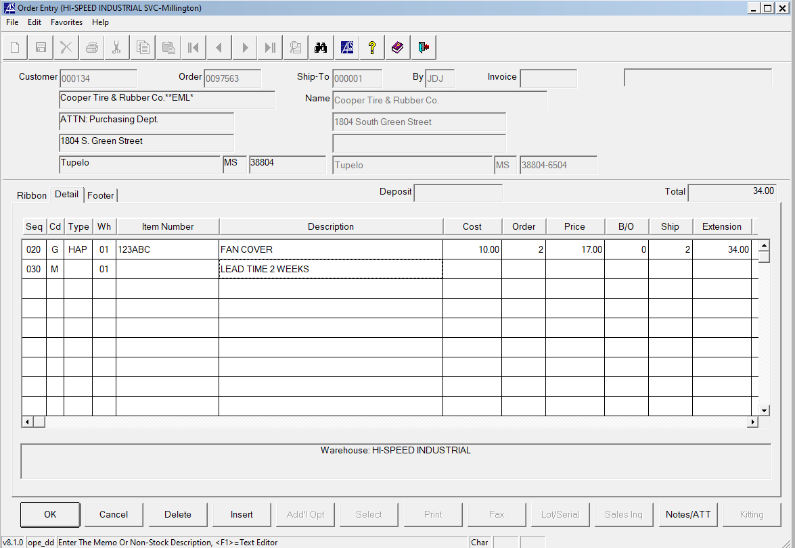

- STEP 9A – STOCK PARTS
  - FOR STOCK PARTS, THE CD COLUMN SHOULD BE “S”
  - FOR THIS EXAMPLE WE WILL USE PART NUMBER SBP2-2-WA FOR ONE OF THE PENDANTS WE STOCK IN WAREHOUSE
  - WE DO NOT HAVE TO SELECT A “PART TYPE” FOR STOCK PARTS
  - THE ITEM DESCRIPTION POPULATES TO SHOW WHAT WE EXPECT AND THE INFO BOX ON THE BOTTOM OF THE QUOTE SCREEN SHOWS THAT WE HAVE 6 OF THESE PENDANTS AVAILABLE.
  - NOTE: BE CAREFUL WHEN LOOKING AT THE NUMBER AVAILABLE. IF THE ITEM SHOWED “6⁻ “ IT WOULD MEAN WE HAVE NEGATIVE 6 OF THIS ITEM IN STOCK MEANING THE ITEM IS ON BACKORDER.
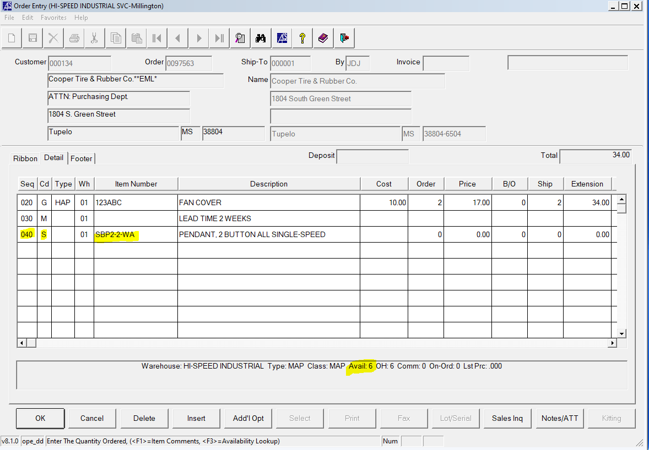

- STEP 10A – STOCK PARTS
  - IN THE ORDER BOX PUT THE QUANTITY TO QUOTE. WE WILL QUOTE 1 PENDANT FOR THIS EXAMPLE
  - THE PRICE SHOULD POPULATE IN THE PRICE BOX BUT SHOULD BE VERIFIED BY EITHER CALLING THE VENDOR OR REFERENCING THE VENDOR WEBSITE TO CONFIRM LIST PRICE AND DISCOUNTING THE LIST PRICE LIKE WE DID IN STEP 12. IN OUR CASE THE VENDOR WEBSITE SHOWS THIS PART AT $96.00 LIST PRICE AND $38.88 OUR PRICE.
  - SINCE THIS IS A MAGNETEK PART AND NOT A HARRINGTON PART THE DISCOUNT PERCENTAGE COULD BE DIFFERENT. WE OFFER DIFFERENT DISCOUNT PERCENTAGES TO OUR CUSTOMERS DEPENDING ON THE VENDOR SINCE DIFFERENT VENDORS GIVE US DIFFERENT DISCOUNTS
  - IN THIS EXAMPLE WE WILL SELECT AN ARBITRARY CUSTOMER DISCOUNT OF 10% OFF MAGNETEK PARTS. OUR PRICE TO THE CUSTOMER SHOULD BE PRICE=96*0.9=86.4
  - NOTE: THE INFO BOX ON THE BOTTOM OF THE SCREEN WILL SHOW YOU WHAT YOUR GROSS PROFIT MARGNI PERCENTAGE IS FOR THE QUOTED PART
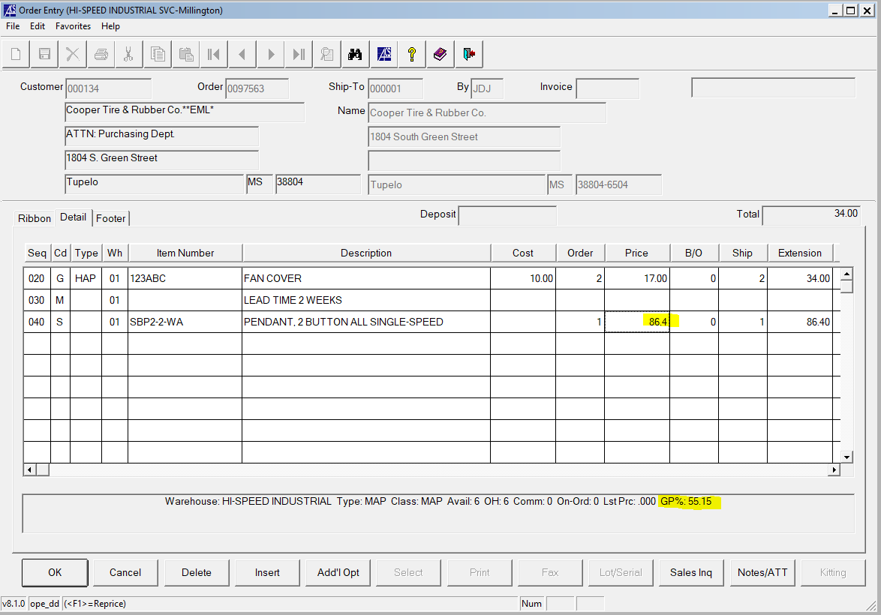

- STEP 11A – STOCK PARTS
  - WE DETERMINED IN STEP 9A THAT WE HAVE 6 OF THE PENDANTS IN STOCK.
  - IF WE WERE QUOTING MORE THAT 6 PENDANTS WE WOULD NOTE TO THE CUSTOMER THAT WE HAVE 6 PENDANTS IN STOCK AND THE REMAINING HAVE AN “X” WEEK LEAD TIME FROM THE VENDOR.
  - SINCE WE ARE ONLY QUOTING 1 PENDANT IN THIS EXAMPLE OUR WAREHOUSE CAN SATISFY THE QUANTITY REQUIREMENT SO WE DO NOT NEED TO FILL OUT THE “VENDOR” BOX, THE “D/P” BOX, OR THE “R/P” BOX SINCE WE ARE PULLING FROM STOCK.
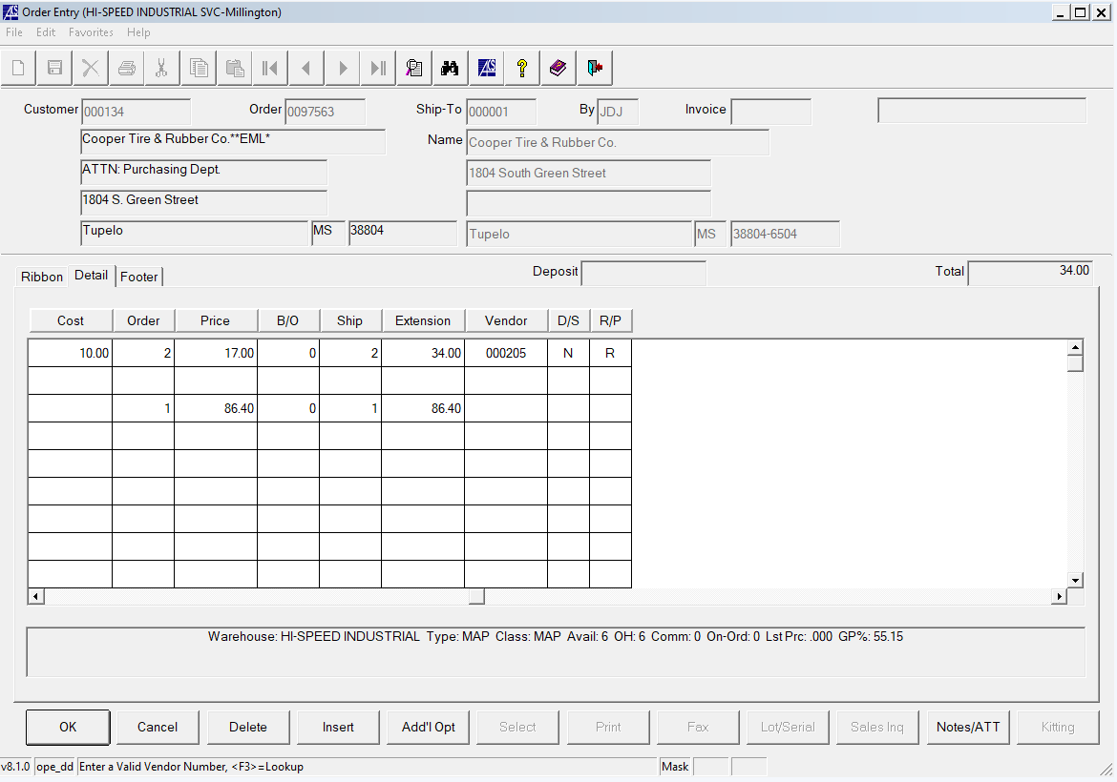

- STEP 11A – STOCK PARTS – CONTINUED…
  - IF WE COULD NOT MEET THE QUANTITY REQUIREMENT FROM OUR WAREHOUSE, WE WOULD NEED TO FILL OUT THE “VENDOR” BOX, THE “D/P” BOX, OR THE “R/P” BOX.

- STEP 12A – STOCK PARTS
  - LIKE WE DID IN STEP 16, WE WOULD MAKE A COMMENT LINE BELOW THE STOCK PART LINE TO SHOW LEAD TIME AND AVAILABILITY. SINCE THIS IS AN AVAILABLE STOCK PART OUR DEFAULT LEAD TIME WOULD BE 1-2 DAYS FROM THE QUOTE DATE. IF YOU QUOTED A STOCK PART ON A FRIDAY, THE ESTIMATED SHIP DATE WOULD BE THE FOLLOWING MONDAY ASSUMING THAT DAY IS NOT A HOLIDAY.
  - SOME MAY DO THIS PART SLIGHTLY DIFFERENT BUT THE MAIN IDEA IS TO COMMUNICATE THE AVAILABILITY TO THE CUSTOMER
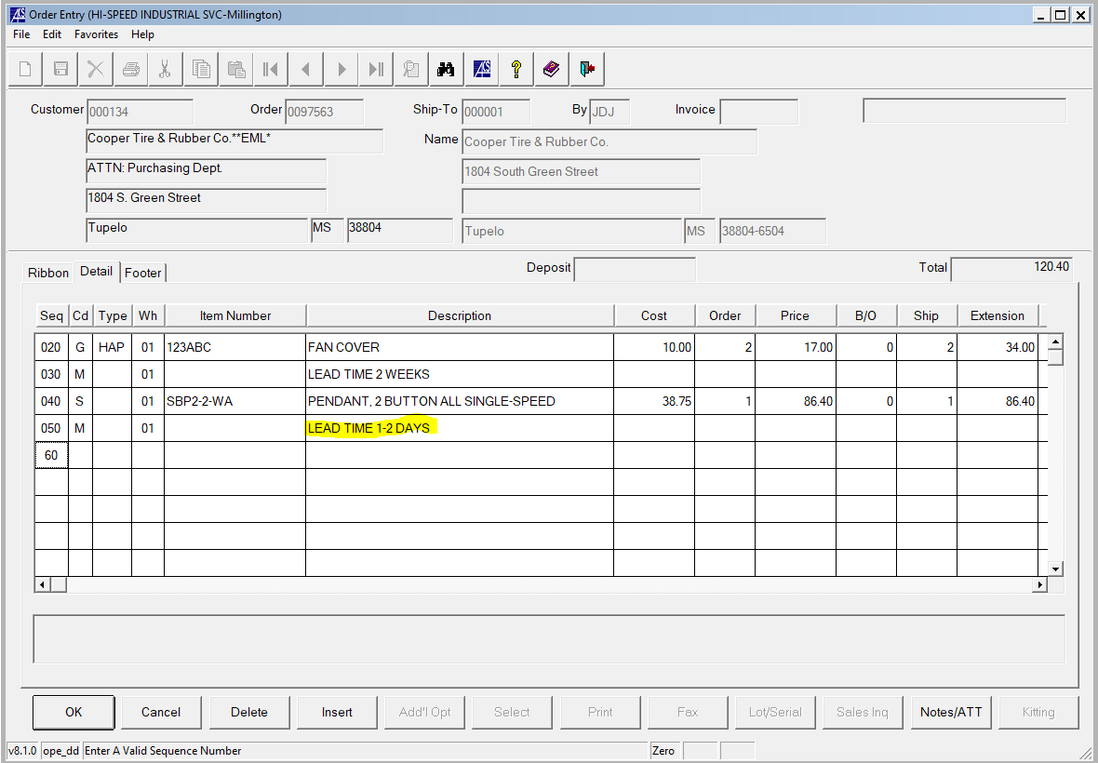

- STEP 17
  - YOU WOULD REPEAT THESE PROCESSES UNTIL ALL ITEMS HAVE BEEN QUOTED
  - AT THE BOTTOM OF YOUR QUOTE IT IS NORMALLY GOOD PRACTICE TO INCLUDE ANOTHER MEMO LINE THAT STATES SOMETHING ALONG THE LINES OF FREIGHT IS NOT INCLUDED IN THE QUOTE AND THAT A PO IS REQUIRED TO PROCEED.
  - THE TERMS I USUALLY INCLUDE ON MY QUOTES LOOKS LIKE THE BELOW PICTURE
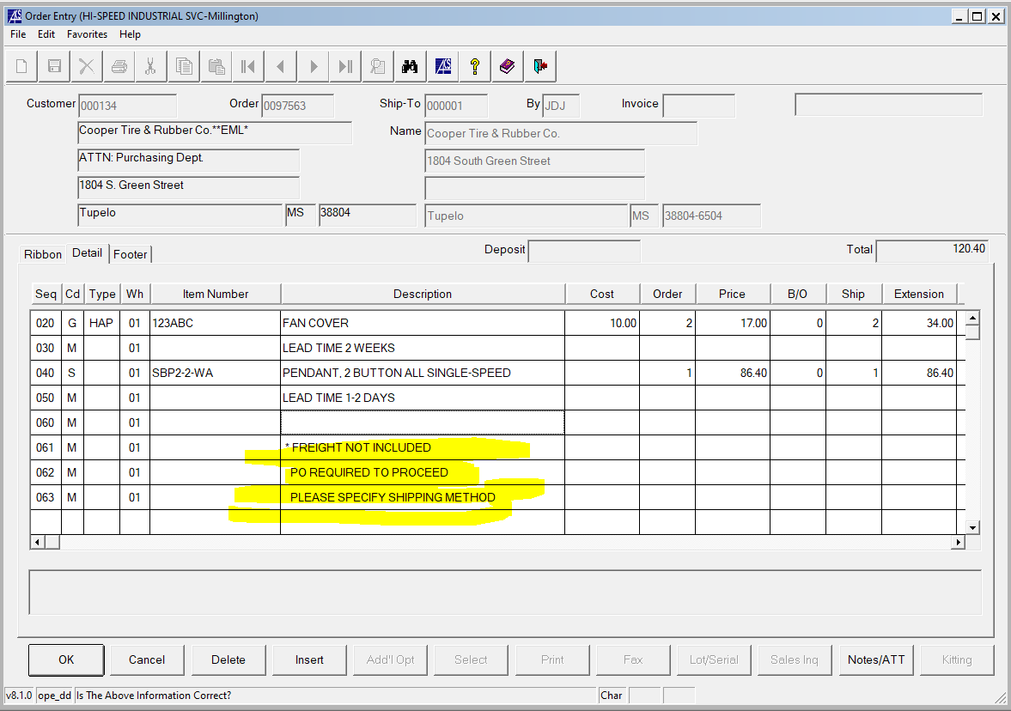

- STEP 18
  - NOW GO BACK TO THE FIRST PAGE YOU WERE ON WHEN YOU WERE CREATING THIS QUOTE BY CLICKING ON THE RIBBON TAB
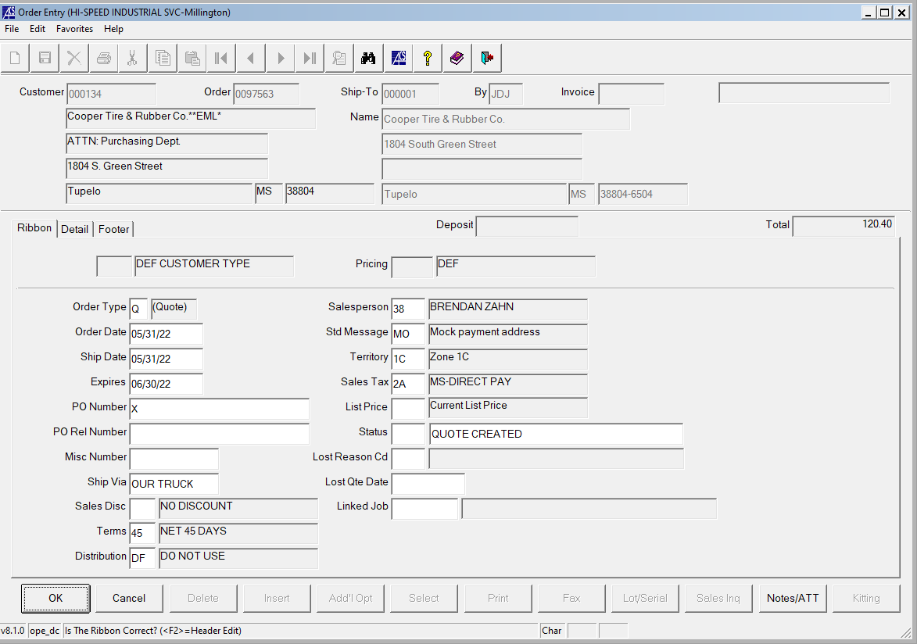

- STEP 19
  - HERE YOU WOULD SPECIFY THE SHIP DATE, THE EXPIRATION DATE. THE EXPIRATION DATE SHOULD BE ONE MONTH FROM THE QUOTE DATE
  - YOU WOULD PUT “QUOTE ONLY” IN THE PO NUMBER BOX
  - YOU WOULD PUT THE NAME OF THE PERSON REQUESTING THE QUOTE IN THE “PO REL #” BOX
  - YOU WOULD TYPE “BEST WAY” IN THE “SHIP VIA” BOX
  - IN THE “DISTRIBUTION” BOX YOU WOULD TYPE
    - HP FOR STOCK HOIST PARTS
    - NP FOR NONSTOCK HOIST PARTS
    - HU FOR STOCK HOIST UNITS
    - NU FOR NONSTOCK HOIST UNITS
  - FOR OUR EXAMPLE WE WILL SELECT NP BECAUSE WE ARE QUOTING A NONSTOCK HARRINGTON FAN COVER AND A STOCK MAGNETEK PENDANT. IF YOU HAVE MORE STOCK THAN NONSTOCK PARTS YOU WOULD SELECT HP AND VICE VERSA
  - YOUR SCREEN SHOULD LOOK LIKE THE PICTURE BELOW
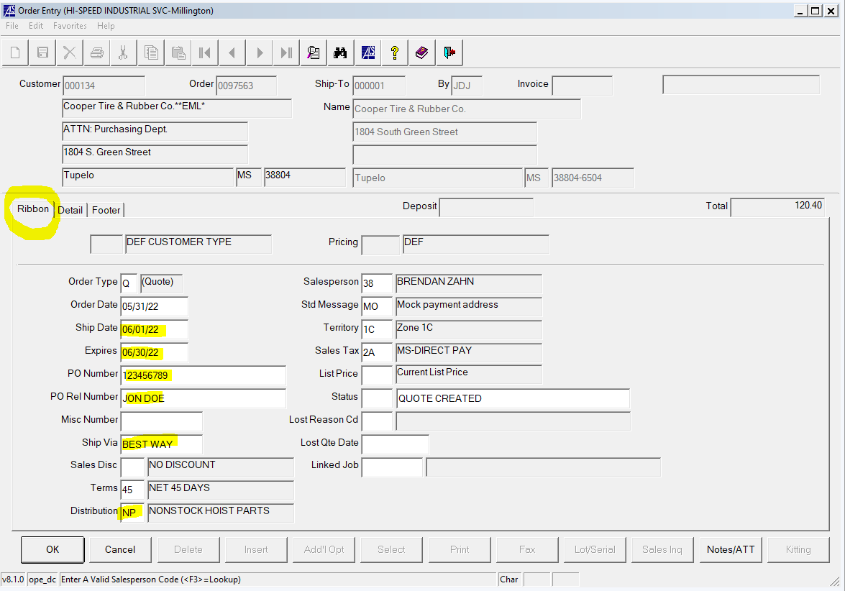

- STEP 20
  - CLICK ON THE FOOTER TAB TO GO TO THE FINAL SCREEN TO SAVE YOUR QUOTE
  - CLICK THE PRINT BUTTON
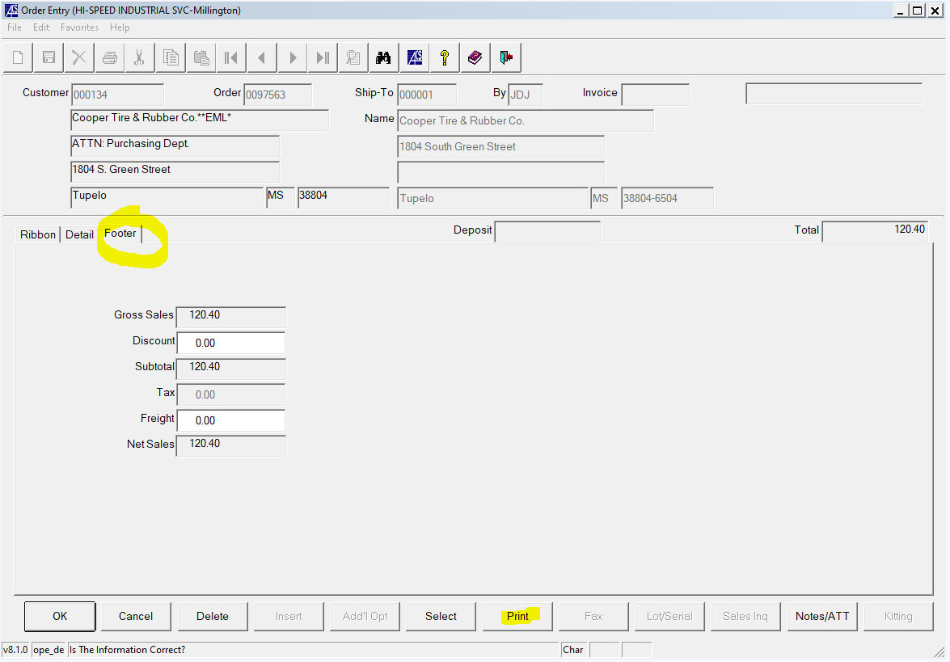

- STEP 21
  - CLICK THE “EMAILING TO CUSTOMER” BOX IN THE POPUP WINDOW AND CLICK “OK”
  - YOU WILL SEE ANOTHER POPUP COME UP AFTER CLICKING YES THAT SAYS “PRINT TOTALS AT BOTTOM OF THE QUOTE?”
    - SELECT YES
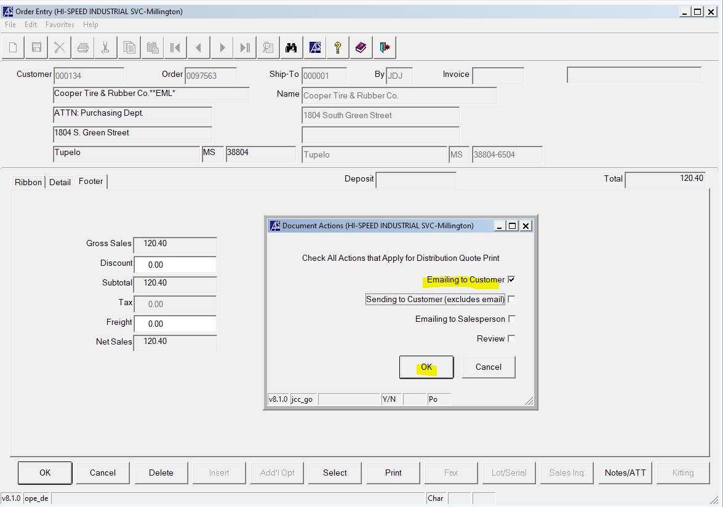
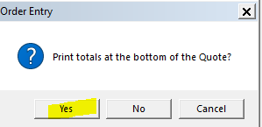

- STEP 22
  - YOUR ACS OUTPUT MANAGER SCREEN SHOULD POP UP
  - SELECT “PDF” AND CLICK “EXECUTE”
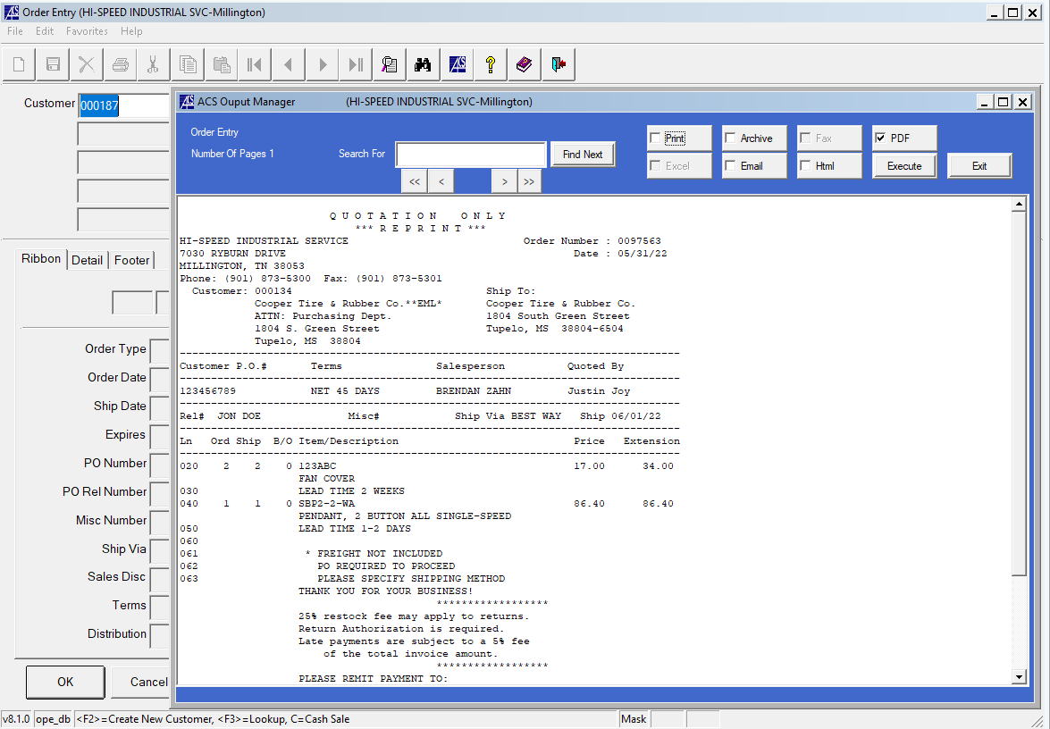

- STEP 23
  - YOUR PDF EDITOR SHOULD OPEN UP SHOWING THE QUOTE YOU MADE AND IT SHOULD LOOK SIMILAR TO THE BELOW PICTURE
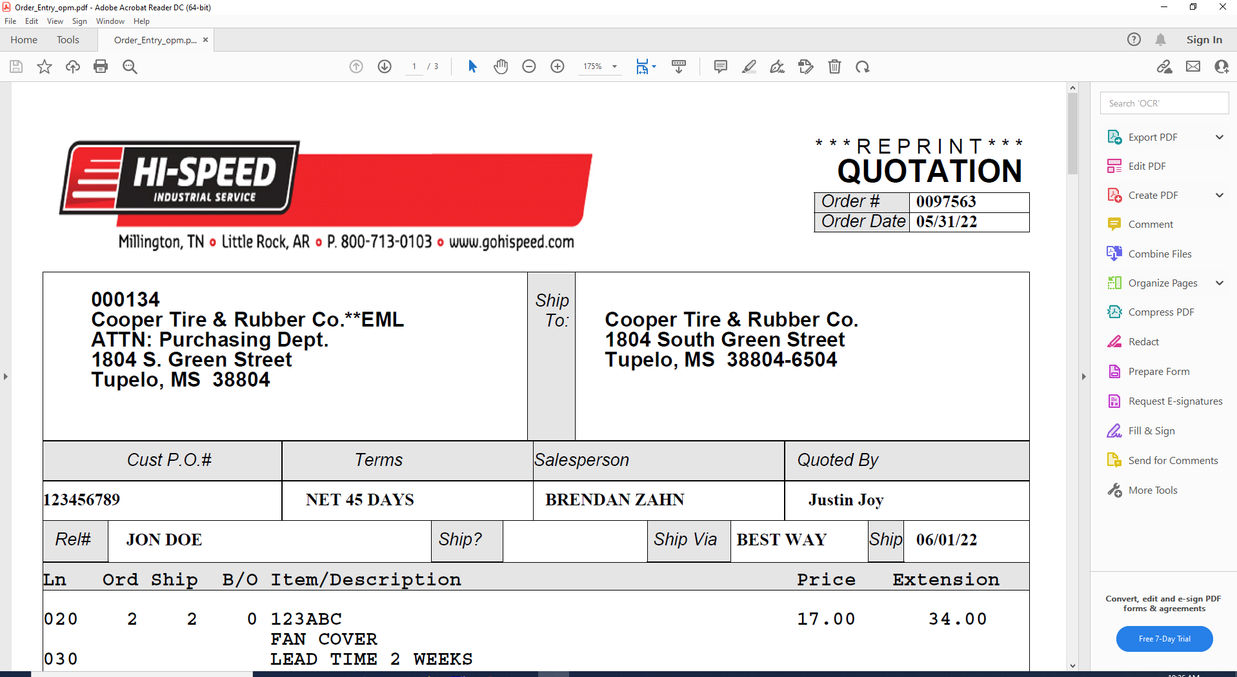

- STEP 24
  - SAVE YOUR QUOTE TO Z:\firms\firm01\images\salesord\ORDER NUMBER
  - IN OUR CASE OUR QUOTE NUMBER IS “0097563”
  - SO THE FOLDER WE WOULD SAVE TO IN THIS CASE WOULD BE Z:\firms\firm01\images\salesord\0097563
  - YOU CAN SAVE THE FILENAME AS QUOTE 97563 OR SOMETHING OF THAT SORT
  - ONCE IT HAS BEEN SAVED YOU CAN UPLOAD THE QUOTE TO AN EMAIL TO RESPOND TTO THE CUSTOMER
  - NOTE: IT IS ALWAYS A GOOD IDEA TO DOUBLE CHECK THE QUOTE BEFORE SAVING TO SEND TO THE CUSTOMER

